Refer to following for additional references: http://www.camerasunderwater.co.uk/articles/optics/lens-fov, http://www.camerasunderwater.co.uk/articles/optics/flat-port-theory,
http://scubageek.com/articles/wwwposn.html,
http://scubageek.com/articles/wwwfeff.html

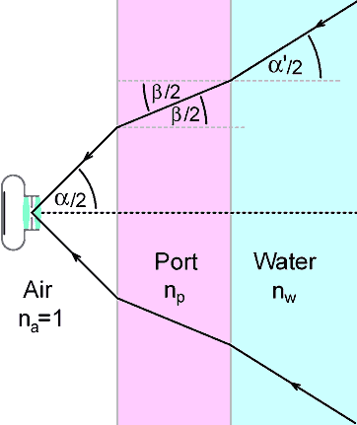
Using Snell’s law, the relationship between the camera lens half angle a and the resultant lens half angle after going through a glass port and water can be found:

$$α^{'}=asin⁡\left(sin\left(α\right)\frac{n_{a}}{n_{w}}\right)$$

For the Sony A7Sii used with the 90mm/2.8 lens, the following parameters are:
α = 27 deg
F (lens focal length) = 90 mm
n_{a} = 1
n_{w} = 1.33

Therefore, given these parameters, the air-water interface changes the spread angle and focal length of the lens to 22 deg and 110 mm, respectively.

Measuring the FOV size in-air and using the in-water parameters, the in-water FOV can be estimated.

Distance from the image sensor (in) | In-air FOV (in) | In-water FOV (in) | Notes
11 | 2x1 | 1.5x1 | At minimum focus distance
13.5 | 3x2 | 2.5x1.5
16.5 | 4x2.5 | 3.25x2
19 | 5x3 | 4x2.5 | At 20 in, switch to 0.5 to inf setting
22.5 | 6x3.5 | 5x3
24 | 7x4 | 5.75x3.25 | Ideal dist. between 22 and 26 in
34 | 11x6 | 9x5

Therefore, the in-water FOV that meets our science goals, ranging from 6 to 4 in, is achieved with a distance between the object and image sensor from 22 to 26 in. Therefore the working distance (or the distance from the end of the lens to the working object) can be between 16 and 20 in.

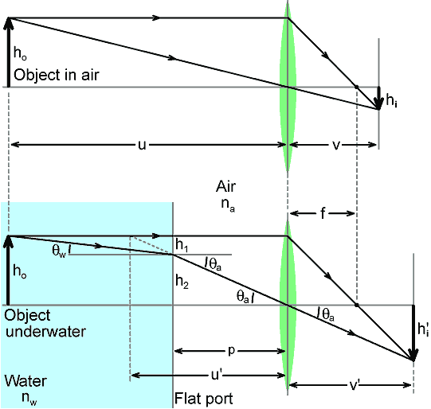
When underwater, the object appears to be closer (a distance u’) than it really is to the image sensor (a distance u), which results in a magnification of the object. Therefore, not only does the FOV size change, but the focal plane distance (e.g., the focus setting) has to as well. Using the ray diagram below, the magnification of the object due to the port (Mp) is:

$$M_{p}=\frac{u-F}{u^{'}-F}$$

The magnification of the image due to the port can be determined from Snell’s law and our resulting change in spread angle, which was found to be 1.23. Using the equation above to solve for u’ with u set as 24 in and F to 90 mm, the apparent distance is 20 in. Therefore, the focal plane needs to be set to 20 in despite the object being 24 in away from the camera sensor underwater.

To summarize:

 | In-air | In-water
Refractive index | 1 | 1.33
Optical spread angle | 27 deg | 22 deg
Lens focal length | 90 mm | 110 mm
FOV | 7in x 4 in | 5.75 in x 3.25 in
Focal distance setting (measured from sensor) | 24 in | 20 in

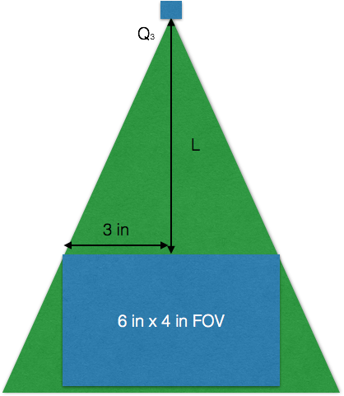
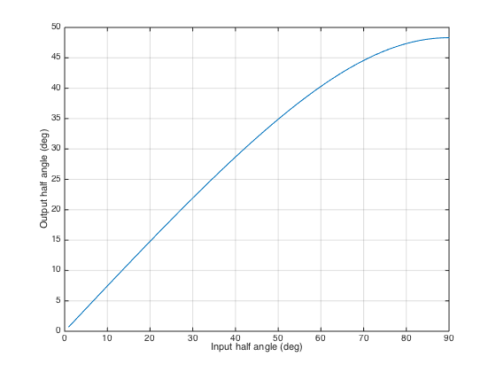
The ideal FOV size for our measurements would be 7in x 4in. To completely illuminate that FOV, the vertical height of the laser optics must be selected depending on the line-generating optics used. The vertical height (L) is found using θ3, where θ3 is the output angle of the line-generating optic due to the air-glass-water refractive index changes. Therefore, for the 60 and 90 deg line optics, the vertical height of the laser optics should be 8.7 and 5.6 in, respectively to illuminate a FOV that is 7in x 4in.
3.5 in
To summarize:
 | θ1 | θ3 | L
45 deg line optic | 22.5 deg | 17 deg
60 deg line optic | 30 deg | 22 deg | 8.7 in
75 deg line optic | 37.5 deg | 27 deg | 6.9 in
90 deg line optic | 45 deg | 32 deg | 5.6 in

