Project Summary
  - Integrated Time Series (901512)

Introduction

- 2013/2014 Feasibility Study: Is it feasible to combine the 3 series? Monterey Bay Time Series (upper water column), Midwater Time Series (midwater), and Pelagic-Benthic Coupling (benthic)
  - Science and engineering worked together to define what would be needed scientifically and technically to combine the three series.
  - White paper was generated that defined the vision for the 5-year project
- 5-year project began in 2015 to combine the time series.
- This report summarizes that 5-year project
- In order to make operations more efficient and cost effective, each time series was working on a migration from ship-based operations to autonomous vehicle operation. This work is being done under each respective time series project.

Original Goals

- Near-term goals: Integrate data from the 3 time series. Integration work consists of both scientific data integration as well as technological integration.
  - Scientific:
    - Analysis to identify links between surface, midwater and benthic environments
      - concurrent climate driven changes across trophic levels
      - carbon fluxes from primary production to higher trophic levels and export to the seafloor
    - We identify these possible areas for scientific data analysis
      - Data Synthesis
      - Synchronous Variability
      - Prediction
      - State of the Ecosystem
      - Outside datasets
      - Carbon Budget
  - Technical
    - Propose common data store
    - Publicly share data
    - Add visualization based on scientific analyses
- Long-term goal is an integrated time series to achieve:
  - Affordable and sustainable system
  - Enable key ecosystem processes to be monitored
  - Enable tracking of organic carbon production and utilization throughout the water column
  - Enable assessment of the impact of climate variability
  - Improve prediction of future states of the system, particularly under climate change
  - Provide tools to monitor the state of Monterey Bay
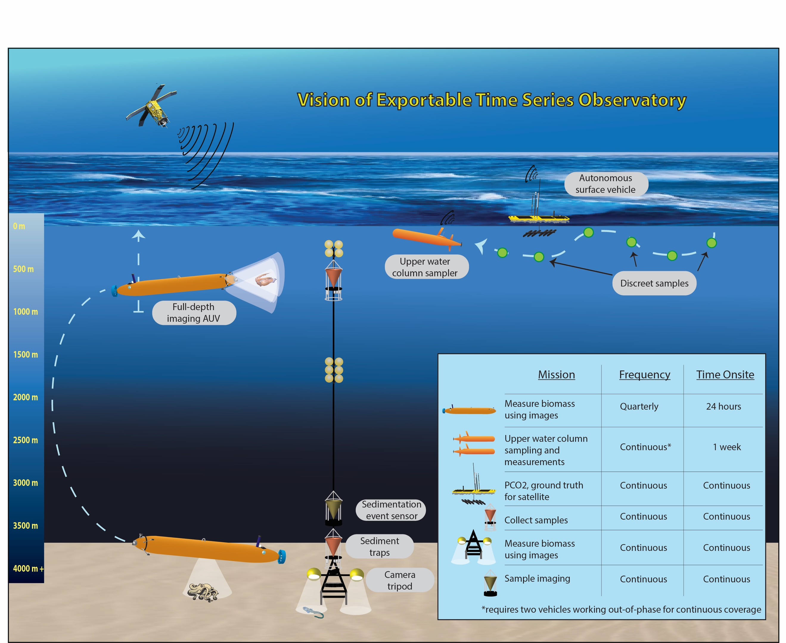
Figure 1 Long Term Vision of Combined Time Series
- Actions to achieve long-term vision
  - Infrastructure components:
    - Complete development of midwater and benthic imaging AUVs
    - Complete development of 300m LRAUV water sampling system
    - Develop LRAUV docking capabilities for both data and power exchange
    - Develop 4000m LRAUV to conduct full depth optical and acoustic monitoring at both stations
    - Develop 4000m LRAUV with docking capabilities for both data and power exchanges
    - Install a mooring of two sediment traps and time-lapse camera at Sta. MB
    - Develop mooring based instrumentation to provide continuous monitoring of water column (low cost cameras, RDI acoustics, SES, Rover) for LRAUV data and power exchanges through docking stations
    - Install a 500 m depth sediment trap with extended mooring at Sta. M
    - Establish data management and acquisition system for all MBARI time-series data.
    - Develop VARS routines for processing AUV images from midwater and benthic transects
    - Export time-series instrumentation and data management system
  - Time-series monitoring implementation:
    - Begin monitoring of upper ocean parameters using LRAUV at Station MB and Station M and processing data
    - Begin monitoring of physical and chemical parameters as well as the distribution, abundance and size of pelagic fauna using optical and acoustic imaging at 100m intervals down to 1000 m depth and processing data at both stations.
    - Begin oblique AUV faunal transects of water column between 1000 m and the bottom at both stations.
    - Begin monitoring of the physical and chemical parameters as well as the distribution, abundance and size of benthic boundary layer fauna using optical and acoustic imaging from the sea floor to 50 m above bottom at both stations.
    - Continue annual servicing of moorings and processing of sediment trap and time-lapse images from both stations.

Results – Near Term Goals

Scientific – Data Synthesis

The goal of this work was to identify key variables and reduce the number of parameters being compared to each other to a manageable number.
- Reducing using techniques like clustering and/or Empirical Orthogonal Functions (EOFs)
- 2015:
  - ecosystem indices were chosen to be:
    - Surface: plankton concentration (counts per volume) and biomass (from 1989)
    - Midwater: animal density (counts per volume) from ROV transects (from 1997)
    - Benthos: echinoderm density (counts per area) from towed camera-sled images (from 1989) and animal density from benthic ROV transects (from 2006)
  - Using the following:
    - 60 plankton species
    - 16 plankton functional groups
    - 90 midwater taxa (mostly defined at genus level)
    - 40 benthic taxa (mostly defined at the family to class level)
    - 10 benthic echinoderm taxa
  - Surface and midwater datasets were re-gridded monthly from an original resolution of 3-4 weeks, gaps no longer than 1 month filled by linear interpolation
  - Midwater transects, vertical gaps were filled and counts averaged over depths 200 to 1000m (the full vertical resolution is retained for some analysis)
  - The original temporal resolution (yearly or every few months) was retained for benthic time series.
  - Anomalies were generated for each of the taxa defined above by log-transforming the data (all), and removing the seasonal cycle (surface and midwater only)
- 2016:
  - Created data synthesis data working groups
  - Integrated more datasets: phytoplankton cell sizes and satellite environmental data. MBON krill data might be useful for proxy identification
  - Continued work on indices: biodiversity indices, principal component analysis, multidimensional scaling analysis or self-organizing maps. More work needed to define taxonomic groups
  - El Nino study:
    - Changes during El Nino: food supply: Looking at plankton size and primary production. Hypothesis = food supply decreases during El Nino. No linkages, more work to be done, challenges our understanding.
    - Changes during El Nino: timing: propogation of anomalies in space and time and across trophic levels. No significant nor consisten relationship found, again, challenging our understanding
    - Community structure and change: Work so far has not identified clear simultaneous changes across time series. More work needed, specifically choosing taxonimic groups.
  - El Nino: not seeing much linkage and is much more challenging. Could be that signals from El Nino are weak compared to local forcing, thus masking them. Also could be that isolating sources of variability are challenging given current sampling techniques.
  - Also working on carbon budget in water column, we are finding this will not be straightforward and will require significant work. Focus on midwater and identify what is missing.
- 2017:
  - Examined results on timeseries of techniques like PCA, non-metric multidimensional scaling. They have identified similar characteristics in the three time series. Basically, nMDS and PCA show trends in variability (this is using integration)
  - Wrap up current lines of investigation since it will be put on hold when Monique goes on leave
  - Shifted focus to expanding on ecosystem indices that are showing results.

Scientific – Synchronous Variability

Compare the time series from (1) with ech other and with climate indicies to identify similar variability at the seasonal and interannual scale. Could be simple techniques, like lagged correlations or advanced techniques, TBD. Forcing could be assessed from satellite data and climate indices like Pacific Decadal Oscillation (PDO). Not sure what to put for results here.

Scientific – Prediction

Develop predictive capabilities by identifying lags (e.g. animals responding to climate variability with some time delay) and processes (e.g. features observed in situations likely to become more common with climate change, such as strong upwelling or low oxygen). Identify lagged-relationships based on (2) and identify species for which those are robust enough to enable prediction. Not sure what to put for results here.

Scientific – State of the Ecosystem

Develop proxies related to the state of the ecosystem, and in particular to biodiversity, productivity and ecosystem health. Study how those crucial parameters have been evolving with time and how they might be influenced by the environment or anthropogenic stressors. Not sure what to put for results here.

Scientific – Outside Datasets

We were going to compare the MBARI time series to external datasets, either in Monterey Bay (related to parameters not currently measured such as zooplankton or top predators) or in the California Current (e.g. CalCOFI), I couldn’t find much on that work, need some help here.

Scientific – Carbon Budget

Work toward a carbon budget by quantifying carbon fluxes from the surface to the ocean floor and to harvested species (where possible), looking at pathways such as grazing, respiration and carbon export. Start combining midwater animal counts with biomass and respiration numbers. Work is being done in midwater ecology to get average carbon amounts for dominant species.

I am guessing we want to talk about why this was difficult and what pieces are missing that would enable this. This would then tie into the recommendation section at the bottom.

Technical – Common Data Store

In the early years of the Integrated Time Series project, the STOQS application was discussed as a possible solution to long term storage for the time series data being extracted during the scientific explorations. The data storage technology utilized in STOQS is the relational database PostgreSQL and was a likely candidate because of its performant retrieval of data and built in geospatial capabilities. Loaders were written to upload the extracted data sets from the three time series project into a STOQS database. The worked well as the amount of data generated by the data extractions and analyses were not large. However, one goal of this work was to focus on an architecture that could be extended beyond the data in this project.

Up until recently, it has been well documented that relational database technologies were often times more difficult to manage as the scale of data increased. While there are ways of scaling traditional relational databases like PostgreSQL, they are not straightforward and it was decided to take the opportunity to explore other methodologies to store time series data that would scale well.

Many different technologies, frameworks and architectures were explored to meet this requirement. Early on in the project, along with efforts in other parallel projects, different storage technologies were evaluated based on the unique requirements that large-scale long-term time series data storage and retrieval brings. Some examples of these storage technologies were traditional relational databases with architectures targeted for scale (PostgreSQL, Microsoft SQL Server, MySQL, etc.), along with NoSQL databases (CouchDB, MongoDB, Elasticsearch, Cassandra, etc.) that were built for the purposes of scaling. There were many tradeoffs between all these different storage technologies and, at the time, none seemed to meet all our needs.

Late in the project (late 2017) a technology named TimescaleDB began to get traction and seemed to fit our requirements. It was based on PostgreSQL and is, in fact, API compatible with PostgreSQL, but was designed to solve the scaling problems faced by traditional RDBMS systems to date. TimescaleDB performance metrics seem to meet our projected time series data storage needs and boast regular testing at scales of 10+ billion rows while sustaining insert rates of 100-200k rows/second. With scaling, they have seen upwards of 500 billion rows with sustained inserts of 400k rows/second. Basically, TimescaleDB was designed to by compatible with PostgreSQL, but built to scale like NoSQL solutions. One key benefit of utilizing TimescaleDB is, that if we are successful it will be able to serve data to the STOQS application stack as well due to it’s API compatibility with PostgreSQL.

With this evaluation was going on, three other projects (ESP, CANON/ODSS, and Data TAG) were also defining data storage requirements for their respective infrastructure. As development proceeded, it was clear that most of these projects had similar requirements, albeit some were subsets of others. Still, it was deemed worth trying to build a single software stack that would meet all the requirements, which would also meet the goal of the Integrated Time Series project to build an infrastructure that could scale to other data sets.

The last couple of years of the combined efforts focused on building a set of service-based components to catalog and serve different kinds of data, including time-series data. While this system meets more requirements than are needed for the Integrated Time Series project, it ensures, that if we are successful, we can work off one application codebase moving forward for several projects. A high-level architecture of this system is shown below.

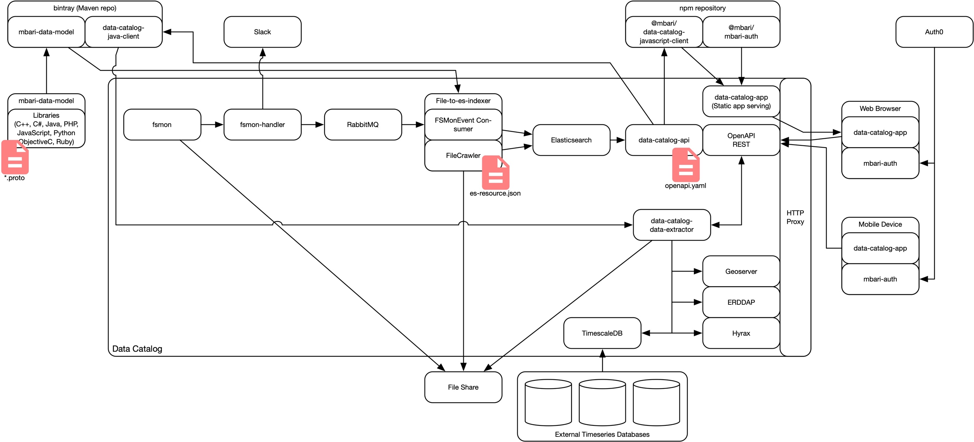
Figure 2 Data Catalog and Storage Architecture
While some of the components in the architecture may not be utilized to serve the Integrated Time Series data, it will be responsible for parsing, loading and serving the data extracted during the data analysis portion of this project. At a high level, this architecture basically monitors a file system and catalogs information placed in that file store. If the software recognizes specific features in the data sets, it will perform additional functionality to give end users more meaningful ways of accessing the data.

While, at the time of this writing, this process is not yet in place for the Integrated Time Series, the process starts with comma-separated value (CSV) data files that are being generated by the science analyses described in the sections above. These files will be loaded into a directory that is being monitored by the software shown in the figure above. Because it is in CSV format and contains time-series data, the architecture will automatically parse the data in those files and load them into a TimescaleDB instance. That relational data can then be served through and connector that is designed to serve relational database data through an ERDDAP server.

Technical – Publicly Share Data

As describe in the previous section, the data from this project will be available through both a REST style API as well as an ERDDAP server.

Technical – Added Visualization

While visualization products were prototyped during this development, no specific products have been finalized at the time of this writing. The prototype code is being migrated to serve as visualization interfaces on the data architecture show in the above figure so that it can be generalized across other data sets beyond the Integrated Time Series.

Results – Long Term Goals
- Infrastructure components:
  - Complete development of midwater and benthic imaging AUVs
    - i2MAP vehicle nearing completion
    - Benthic (4000m) rated LRAUV was not developed due to limited resources at MBARI.
  - Complete development of 300m LRAUV water sampling system
    - This was the sipper developed under the CANON project correct? Not sure what the current status is.
  - Develop LRAUV docking capabilities for both data and power exchange
    - This is an active development under the LRAUV project
  - Develop 4000m LRAUV to conduct full depth optical and acoustic monitoring at both stations
    - This work was delayed due to resource limitations at MBARI.
    - There will be some work in 2020 to scope the development of a 1500m rated LRAUV
  - Develop 4000m LRAUV with docking capabilities for both data and power exchanges
    - Dependent on the development of the 4000m LRAUV which was delayed.
  - Install a mooring of two sediment traps and time-lapse camera at Sta. MB
    - Not sure of the status of this work
  - Develop mooring based instrumentation to provide continuous monitoring of water column (low cost cameras, RDI acoustics, SES, Rover) for LRAUV data and power exchanges through docking stations
    - Not sure of the status of this work
  - Install a 500 m depth sediment trap with extended mooring at Sta. M
    - Not sure of the status of this work
  - Establish data management and acquisition system for all MBARI time-series data.
    - This work is being developed under the Improving Impact of MBARI’s Data project. It’s will be a continuation of the work that was done under this project that was combined with the data systems work on the ESP and CANON projects.
    - See the results section for more details
  - Develop VARS routines for processing AUV images from midwater and benthic transects
    - I believe this work is done. I can check with Brian, but I think the i2MAP vehicle images are being processed into the M3 system. Anybody verify?
  - Export time-series instrumentation and data management system
    - Not sure about hardware export
    - All the components of the data management system described in this document are on BitBucket in public repositories:
      - fsmon: https://bitbucket.org/mbari/fsmon/src/master/
      - fsmon-handler: https://bitbucket.org/mbari/fsmon-handler/src/master/
      - file-to-es-indexer: https://bitbucket.org/mbari/file-to-es-indexer/src/master/
      - data-catalog-api: https://bitbucket.org/mbari/data-catalog-api/src/master/
      - data-catalog-app: https://bitbucket.org/mbari/data-catalog-app/src
      - data-catalog-data-extractor: https://bitbucket.org/mbari/data-catalog-data-extractor/src/master/
      - mbari-data-model: https://bitbucket.org/account/user/mbari/projects/DC
      - data-catalog: https://bitbucket.org/mbari/data-catalog/src/master/
- Time-series monitoring implementation: (Please comment on these bullets as I don’t have much knowledge on them. I think many of them were kind of dependent on developments that were never done, so I think they are on hold)
  - Begin monitoring of upper ocean parameters using LRAUV at Station MB and Station M and processing data
  - Begin monitoring of physical and chemical parameters as well as the distribution, abundance and size of pelagic fauna using optical and acoustic imaging at 100m intervals down to 1000 m depth and processing data at both stations.
  - Begin oblique AUV faunal transects of water column between 1000 m and the bottom at both stations.
  - Begin monitoring of the physical and chemical parameters as well as the distribution, abundance and size of benthic boundary layer fauna using optical and acoustic imaging from the sea floor to 50 m above bottom at both stations.
  - Continue annual servicing of moorings and processing of sediment trap and time-lapse images from both stations.

Lessons Learned

- Scientific
  - Need help here
- Technical
  - One key development that was enabled during the Integrated Time Series was the automated detection of 6 key species by the Video TAG project. I need to get some information from Duane/Danelle for this part.

Recommendations

- Looking for help here, but I am assuming we will want to re-enforce the things that were not approved for development (4000m AUV, etc.)
- We still recommend one or two sites that are fully instrumented (top to bottom): we probably want more details on how this would work??
- In order to get accurate carbon content measurement, we would need a platform like Mesobot, but that can track an animal for much longer periods of time (e.g. to observe the entire lifecycle) so that accurate size estimates can be made, thus giving more accurate carbon data.
- Another possibility to explore is the use virtual reality (VR) to capture a 3-dimensional view of organisms which may increase the likelihood of accurate carbon estimations.
- Examine the possibility of incorporating eDNA data into this combined time series

