Emerging Technology
Daniel L. Rudnick, Christian Meinig, Ken Ando, Steven Riser, Uwe Send, Toshio Suga
Abstract
Background
Traditional TAO/TRITON in-situ technology, role of ships
Surface & subsurface Moorings, drifters, ARGO floats, etc
Lessons that a flexible obs system has enduring value(for example: added carbon, flux, fish pingers to ATLAS buoys over the past 20 years
Atlas Buoy as reference (incl cost)
Co-located high resolution observations from the surface of the atmosphere & upper 500m ocean depths
Requirements-
Sustained Observations (has organizational implications)
Vessel Requirements (mix of vessel capabilities)
Dedicated Ship, Boats & Vessels of Opportunity
        - Underway carbon systems, ADCPs, etc

Functional Specs: flexibility (expansion)
Accuracy, time/space resolution, drift
Benefits of Eulerian&Lagrangian measurements
Telemetry (acoustic modems, inductive modems, RF coms, etc)
Rough Costs ($)
-capitol costs
-ongoing operation and maintenance
Method
A “Rapid Spiral Development” model: 1)Determine Requirements, 2)Analyze Risks, 3)Development/Test,4) Review & Plan(Repeat cycle)
How technologies were evaluated, parameters include:
Following 10 GCOS Observing Principal for tech migration (FOO document?)
Flexibility/expansion capability of sensor hosting
Evolution
Overlap with satellite obs
Addressing Gaps
Technology & ‘brainware’ maintenance plan (not a one-time insertion of new tech)
In-situ Technology Put in table form-later! (All)
-(from Framework for Ocean Obs document)
Platforms(grouped into platforms for meteorological vs. oceanogobs?)
-near term (TRL: 8,9) or now [Should we use ‘Readiness’ from Framework doc?]
- Drifters (TS, Baro, Wirewalkers)-Dan
- Profiling & Deep Float-(bio-geochem)-Steve, Toshio
- Underwater Gliders & LRAUVs-Dan
- Triton & m-Triton buoys/moorings- Ken
- UAS-(Autonomous Aircraft)-requirements needed
- Subsurface moorings (ADCPs, bio-geochem)& gliders-acoustic modems links-Uwe
- Subsurface profilers(MMP) & winch profiler (hybrid OOI-type profiler)-Uwe

-mid term(TRL: 7) or 2-5 years
      - Small buoys/moorings(PICO, m-Triton, etc), mooring profilers on surface buoys (Prawler, wirewalkers, Seahorse, etc)-Chris
      - ASVs (WGs, Saildrone, Harbor Wing)-Chris
      - Subsea Telecom dual-use Cables-Chris (cost is difficult)

Emerging Sensor technology required for new platforms
Meteorological profilers
Miniaturization of sensors for floats
Discussion
Process based on science requirements, budget, etc
Effectiveness of meeting requirements in sampling:
Spatial
Temporal
Addressing Gaps
Next Steps
Summary

Profiling Floats
(i) Basic technology
ALACE floats were developed in the 1980s as a part of WOCE, and within a decade the first CTD units were added to these instruments. The first Argo floats were deployed in 1999, and shortly after this the first CTD units from SeaBird Electronics (SBE) were tested on the floats. Argo has now been operational for well over a decade, with over 5000 floats deployed and over 3500 still active. The float technology has evolved since the early ALACE versions, and there are now at least 5 commercial versions of floats (instruments that include a buoyancy engine and a CTD) available. At present, all of these instruments still use various versions of the SBE 41 CTD that was first tested in 1999. The SBE 41 has proven to provide generally high stability and accuracy over many years in the water (Riser et al., 2008).
The original ALACE floats employed a rotary pump to inflate and deflate an oil-filled bladder. Early in Argo this design was replaced by a single-stroke pump (basically a piston). This simplified the buoyancy control of the float but limited the amount of buoyancy that could reasonable be pumped. For Argo applications, the single-stroke design worked well. Argo floats typically profile from 0-2000 m and require 200-300 cm³ of bladder inflation over this range. In recent years a newer instrument designed at Scripps and now commercially available through MRV Systems has returned to an updated variant on the rotary pump, with good results. This allows the float to be smaller and more efficient, resulting in potentially longer lifetimes after deployment. At the present time about 70% of the active floats in Argo originate from Teledyne/Webb Corporation, purchased either as fantail ready units or as components that are assembled and tested at a few research laboratories. The remaining 30% of the floats are composed of the original Scripps SOLO, the newer SIO/MRV SOLO2, the French Provor, with a few floats originating from other smaller vendors. All of these floats use the SBE CTD in various configurations.
Originally all floats in Argo used the Systeme ARGOS for communications; beginning in 2003 the first Iridium prototype floats were deployed. In recent years the number of Iridium floats has increased greatly, and it is projected that by 2017 nearly all floats in the Argo array will communicate using Iridium. There are two types of Iridium communications used by these floats. The Teledyne/Webb floats use Iridium/RUDICS, a packet-switched version that requires floats to login to a land-based server to transmit their data. The SOLO2 floats use Iridium/SBD (short burst data), a version that transmits data in a form analogous to a text message and is received as an email message. There are advantages and disadvantages to each of these methods. RUDICS requires a dedicated server and substantial processing software but allows nearly an unlimited amount of data to be transmitted during a single session. SBD is simper (and somewhat cheaper) but is more limited in the amount of data that can reasonably be transmitted in a single session.
At present, the Teledyne/Webb floats contain sufficient to collect over 300 profiles from 0-2000 m, with data transmitted at 2 m intervals using Iridium; a number of these floats have lasted well over 7 years. The SOLO2 floats are as yet only a few years old, but their higher efficiency suggests that they should be able to last as long or even longer.
(ii) Additional sensors
Given the reliability of the buoyancy engine on these floats, various groups have attempted to add additional capabilities and functionality to the instruments. Several versions of dissolved oxygen sensors have been added (SBE 43, Aanderaa 3830 and 4330, SBR 63), with varying results (Riser and Johnson, 2008). These sensors have proven to be reliable over times of several years in the sense that they continue to operate and provide useful data, but there are ongoing problems with calibration and drift that are being addressed. Additionally, several versions of dissolved nitrate sensors have been tried, including both ISUS and SUNA, that have worked well (Johnson et al., 2010). To date, these sensors have been built at MBARI and have not been generally available commercially; however, it is likely that a commercial version will be available from Satlantic, Inc. within a year or two. Additionally, MBARI has developed a Durafet-based pH sensor for deep-sea use that has been successfully deployed on several floats. Given the present interest in ocean acidification, it is likely that the use of these sensors will grow in the future. Efforts are now underway to find a suitable commercial vendor. Particulate backscatter and chlorophyll sensors (FLBB sensor, commercially available from WebLabs, Inc.) have also been successfully added to floats (Boss et al., 2008). In addition, floats have carried hydrophones that can be used for low-frequency acoustic tracking (RAFOS) and also for higher-frequency studies that attempt to estimate wind-speed and rainfall rates acoustically (Riser et al., 2008). In the near future, it appears that a version of a pCO2 sensor will be marketed by Aanderaa, and it is likely that a prototype float carrying such a sensor will be deployed shortly after the sensor becomes available.
(iii) Other capabilities
Originally floats were deployed from research vessels while on station. By the 2002, it was possible to deploy floats from rapidly moving container ships (without stopping), allowing important expansion in the geographical extent of the Argo array. Additionally, several hundred floats have been air-deployed by US Navy C130 aircraft, with good success. At this present time, this capability is not available to non-navy researchers (it was used by civilian scientists during the years 2003-2006), but there is hope that civilian air deployments might resume in the future. To allow the array to expand to higher latitudes, the capability of using floats under sea-ice has been developed and used extensively in the Antarctic (Wong and Riser, 2011). Using the present generation of floats in the Arctic, where the buoyancy requirements are more severe, is more problematic, but such deployments will be attempted in the near future.

(iv) Cost estimates

Item | Estimated Cost ($)
Basic 0-2000 float with SBE CTD and Iridium communications | 20000ª
Iridium data transmission costs | 1000/year^{b}
Deployment costs | 0^{c}
Dissolved oxygen sensor | 5000^{d}
Dissolved nitrate sensor | 12000e
pH sensor | 6000e
Hydrophone | 2000
FLBB | 8000
pCO2 | ??

ªThis is the cost for a Teledyne/Webb APEX float. Other floats (SOLO2, Provor, etc.) will likely have slightly different costs.
^{b}This number will depend on the type of Iridium communications, the profiling interval, and the amount of data transmitted. The value given is typical for a Teledyne/Webb APEX float with the complete sensor suite listed here.
^{c}This is typical for most floats deployed in Argo. There is possibly a charge of a few hundred dollars for shipping, depending on the deployment location.
^{d}This is a good estimate for either the SBE 63 sensor or the Aanderaa 3830/4330 sensors.
^{e}These are estimates for commercial versions when they become available, likely within the next 2 years.

References
Boss, E., D. Swift, L. Taylor, P. Brickley, R. Zanevald, S. Riser, M.J. Perry, and P. Strutton (2008) Observations of pigment and particle distributions in the western N. Atlantic from an autonomous float and ocean color satellite. Limnology and Oceanography, 53(5, part 2), 2112-2122.
Johnson, K., S. Riser, and D. Karl (2010) Nitrate supply from deep to near-surface waters of the North Pacific subtropical gyre.Nature, 465, 1062-1065.
Riser, S., J. Nystuen, and A. Rogers (2008) Monsoon effects in the Bay of Bengal inferred from profiling float-based measurements of wind speed and rainfall. Limnology and Oceanography, 53, 2080-2093.
Riser, S., and K. Johnson (2008) Net production of oxygen in the subtropical ocean.Nature, 451, 323-325.Riser, S., L. Ren, and A. Wong (2008) Salinity in Argo: a modern view of a changing ocean. Oceanography, 21, 56-67.
Wong, A. and S. Riser (2011) Profiling float observations of the upper ocean under sea ice off the Wilkes Land coast of Antarctica. Journal of Physical Oceanography, 41, 1102-1115.

Underwater gliders
Functional description
Autonomous underwater gliders developed over the last several years, and now operated routinely, offer the possibility of sustained fine resolution observations (Rudnick et al., 2004). In typical use gliders profile from the surface to 500-1000 m, taking 3-6 h to complete a cycle from the surface to depth and back. During the cycle the gliders travel 3-6 km in the horizontal for a speed of about 1 km/h. Deployments of 3-6 months are routine, during which time the gliders survey track extends well over 2000 km. During a few minutes on the surface, gliders obtain location by GPS and communicate through the Iridium satellite phone system. Sensors on gliders measure such physical variables as pressure, temperature, salinity, and velocity, biological variables relevant to the abundance of phytoplankton and zooplankton, and ecologically important chemical variables such as dissolved oxygen and nitrate. Gliders may be deployed and recovered from a wide range of platforms, including small boats and chartered fishing vessels.
Sampling characteristics
Underwater gliders are profile generating machines, much like profiling floats, with the added capability of control over horizontal position. In sustained operation gliders are most often used to repeat a survey pattern, the simplest being a single repeated line. For example, three approximately 500-km lines off California have been continuously occupied starting in 2006, constituting the longest running sustained glider network to date (Davis et al., 2008; Todd et al., 2011a; Todd et al., 2011b). In the first attempt at a sustained equatorial glider deployments two gliders were recently deployed from the Galapagos Islands, with the goal of making repeated sections along 93°W, between 2°N-2°S (Figure 1). One glider takes about 20 days to complete this line, so the two gliders provide a realization of this section on a roughly 10-day interval. To summarize, in an equatorial application, underwater gliders would provide 10-day resolution of a section between ±2°, with 150 profiles per section when profiling to 500 m.
Operations and resource requirements
Underwater glider operations involve a series of considerations with substantial effect on operations and costs. Capital costs are strongly dependent on the sensors used, but a fair ballpark estimate for an appropriately instrumented commercial underwater glider is $150K. Gliders built in house by glider operators can be considerably less expensive. Glider operations include refurbishment, shipping, deployment and recovery, piloting, communication, and data acquisition, archiving and quality control. A recent estimate by glider users in the US (Rudnick et al., 2012) puts the cost of a glider-year of operations at $200K, based on 3-4 glider deployments per year. This sort of operation is practical from land exclusively using small boats for deployments and recoveries. A number of efficiencies may be achievable with a fully realized network of gliders. If glider missions can be lengthened the annual operating costs could be lowered. While it is fairly simple to add batteries to gliders, the ultimate limiting factor is likely biofouling. Capital costs could be dramatically lowered if the market for gliders were bigger, as is the market for profiling floats. In any case, with current operational constraints and costs it is practical to begin an equatorial glider network.
Figure 1. Sections of (a) potential temperature, (b) salinity, and (c) eastward velocity at 93°W measured by two Spray underwater gliders equipped with CTDs and Doppler current profilers. Values for each variable are indicated by color shading, and potential density is contoured using black lines. Tick marks on upper axes of each panel indicate the locations of 170 profiles for an average spacing of 2.6 km. The section was occupied during 24 October – 6 November 2013. Features of note include the equatorial front in temperature and salinity at the surface near 0.7°S, relatively salty water from the southern hemisphere penetrating as far north as 0.3°S between isopycnals 25 and 26 kg m⁻³, and the equatorial undercurrent centered near 80 m depth and 0.3°S.
References

Davis, R. E., M. D. Ohman, D. L. Rudnick, J. T. Sherman, and B. Hodges, 2008: Glider surveillance of physics and biology in the southern California Current system. Limnology and Oceanography, 53, 2151-2168.
Rudnick, D. L., R. E. Davis, C. C. Eriksen, D. M. Fratantoni, and M. J. Perry, 2004: Underwater gliders for ocean research. Marine Technology Society Journal, 38, 73-84.
Rudnick, D. L., R. Baltes, M. Crowley, O. Schofield, C. M. Lee, and C. Lembke, 2012: A national glider network for sustained observation of the coastal ocean. Oceans 2012, doi:10.1109/OCEANS.2012.6404956.
Todd, R. E., D. L. Rudnick, R. E. Davis, and M. D. Ohman, 2011a: Underwater gliders reveal rapid arrival of El Niño effects off California's coast. Geophysical Research Letters, 38, L03609, doi:10.1029/2010GL046376.
Todd, R. E., D. L. Rudnick, M. R. Mazloff, R. E. Davis, and B. D. Cornuelle, 2011b: Poleward flows in the southern California Current System: Glider observations and numerical simulation. Journal of Geophysical Research, 116, C02026, doi:10.1029/2010JC006536.

Emerging Surface Moorings for TPOS 2020
Emerging surface mooring technology shows promise of integrating surface ocean and atmospheric measurements along with sub-surface profiles in realtime. The smaller, easier to deploy technology is not necessarily intended to replace all conventional moorings, such as those used as reference stations with heavy and redundant instrument loads. However, the low cost, high frequency sampling, long endurance, potential for some vandal resistance and ease of deployment will complement some observing needs and completely enable other fixed time series measurements.
Smaller, cheaper and easy-to-deploy moorings for full ocean depths are commercially available for tsunami observations (Lawson et al. 2011) and the design has been proven in limited production quantities (<12) in high and low latitudes and in depths up to 5000m.
Surface moored profilers that use wave energy from surface moorings to sample the water column are emerging and have show values in making and reporting high resolution CTD profiles in realtime. Systems such as the Wirewalker, Seahorse and PICO-Prawler are potential candidates and the PMEL Prawler has averaged over 20 profiles per day (over 6months and up to 500m depths) for a recent SPURs experiment (ref2). The Prawler uses wave energy for locomotion and batteries for sensing, control and inductive communications.

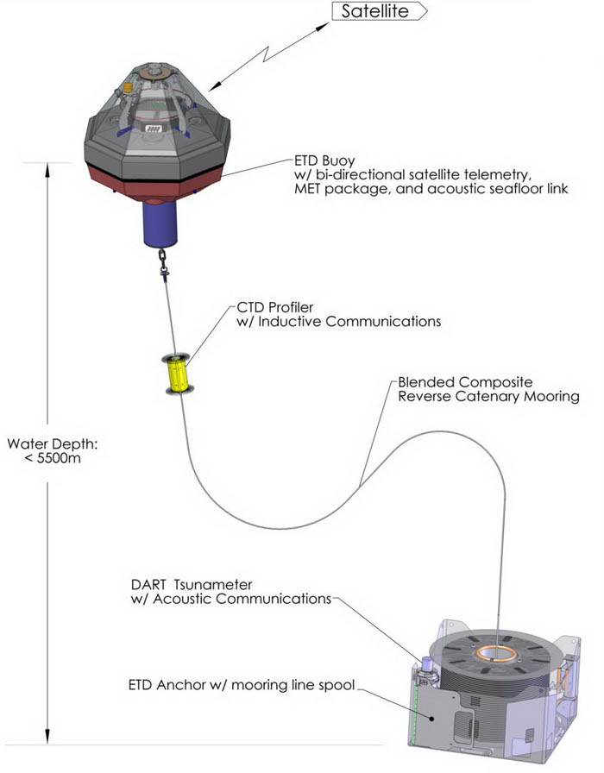An example: PMEL Emerging Surface Moorings
- Anchor and Mooring Line: The patented compound synthetic mooring line has several unique elements that are seamlessly manufactured in one continuous piece. It is then spooled onto a steel reel under tension and placed in a steel box that serves as a bobbin holder, a pallet, and anchor for the buoy. During deployment, the line is drawn off the outside of the reel, through a path of sheaves, and out the center of the anchor. As the anchor falls to the ocean floor, the line is spooled out automatically and without kinks and hockles. Typical mooring scope is between 1.10 to 1.45 depending on the mission, water depth and oceanic conditions.
- Buoy: The octagonal buoy hull is a simple fabrication with a galvanized steel framework, structural foam core and tough polyurea skin. Electronics are housed in a large central fiberglass well.
- Prawler: The Prawler (Profiler + Crawler) is a wave-powered subsea instrument that eliminates the need for multiple sensors on the mooring line. Prawler is housed inside the buoy during shipping and is automatically released after the system is dropped into the water. During descent, it makes a CTD profile and communicates those via inductive modem to the surface buoy. Once reaching the pre-determined bottom depth (~500m) a micro-processor activates a ratcheting mechanism and harnesses the wave motion to crawl up the mooring line.
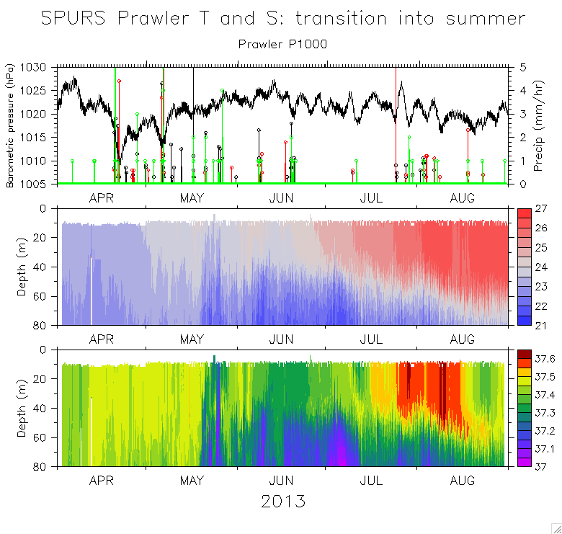
Advantages: Large sensor hosting capability, co-located surface & sub-surface ops, high freq measurements, realtime
Disadvantages:Vandal threats, single point of failure
Requirements/Limitations:
It is important to note that small surface buoys cannot host as many sensors as large traditional Ocean Climate Station type buoys. However, many small buoys are hosting bio-geochem sensor payloads with sufficient power and realtime communications. Profilers on surface moorings require a continuous length of wire to climb and make profiles. Any disturbance or major fouling of the line will impede profiling. Although the surface wave action provides motive power, batteries are still required for sensor, processor and inductive communication.

Comparison Chart
 | Emerging Moorings | Conventional Moorings (CM)
Size | 20 pre-packaged PICO units can fit into a single 40 ft. shipping container. | 1-2 CMs fit into a 40 ft. container in ~15 pieces each (anchors, buoy, bridle, tower, wire rope, nylon line, barrels of chain, hardware, and tools).
Sea Transport | Can be sent aboard smaller vessels of opportunity, i.e. a fishing craft on its regular route. Able to deploy in higher sea states than CM. | Large research ships with specialized personnel and equipment.
Building & Assembly | Pre-built, factory assembled, and deployment-ready when shipped. | Deployments are sea state limited. Shipped in many parts and assembled on ship deck with skilled technicians in the field.
Manpower | Can be deployed by 1-3 people with basic seagoing skills. Buoy/mooring experience is unnecessary. | Requires 6-12 specialized crew and technicians.
Operational Life | Estimated 2-3 years. | 1 year.
Vulnerability to Vandalism | Smaller surface expression that's harder to see and has less radar return. Nothing to climb on and no hardware to steal. | Vandalism is a major cause of failure for CMs.

TRITON and m-TRITON system

TRITON
- Basic technology
The basic technology was developed in 1990’s , based on the ATLAS buoy taut-line mooring system. The biggest differences between ATLAS and TRITON is the concept for safety operation. The surface buoy was designed to persist under higher vandalized area with strong towing cases. The surface float is 2.4 tons in a air, and has 7 tons of buoyancy. The wire cable is 18mm diameter down to 750meters, and Nylon is 24 mm diameter down to the sea bottom. The scope ratio is 0.9, which is similar with ATLAS. The TRITON has also equipped with mid-layer buoyancy to be able to revocer sensors even in case when surface buoy is lost.

- Sensors
The ocean sensors are SBE37IM for underwatertemperature and salinity measurements, and Teledyne current meter for 10 meters current. In addition to the commercial CTD sensors, JAMSTEC original CTD sensor has been developed and tested. The calibration system has also been developed for calibrating our original sensor. The calibration system is traceable to the Japanese national standards. The meteorological sensors are packages of JMASTEC original signal processing system with commercial analogues sensors from R.M. young etc. The sampling strategies are the same as ATLAS and the depth of ocean sensors are the same as TAO in the western Pacific.

- Data telemetry
Argos-2 is used for the data telemetry system, which collect the 1 hour data in near real-tme.

- Data return
The data return rate in real time and delayed modes are continuously higher than 80% in the last 13 years, and the average of these are **% and **% respectively, except for the sites near the coasts of New Guinea and Sumatra.

- Counter measures for vandalism
Lowering of data return is mainly from vandalisms. The counter measures have been applied to buoys in many years, but it is impossible to protect from vandalism perfectly. Even in such sever condition, the counter measures for the buoy worked at certain degrees, and the data return rate from TRITON buoy system was higher than m-TRITON system and ATLAS system. The followings are the list of counter measures for the vandalism for the TRITON buoy system

Pentagon type bolts and nuts
Stainless steel tower
Hidden satellite transmitter to send position for backup
Flat type transmitter to send data
Double steeled wire rope down to 750 meters
Underwater sensor protectors from long-line
Iron-mask met tower for the heavily vandalized region
Meteorological sensor and tower painted to be old and vandalized

- Cost
Buoy (Initial) was 9,800K, and maintenance cost is about 200K per buoy in average.

- Others
The challenges to the TRITON buoy system is basically longer period of mooring from originally 1 year to 1.5 year, and possibly 2 years in future. The problems of the challenge are again vandalism and biofouling to sensors. For the vandalisms, towing by fishing boats is main issues, so we are testing double steeled wire rope for this purpose, too. Biofouling issues are not well solved yet, and it is just confirming stage about the quality of data from 1.5 year mooring.

m-TRITON
- Basic technology
No like the TRITON buoy system, m-TRITON was designed to be deployed by smaller vessel of 2000 tons. The system is not taut line but slack line type. By using slack like, the surface buoy was one thirds of TRITON. Below the surface buoy, the wire and nylon are the same except for using lighter rope than water (***) below nylon ropes to keep the mooring line S-shape below sea surface.

- Sensors
The sensors for m-TRIOTON is the same as we use for TRITON.

- Data telemetry
The data telemetry system for m-TRITON is Argos-3, which allows two ways communication with higher data transmission. The real-time acquisition of 10 minutes data is available.

- Data return
The data return rate is lower than TRITON as the mooring system is small. Again vandalisms are main causes to lower the rate. In particular, the m-TRITON systems have been used in the eastern Indian ocean, where vandalisms occur more often than western Pacific ocean, therefore the preventing vandalism in the eastern Indian ocean is our big issue for data return.

- Counter measures for vandalism
Counter measures are almost same as TRITON.

- Cost
Cost for m-TRITON buoy system is 350K to 400K at present, and the maintenance cost per buoy is 180K excluding ship and technitians.

