Park n Fly meeting notes 18 August 2016
- Concept design review in December
- Smith cruise acoustic payload test deployment
- ToDo:
  - Refine ConOps: Brett, Hans
  - Review software: Hans, Rob, Kent (?), Rich (?)
  - Draft Hibernation controller requirements: Hans, Brett, Paul, Scott – Tuesday at 10 am?
  - Refine battery test plan: Paul, Hans
  - Homing trials: Brett, Rob, Hans, Andy (hardware)
  - Begin reliability review: Hans, Brett, Mathieu, Kent –
- Tuesday meeting -
  - Hans, Paul, Scott, Brett, Kent, Andy
  - Outlined how existing system works now
    - Connect to umbilical, power up, batteries come on line, MVC boots, user
    - Shut down; SMBus transaction
  - Hibernation controller
    - Own battery – ~1mw for a year – double D, run on 7.2 volts with possible boost to start secondary batteries
    - Could use variant of Wakey or Hans’ LPC1769
      - Minimize computers – use LPC1769 – but may take work to get power down
  - Secondary Batt
    - Supply a voltage pulse greater than 18 volts to turn on for
    - Embedded micro comes on and could be programmed to automatically come on line; if it doesn’t get a watchdog (via Ethernet) in X min it shuts down. If it still has the turn on
    - 55 packs/sphere
  - Primary pack would be simpler – no startup, just relays
    - Star distribution, add relays in MVC
  - ? Self discharge of 18650 – Inspired/Panasonic
  - ? Self discharge of Ti controller – Inspired
  - Clock accuracy?
    - 10%
    - Dallas RTC with programmable alarms – can we use this instead of a micro

  - Floatation test 1
  - Battery test
  - Prep for 2017 homing trials
  - Continue discussions with Hydroid

- ToDo:
  - Refine ConOps: Brett, Hans
  - Review software: Hans, Rob, Kent (?), Rich (?)
  - Draft Hibernation controller requirements: Hans, Brett, Paul, Scott – Tuesday at 10 am?
  - Refine battery test plan: Paul, Hans
  - Begin reliability review: Hans, Brett, Mathieu, Kent – Meeting?, perhaps extension of

- Tuesday meeting -
  - Hans, Paul, Scott, Brett, Kent
  - AUV now
    - Connect to umbilical, power up, batteries come on line, MVC boots, user
    - Shut down; SMBus transaction
  - Rover
    - Wakey
  - HANS
    - Own battery – ~1mw for a year – double D
    - Voltage?
  - Batt
    - Supply a voltage pulse greater than 18 volts to turn on for
    - Embedded micro comes on and could be programmed to automatically come on line; if it doesn’t get a watchdog (via Ethernet) in X min it shuts down. If it still has the turn on
    - 55 packs/sphere with
  - Define load
  - Can Han’s battery controller decrease its energy consumption enough?
    - LPC1769 NXP 32 bit

  - Can Rover’s power architecture be used?
    - Battery packs – cost and power
    - Sleepy
    - I/O
  - Self discharge of 18650 – Inspired
  - Discharge of Ti controller – Inspired
  - Clock accuracy?
    - 10%
    - Dallas RTC with programmable alarms – can we use this instead of a micro

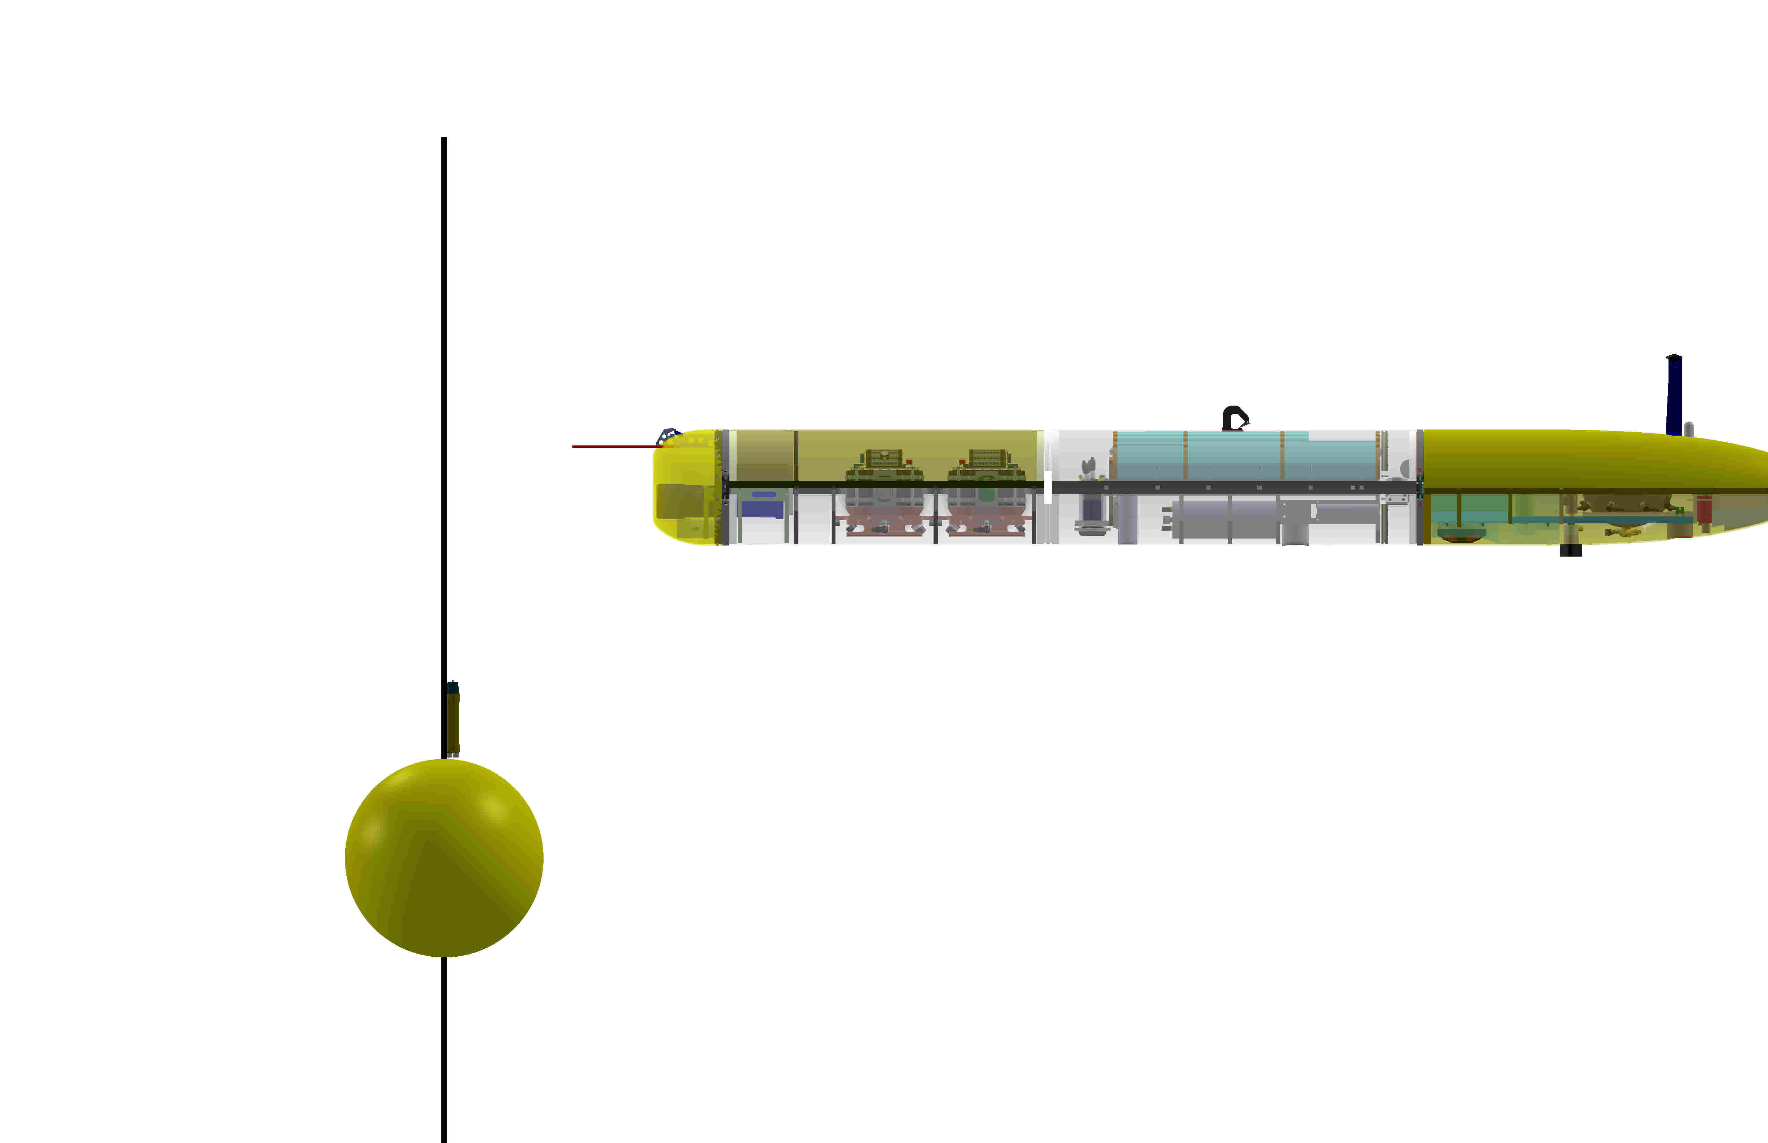

Outline, with Primary batteries

