Park n Fly meeting notes 11 August 2016
- Overview of 2017 Proposal
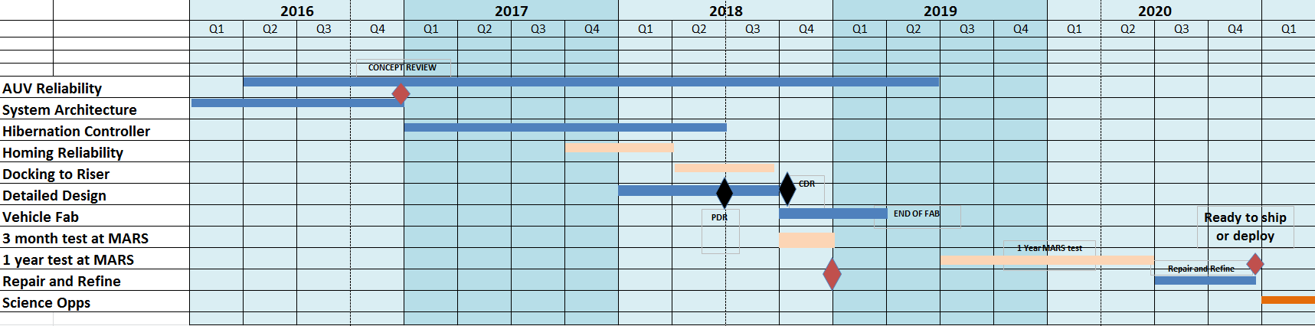
  - AUV reliability: Analyze past failures and estimate MBTF; then capture future events/issues that reduce vehicle reliability.
  - System Architecture: Refine ConOps and system design. Conduct a PDR by June, CDR by November
  - Hibernation controller development: Come up with a system that requires minimal changes to the core AUV but provide a method to power up, initiate automated built-in-tests and initiate a mission and scuttle the vehicle if it cannot get back to the dock. Power efficiency is important.
  - Homing reliability analysis: Running over 100 homing missions during 2017. Integrate a new Sonardyne iUSBL into the old Benthic Imaging AUV nose and mount the nose on the Iceberg AUV. Conduct tow-out vehicle operations and use video to assess homing reliability.
  - Docking to riser: Design mechanical latch that holds the AUV to the dock
  - AUV detailed design-PDR-CDR: Perform the detailed design of a dedicated AUV and at this point decide how many vehicles are needed.
  - 3-month deployment at MARS: While the new vehicles are being designed and build the prototype system will be deployed for a 3-month series of missions at MARS.
  - 1 year deployment at MARS: After the new vehicle(s) are built and tested, a 1-year extended deployment will be run at the MARS observatory and/or at Station M.
  - Repair and refine: Following the 1-year test, we will repair and refine the design and AUV and consider moving forward with science deployments. If serious problems remain another series of development and testing will be required.
  - Science Operations: If all the previous steps are successful, we could begin science operations in early 2021.
- Overview of 2016 objectives:
  - Concept Design Review
    - Refine ConOps
    - Assess existing software to estimate required changes
    - Derive requirements for hibernation controller (HANs)
    - Vehicle design
      - Nose section with wiskers/latch, iUSBL, OBS, water sensors
  - Floatation test 1
  - Battery test
  - Prep for 2017 homing trials
  - Continue discussions with Hydroid
- ToDo:
  - Refine ConOps: Brett, Hans
  - Review software: Hans, Rob, Kent (?), Rich (?)
  - Draft Hibernation controller requirements: Brett, Paul
  - Refine battery test plan: Paul, Hans
  - Begin reliability review: Hans, Brett, Mathieu

