1 July 2015
Park-n-Fly AUV proposal
Overview:
Autonomy from ship-based measurements – key to success of long time-series studies
Critical goal of integrated time-series at MBARI.
Two internally funded projects to develop 2 AUVs - sampling/imaging upper 1000 m water column

Vehicle | LRAUV | Midwater AUV | Deep AUV
Depth rating | 300m | 1000m | 4000m
Power Duration | Weeks | Days | Year
Range | 1000km | 100km | 100km
Sensors | CTD, O₂, Fluorometer | CTD, O₂, Fluorometer | CTD, O₂, Transmissometer
Camera system | Under development | Video w/lights | Still w/strobes
Acoustic backscatter | Under development | EK15 | Multibeam (200kHz)
Total onboard energy | 6kwhr(rech)/  18kwhr(primary) | 10kwhr | 20kwhr

Table 1. Comparison of existing time-series AUVs and proposed Deep AUV (Park-n-Fly AUV)

Figure 1 – Cartoon of 3 AUVs with depth
Proposed capabilities of Park-n-Fly AUV:
- Working depth to 4000 m
- Bottom photo-transect period (48 hrs over 12 month deployment) seasonal or event triggered transects over same trajectory (events detected by SES and Rover)
- Benthopelagic acoustic backscatter transect period (48 hrs over 12 month deployment) seasonal or event triggered transects over same trajectory (concurrently with photo-transects)
- Record CTD/O₂ data on each transect
- Dock on sea floor in sleep-mode between 12-hour surveys
- Communicate via acoustic modem with Wave Glider for status reports only
- Emergency scuttling and recovery
Scientific justification:
26-year time series at Sta. M reveal significant daily to weekly changes in benthic community and environment.
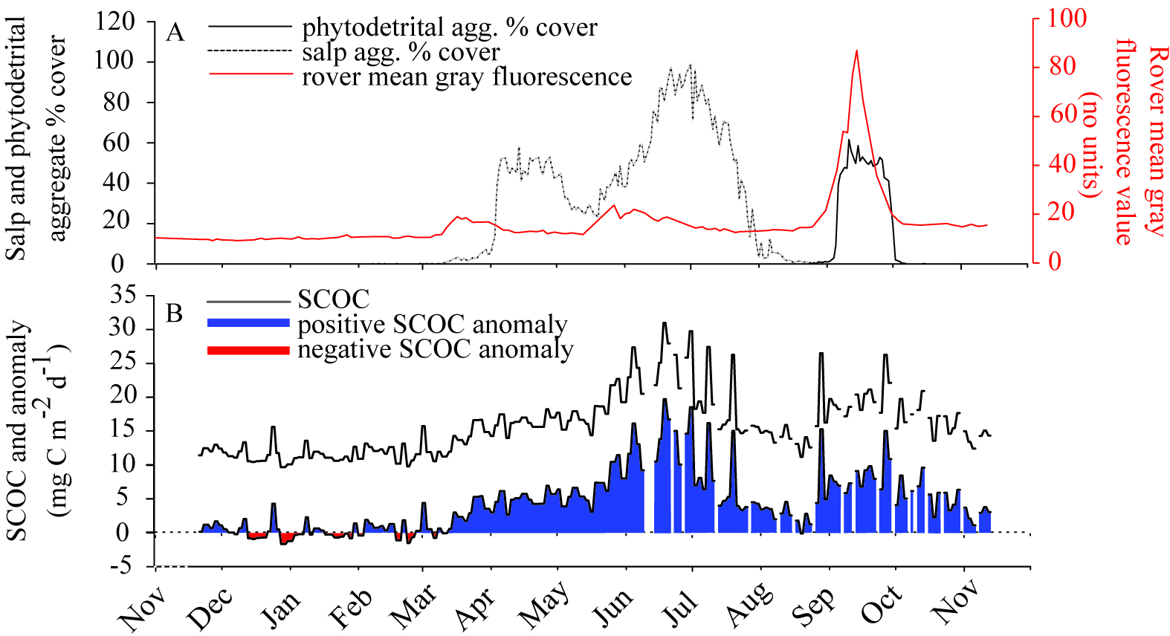
Figure 2 -Salp paper plot w/time
Figure 3 - Peniagone plot w/ time
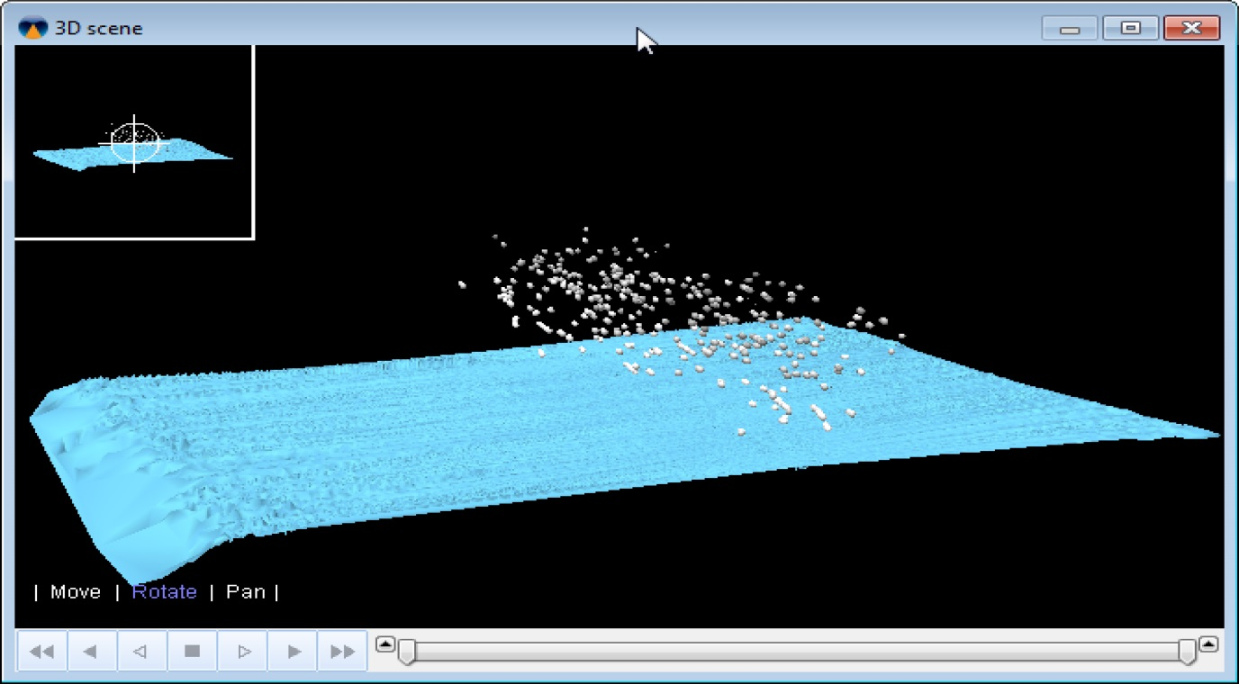Figure 4 – Echoview plot of backscatter data from Reson Multibeam data in Monterey Canyon
Why mobile versus series of stationary platforms in study area:
- Seasonal or event triggered surveys not feasible using ship-based facilities
- Series of stationary moorings not realistic given patchy heterogeneity of bottom communities on scales of <10m to > 1km Why do this with a mobile platform? Justify need for spatial coverage. Patchiness at scale of 100m, need far more than 5 replicate systems. Turnover time of 5 systems would significantly increase needs for ship time. Crissy, Kathy, Henry to get patchiness references
- System flexibility, scalable frequency vs spatial coverage (considering docking error, number of times docking needed)

Table 2. Cost comparison of ship-based versus Park-n-Fly photo transects—CHART OF CROSSOVER TIME (cost vs. time), what is available now in house vs have to buy.
Cost | Deep AUV | Shiptime with ROV
Dorado AUV | $600k
Batteries | $40k
Camera and strobe* | $105K
Sonar (dual head T20)* | $320k
Additional bio-optic  Instrumentation(Lisst-100, etc) | $100k
INS* | $200k
Acoustic modem | $5k
USBL* | $60k
Docking riser | $150k
Echoview (MBARI-wide) (Kelly as a collaborator?) | $300k
TOTAL | $1.9M | $
*=in house, could be used by this project

Western Flyer/Rickets Day Rate - $28,100
If we did 7 day trips 3 times a year (we’ll call one trip a year “free”, since it is required for turnaround of other instruments; 4 trips total a year is not realistic), this would cost 3*7*$28,100 = $590,00/year

So, the payback time for such a vehicle, not counting development labor (which is a big number, but is considered sunk cost, since no new staff would be hired) would be ~3 years
Proposed development:
- Dorado AUV
- Rechargeable battery packs w/ shutdown feature
- Downward-looking still camera/strobe system (VARS analyses, processing- Crissy figure?)
- Upward-looking multi-beam sonar (Echoview analyses – see Fig. 4)
- Inertial navigation system (running same trajectory for each transect)
- Acoustic modem for Wave Glider communications (status reports)
- Acoustic triggering of surveys from surface
- Mechanical docking using USBL to anchored riser with acoustic beacon (existing USBL)
- Scuttling/emergency anchoring system (for emergency anchoring in case of docking failure)
Proposed Schedule:

