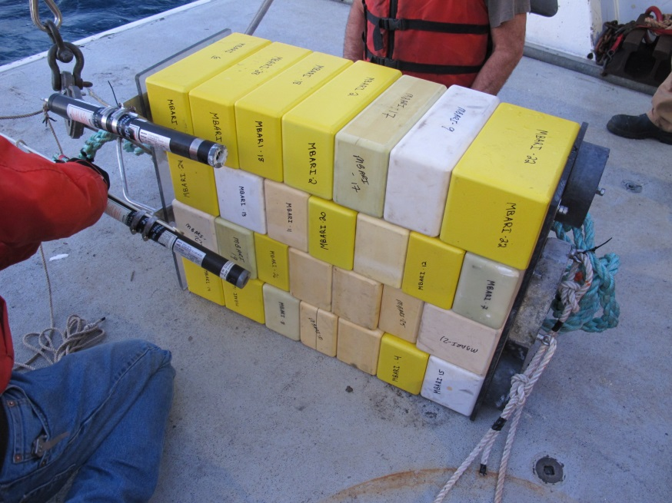
Last year we deployed 28 blocks that weighed 163 lbs in air, and -162 lbs in water. It was ballasted with one lead brick and two lead disks that weighted ~ 50 lbs. The two Novatech beacons and the homer were about 8 lbs and the bail as another 2 lbs. Package should be ~100 lbs buoyant. A large mushroom anchor was added to hold it down. Not sure how much the mushroom weighted

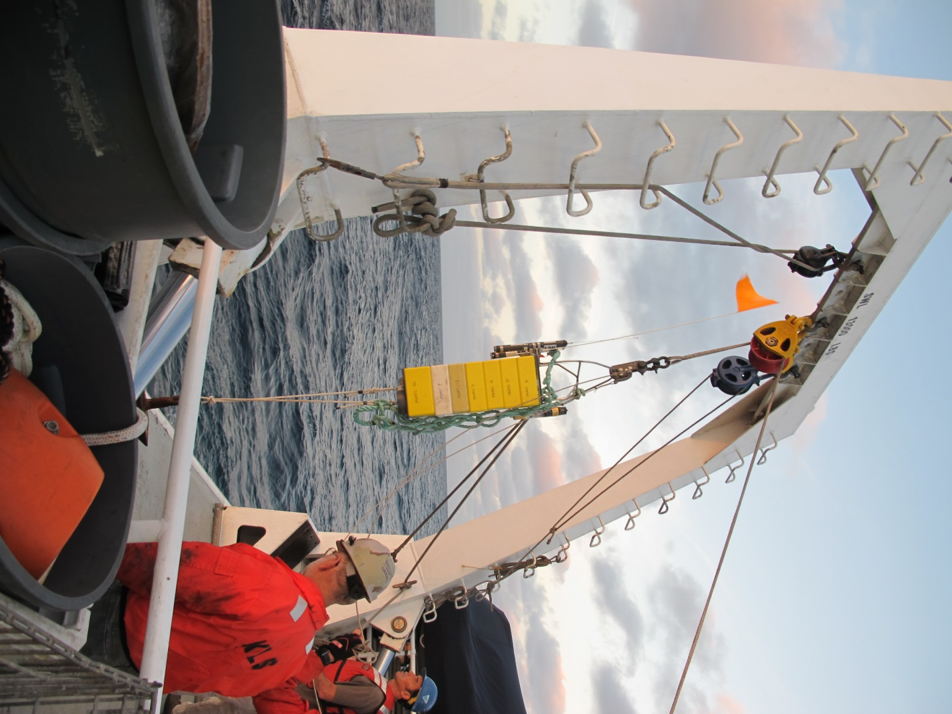
2016 Test: 28 blocks total 4 stacks of 7 mounted on old elevator

(28) Blocks to be mounted to the old elevator
Blocks weigh 221 lbs in air
Blocks weigh -195 lbs in water

Ballast and beaconsr
~60 lbs of ballast, beacons and frame
Elevator assembly is ~135 lbs buoyant and stable on the surface (195 buoyancy 60 lbs ballast)

An anchor is needed to sink and hold the elevator down at about 2:1, so 2*135 lbs=270 .
Anchor needs to be ~270 lbs in water.
Use (2) double rail assemblies that provide 130 lbs ballast each for 260 lbs combined.
Anchorr

