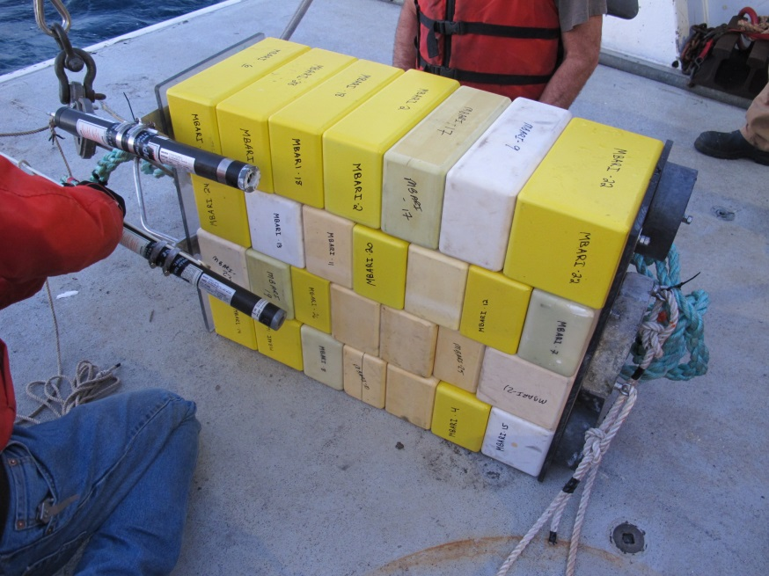
Last year we deployed 28 blocks that weighed 163 lbs in air, and -162 lbs in water. It was ballasted with one lead brick and two lead disks that weighted ~ 50 lbs. The two Novatech beacons and the homer were about 8 lbs and the bail as another 2 lbs. Package should be ~100 lbs buoyant. A large mushroom anchor was added to hold it down. Not sure how much the mushroom weighted

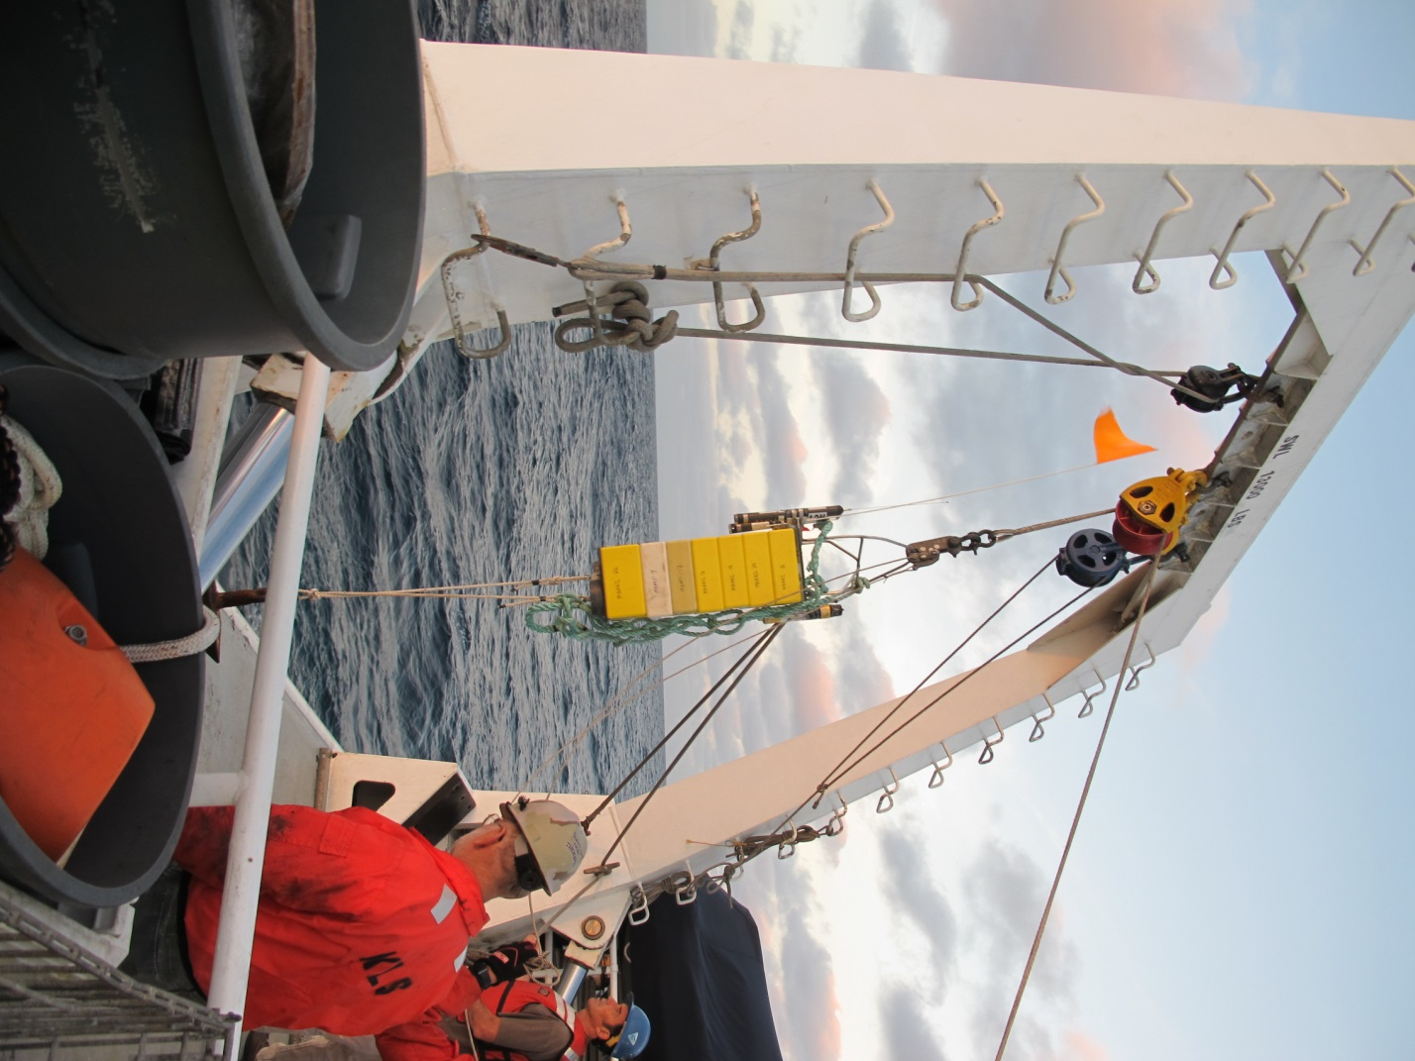
2016 Test: 31 blocks total, 16 on old elevator, 15 in cargo net tied to elevator
(16) Blocks to be mounted to the old elevator
Blocks weigh 150 lbs in air
Blocks weigh -121 lbs in water

Ballast and beaconsr
~60 lbs of ballast, beacons and frame

Elevator assembly is ~60 lbs buoyant and stable on the surface (121 buoyant – 60 lbs ballast)

Cargo Net covering blocks: 74 lbs positive
(15) Blocks to in net
Blocks weigh 96 lbs in air
Blocks weigh -74 lbs in water

(31) Blocks total
All Blocks weigh 245 lbs in air
Blocks weigh -195 lbs in water

An anchor is needed to hold the two packages that have ~134 lbs of buoyancy. Anchor needs to be ~250 lbs in water.
Use (2) double rail assemblies that provide 130 lbs ballast each for 260 lbs combined.

Anchorr

