Methods

Calibration tests and measurements were made in the MBARI sea water lab using a 1m x 1m x 1.6 m salt water tank. Two Sony A6300 cameras with 12mm Rokinon lenses were centered outside the test tank and spaced 40 mm apart.

Calibration video was created using a SeaGIS calibration cube (0.5m x 0.5m x 0.3m) according to the SeaGIS protocol (Figure 1). The cube was rotated through 20 calibration configurations. Stereo calibration was performed in CAL software, and measurements made in EventMeasure. A set of 6 measurement sequences were performed using a calibrated SeaGIS target bar with three precisely known lengths (Figure 2).

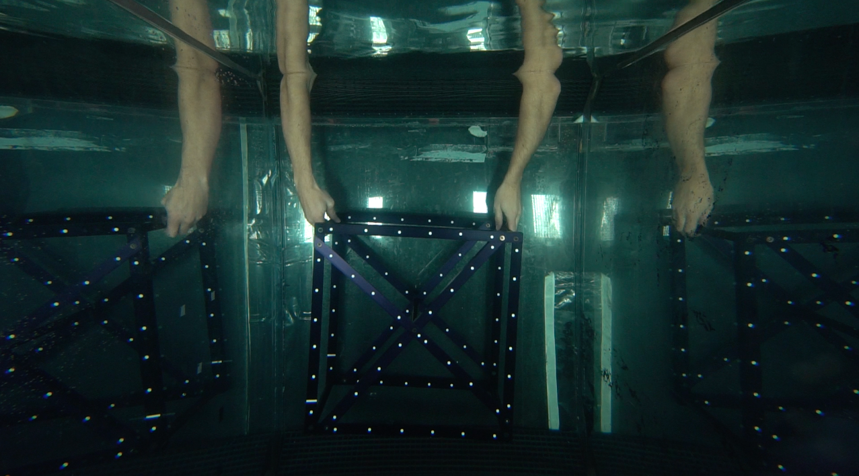

Figure 1: Mini-cube calibration in MBARI test tank

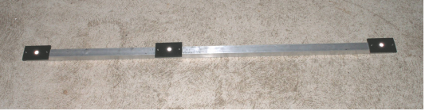
Figure 2: Calibrated target bar

These tests were:
- Target bar at 150 cm distance
- Target bar at back of tank (160cm distance)
- Target bar at 90cm distance
- Target bar at 75cm (closest distance possible with this size target)
- Target at 150cm distance and cameras moved back from face of tank by 5mm
- Target at 150cm and cameras slightly angled back from face of tank

The last two configurations were designed to test how the camera’s position relative to ‘port holes’ will affect measurements. The last test specifically was performed to test measurement accuracy when cameras are tilted with respect to a flat port hole window. The target bar was lowered perpendicular to the direction of the cameras and rotated back and forth to simulate angles that fish might swim by the cameras. A semi-even mixture of target sizes, across a range of angles, was measured in EventMeasure. Target bar sizes were 224.2 mm, 363.7 mm, and 587.9 mm.

Measurement error was calculated as a percent of known target bar length.

Results

A single measurement with a mean measurement error of 10.7% was excluded as an outlier. Across all distances and angles tested, a majority of measurement error was less than 2% of the target bar length (Table 1, Figure 3). The 75cm distance test was most variable in measurement error, and was significantly different than the other tests measured (ANOVA: F_{(5,283)} = 11.04, p < .001). Other configurations did not have significantly different mean measurement error.

Table 1: Summary statistics for measurement configurations

Test | N | Mean measurement Error (%) | SD | SE | 90th Percentile Error (%)
75cm | 42 | 1.309 | 1.236 | 0.191 | 3.645
90cm | 50 | 0.592 | 0.596 | 0.084 | 1.201
150cm | 41 | 0.426 | 0.682 | 0.107 | 1.520
160cm | 36 | 0.364 | 0.520 | 0.087 | 1.107
150cm_5mm | 61 | 0.344 | 0.377 | 0.048 | 0.830
150cm_angled | 59 | 0.568 | 0.706 | 0.092 | 1.310

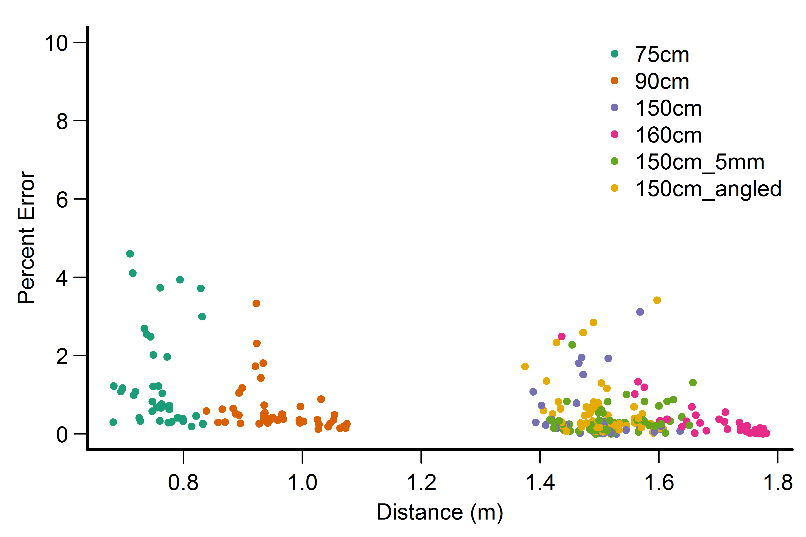
Figure 3: Percent measurement error with increasing distance from camera. Distance here is estimated in Event Measure. Colors denote particular test

Mean and variability of percent measurement error decreased as the target was placed further from the cameras (Figure 3). There was no clear pattern in error with increased target angle (Figure 4). Note: EventMeasure seems to be having some trouble measuring the true angle of the target with our cameras in a vertical position. More work will need to be done to determine how accurate these angle estimates are.

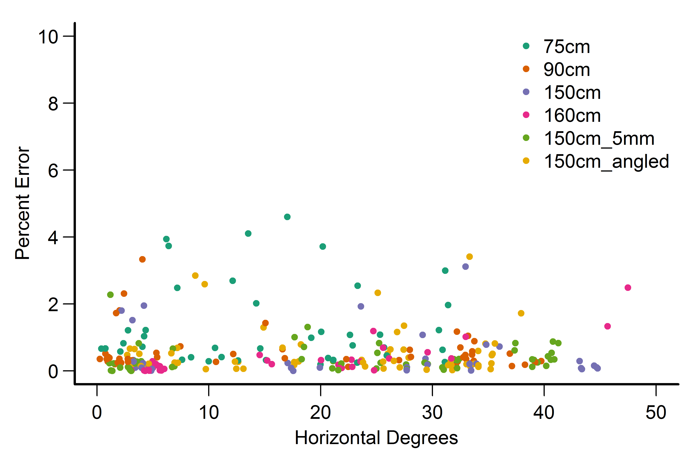
Figure 4. Percent measurement error with respect to target angle

Finally, we can look at overall average percent error for our different distance tests and by target size (Figure 5, 6).
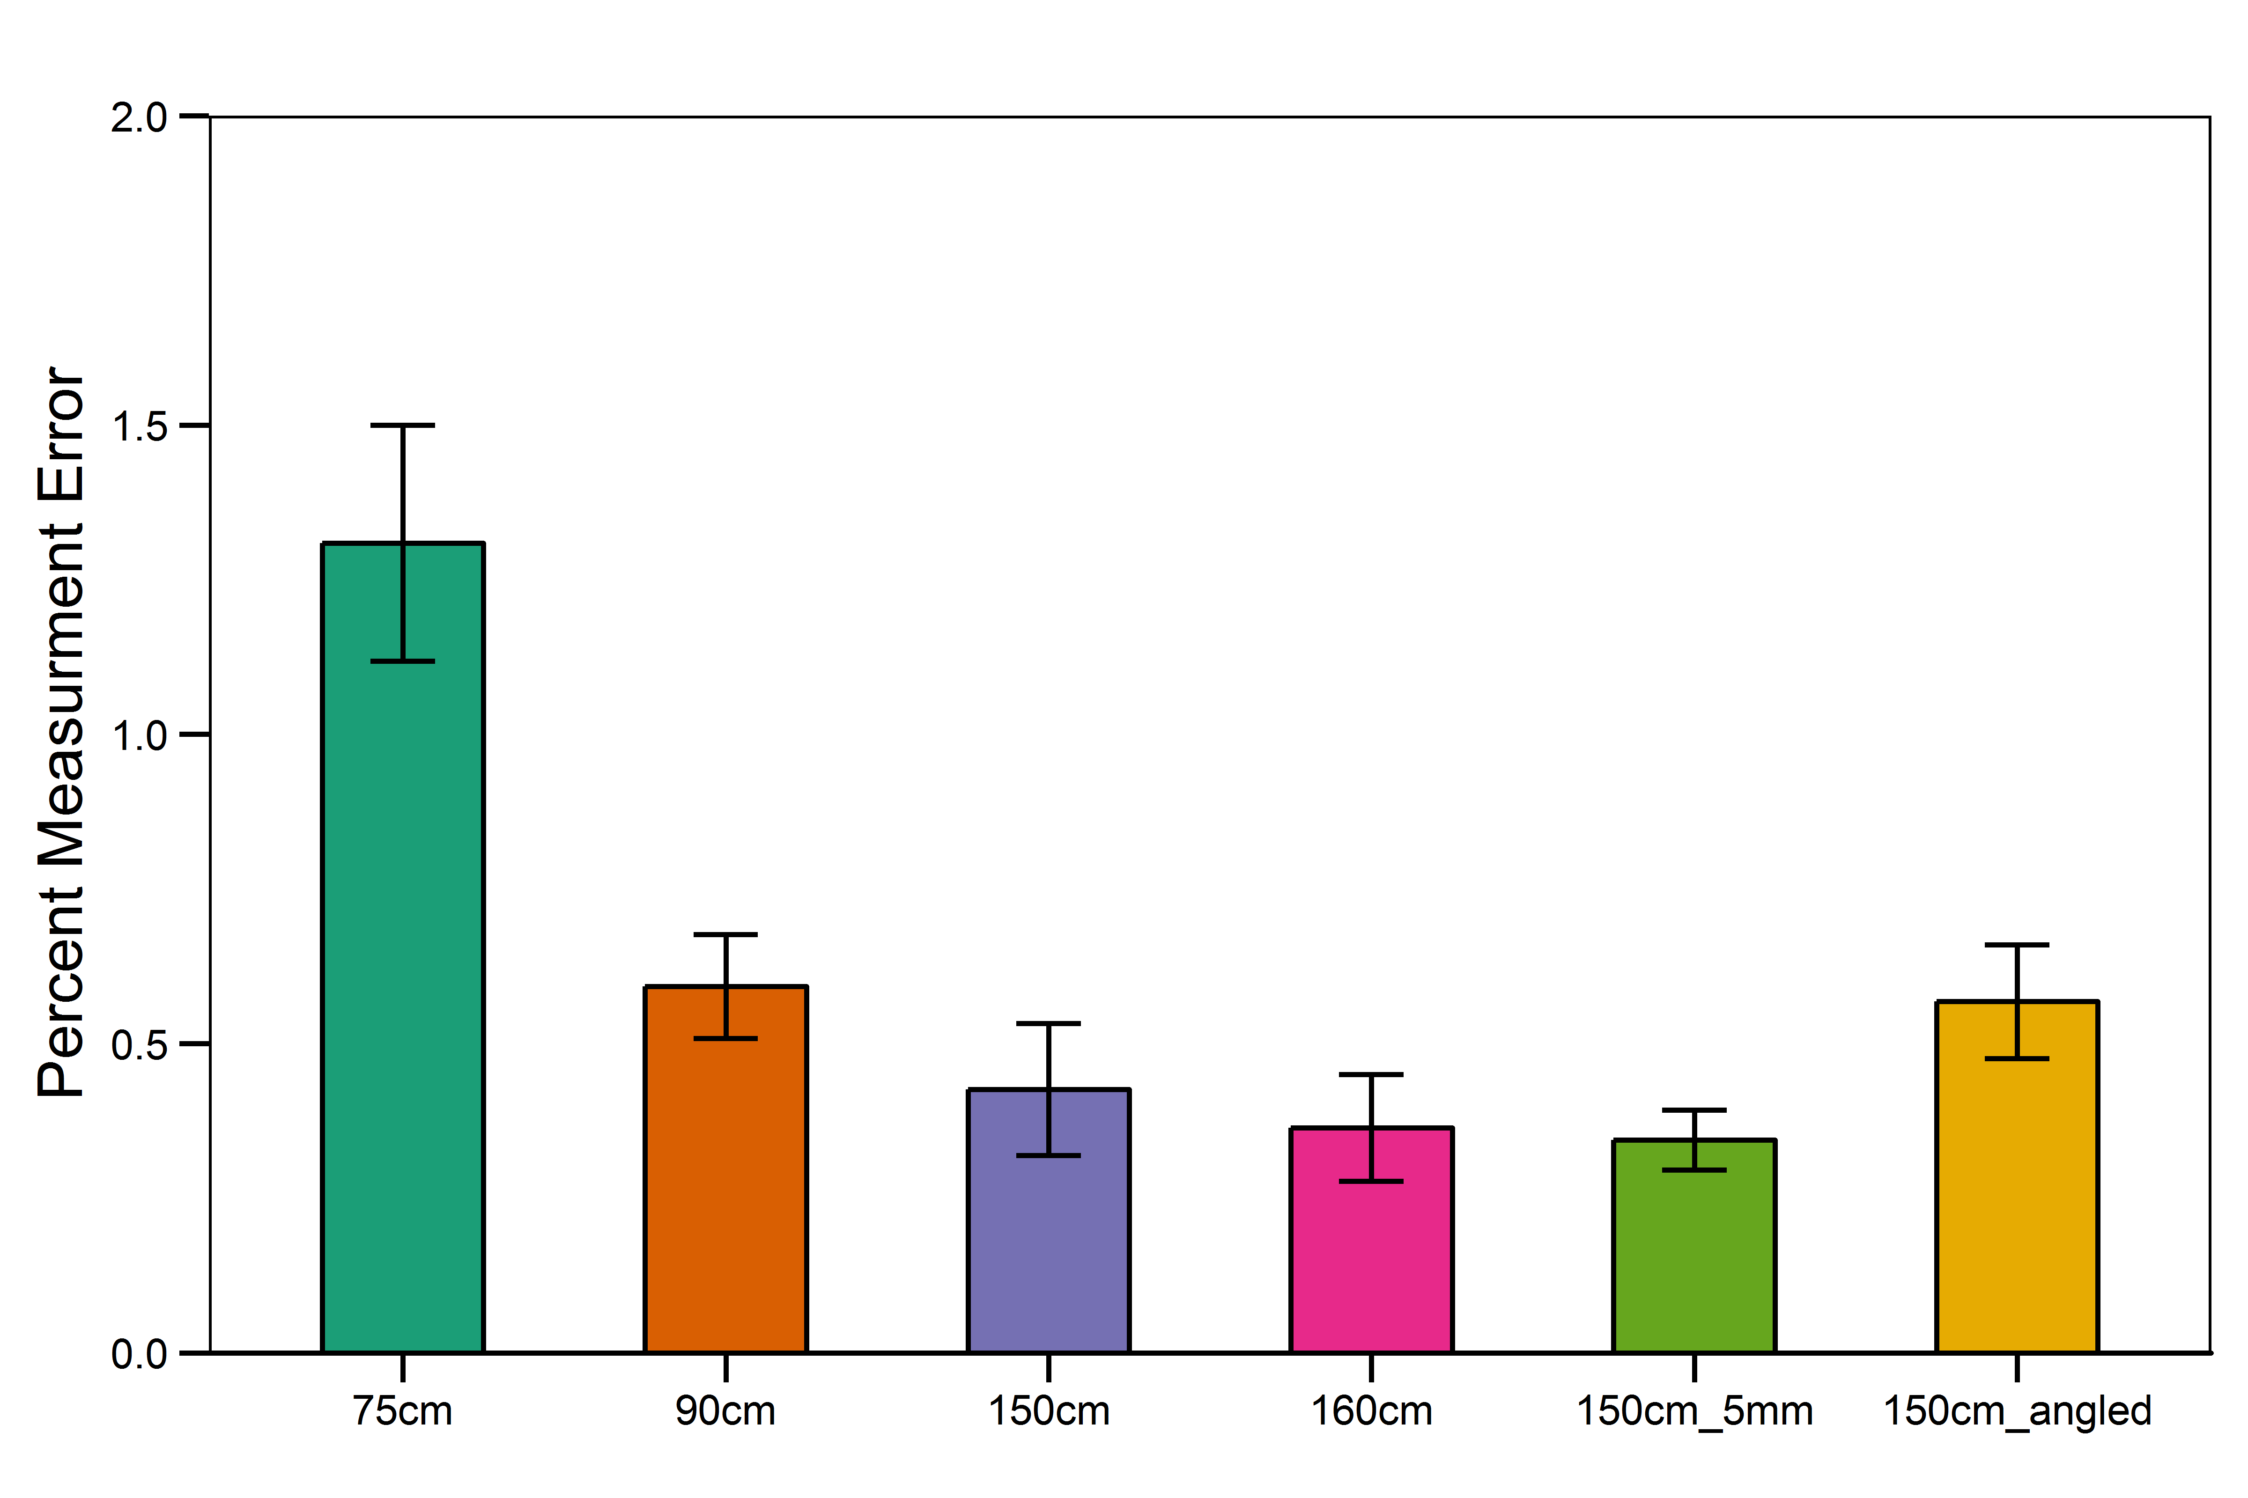
Figure 5: Mean percent measurement error (+/- SE) for 6 distance and configuration tests performed
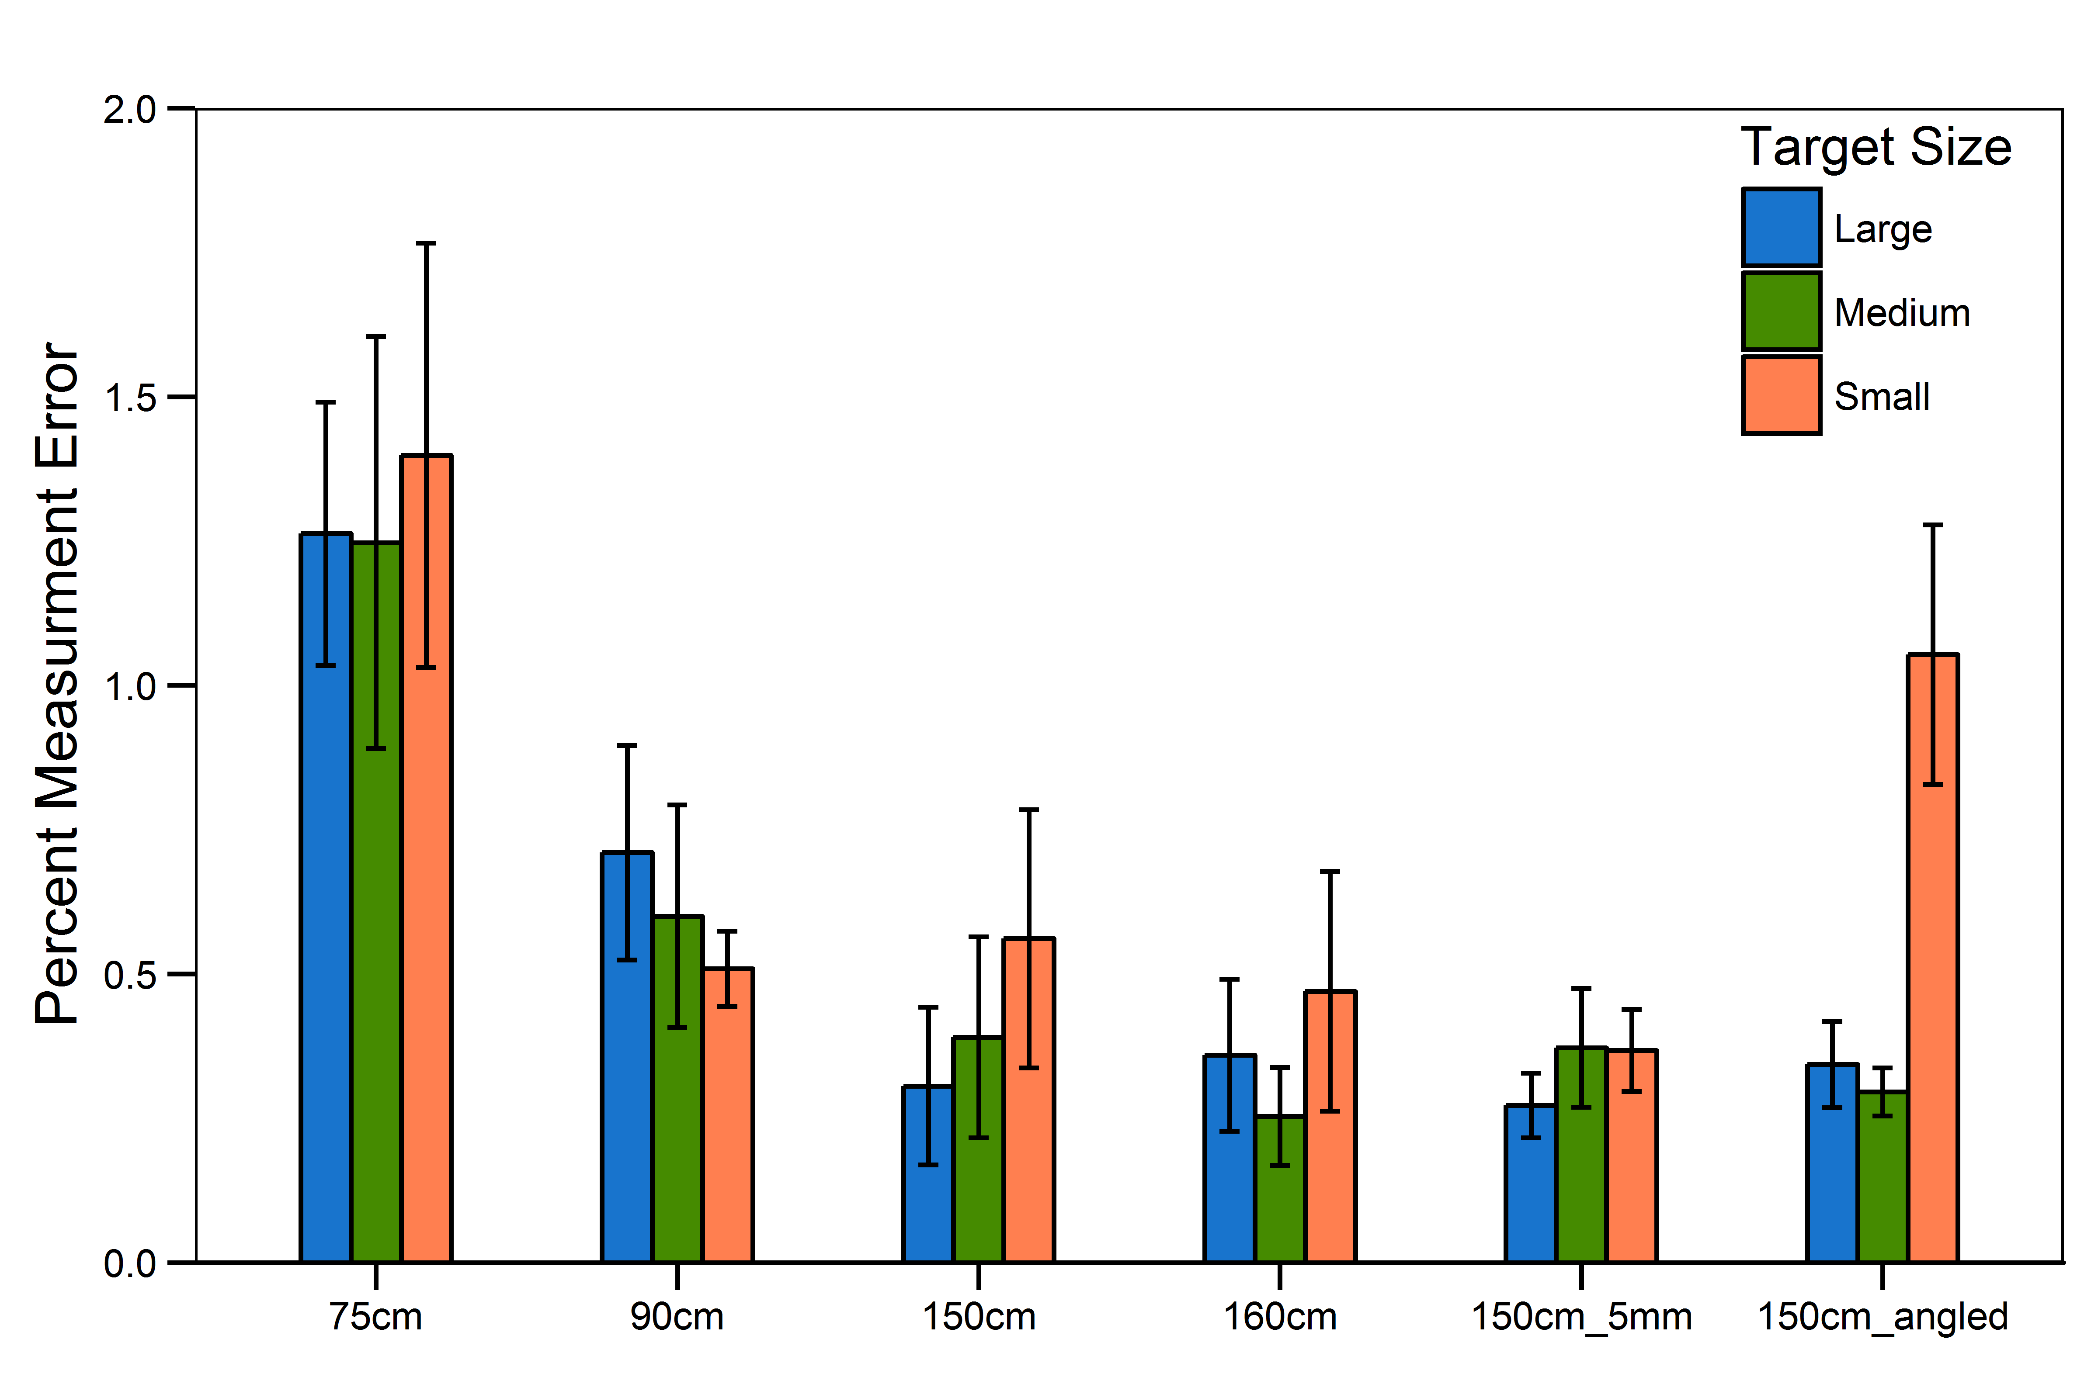
Figure 6: Mean percent measurement error (+/- SE) with respect to distance tested and size of target measured

Summary

The mini-cube and calibration procedure seem to have worked well as most of our measurement error is below 2%. Average measurement error is below 1%. Error seems to be slightly greater for smaller sized targets. These trends are consistent with what we have previously observed.

It would be worth trying to hold the target at steeper angles during the next test to see what our limits may be. We don’t have the ability to test further distances at this time but it would be helpful to know what our error is out at 3-4 meters distance.

