Camera FOV and Base Spread Test
November 2016
Summary:
We calculated measurement errors associated with stereo video cameras placed in a variety of camera configurations and distances from a target. Our conclusions are:
- Cameras should have a separation of at least 40 cm.
- A Field of View (FOV) equivalent to a 20 mm lens in air provided the least error.
- Cameras can be placed in a vertical plane (horizontal orientation of camera sensor) to achieve a smaller footprint of a lander.
- We need more modeling simulations to select an optimum balance of the width of the lens and the circular coverage of the study area.
Methods:
An aluminum bar was drilled to accommodate two RecSea 4 dive housings spaced at 25cm, 40cm, and 70cm apart as measured by the center of the camera lens. Two GoPro Hero 4 cameras were used, and consistency between port and starboard side assignment was maintained.
A total of 9 camera-spread and combinations of FOV was tested. Wide field of view (FOV; 17.2mm air equivalent), Medium FOV (21.9mm air equivalent) and Narrow FOV (34.4mm air equivalent) settings were tested at each of the three base camera distances (1m, 2m and 4m from the cameras).
For each camera-spread/FOV combination we first calibrated the cameras using a calibration cube. We then recorded video of a 39.5 cm-long target at four positions: center, left, right, and down relative to the center of the field of view. The target was rotated at each position to simulate realistic angles of fish that might be encountered.
Points were measured in EventMeasure. Measurement error is reported as a percent difference from the true total length of targets.
|(Measured Length-True Length)/True Length|*100%
Analysis:
Data was restricted to target angles less than 40 degrees from parallel to cameras. All analyses were performed in R.
Results
Below, Figures 1 and 2 show a general increasing percent error with increased distance from the camera. Cameras spaced 25 cm apart had greater error than cameras spaced 40 cm or 70 cm apart. At closer distances (1-2m), cameras spaced 70 cm apart performed the best, although error was less than 2% of the target length for all camera spacings.
It is also apparent that the Wide FOV starts to show strong increases in percent error at a distance of 4m; whereas, Medium FOV maintains relatively small error rates for the 40cm and 70cm camera spread at the 4m distance. The Narrow FOV had the greatest error when cameras were 25cm apart. Error was comparable between medium and narrow FOV when cameras were 40cm and 70cm apart.
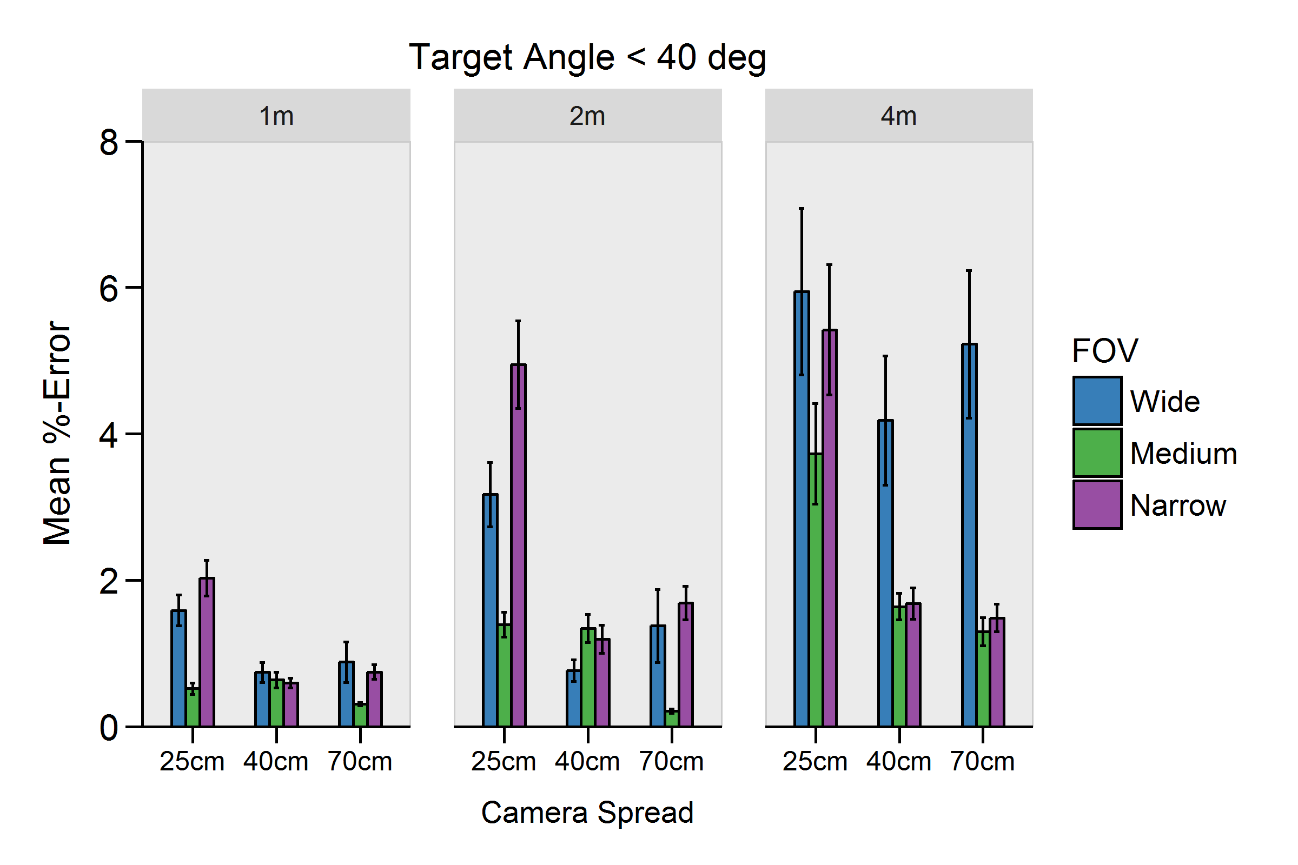
Figure 1: Mean percent measurement error at varying distances and camera spreads for wide, medium and narrow FOV

Here is the same data plotted slightly differently. Distance from camera is now on the x axis and plots are grouped by camera base spread.
Again the obvious trend is that the Wide FOV shows sharp increases in error rates with distance from the camera. Medium FOV displayed stronger increases in mean error when camera width was 25cm and was much more stable at 40cm and 70cm camera base widths.
Narrow FOV had greatest error when cameras were 25cm apart.
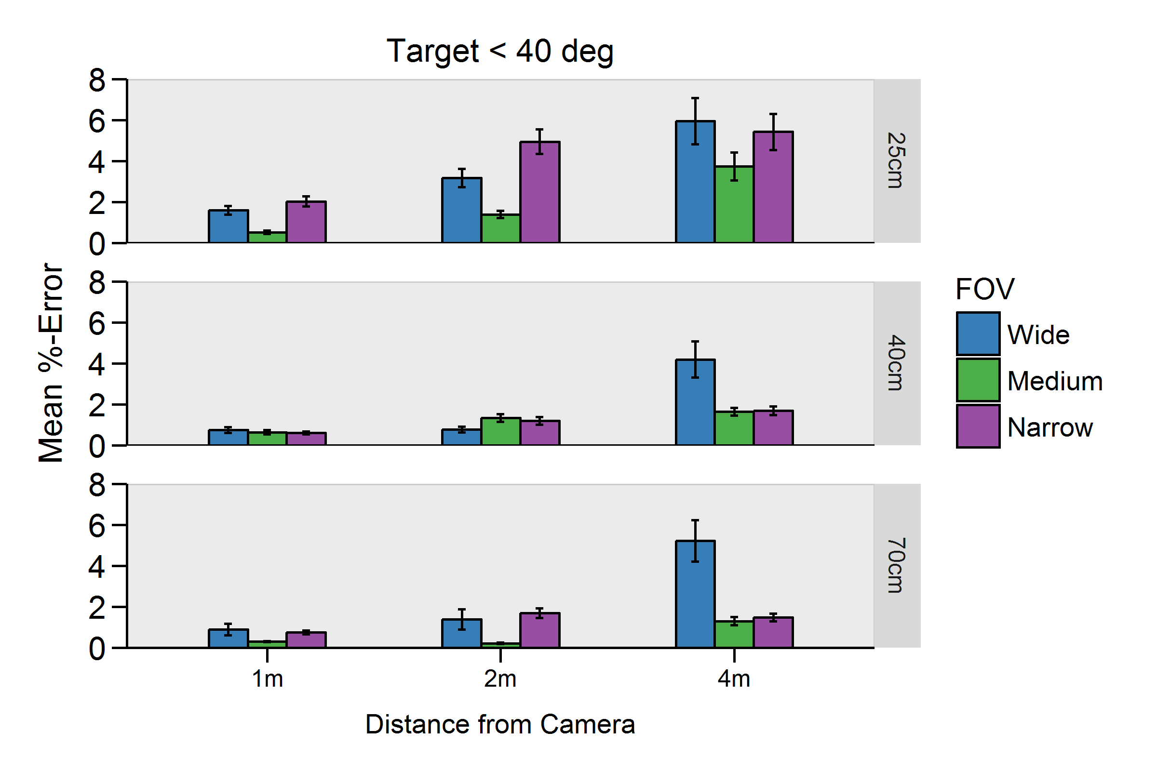
Figure 2: Mean percent measurement error at varying distances and camera base widths for wide, medium and narrow FOV.

Error with different target angles:
As expected, sharper target angles led to increased mean percent error (Figure 3). We include all degrees measured to show that error stabilized around 7-10% of target length- even at more extreme angles. Cameras 25cm apart had the greatest error. Error was between 3-4% target length for Wide FOV at camera spreads of 40cm and 70cm.
Medium and Narrow FOV generally had mean percent error of ~5% or less when cameras were 40cm and 70cm apart.
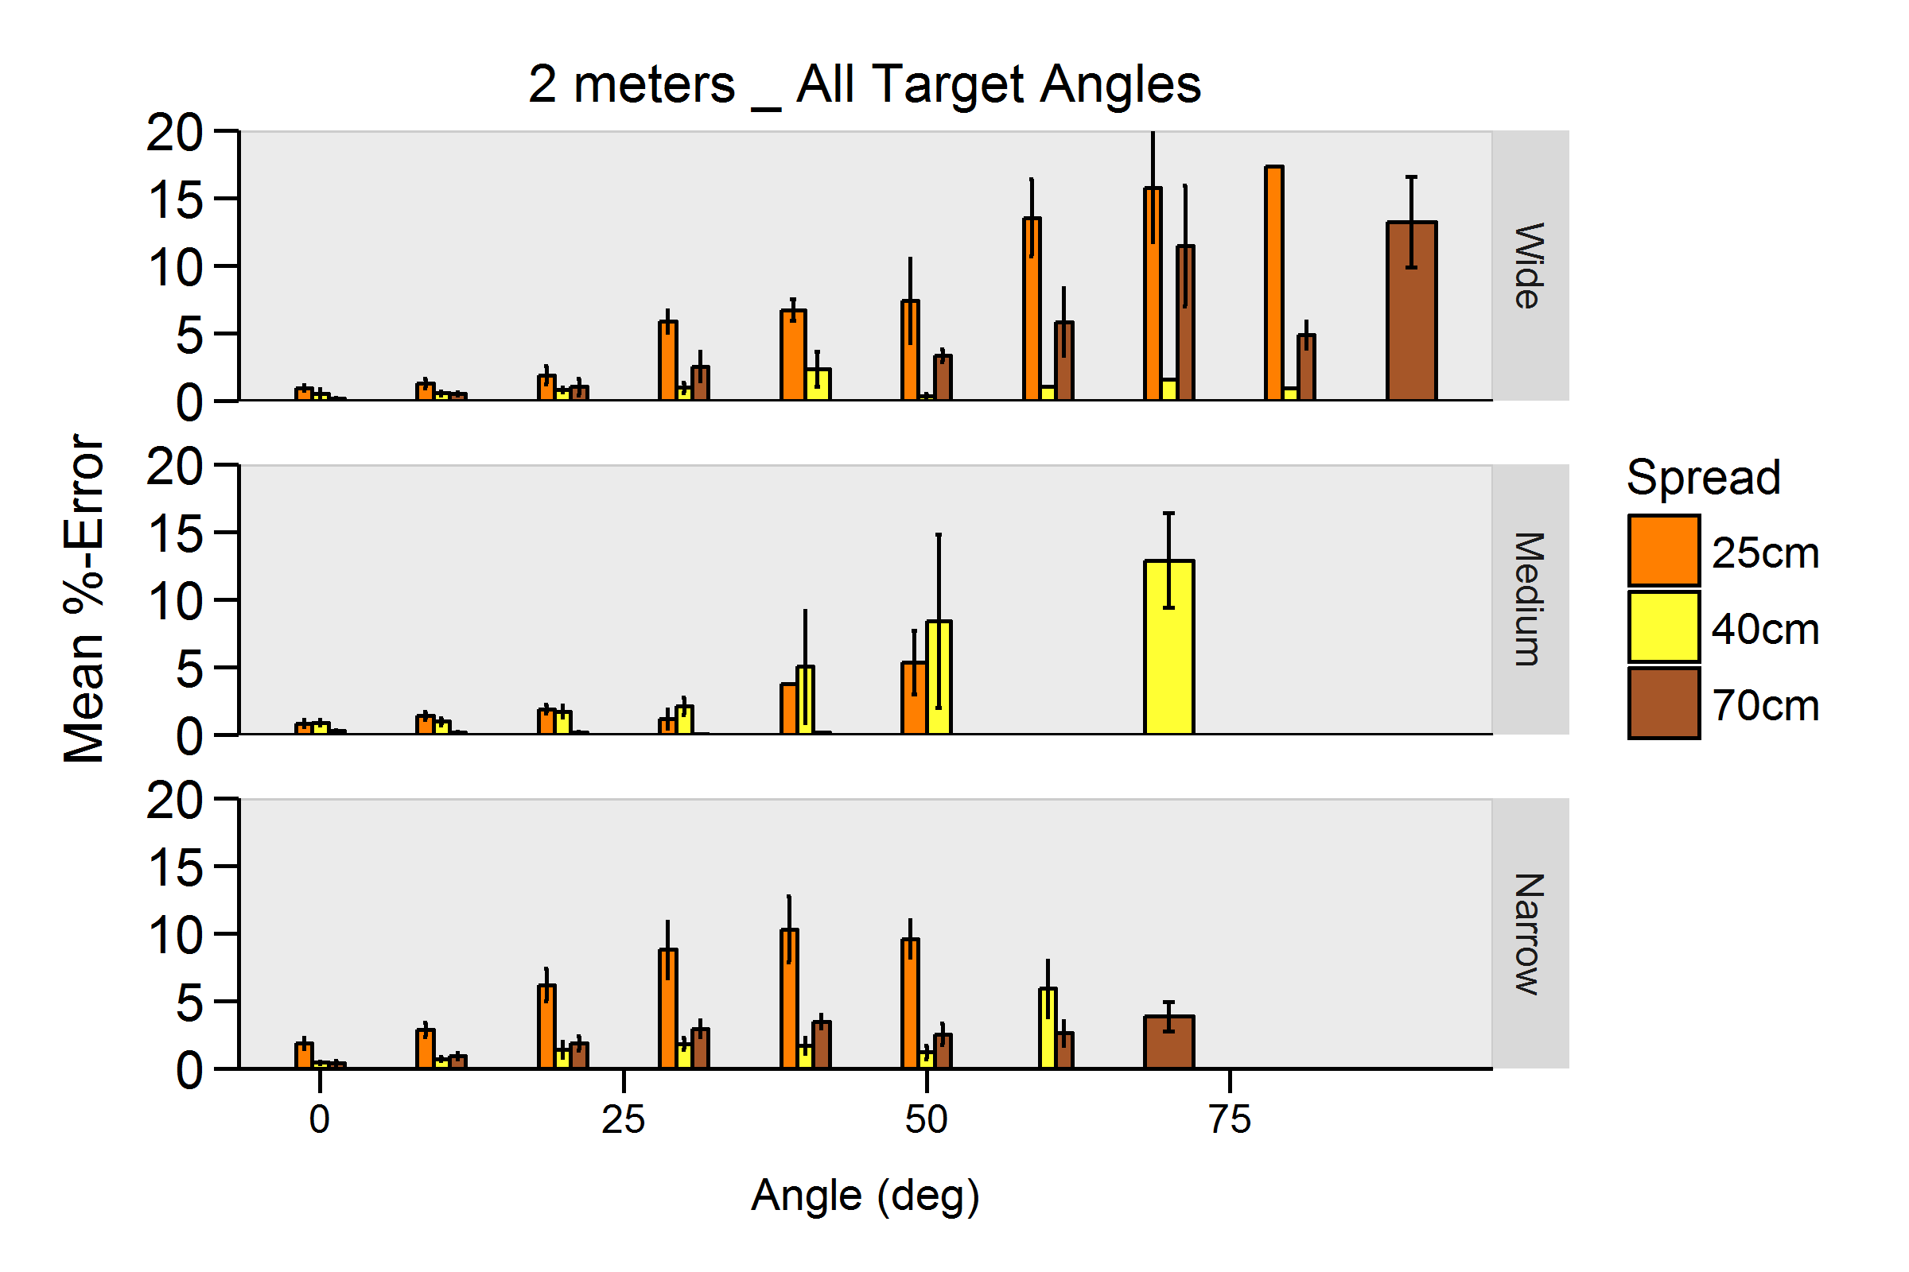
Figure 3: Mean percent measurement error by target angle (rounded to nearest 10 degrees) for wide, medium, and narrow FOV. Data was restricted to measurements made 2 meters away from camera.

Below is the same data truncated to less than 40 degrees target angle for clarity (Figure 4)
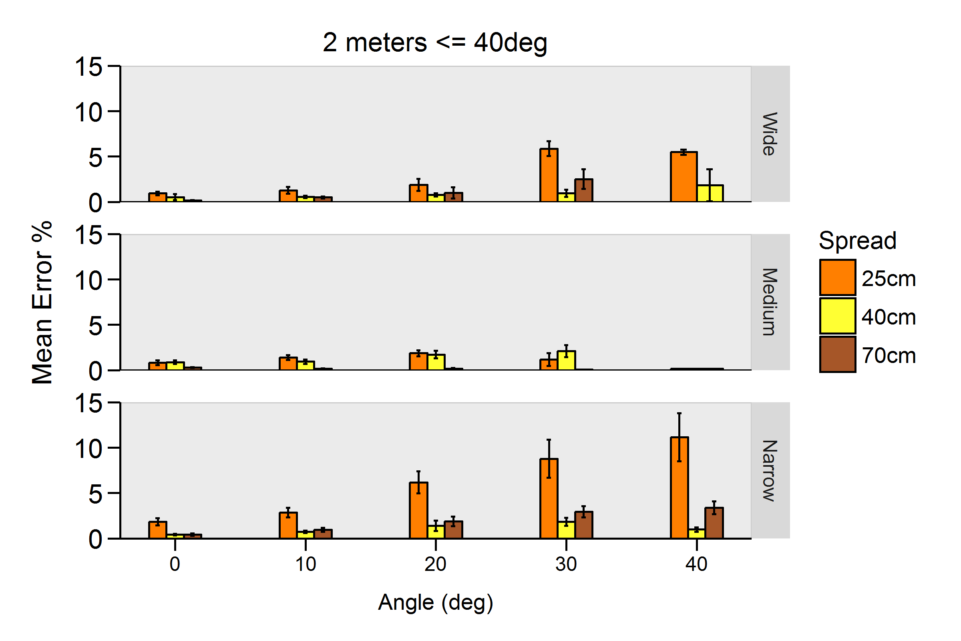
Figure 4: Mean percent measurement error by target angle (rounded to nearest 10 degrees) for wide, medium and narrow FOV.

Error at Edges of FOV:
Targets were moved towards the edges of the frame to test for increased error rates. Measurements were restricted to those greater than 40cm offset from center of frame (left, right, or down)
Error increased with distance for the Wide FOV, and edge of frame errors were generally greatest when cameras were 25cm apart
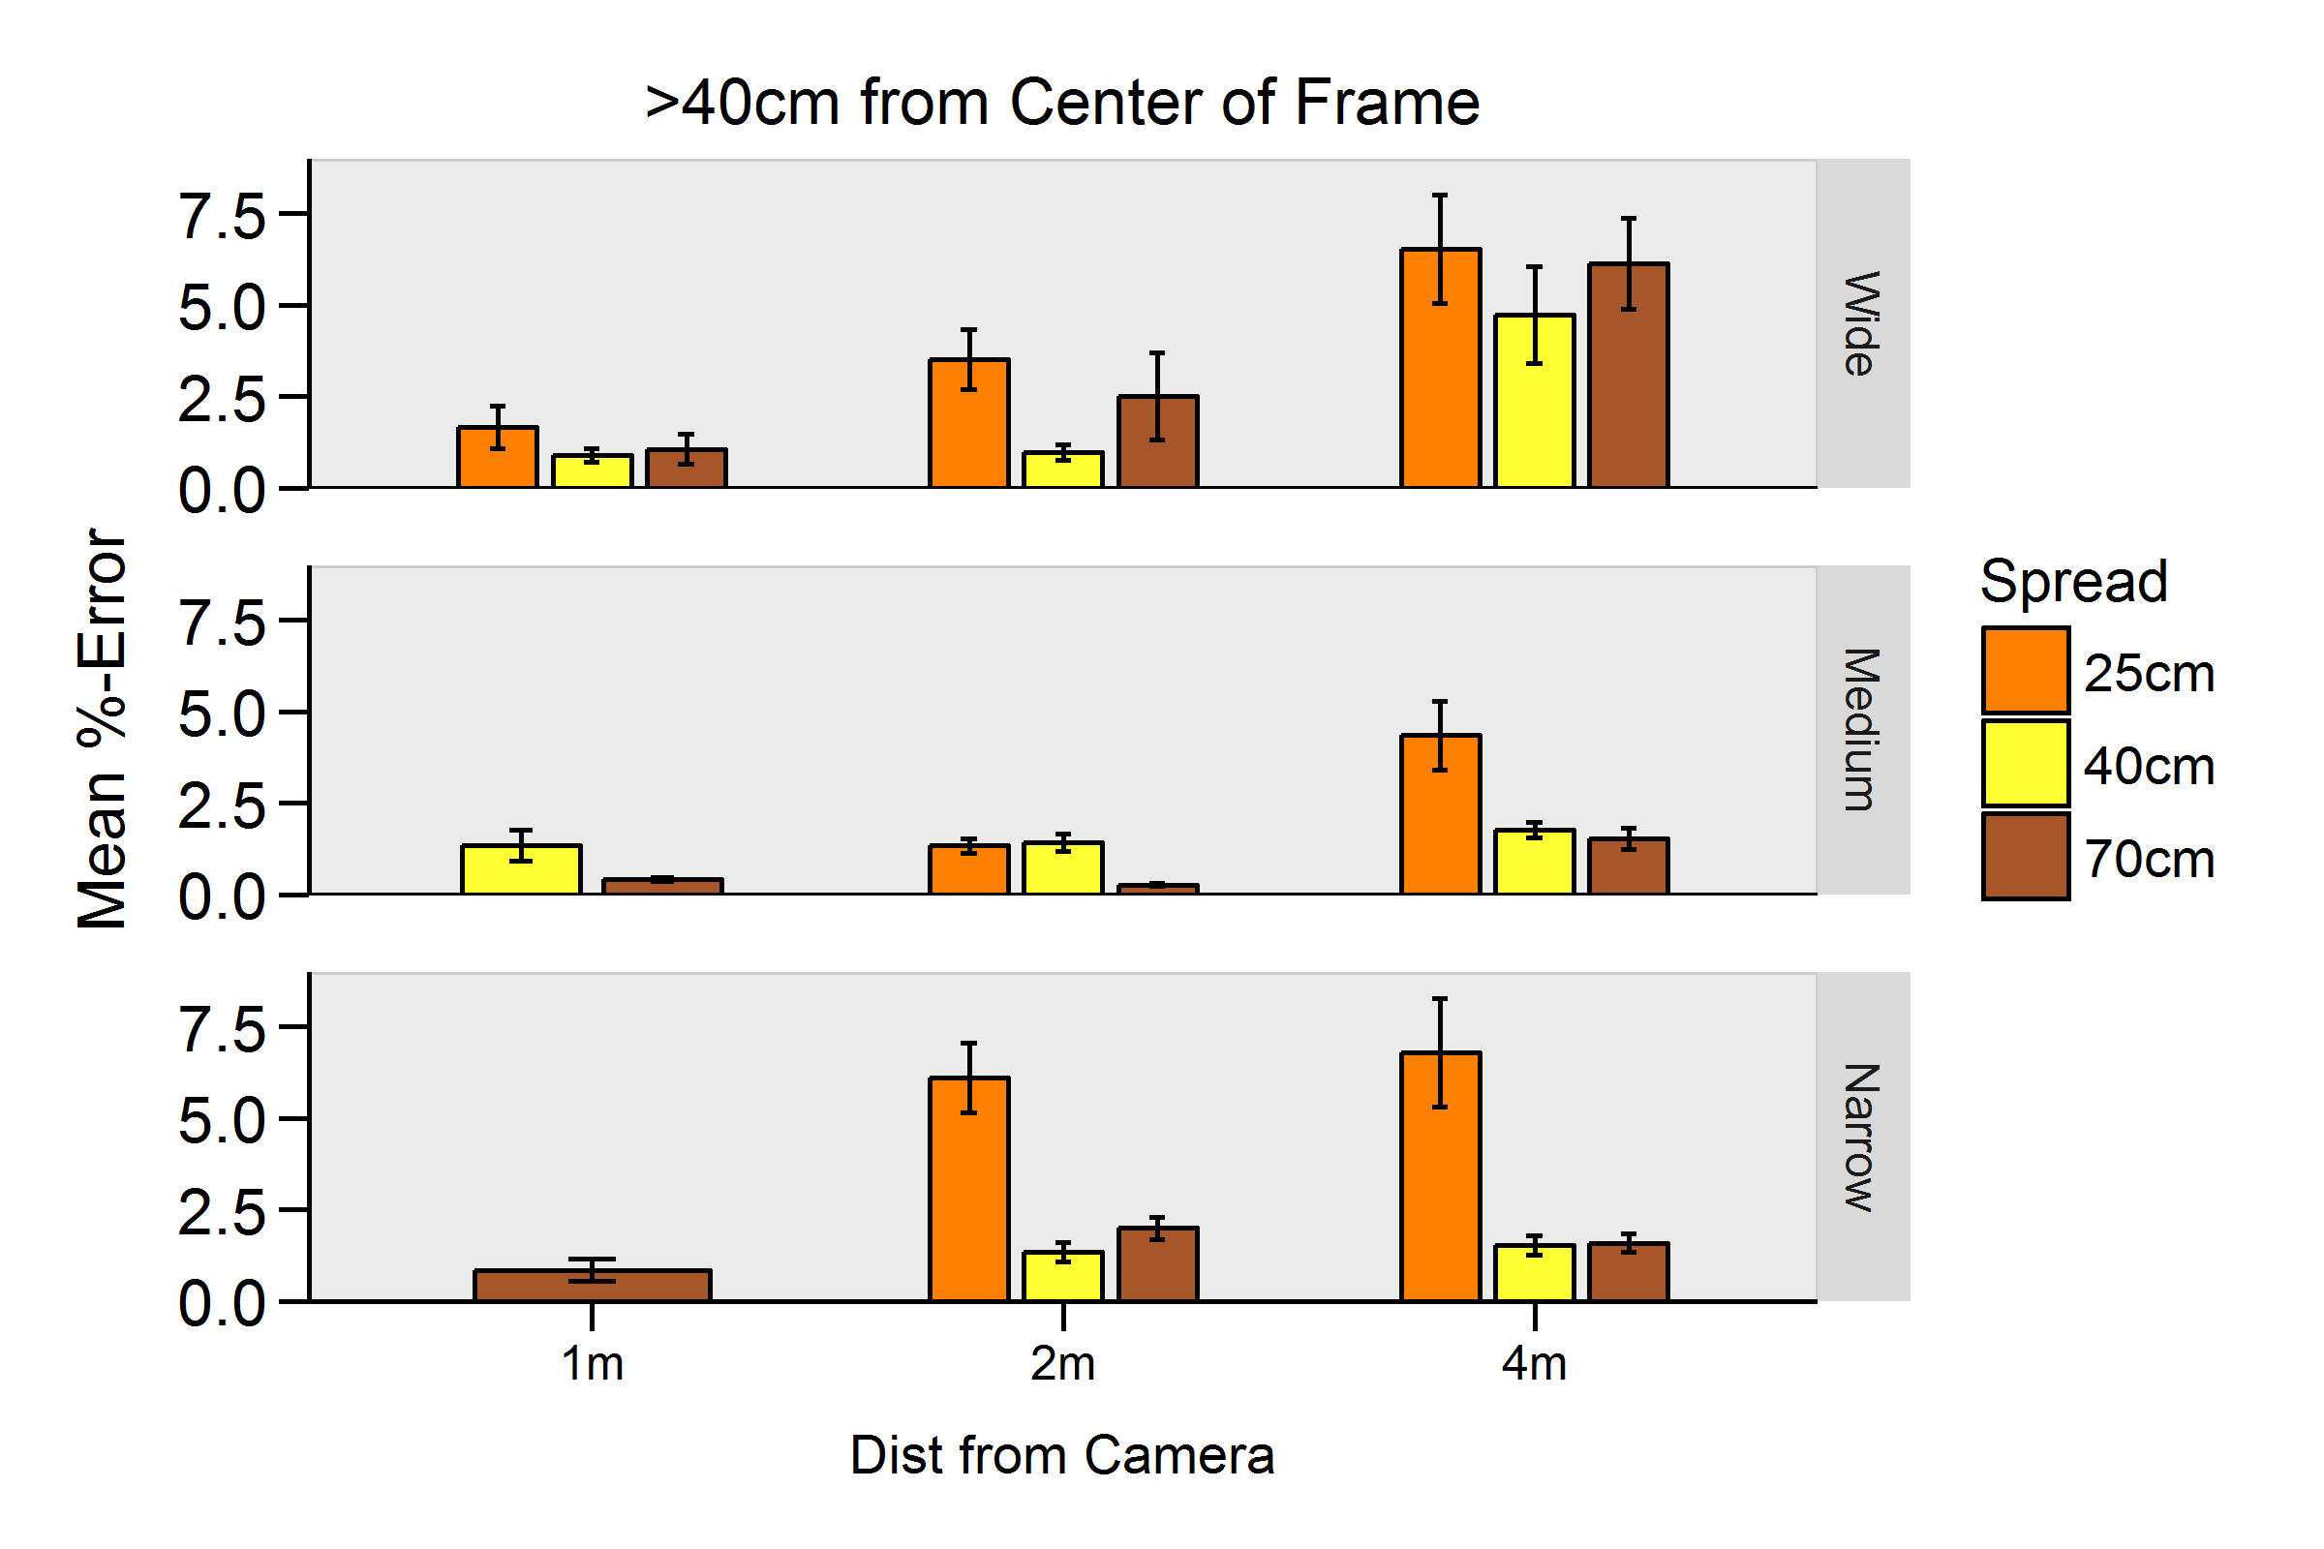
Figure 5: Mean percent measurement error. Target placed greater than 40cm from center of frame.

Vertical Camera Test:
In this test, cameras were spaced 40cm apart in a vertical plane. Measurements were made along the top edge as well as diagonally along the calibration cube surface. Target angles were again restricted to those less than 40 degrees parallel to the cameras.
The vertical camera performed well with Wide FOV at all distances. (Figure 6)
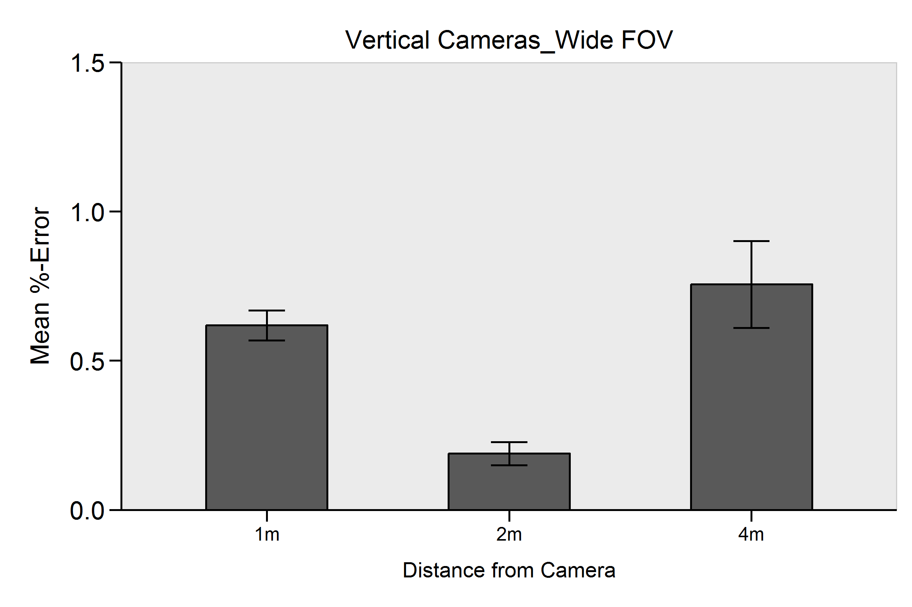
Figure 6: Vertical camera configuration mean percent measurement error by distance from camera.

Diagonal Camera Tests
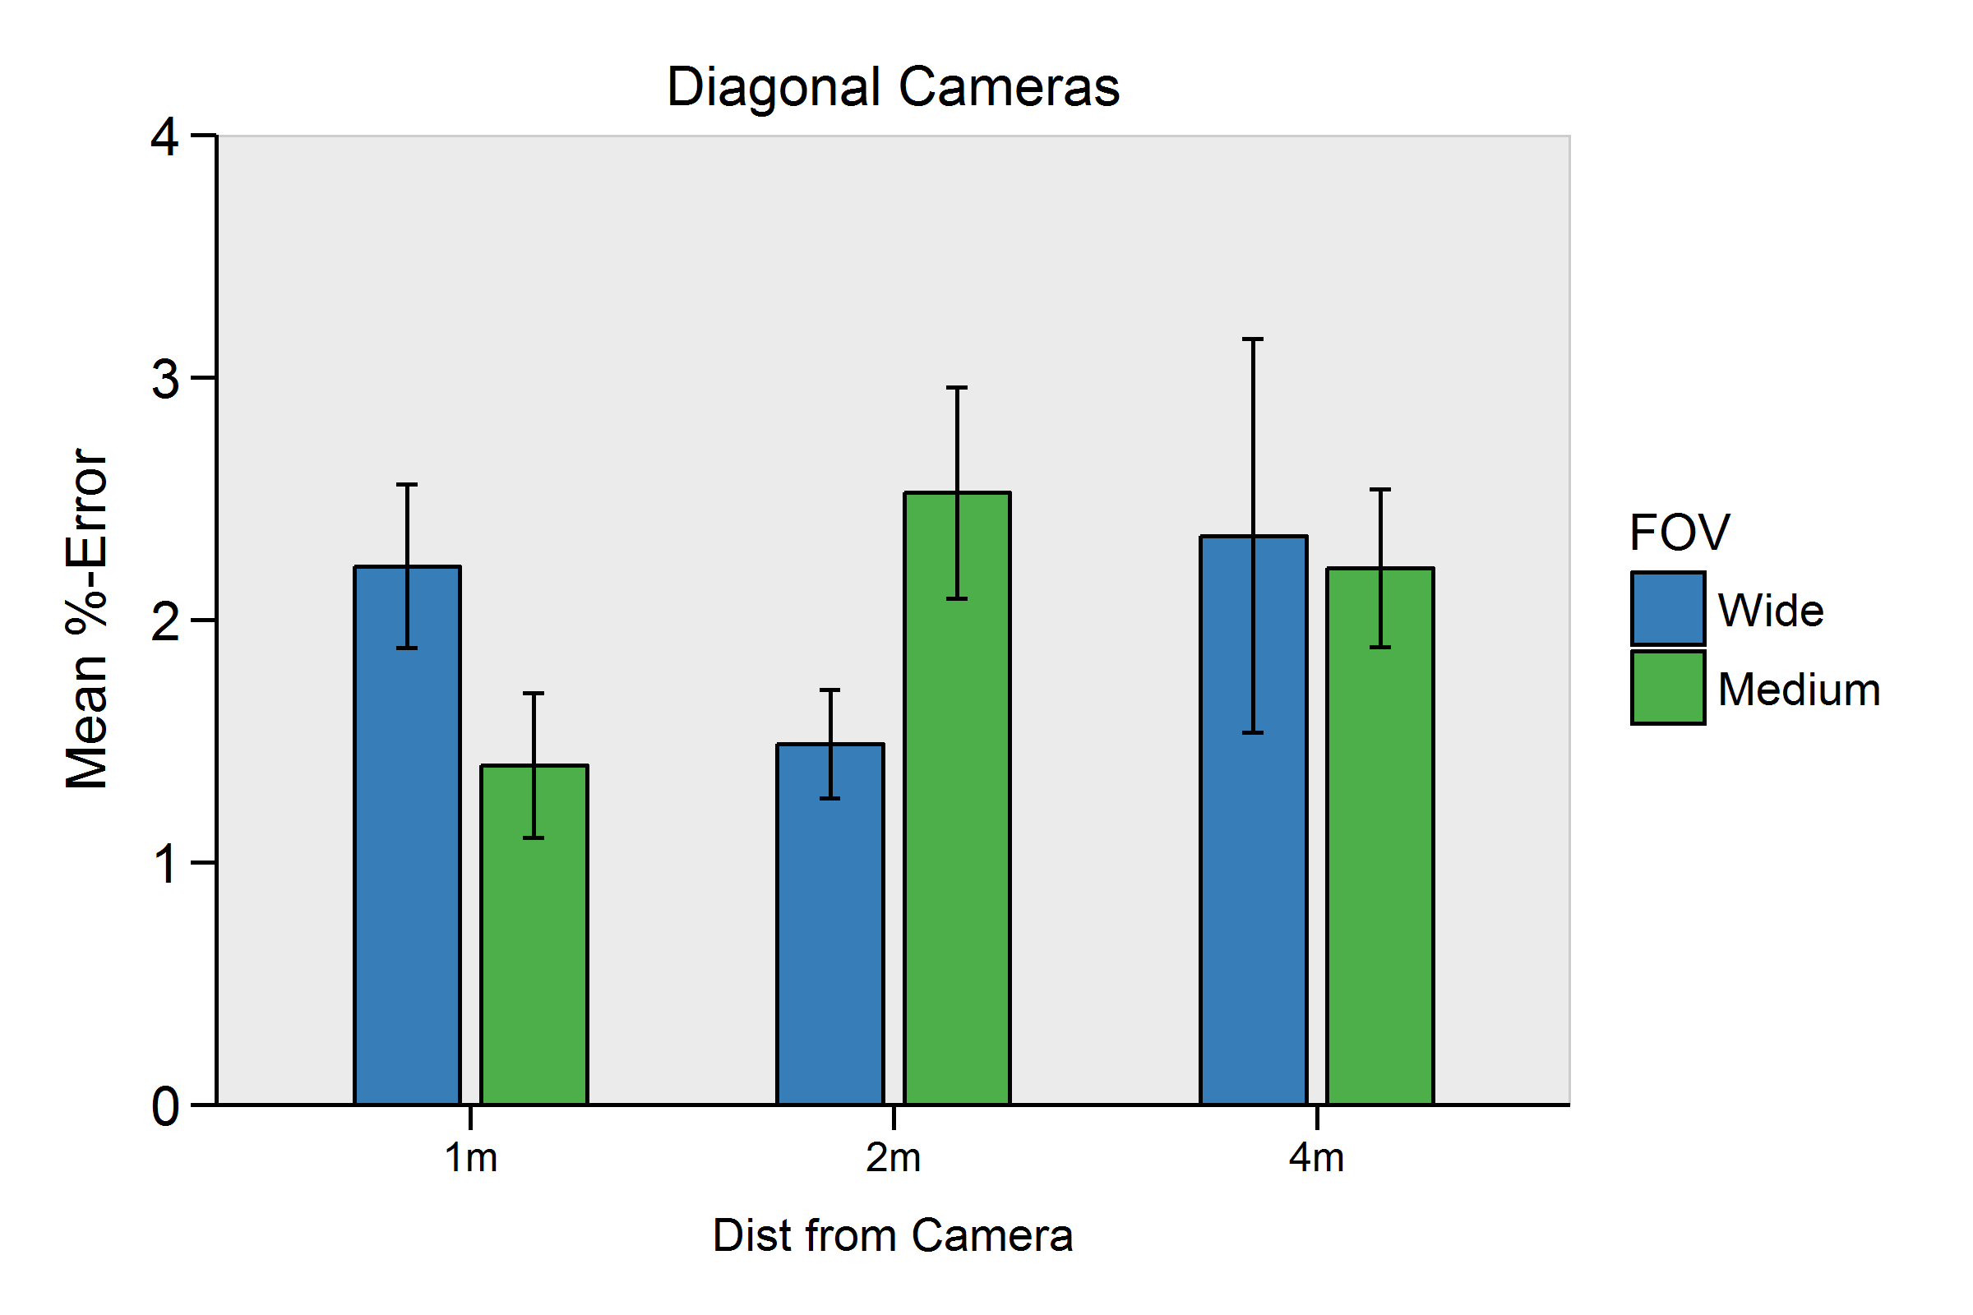
In this test, cameras were spaced 40cm apart in a diagonal plane.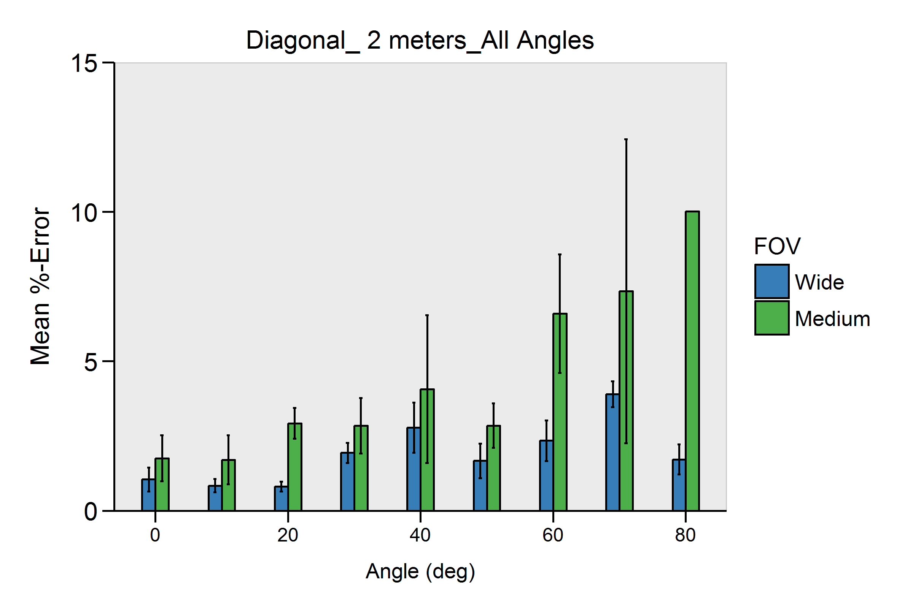 Below is the diagonal camera test with two different FOV at three distances.

Fig 8-9: Mean percent error of Diagonal Camera configuration
Finally, we looked at error at the edges of the frame for the diagonal tests. Error decreased with distance. This may be because at greater distances, the target was at less extreme offsets from the center of view.
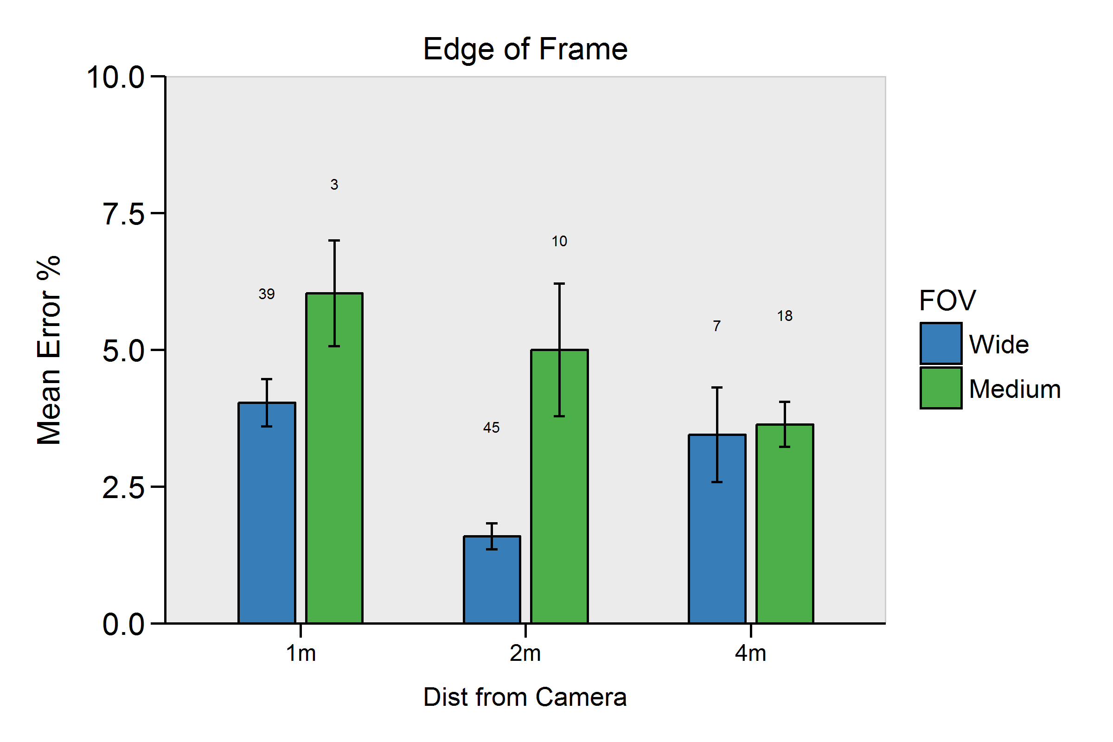
Figure 10: “Edge of frame”, mean percent measurement error for diagonal configuration.

