Test of Rokinon 12mm lens, with Sony Alpha 6300 camera.
François Cazenave, 02/02/17

Test in air
Test was performed on my desk, using ambient light (neon and natural).
Distance to target: 0.57m.
I measured the angles of view in air:
Viewing angle for stills: 87 Wide, 65 vertical (3:2 ratio)
Viewing angle for video: 77 Wide, 48 vertical (16-9 ratio)
I calculated the angles of view in water:
Viewing angle for stills in water through flat port: 62 Wide, 47 vertical (3:2 ratio)
Viewing angle for video in water through flat port: 56 Wide, 35 vertical (16:9 ratio)

Description of images:
Images are placed in the same folder as this word document

File name | Type | Aperture | Exposure time | ISO | Remarks
RokinonTest01 | Video 1080p, MP4 | F2
RokinonTest02 | Video 1080p, MP4 | F8 | 1/320 | 500 | Much greater depth of field than 01
RokinonTest03 | still | F2 | 1/320 | 500
RokinonTest04 | still | F8 | 1/125 | 500 | Much greater depth of field than 03

Test in water through flat window

This test was performed in MBARI’s seawater lab. The camera was placed outside a glass tank filled with water. The lens was placed a short distance from the side of the tank (12mm). A camera calibration target was placed inside the tank. The length of the tank was 50cm. The tank’s glass wall is 12mm thick. Two LED lights were placed on the sides of the camera. Video and still images were recorded. Then, the camera was moved down a few centimeters and angled up 7.5^{O}.

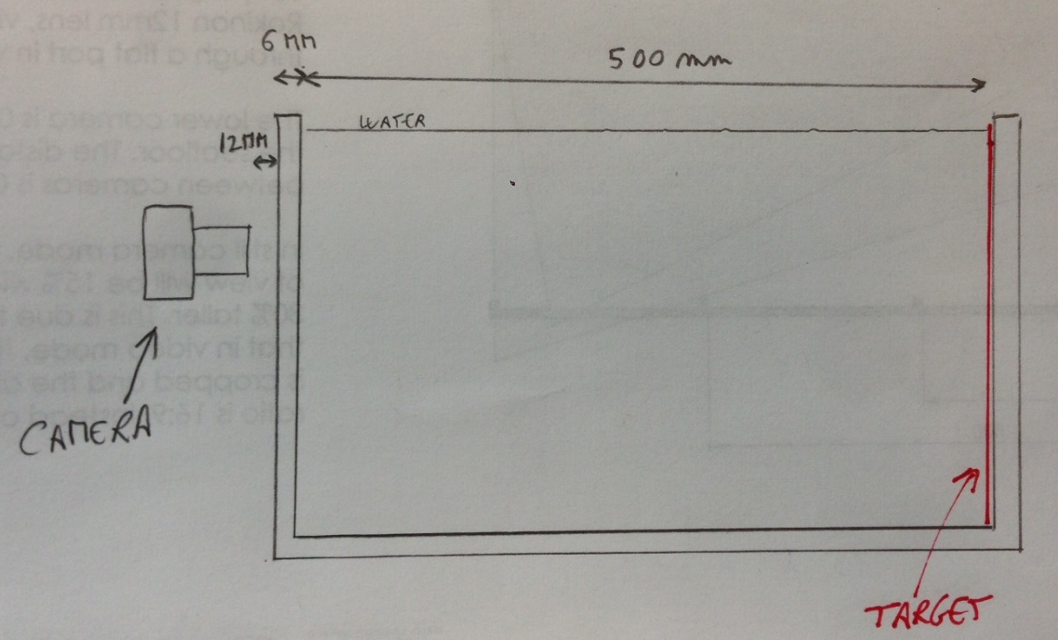
Figure 1: Side view of camera test setup

Description of images:

File name | Type | Aperture | Exposure time | ISO | Remarks
RokinonTest05 | still | F8 | 1/125 | 500 | Image width = 67cm
RokinonTest06 | Video 1080p, MP4 | F8 | 1/320 | 500
RokinonTest07 | Video 1080p, MP4 | F8 | 1/320 | 500 | Moving object
RokinonTest08 | still | F8 | 1/125 | 500 | Camera angled up 7.5 deg
RokinonTest09 | Video 1080p, MP4 | F8 | 1/320 | 500 | Camera angled up 7.5 deg

Taking images through a metal ring

A 70mm metal ring was used to simulate the port opening. The metal ring was placed against the glass window, in front of the lens. With the camera perpendicular to the window, 1cm from metal ring, there was not cropping of the image, even in photo mode.
With the camera angled 7.5º, there was some cropping of the corners in photo mode. In video mode, there was almost no cropping. If the distance between the lens and the ring had been reduced to 2mm for example, there would have been more margin. So it appears that a 70mm diameter is the minimum required. A larger port (80mm) gives more margin and does not require as careful alignment of port and lens.

Test with two cameras (not calibrated)

Two cameras were mounted on a rigid fixture. The camera were toed in 7.5º and separated 40cm. First, pictures were taken in the small test tank (same setup at above). These images give an idea of the overlap of the two fields of view at 50cm distance. Both still and video images were taken.
Then, the camera pair was placed outside a larger tank (178cm long, 86cm wide, 119cm deep). The target was placed 150cm from the cameras. A picture of a rock fish was placed in front of the target.
Video and still Images are placed in a folder named 2017-02-07-Camera Test.

