Benthic Observation System Failure Report

MBARI Project: 901704 Benthic Observation System
Date: November 14, 2019
Author: Eric Martin

Incident
The BOS experienced a communication failure while at sea on October 26, 2019. The incident as described occurred on a routine bottom observation to 70-meters. When the station observations were complete, the system was set to be retrieved and upon haul-in of the winch, communications were lost. Field inspection determined the loss of communications was contained within the fiber-optic tether. The system returned to Moss Landing for inspection and determination of the failure.

Physical Inspection
Dissection of the tether was able to localize the fault to a break in the tether, 12-meters from the attachment point of the clump. Pictures below show the broken section after the outer jacket has been removed. The left image shows the unbundled conductors (white and black) and the two fiber optic cables (green). The only proof of damage here is the broker fiberglass fill element that is the core member of the tether. The right image shows the visible break in the fiber when illuminated by a visible light source injected at the far end of the tether. I would expect more damage held as small bends in the copper conductors, but their straight nature might be explained as a result of being pulled back through the sheaves under load on final recovery. No other local damage was visible.
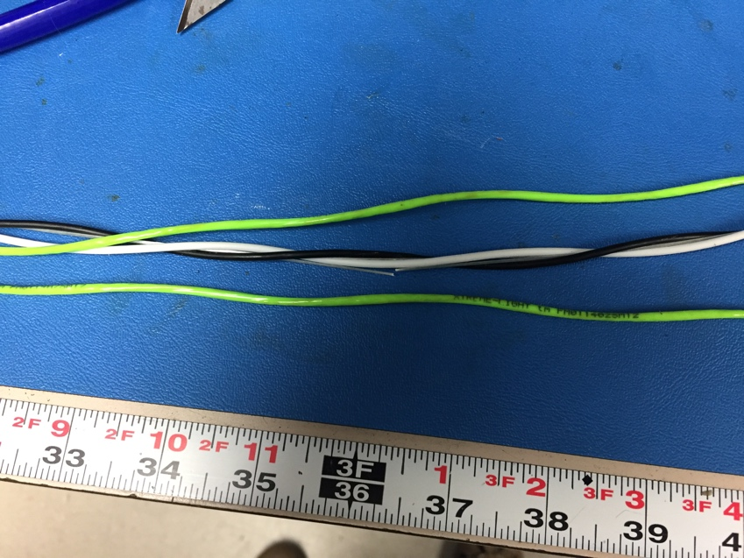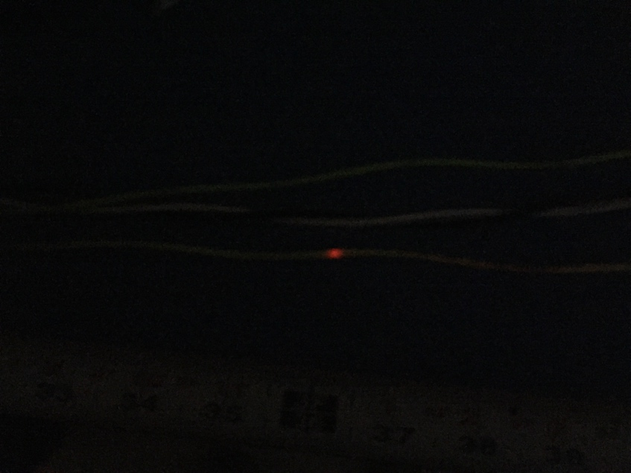

Data Inspection
Data files were supplied for analysis, ones that captured all available data leading up to the failure. See below for a set of relevant signals. Heading, pitch and roll are from the attitude sensor on the BOS. A similar sensor provides the heading of the ship. Integrating the change in heading over time gives us the values of “turns”, which is the number of times the heading has completed a revolution of 360˚, and it’s sign indicates a clock-wise (positive) or counter-clock-wise (negative) turn. In these plots the turns are presented as the value with respect to its platform. What is operationally important is the instantaneous value of difference between the ship’s turns and the BOS’s turns. If the two drift far apart, and there is slack tether, the tether will develop a hockle, or a twist, that can result in damage when tension is applied again.
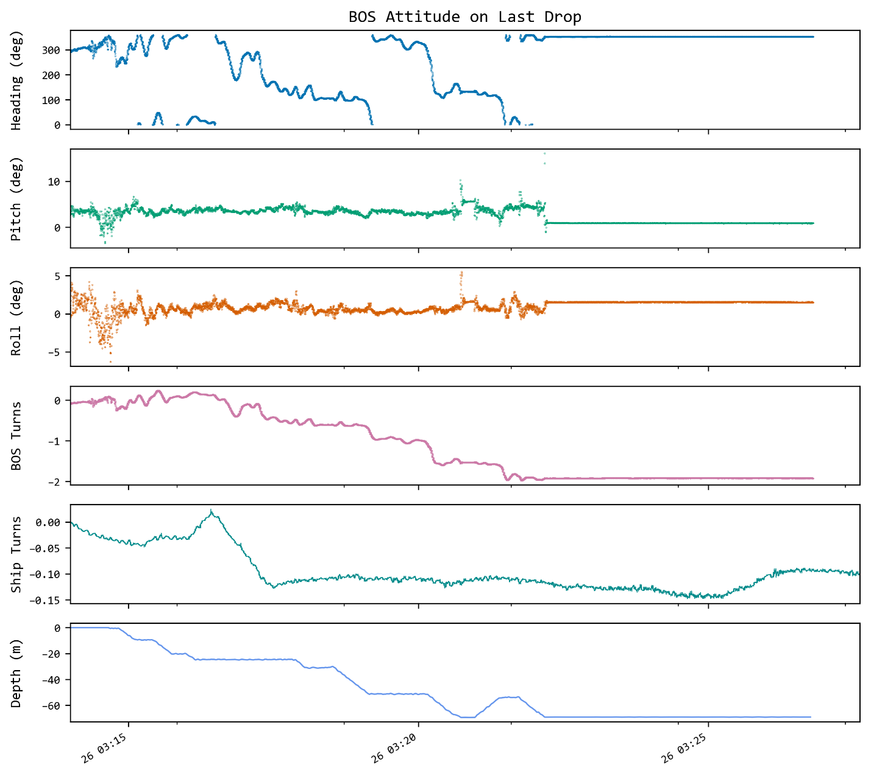
The data above is just the final segment of the file provided that encompassed the incident. Within just this file, it is clear that the BOS develops a -1.97 turns value, and the boat has a -0.15 value. The net turns captured in the tether is ~-2.15 turns, enough to develop a hockle.

Final conclusions

The physical damage and data support a conclusion that the tether experienced a failure as a result of a twist in the tether and a potential self-tangling incident subsea. Since there are no kinks in the copper conductors near the failure point, I believe that the system did not get caught on a float or the clump weight. Because the system was recovered through the sheaves on-board, some other kinks may have been removed. Since the failure did not occur at an attachment point of the floats or depressor weights, I believe the design remains sound.

Recommendations
While hockles in free floating tethers are a risk for any two-body system, there are some clear recommendations for future improvements.
- The turns counters must exist, be reliable and visible to the BOS operator, so that informed operational decisions can be made.
- Operators should wait for a high turns estimate to equalize before bottoming the platform.
- Logging the payout from the winch will help in future data analyses, this requires an effort by the winch manufacturer.
- If payout can be logged, then displaying a value of difference between payout and depth will enable two operational benefits:
  - Operators can better manage payout after bottoming, targeting a value that best manages the free tether: deploying more when the boat drifts far from the BOS on-bottom, and minimizes the value when the boat is directly above the BOS.
  - This indicator will also signal if the BOS is under the boat before sending the vehicle to bottom.
- Reduce the tangling hazards of the current depressor weights.
- Move the clump attachment point higher on the tether.
- Log the calculated value of turns on the platform.

These are recommendations for preventing the failure in the future. As a group we have already started a supplementary discussion around making the system for field serviceable so that a failure such as this can be diagnosed and repaired at sea. Some of these suggestions are already underway.
- Present the second tether fiber on the exterior of a junction box through addition of a second Lancer bulkhead. [underway]
- Add diagnostic tools to the kit for fiber-optics, such as a visible fault detectors and a power meter/source pair. Provide training.
- Develop a document for troubleshooting the fiber path.
- Develop instructions, supplies and training for re-terminating the tether in-field.

