Benthic Observation Survey System (BOSS) Specification Sheet
Principal Investigators: Rick Starr (MLML), Mary Gleason (TNC)
Project Manager: Chad Kecy (MBARI)

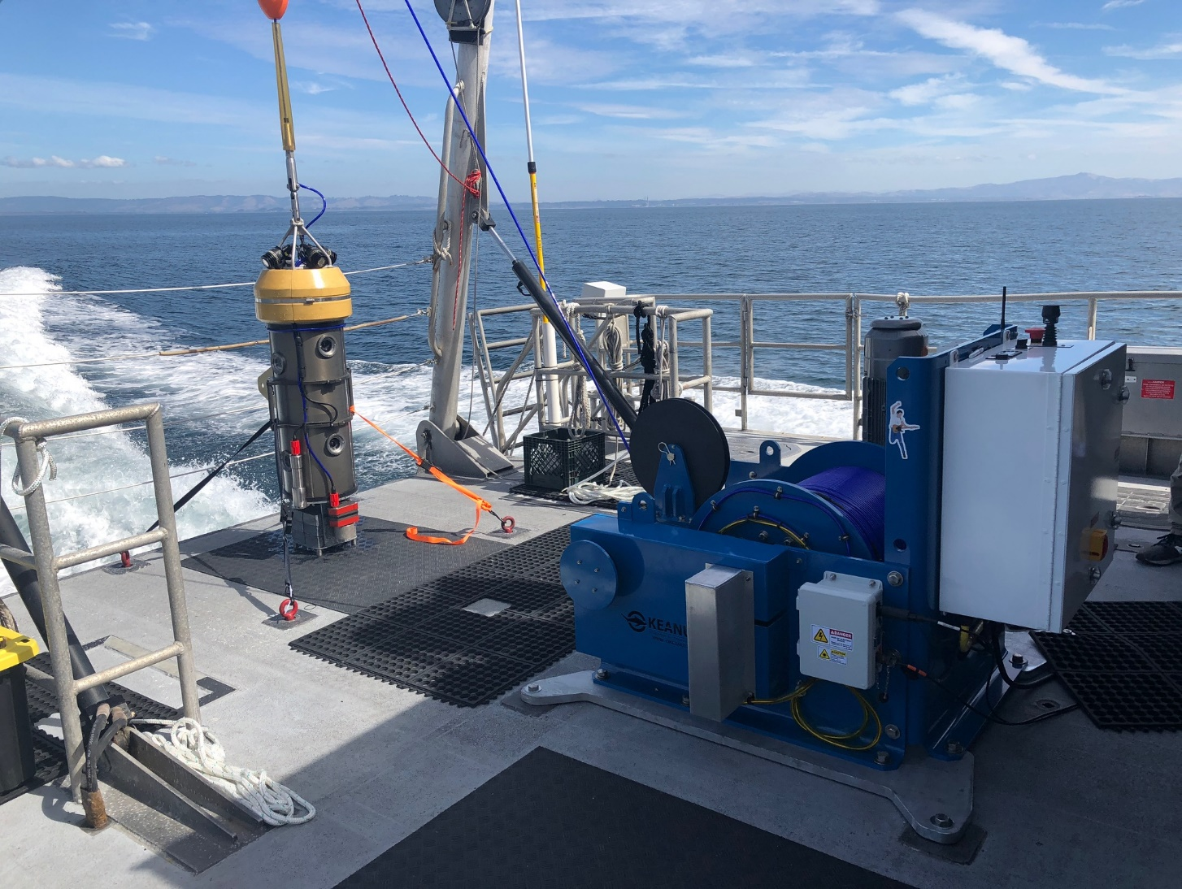

The Benthic Observation Survey System (BOSS) is a video collection platform designed to capture imagery in hard to reach subsea areas such as rocky outcroppings. Four sets of vertically mounted stereo pair cameras provide nearly 360 degrees of coverage. A ninth downward looking camera is used to assist with the positioning and landing of the BOSS on the seafloor. Live video from the nine cameras is streamed to the ship via the load-bearing tether; a topside deck recorder records all nine HD channels simultaneously. Real-time control of the BOSS is achieved with the use of the PDU and data collection laptop. Deployment of the BOSS can be accomplished with a science crew of 3-4 people; an additional ship’s crew to operate the A-frame is also required.

Winch
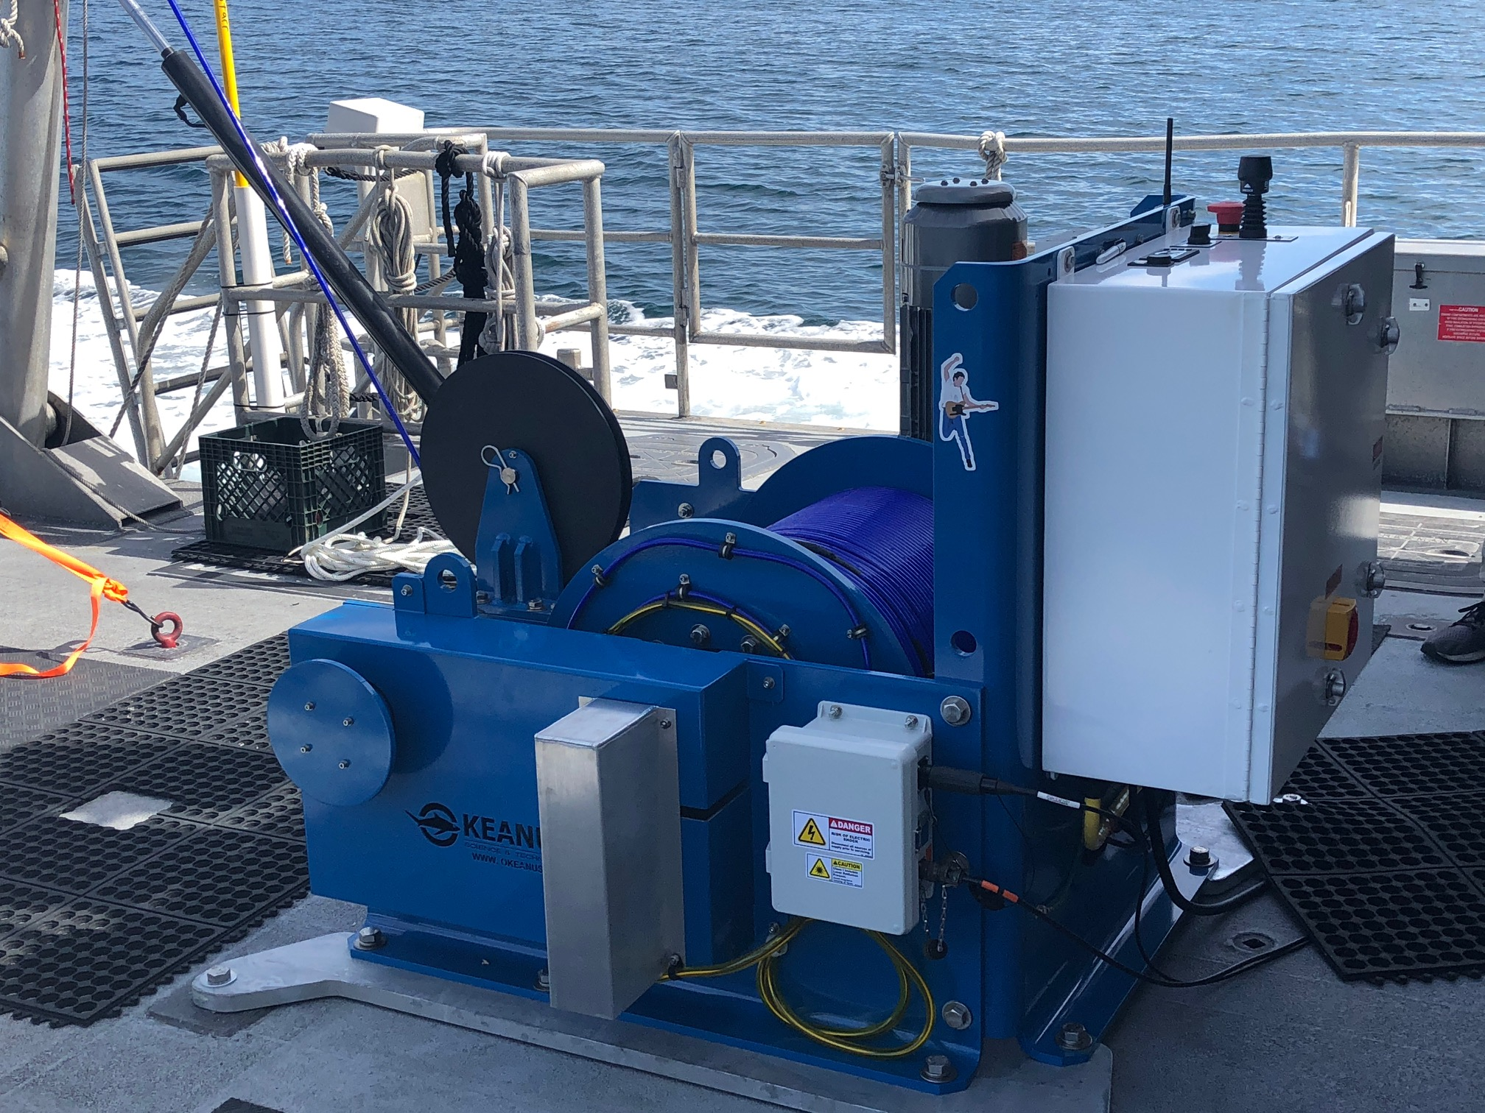

Model: Okeanus Eco-2000
Description: Electric winch with Liebus shell, level wind, payout indicator, & remote belly pack.
Weight: 1250 pounds
Dimensions: W=52 inches, L=53 inches, H=43 inches
Power: 3HP
Electrical Input: 220Vac 60Hz, 10 amps (nominal, see below)
Tether Input: Electrical deck lead (480Vac) and optical deck lead (single mode fiber)
Fiber Optics: Alpha optical single-pass slip ring (aluminum cover next to stationary junction box)
Line Speed: 121 feet/minute (full drum), 98 feet/min (bare drum)
Line Pull: 600 pounds (full drum), 750 pounds (bare drum)
Brake Holding Capacity: 1050 pounds (full drum), 1312 pounds (bare drum)
Pay-Out Current: 8 amps (peak), 6.2 amps (continuous)
Haul-In Current: 12.2 amps (peak), 10.5 amps (continuous)
Mounting: Attached feet (see above) with standard UNOLS pattern

Tether
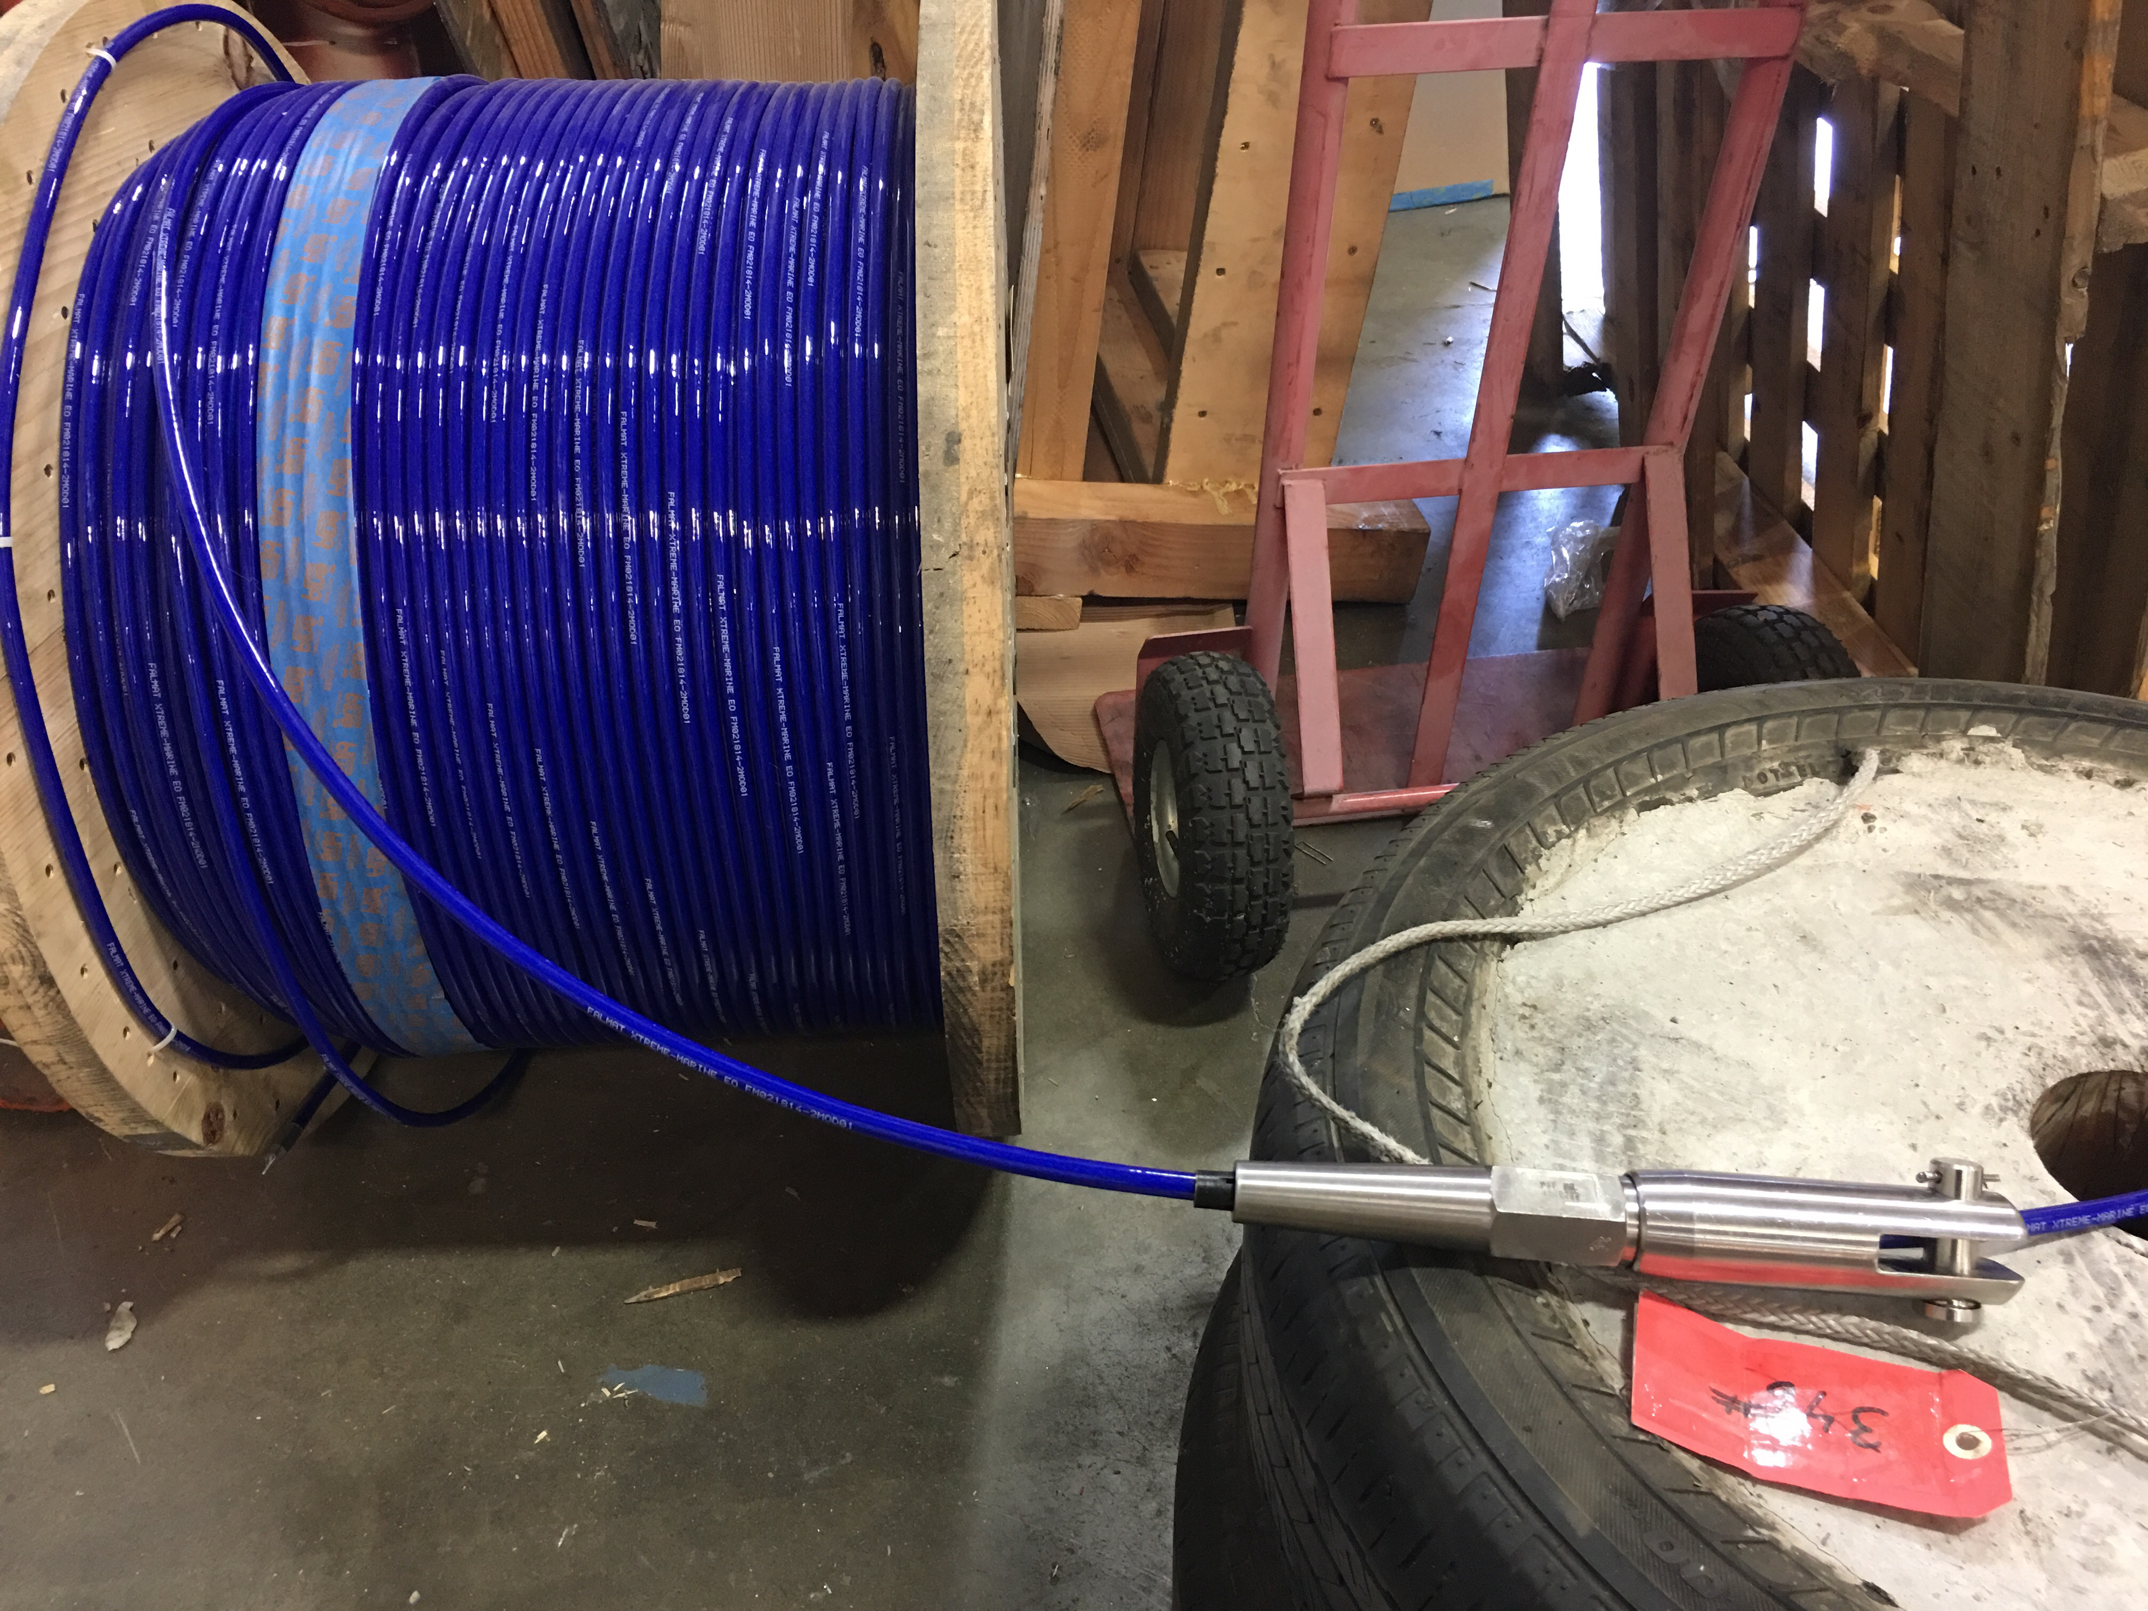

Model: Falmat Xtreme-Marine EO, PN# FM021814-2MODXX
Description: Reinforced kevlar, 16AWG(x2), SMF(x2)
Length: 400 meters
Voltage Rating: 1000 volts
Operating Strength: 450 pounds
Breaking Strength: 2700 pounds
Minimum Bend Radius: 6 inches
Outer Diameter: 0.394 inches
Weight in Air: 0.26lbs/meter
Weight in Water: 0.9lbs/meter
Maximum Depth Rating: 6000 meters
Physical Connection to Lander: Esmet load bearing fitting & weak link (break strength=2000lbs)
Electrical Connection to Lander: Junction box (with Re-entrant able compound - power + fiber)

BOSS Lander
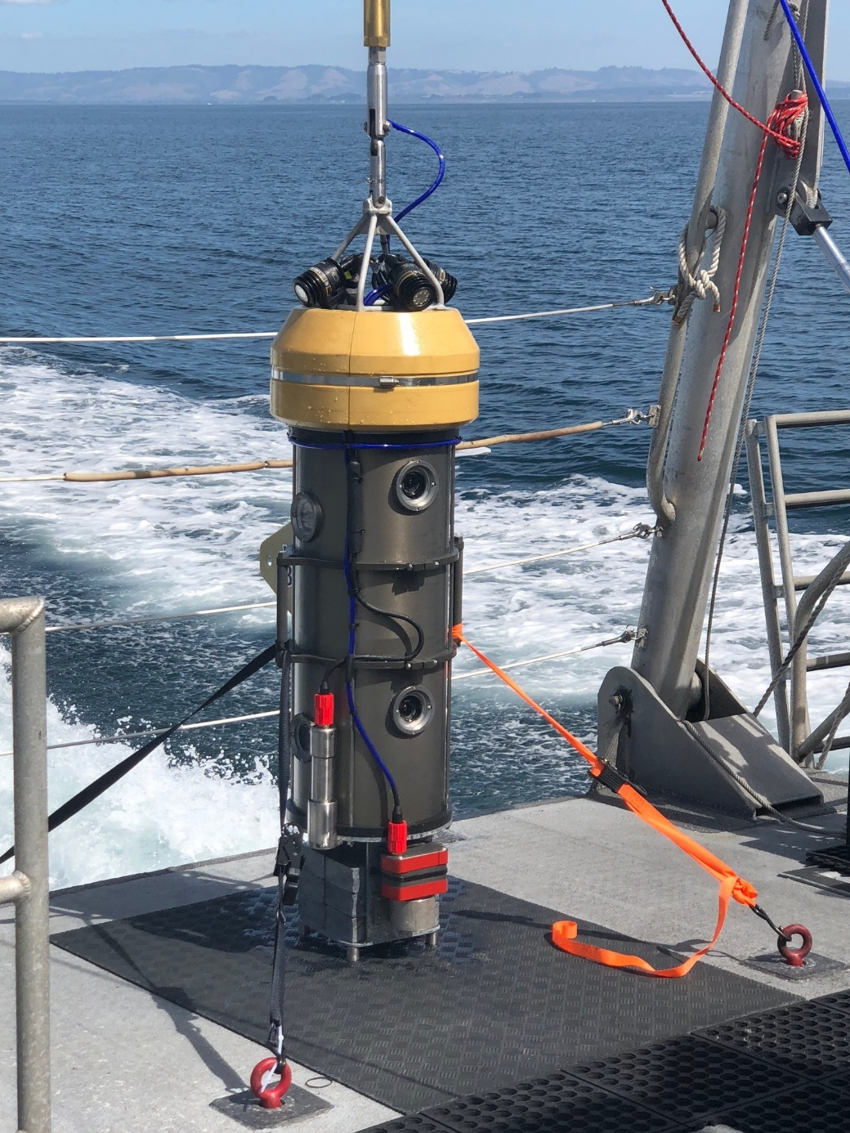

Description: Subsea 9-camera benthic lander with 5 lights and altimeter/depth sensor.
Weight: Dry = ~350 lbs (with lead bricks), Dry=190 lbs (no bricks), Wet =140 lbs (with bricks)
Dimensions: H=72 inches, Diam = 12 inches
Depth Rating: 300 meters
Housing Material: Anodized aluminum
Power: 1200W max
Input: 480Vac 60Hz, 2.5 amps
Camera Lens: Fixed focal length of 7.5mm
Camera Field of View: 60 degrees (horizontal), 40 degrees (vertical)

Deck Recorder (left) and PDU (right)
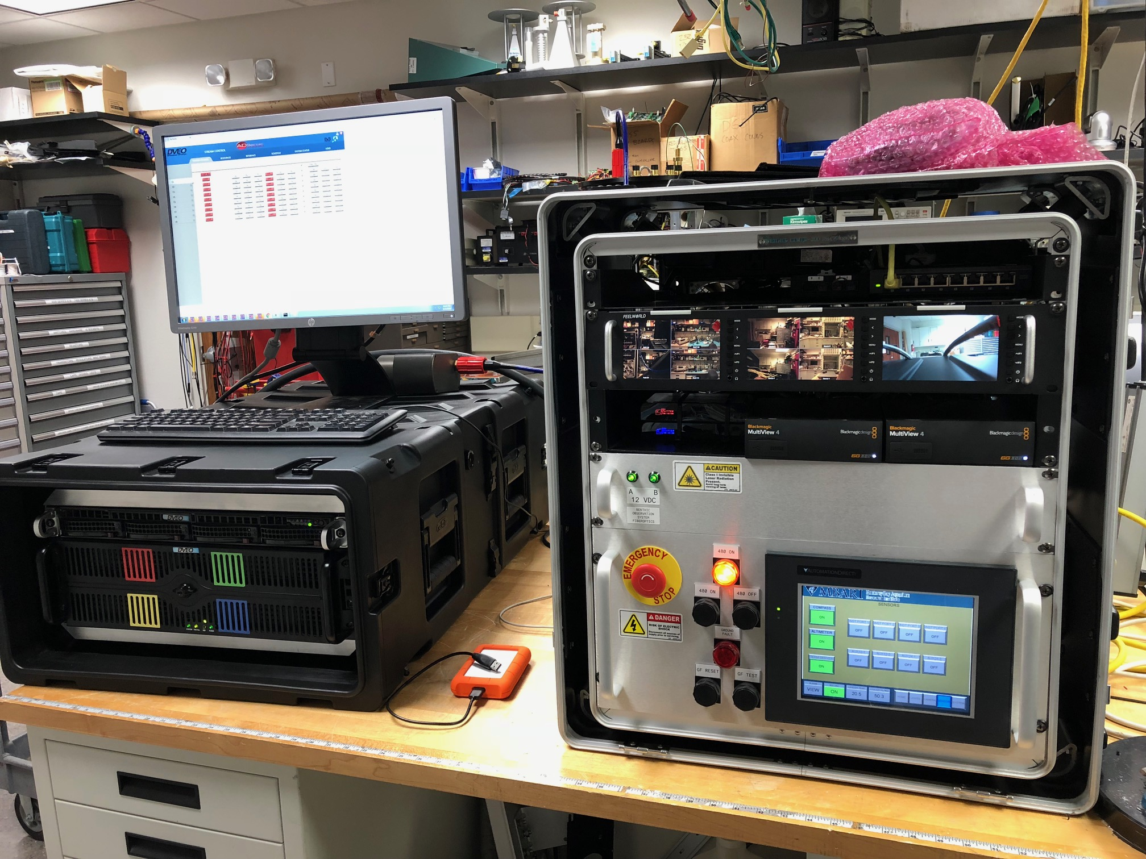

PDU
Description: Power and Control unit for BOSS
Weight: ~100 pounds
Dimensions: H=30 inches, W=30 inches, Length=24 inches
Power: 1200W (supplies power to lander) [contains a 1:4 step-up transformer for 480Vac]
Input: 110Vac, 12 amps

Deck Recorder
Description: Computer for recording the 9 HD (1080 30p) video streams
Weight: ~150 pounds
Dimensions: H=12 inches, W=20 inches, Length=72 inches
Power: ~650W
Input: 110Vac, 6 amps

* The PDU and Deck Recorder need to be plugged into separate 110Vac circuits due to start up surge currents.

Sheave
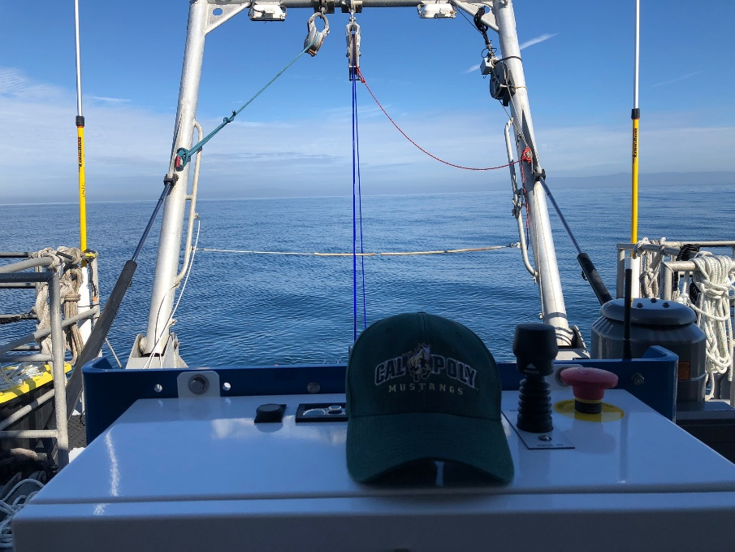
Sheave is in upper portion of the photograph, attached to the ship’s A-Frame.

Minimum Sheave Height: 10 feet from the deck

Main Deployment Components

Back Deck
Winch (with tether)
BOSS Lander
Sheave
Launch and Recovery Tote (Football floats, Callum grip)
Clump Weights (50 pounds x 3)
GPS Antenna

Internal
Power Distribution Unit (PDU)
Deck Recorder (with monitor, keyboard, and mouse)
Viewing Monitors (3)
Data Acquisition Laptop
Navigational (Waypoint) Laptop
Safety gear

Other
Storage Totes (~6)
Tool Boxes (2)

