Benthic Observation Survey System (BOSS) Video Lander Summary
For Monterey Bay Aquarium Research Institute
By Mary Gleason (The Nature Conservancy), and
Rick Starr, Katie Cieri, Jackie Mohay (Moss Landing Marine Laboratories)

The Nature Conservancy (TNC) and Moss Landing Marine Laboratories (MLML) work on coastal resource issues, specifically to develop new partnerships, tools, and approaches to cost-effectively gather information needed to better assess and manage our fisheries and ocean ecosystems. From 2017–2019, with support from the David and Lucile Packard Foundation, engineers at the Monterey Bay Aquarium Research Institute (MBARI) worked with scientists from TNC and MLML to design and build a novel video lander for surveying fishes and invertebrates in nearshore waters. The video lander, named the Benthic Observation Survey System (BOSS) was built to assess the size and density of fish and invertebrate species in rocky habitats on the continental shelf and slope. A team of engineers led by Chad Kecy designed and built the BOSS.
The BOSS video lander utilizes stereo-video technology, which, with calibrated cameras and EventMeasure software (SeaGIS, Australia), enables us to measure the length of fishes and invertebrates with a high degree of accuracy. At sea, the BOSS is lowered to the bottom relatively quickly (~40 m/min) using a fiberoptic, load-bearing cable that provides power for the lights and cameras, and carries video back to the surface. Special software is used to stitch these images together to create stereo images, which are used to identify, count, and determine the sizes of fish. The system has a weighted bottom and floatation on top that makes it stable when landing on uneven terrain, as well as a downward-looking camera that that allows the BOSS to be landed carefully. Once on the bottom, eight high-definition video cameras record video in all directions for several minutes, after which the system is lifted off the bottom and moved to a new location. The BOSS system is a unique survey tool in that it can quickly be deployed and retrieved, thus allowing “point-count” surveys to occur at many locations in a day.
To date, we have conducted more than 1000 BOSS surveys, or drops, all along the California coast (Figure 1, Table 1). In the Fall of 2018, we spent 24 days at sea surveying the California coast from Half Moon Bay to the Channel Islands to demonstrate how our system can be used to conduct broad-scale surveys of high-relief habitats. We demonstrated that the BOSS video lander can be deployed rapidly in untrawlable rocky habitats at large geographic scales to collect data on density and size of demersal fishes, including stocks of important commercial fishes such as Cowcod (Sebastes levis), Yelloweye Rockfish (S. ruberrimus), Canary Rockfish (S. pinniger) and Lingcod (Ophiodon elongatus).
We’re continuing to use the BOSS to conduct visual surveys in the untrawlable parts of the Cowcod and Rockfish Conservation Areas (CCAs, RCAs, established in 2001) and compare results with the density of demersal species as determined by NMFS hook and line surveys in similar untrawlable rocky habitats. Our current objective is to determine how well visual surveys can be combined with hook and line surveys to improve rockfish stock assessments. From September 13th-27th, 2021, we conducted 12 days of video surveys in conjunction with NMFS hook and line surveys in the Channel Islands. Our primary objective was to survey sites selected by NMFS scientists at fishing sites around the Channel Islands using our BOSS (Benthic Observation Survey System) video lander. Our video data will be used to compare frequency of occurrence, density, length-frequency distributions, and calculated biomass of important species with information from NMFS standardized hook and line surveys that occurred closely in time and space to our data collection.
We’ve also used the BOSS in collaboration with CSU Monterey Bay and the US Navy to conduct surveys at San Clemente Island to explore fish-habitat interactions and build upon previous ROV surveys. The military presence at the island has created a de-facto MPA, which gives us the opportunity to study fishes and habitats removed from fishing pressure. We conducted four cruises at the island (October 2019, February 2020, March 2021, and June 2021).
We are currently working in partnership with the Monterey Bay National Marine Sanctuary (MBNMS) and CSU Monterey Bay with funding from the NOAA’s West Coast Deep-Sea Coral Initiative to survey corals and fishes in Monterey Bay. Visual surveys in sanctuary ecologically significant areas (SESAs), including central California Marine Protected Areas (MPAs) and recently modified (e.g., closed or reopened) Essential Fish Habitat Conservation Areas (EFHCAs) are needed to better understand the occurrence and status of corals and sponges within Monterey Bay National Marine Sanctuary. These sites represent a poorly characterized depth range of MBNMS; deeper than standard SCUBA diving depth and shallower than most ROV work. NOAA’s West Coast Deep-Sea Coral Initiative and MBNMS are supporting image-based surveys within EFHCAs and MPAs to determine and characterize the occurrence of corals and sponges in depths ranging from 40-350 meters. Our goals on this project are to collect high-definition imagery data with the BOSS video lander within Essential Fish Habitat (EFH) Conservation Areas (EFHCA) and California marine protected areas (MPAs) in depths ranging from 40-350 meters and to characterize the occurrence of corals and sponges, and associated animals
.

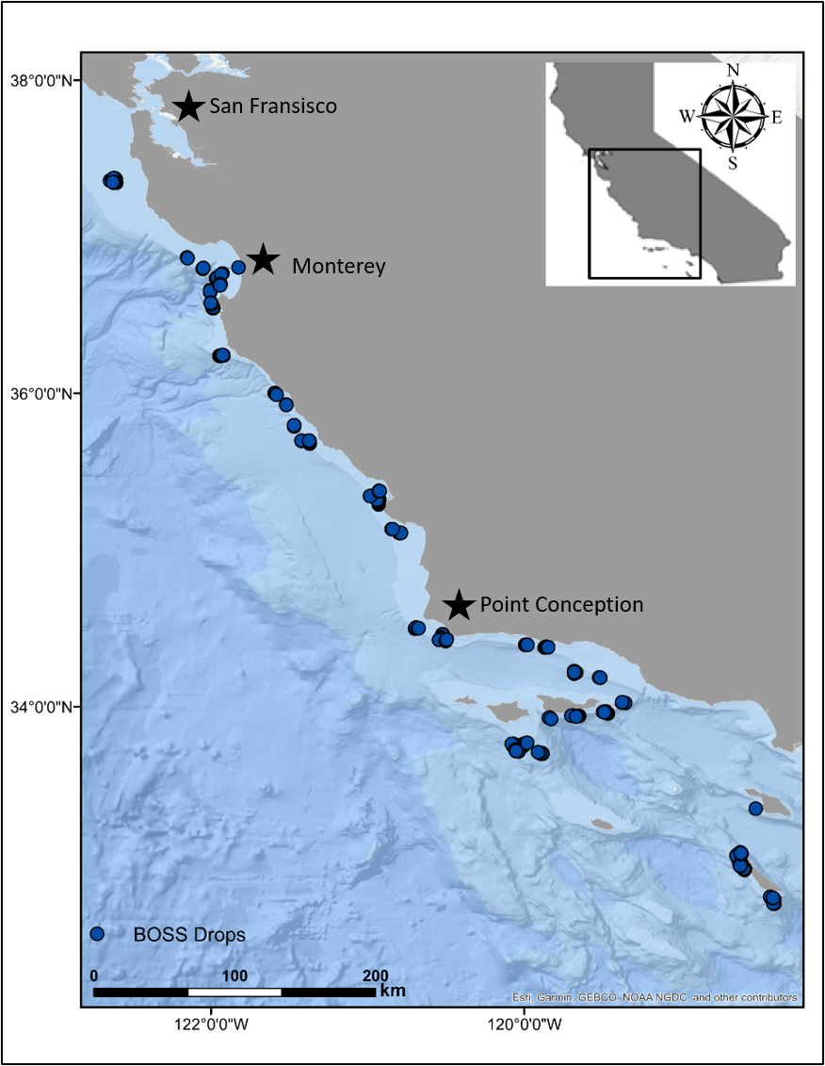
Figure 1 A map of locations of all BOSS video lander surveys since 2018.

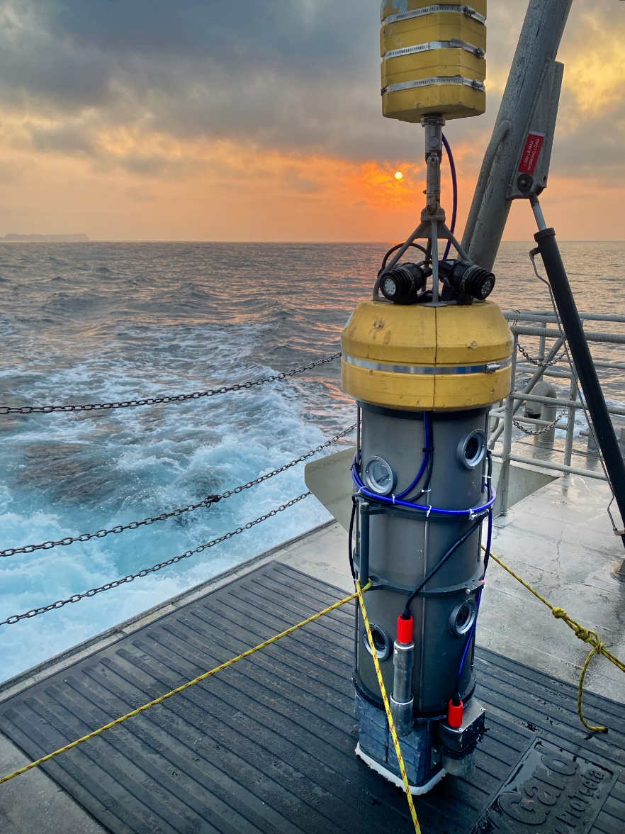 | 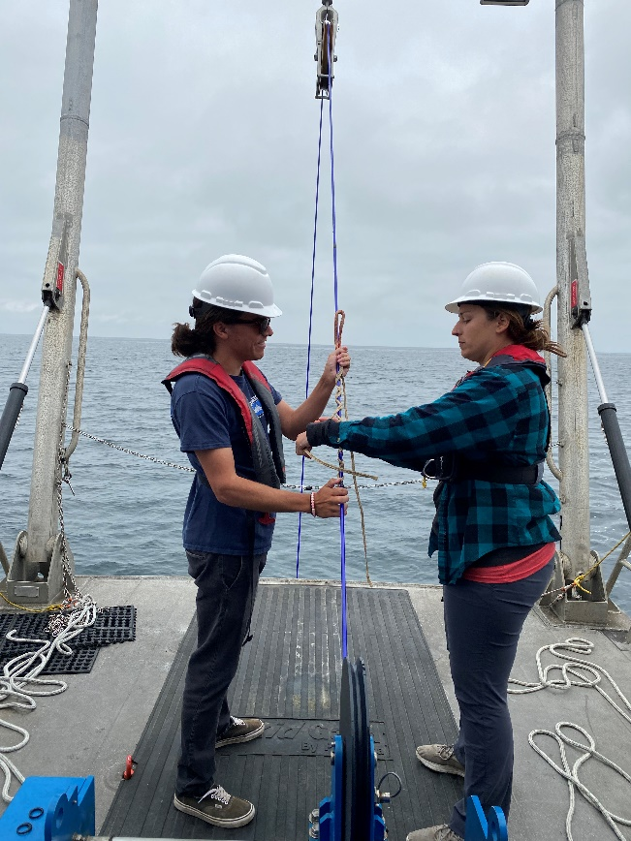
Figure 2. Left: the BOSS video lander on deck. Right: Science crew members prepare a Yale grip during a BOSS deployment.

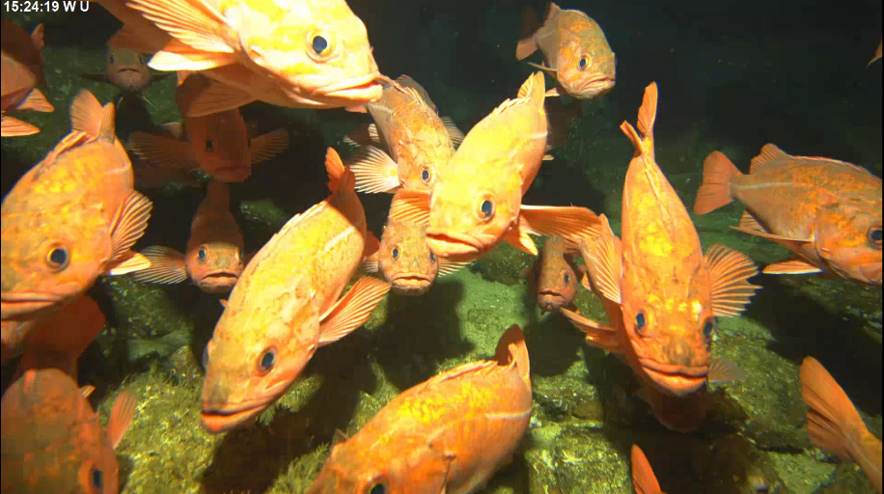 | 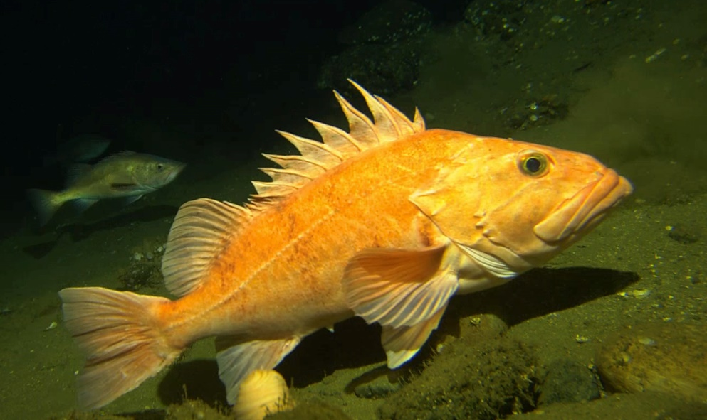
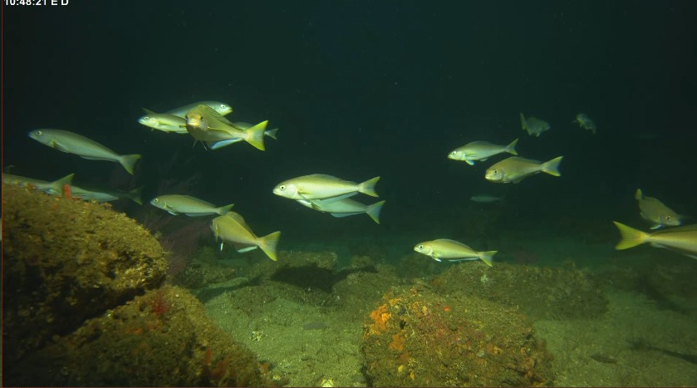 | 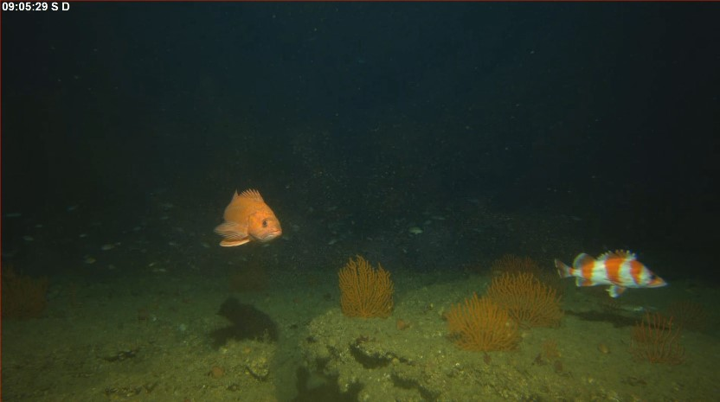
Figure 3. Clockwise: A large school of Vermilion Rockfish (Sebastes miniatus), a Cowcod (Sebastes levis), a school of Ocean Whitefish (Caulolatilus princeps), and a Vermilion Rockfish (Sebastes miniatus) and Flag Rockfish (Sebastes rubrivinctus).

Table 1. A summary of BOSS video lander drops by area and location. Shaded bars represent area totals
Area | Location | Number of Drops | Totals
Halfmoon Bay |  |  | 34
 | Deep Reef | 34
Monterey Bay |  |  | 230
 | Offshore Point Pinos | 15
 | Monterey | 1
 | Portuguese Ledge | 125
 | South Monterey Canyon | 37
 | North Monterey Bay | 11
 | Cypress Point | 35
 | North Monterey Canyon | 6
Big Sur |  |  | 73
 | Lopez Point | 12
 | Point Sur | 19
 | Cape San Martin | 8
 | Diablo Canyon | 12
 | Villa and La Cruz Canyon | 22
Morro Bay |  |  | 31
 | Morro Bay | 23
 | Church Rock | 8
Anacapa Island |  |  | 105
 | Anacapa Island | 68
 | Footprint | 37
Santa Barbara Island |  |  | 79
 | Hidden Reef | 20
 | Kidney Bank | 7
 | Santa Barbara Island | 29
 | Osborn Bank | 23
Catalina Island |  |  | 1
 | Farnsworth Bank | 1
San Clemente Island |  |  | 254
 | San Clemente Island | 254 | 254
Santa Rosa Island |  |  | 118
 | Santa Rosa Flats | 91
 | Santa Rosa Island | 27
Santa Cruz Island |  |  | 39
 | Santa Cruz Island | 39
South of Point Conception |  |  | 71
 | Santa Barbara area | 19
 | Santa Barbara Channel | 26
 | Point Conception | 26
 |  |  | Grand Total 1035

