Chad Kecy
Benthic Observation Survey System (BOSS)

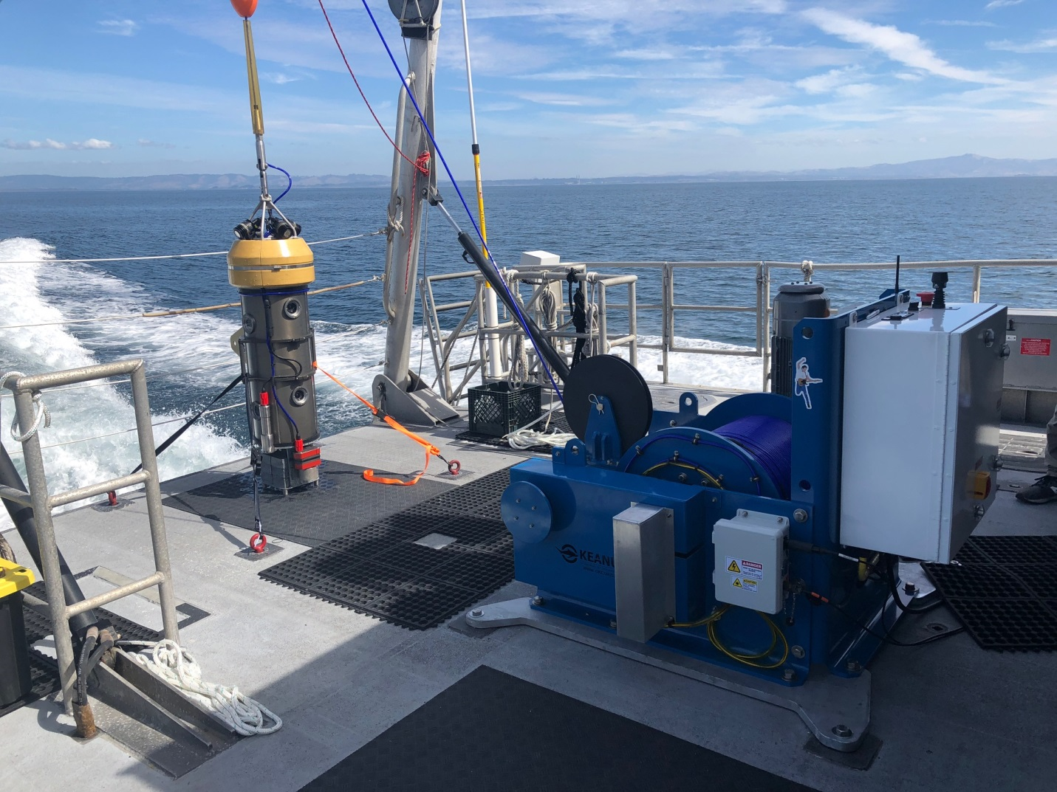
The lander and winch of the BOSS onboard the R/V Fulmar in October of 2018.

Since June, the build of the BOSS has been completed. Integration testing in our test tank was accomplished prior to its deployment in late September. The BOSS was deployed on the R/V Fulmar for the entire month of October (above) and is being operated by Rick Starr of MLML and Mary Gleason of TNC. The streamlined system allows for rapid launch and recovery which allows for a greater number of sampled sites per day. In its first two weeks, the BOSS has surveyed untrawlable habitats in 26 NMFS trawl blocks and over 275 sets of 360 degree stereoscopic video have been collected. All nine high definition video streams are viewed in real time aboard the ship; this gives the scientists immediate feedback on fish populations. All nine video streams can also be recorded simultaneously by the integrated deck recorder.

