Benthic Observation System (PM: Chad Kecy)

The Benthic Observation System was designed based on a desire by multiple research groups, both internal and external to MBARI, for a platform which could combine video imagery in parallel with a wide range of contextual sensors. While there was great interest in such a platform, the widely divergent requirements across the research groups presented a huge design challenge. A comprehensive design review was held last Spring which compared and contrasted these various requirements. The results of the review led to two major paths, a tethered version and an autonomous version. Based on the immediate needs of The Nature Conservancy (TNC), the initial thrust was the design of a tethered version. While TNC eventually requires stereoscopic video simultaneously in 360 degrees, our initial effort, based on the limited time frame, was focused on a two-camera prototype. This prototype, named the Benthic Observation System (BOS) was completed in August and made its first at-sea engineering tests onboard the R/V John H Martin in September. Accompanying the MBARI engineers on these two test cruises were collaborators from The Nature Conservancy (TNC), Moss Landing Marine Labs (MLML), and Marine Applied Research, and Exploration (MARE). The tests proved successful, with only minor changes needing to be made. The BOS will take part in the National Marine Fisheries Untrawlable Habitat Experiment at Footprint site in the Channel Islands in mid-October.

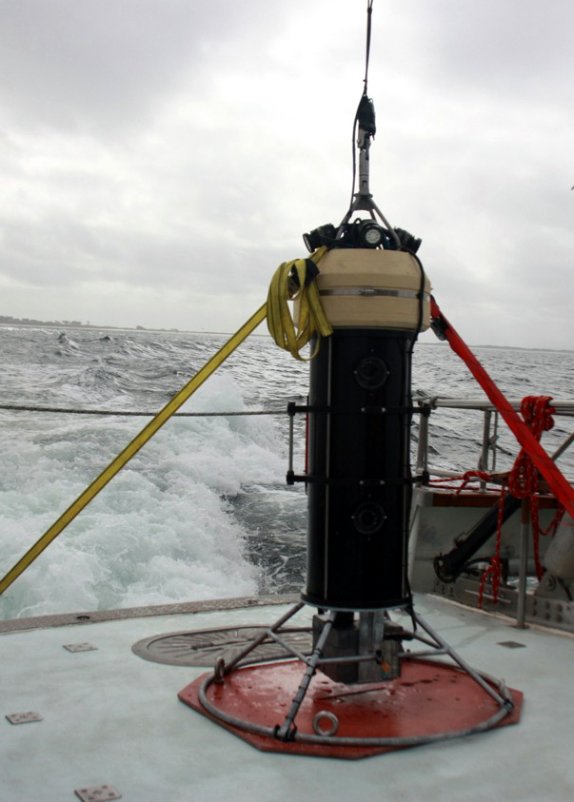
Benthic Observation System (BOS) during initial engineering tests onboard the R/V John H Martin in September 2017.

