Project Summary: Improving stock assessments of rebuilding species in untrawlable habitat by using visual surveys to complement NMFS trawl surveys
PIs:
Dr. Mary Gleason, Lead Scientist  California Oceans Program  The Nature Conservancy  99 Pacific St., Suite 200G  Monterey CA 93940  (831) 333-2049  mgleason@tnc.org | Dr. Rick Starr, Research Faculty  San Jose State University  Moss Landing Marine Laboratories  8272 Moss Landing Road  Moss Landing, CA 95039  (831) 771-4442  Starr@mlml.calstate.edu

Introduction:
The primary fishery-independent data set for monitoring groundfish stocks is the annual West Coast Groundfish Bottom Trawl Survey, which is conducted by NMFS almost exclusively on low-relief soft-bottom habitats, and thus provides little information about the rebuilding rockfish species that inhabit high-relief, untrawlable habitats. In the absence of information about density of fishes in all habitats, the current assumption is that the annual trawl surveys will catch some consistent proportion of rebuilding species that move off the rocky habitats and into trawlable areas, and that the proportion of rebuilding species caught in trawl tows will be representative of the relative abundance in untrawlable habitats. Several NMFS researchers have suggested that this assumption may not be true if there are density-dependent processes driving the relative abundance of a given species across optimal (e.g., high relief) versus suboptimal (e.g., low relief or soft-bottom) habitats.

We are conducting a collaborative project that brings together the fishing industry, NGOs, state and federal agencies, and academia to provide information about the distribution, density, and size structure of demersal fishes, including rebuilding species, in untrawlable (high relief) habitat as a complement to the existing NMFS West Coast groundfish trawl survey. We plan to demonstrate how video surveys in the untrawlable portions of NMFS Groundfish Survey blocks can be used to improve stock assessments. We are working with NMFS Fishery Resource Analysis and Monitoring Division (FRAM) scientists to compare frequency of occurrence, density, length-frequency distributions, and calculated biomass of rebuilding species from their trawl surveys and from our video surveys in the same sites across a broad geographic study area in central California. Our working hypothesis is that video surveys conducted in a statistically sound manner can provide information to improve stock assessments of species that primarily inhabit untrawlable rocky areas. In 2018, we plan to conduct test video surveys in the untrawlable portions of NMFS Groundfish Trawl Survey blocks in central California and develop techniques to use the information we generate to improve stock assessments.

The overall project goals are to:
1) Improve fishery-independent data collection in untrawlable habitats that are not adequately covered in the annual West Coast Groundfish Bottom Trawl Survey, and
2) Develop ways to use video surveys in stock assessments, with the ultimate goal of improving our knowledge of the status of rebuilding stocks that constrain fishing opportunities.

Background
From 2012–2015, we conducted >900 video surveys in a pilot project using a prototype stereo video lander (designed and built by Marine Applied Research and Exploration) to gather information about the density and size composition of fishes in rocky habitats in Central California (Fig. 1). Video files collected on each cruise were analyzed using SeaGIS ltd. (www.seagis.com.au) stereo-video software (EventMeasure), which enables us to measure lengths of fishes observed to within 2% of total lengths. Data collected from each video included geographic coordinates, starting and ending times, fish counts, and species and habitats observed.
We identified all fish to the lowest possible taxonomic level and recorded the maximum number of individuals (Max N) of each species present in the field of view. Also, we measured the lengths of observed fishes. All fish whose head and tail were clearly visible simultaneously in both cameras were measured using the EventMeasure software. The stereo-video software enabled us to measure the distance that fish targets were observed, thus enabling us to calculate densities of each species in each survey (Fig 2). Also, habitat characteristics within a single 360° sweep from each drop were described and recorded. Habitat classifications included sediment grain size, relief, rugosity, and biogenic cover of common macro-invertebrates, and fish-habitat associations were determined from the frequency of occurrence in each habitat category.

While these video surveys demonstrated proof-of-concept for use of a drop camera system to collect data on demersal fishes, the prototype stereo video lander with a rotating plate with two stereo cameras had limitations in terms of speed of deployment and bottom-time required.

In 2016-2017, we worked in close collaboration with MBARI who designed a new 8-camera stereo video lander called the Benthic Observation System (BOS) that aimed to meet the scientific data requirements and to address the operational limitations to enable the platform to deployed more quickly across larger spatial scales. The BOS is designed to have four pairs of vertically oriented stereo cameras and to be deployed for a short amount of time (<5 minutes) per location. A two-camera prototype was built and tested in 2017……

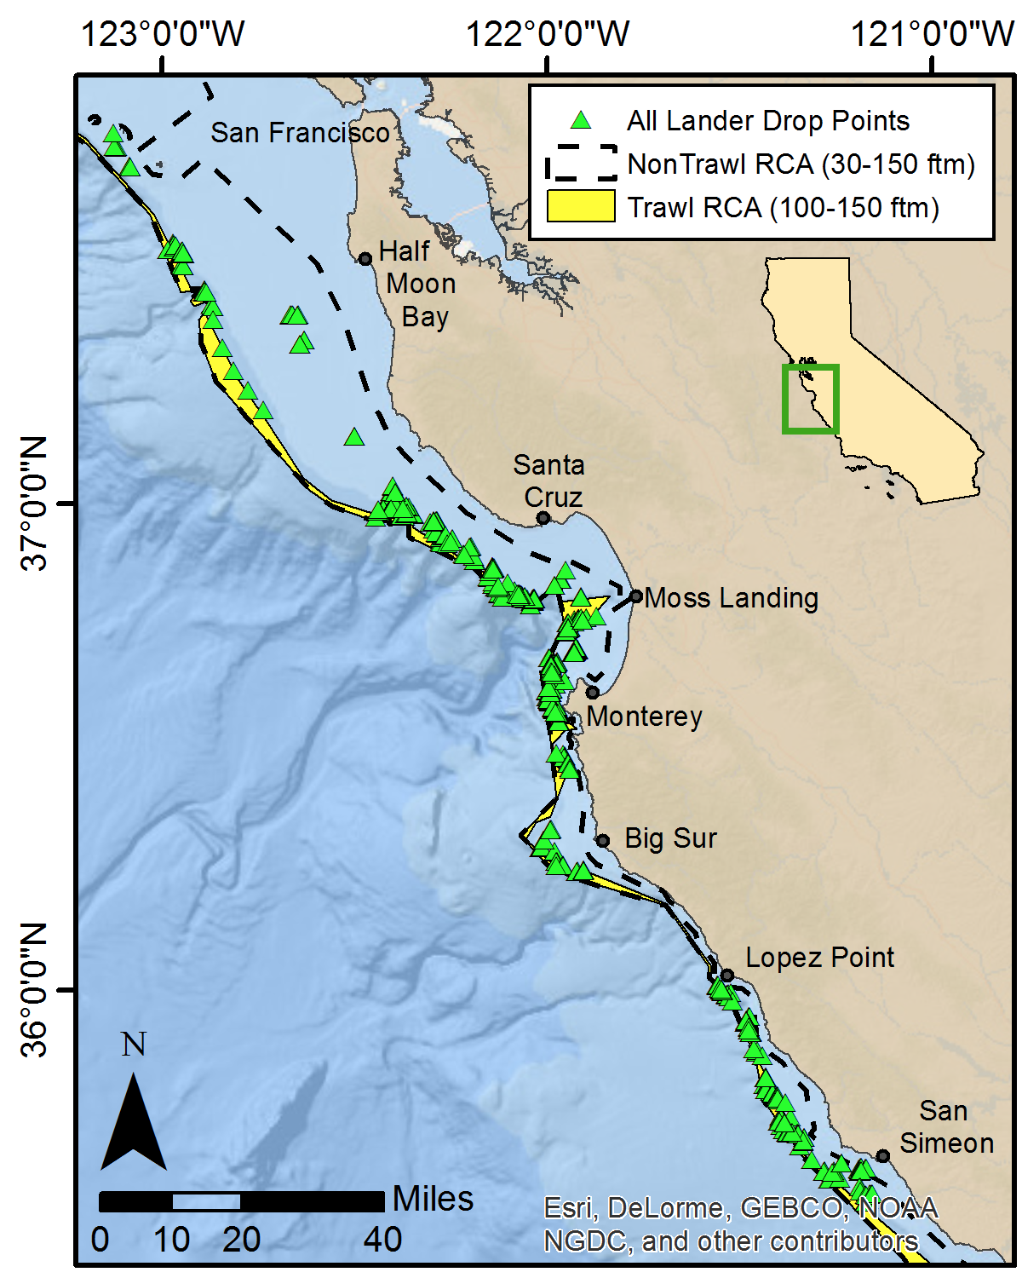

Fig 1. Map of locations of video surveys in central California from 2012-2015.

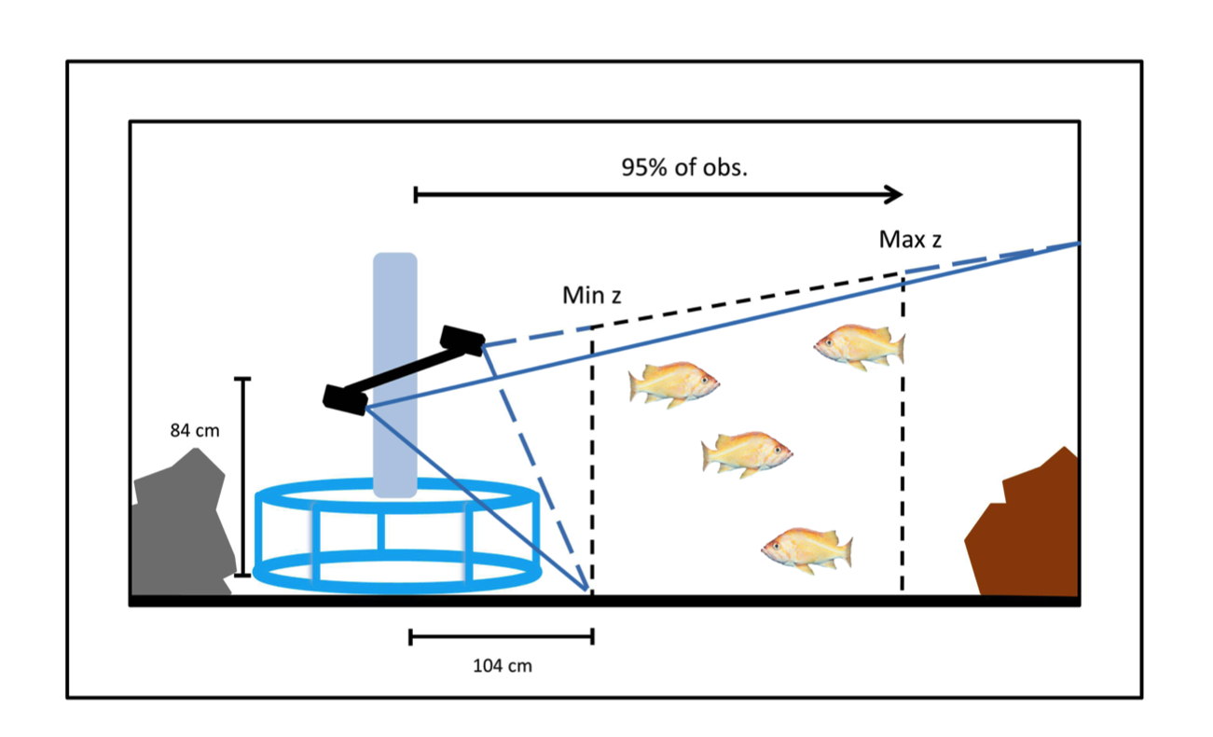
Fig 2. Schematic of area surveyed by stereo-video cameras.

Proposed Work in 2018

We plan to use the BOS video lander to survey large areas of the coast in collaboration with FRAM, beginning in June 2018. For these surveys, once untrawlable habitat has been identified in the survey blocks, we will distribute video surveys across the range of untrawlable habitat in NMFS survey cells that fall between 50–300 m deep. We will deploy the BOS lander, which is designed to provide a circular “Point Count”, into rocky habitats. We will record video from the camera for up to 5 minutes in one spot, then will pick the lander up 50 m off the bottom and move to another sampling site, which is at least 50 m away. If the sample cell has large areas of untrawlable habitat, we will retrieve the camera and move to another area of the cell. We expect to collect about 20 samples of video in each grid cell. After a grid cell is complete, the survey vessel will move to the next randomly chosen grid cell and repeat the operations. At the end of the day, video will be downloaded from the cameras and backed up to hard drives.

As with the prior MARE lander, data collection will include the identification of all fish to the lowest possible taxonomic level and recording the maximum number of individuals (Max N) of each species present in the field of view. We will measure the lengths of observed fishes whose head and tail are clearly visible simultaneously in both cameras, using SeaGIS EventMeasure software that has been modified to deal with video streams from vertically-oriented stereo pairs. The stereo-video software enables us to measure the distance that fish targets were observed, thus enabling us to calculate densities of each species in each survey. Habitat characteristics within each of four camera views from each drop will be described and recorded. Habitat classifications include sediment grain size, relief, rugosity, and biogenic cover of common macro-invertebrates. Fish-habitat associations will be determined from their frequency of occurrence in each habitat category.

We plan to conduct 20 days of video surveys in untrawlable habitats between June - December 2018. The NMFS trawl survey in Central California occurs in two passes, typically in mid-late June and again in Sept-October timeframe. After sampling is complete, we will work with NMFS scientists to compare frequency of occurrence, density and abundance, length frequency distributions, and calculated biomass of rebuilding species and priority species from trawl surveys and from video surveys in selected NMFS sampling blocks in central California. Also, we will work with NMFS stock assessment scientists to develop ways to incorporate the video surveys into a stock assessment. The result should be an improved understanding of the distribution and relative abundance of rebuilding species and other priority species in a variety of untrawlable habitats. In addition, we will assess the time and resources needed to conduct the visual survey and post-processing of data to better understand the scalability of this approach.

Project timeline

January 2017-December 2017 (Year 1):
- Design, build, and test version 1 of BOS video lander
- Work with NMFS stock assessment scientists to design sampling plan
- Participate in NMFS untrawlable habitat initiative to identify selectivity of video lander
January 2018-June 2018:
- Collaborate w/ MBARI to design and build version 2 of BOS video lander
- Test BOS v. 2 at sea [probably need $$ and use of John Martin for this?]

June 2018-December 2018: [funded by NOAA SK grant]
- Conduct video lander surveys in untrawlable locations in the Monterey management area off a contracted research or fishing vessel
- Collect and compile data from video surveys of high-relief habitats

