KFA Tether Replacement Estimate
Chad Kecy
07-31-2017

Tether Description
The Kelp Forest Array (KFA) tether supplies power and communication to both the KFA node and MBARI’s FOCE experiment. It is a custom built armored cable from South Bay Cable Corp and is 300 meters in length. The tether consists of five 14AWG copper wires and eight 50/125 multimode fibers. Two conductors are dedicated for power to the KFA, two are dedicated for power to FOCE, and the remaining conductor supplies a seawater return for ground fault detection. Both the KFA and FOCE use two fibers each for duplex communication. The remaining four fibers are reserved as spares.

Tether Deployment
The tether originates in a pumphouse located at The Hopkins Marine Station (HMS). The KFA and FOCE have identical, but separate, power delivery systems, ground fault detection systems, and networking gear. The tether is run out of the pumphouse via conduit located on the floor. An underground channel was dug several years ago to allow the tether to connect from the pumphouse to a larger underground drainage ditch. This larger drainage ditch goes under the road to the beach. Here the tether is exposed near the rocks before being buried on the beach heading out to the ocean.

Underwater Connections
The tether is permanently potted to the KFA Micronode. The Micronode contains two optical-to-electrical (OE) converters which then provide Gigabit Ethernet to both the KFA and FOCE output connections. The Micronode has two 30-meter cables attached to allow either the KFA Central Node or FOCE node to be brought to the surface without disturbing the tether/Micronode.

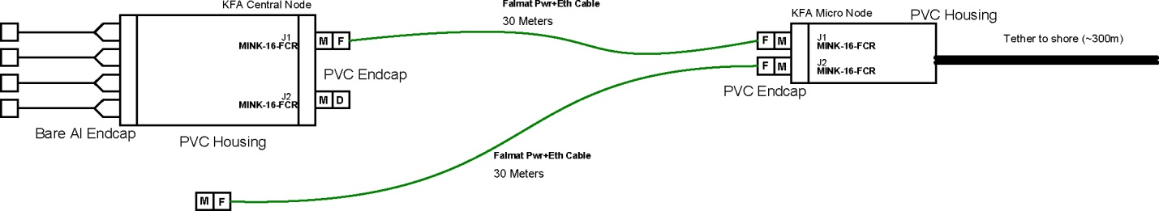
Figure One: Underwater connections of the KFA tether

Potential Replacement
If the decision to withdraw support for the KFA goes through, a subsequent decision on which pieces of gear to remove needs to be made. The system was designed to allow the two primary nodes to be removed without the need to move the supporting infrastructure (tether + Micronode).
If the tether and Micronode were to be recovered, any future FOCE work by MBARI would require the replication and deployment of a new (and nearly identical) tether and Micronode. There are three major considerations with respect to deploying a new tether: 1. Permitting issues, 2. The costs (both material and labor) of gathering and building the tether, and 3. The actual deployment of the new tether.

Permits
We are currently working from an existing permit, which is renewed on a year-to-year basis. Deploying a new tether would require a new round of permitting approval which could be a lengthy process.

Financial Costs

Tether, 300m | 1 | $34,000 | $34,000
OE Converter | 2 | $400 | $800
SeaConn Connector | 2 | $500 | $1,000
PVC Material | 1 | $200 | $200
Fiber Patch Cords | 2 | $100 | $200
Potting Compound | 1 | $300 | $300
Asstd Mech | 1 | $250 | $250
Asstd Elec | 1 | $250 | $250
 |  |  | $0
 |  | Total | $37,000

Table One: Estimated cost of parts needed for a new tether

 | Build | Test | Deploy | Totals
Electrical Engineer | 40 | 40 | 40 | 120
Mechanical Engineer | 40 |  | 40 | 80
E-Tech | 80 | 20 | 20 | 120
M-Tech | 80 | 20 | 20 | 120
Research Tech |  |  | 40 | 40
Diver |  |  | 40 | 40
Paragon Pilot |  |  | 40 | 40
Totals | 240 | 80 | 240 | 560
Table Two: Estimated labor needed for a new tether

Physical Deployment
The initial deployment of the KFA tether required the use of a flat-bed truck, the R/V Paragon and 6-8 employees. The tether spool was placed on the flatbed and driven to the pumphouse. Approximately 30 meters of tether was snaked through the various drainage ditches and then through the conduit, and into the pumphouse. The other end was unspooled and brought to the deployment location by use of the Paragon. A trench was then dug on the beach to obscure the view of the tether from the public.

