shFOCE –enhSWtank ON/OFF Procedure 1/5/16
The system will provide ~4pH Sea Water when 15 psig CO2 gas is admitted to the tank. Other than the CO2 tanks, the whole system can be turned ON/OFF with the electrical switches shown below. No water control valves need to be opened or closed for normal operation. This assumes a few presets in NOTES below.
System is automated and will run unattended save watching CO2 usage and occasional monitoring.

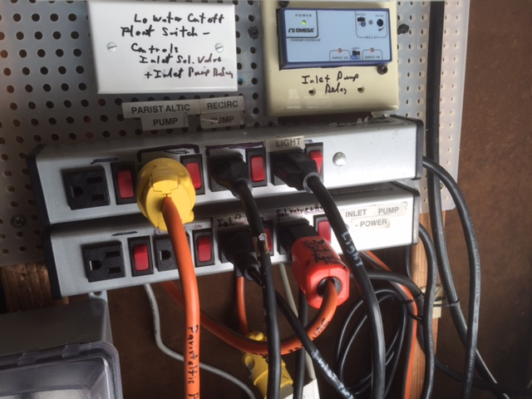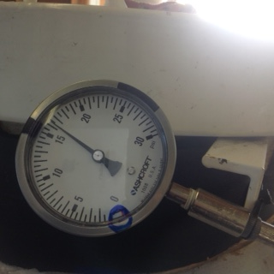

Basic ON/OFF Procedure: from Off condition
- Confirm water level is between or close to the pair of lines in middle of window on tank.
- Tank pressure (upper gauge) should be 14-16 psig.
- Hose Pr. gauge could be anywhere from less than 0 to ~28 psig. (image)
- (Confirm water supply line valves (2) open, Tank inlet valve open 1 Turn, Red hose valve open.)
- Turn ON Peristaltic Pump and Recirc. Pump, switch to right of each plug.
- Turn ON Inlet Pump and Valve/Relay power.
- (Light is optional, just to see inside the tank.)
NOTES:
To turn swFOCE system OFF, flip all switches off. Close valves on CO2 tanks. Water valves can be left open.
It is important the switches mentioned should all be on or all off. Sequence is not important.
The inlet pump will turn on if the water level is below the upper line and will turn off when level reaches the upper line.

P2
Flow into the large Red hose is controlled by the Peristaltic pump, usually 0.5 – 1 L/minute. ( 1 L/m is approx. mid span). If pump does not start, check switch is in the Counter Clockwise (currently) position (center is off). Speed Adj. is upper dial. Read center of float on right hand scale of Flow Meter.
The Red hose needs to attain ~28 psi before the BPRV (back pressure relief valve ) at the seaward end of the red hose opens fully. At that pressure, enhSW is being pumped out to the exp. Chamber. This pressure is attained usually within 30 minutes. However, it takes 6-8 hours for newly made-up water to get all the way out to the exp. Chamber.
The Peristaltic Pump has rollers which pinch the tubing shut when not running so it becomes an intrinsic valve which prevents flow when the pump is off. The tubing can last up to 2 months of continuous use.
When power is off, no flow in or out of the tank is possible, due to the solenoid valve and the peristaltic pump both being off, therefore no valves need be turned.
A power failure at the pumphouse will simply shut the system down, no flow will occur in or out. The SW system should return to normal on it’s own in just a few minutes. The slowest part being repressurizing the hose and restoring flow to the exp. Chamber.
POSSIBLE PROBLEMS:
An electrical fault will potentially turn one of the GFI protected plug strips off which would leave ½ the system running since there are 2 strips. This would need intervention to resolve but would not necessarily lead to leaks.
If tank has gone below the lowest line on sight window or empty, a low water cut-off float switch will have turned off the solenoid valve on the inlet pipe. This switch and valve limits the volume of a serious leak in the plumbing of the tank. The orange plug (solenoid valve/relay power) will need to be moved to a live outlet to bypass the low water float switch. When it has been plugged in, the valve will open allowing flow back into the tank, leave plugged in until water level is above the Low Water cut-off line, then the orange plug can be moved back to the black piggyback plug it was in originally. Tank should continue to fill. It will fill slowly if there is 15 psi in the tank.
If the tank is below 12 psi, water will flow in whether the inlet pump is running or not because the supply water pressure at Hopkins is ~12 psi. At 14 psi in the tank the flow basically stops. As the tank fills, the pressure will build if it is sealed.
If the level control fails in a way that keeps the inlet pump running, the water level in the tank will rise, building pressure as well. When that pressure gets to ~32 psi the flow will slow or stop because that equals the output pressure of the inlet pump (20 +the 12 psi supply pressure). An overpressure relief valve on the tank will vent gas/water outside at~40 psi.

