Shallow Water FOCE Valve Assembly
Hardware Interface Document, v0.3

Chad Kecy
Monterey Bay Aquarium Research Institute

October 23, 2014



Table of Contents
Overview 4
System Level Description 4
B&B 232SPDA Module 5
Hanbay MCM Valve and Actuator 7
Custom Signal Conditioning Board 7
Position Control Signals 7
Position Feedback Signals 7
Calibration 8
Valve Control and Feedback 8
Valve Position Control 8
Valve Position Feedback 8
Signal Conditioning Board Circuit Descriptions 10
Valve Position Control Circuit 10
Valve Position Feedback Circuit 10
2.5Vdc Reference Circuit 10
Power Supply Circuits 10
Appendices 11

Figure 1: Location of the Valve Assembly in swFOCE and the subsea tubing (shown in green). 4
Figure 2: Block diagram of the Valve Assembly 5
Figure 3: The B&B model 232SPDA Analog Module 6
Figure 4: Hanbay actuator and ball valve 7
Figure 5: Simplified diagram of the valve positioning hardware 8
Figure 6: Simplified diagram of the valve feedback hardware 9

Table 1: Model 232SPDA Commands 5
Table 2: Pinout of I/O connector on the 232SPDA 6
Table 3: Pinout of RS-232 connector on the 232SPDA 6

Appendix 1: Electrical Specifications 11
Appendix 2: Mechanical Specifications 11

Overview

The operation of the shallow water FOCE (swFOCE) experiment requires the experimental chamber to maintain a low pH level. To accomplish this, two ruggedized tubes run from the subsea chamber, back to shore, and into the pumphouse to the Enriched Seawater System (ESW). The ESW generates the low pH seawater by injecting a controlled amount of gaseous CO₂ into a large chamber. The low pH seawater is then pumped out to swFOCE when required.

The Valve Assembly is responsible for controlling the flow of CO₂ enriched seawater to the experimental swFOCE chamber. It is an oil-filled housing which is mounted directly onto the frame. Tubing from the subsea manual distribution manifold connects to the two electrically actuated ball valves. Depending on tidal conditions, the low pH seawater must be able to enter from either direction.

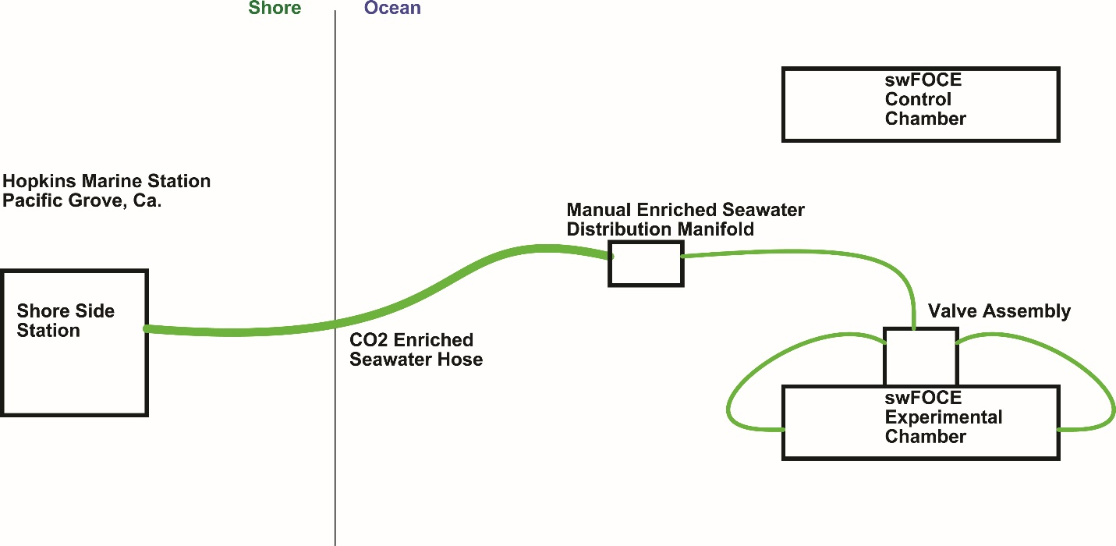
Figure 1: Location of the Valve Assembly in swFOCE and the subsea tubing (shown in green).

System Level Description

The Valve Assembly consists of two electrically actuated ball valves, a commercial analog module, and a custom signal conditioning circuit board. It interfaces to the Gateway Node via serial communication through a Sensor Node port. The Valve Assembly is an integral part of the closed loop control system; it is used to control the flow rate of low pH seawater into the experimental chamber. The low pH seawater enters the Valve Assembly and is routed to both of the ball valves. One controls flow to the forward end of the swFOCE chamber and the other controls flow to the aft end.

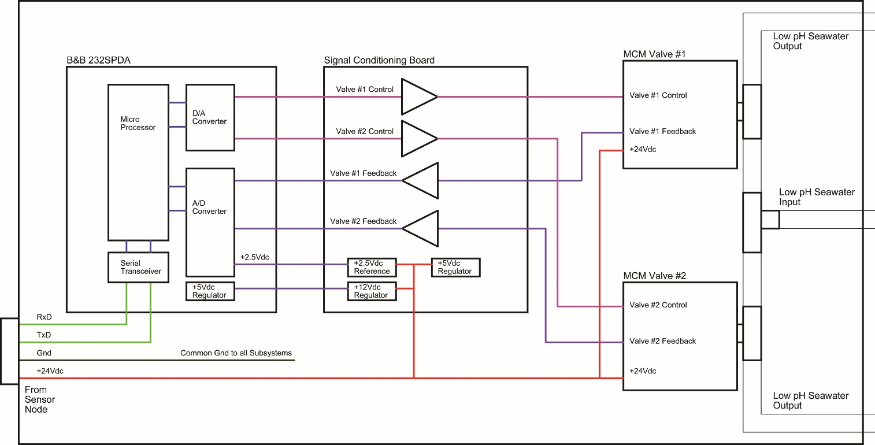
Figure 2: Block diagram of the Valve Assembly

B&B 232SPDA Module
The B&B Electronics model 232SPDA is a serial communication data acquisition and digital-to-analog conversion module. It is used to communicate valve control and feedback signals between the Gateway Node and the electrically actuated valves. The 232SPDA offers 7 channels of 12-bit A/D inputs, 4 channels of 8-but D/A outputs, 1 digital output, and 2 digital inputs. It offers auto baud rate detection, up to 9600, and operates with an input DC voltage of 12 to 18Vdc.

Only four commands are needed to control the 232SPDA: the read A/D command, read digital I/O command, set analog output command, and set digital output command.

Command | Function | Response
!0RA{#] | Read A/D Voltages | {ch#msb}{ch#lsb}{ch#-1mb}...{ch#0msb}{ch#0lsb}
!0RD | Read Digital I/O States | {I/O states}
!0SV{#}{#} | Set Analog Output Voltage | no response
!0SO{#} | Set Digital Output States | no response
Table 1: Model 232SPDA Commands

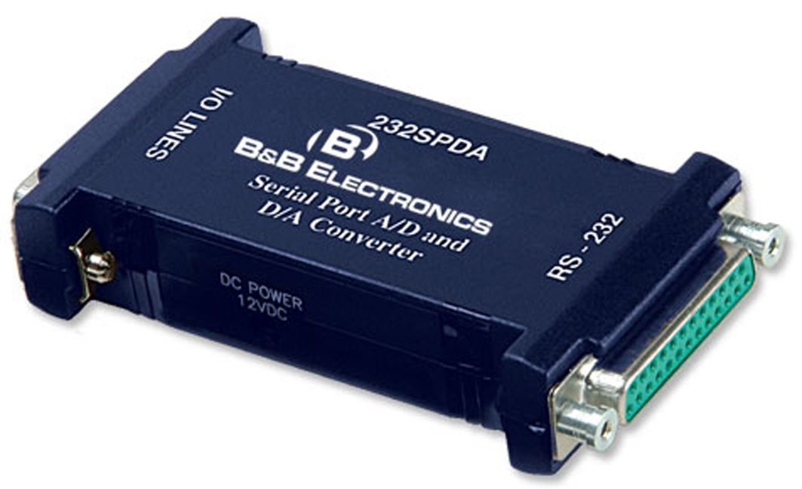
Figure 3: The B&B model 232SPDA Analog Module

Pin # | Function | Pin # | Function
1 | Gnd | 14 | D/A Ref #1
2 | +12Vdc Output | 15 | D/A Ref #2
3 | Digital Output #0 | 16 | D/A Ref #3
4 | Digital Input #0 | 17 | +5Vdc Output
5 | Digital Input #1 | 18 | A/D Ref Input Pos
6 | Digital Gnd | 19 | A/D Ref Input Neg
7 | Analog Gnd | 20 | No Connection
8 | A/D Input #0 | 21 | A/D Input #6
9 | A/D Input #1 | 22 | D/A Output #0
10 | A/D Input #2 | 23 | D/A Output #1
11 | A/D Input #3 | 24 | D/A Output #2
12 | A/D Input #4 | 25 | D/A Output #3
13 | A/D Input #5
Table 2: Pinout of I/O connector on the 232SPDA

Pin # | Function
2 | Transmit Data (TxD)
3 | Receive Data (RxD)
4 | Request to Send (RTS)
5 | Clear to Send (CTS)
6 | Data Set Ready (DSR)
7 | Signal Ground (SG)
8 | Data Carrier Detect (DCD)
20 | Data Terminal Ready (DTR)
Table 3: Pinout of RS-232 connector on the 232SPDA

Hanbay MCM Valve and Actuator
A pair of M series actuator and valve combinations is used to direct the low pH seawater to swFOCE chamber. The MCM actuators were selected for their torque ratings and multi-turn capability (8 turns). Analog voltages provide both position control and position feedback. They operate at 24Vdc and can draw a maximum of 3 amps in high torque situations.

The attached valves are ¼” stainless steel ball valves. The full 8 turns of the actuator brings the valve from a totally closed state to a totally open state.

The Hanbay Part Number is: MCM-000AF-1-SS-8P6T

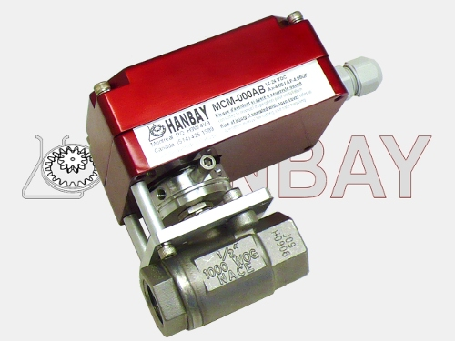
Figure 4: Hanbay actuator and ball valve

Custom Signal Conditioning Board
Because the voltage levels of the 232SPDA and MCM actuator do not perfectly overlap, a signal conditioning circuit board was developed. This board translates the positioning control and feedback signals in order to maximize the dynamic range of the 232SPDA. The circuit has two identical, independent channels to accommodate both of the valves in the Valve Assembly.

Position Control Signals
The 232SPDA’s 8-bit DAC is used to command the actuator to drive the valve to a specific position. The voltage output of the DAC is 0 to 4.4Vdc and the control signal input on the MCM actuator is 1 to 5Vdc. A voltage level shifting circuit translates the 232SPDA output to the MCM actuator’s input range.

Position Feedback Signals
The 232SPDA’s 12-bit ADC is used to read the feedback from the MCM actuator, indicating the position of the attached ball valve. The output of the MCM actuator is a 4-20ma current signal; the signal conditioning board converts this into a 1 to 5Vdc signal.

Calibration
The signal conditioning board has a fixed +2.5Vdc output which can be used to calibrate the A/D converter on the 232SPDA.

Valve Control and Feedback
This section covers the details of the software and hardware values concerning the control and feedback of the two ball valves.

Pin # | Function | Signal | Range
3 | Digital Output #0 | No Connect | N/A
4 | Digital Input #0 | Tied to Ground | N/A
5 | Digital Input #1 | Tied to Ground | N/A
8 | A/D Input #0 | VALVE_1_CNTL_VOLT | 0 to 5.0Vdc
9 | A/D Input #1 | VALVE_2_CNTL_VOLT | 0 to 5.0Vdc
10 | A/D Input #2 | VALVE_1_FDBK_VOLT | 0 to 5.0Vdc
11 | A/D Input #3 | VALVE_2_FDBK_VOLT | 0 to 5.0Vdc
12 | A/D Input #4 | 2.5Vdc_REF | 0 to 5.0Vdc
13 | A/D Input #5 | Tied to Ground | 0 to 5.0Vdc
21 | A/D Input #6 | Tied to Ground | 0 to 5.0Vdc
22 | D/A Output #0 | VALVE_1_CNTL_VOLT | 0 to 4.4Vdc
23 | D/A Output #1 | VALVE_2_CNTL_VOLT | 0 to 4.4Vdc
24 | D/A Output #2 | No Connect | 0 to 4.4Vdc
25 | D/A Output #3 | No Connect | 0 to 4.4Vdc
Table 4: Pin assignments for the SPDA

Valve Position Control
The ball valve goes from fully open to fully closed over a 90 degree span; this can also be thought of as 0% open to 100% open. In either case, the 8-bit DAC gives 256 discrete valve position locations over that span.

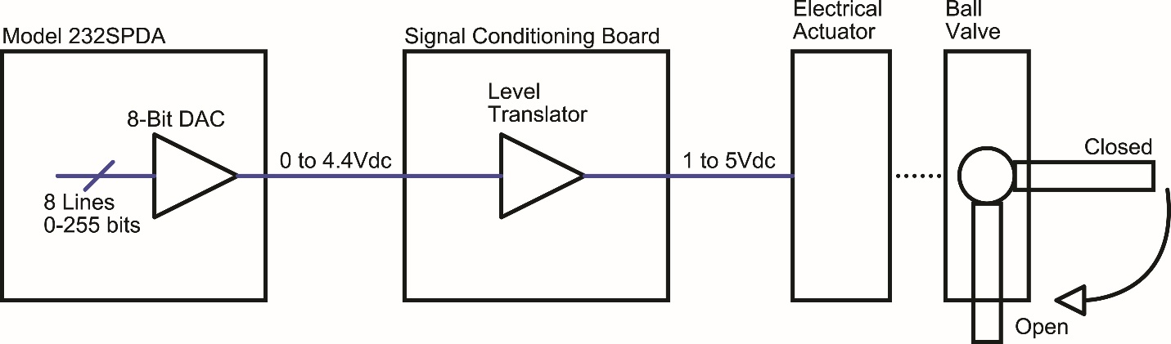
Figure 5: Simplified diagram of the valve positioning hardware

With the DAC set to 0, the valve will fully closed; when set to 255, the valve will be fully open. To calculate the percentage open in between, use the following algorithm:

% Open = Round ( DAC Value * 0.390625)

For example, programming the DAC to a value of 168 gives:

% Open = Round (168 * 0.390625)
% Open = Round (65.625)
% Open = 66%

Conversely, calculating the DAC value for a requested valve position is found by:

DAC Value = Round (% Open * 2.56)

For Example, requesting the valve to be 30% Open gives:

DAC Value = Round (30 * 2.56)
DAC Value = Round (76.8)
DAC Value = 77

Valve Position Feedback
The ball valve goes from fully open to fully closed over a 90 degree span; this can also be thought of as 0% open to 100% open. In either case, the 12-bit ADC reads 4096 discrete valve position locations over that span.

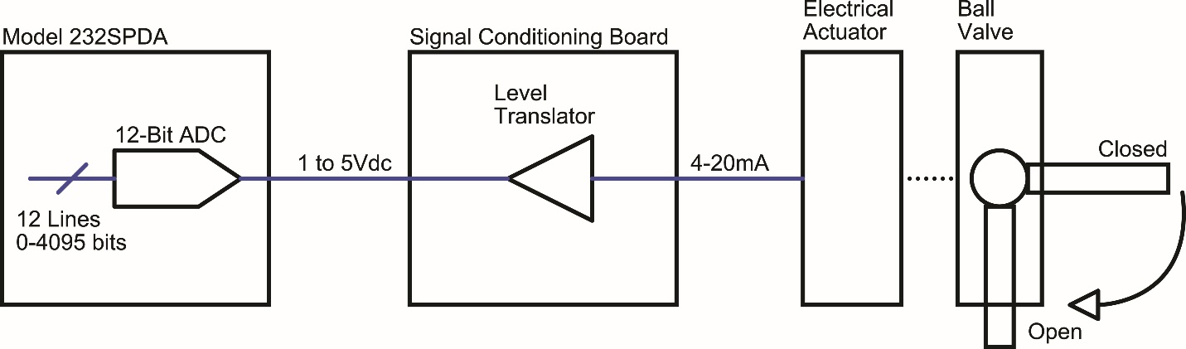
Figure 6: Simplified diagram of the valve feedback hardware

With the ADC reading 0, the valve will be fully closed; when reading 4095, the valve will be fully open. To calculate the percentage in between, use the following algorithm:

% Open = Round ((ADC Value * 0.0305) – 25)

For example, if the ADC is reading 3104 bits,

% Open = Round ((3104 * 0.0244) – 25)
% Open = Round (69.672)
% Open = 70%

Signal Conditioning Board Circuit Descriptions
The following section gives brief descriptions of the signal conditioning board in the event of a failure and troubleshooting is required. Note that for the control and feedback circuits, there are two identical circuits, one for each valve.

Valve Position Control Circuit
The output of the 232SPDA DAC is a 0 to 4.4Vdc signal. In order to scale this signal to the required 1 to 5Vdc level, a two-stage level translation circuit was designed. The input DAC signal is first scaled to 0 to 4.0Vdc by R1/R3/U1A. This can be verified by measuring the signal at U1-1.

The 0 to 4Vdc signal is then sent to an adder circuit. R7/R8/U3A produce a 1.0Vdc signal, derived from the onboard 5V regulator. R2/R4/R5/R6/U2A constitutes a gain of 1 adder circuit. This produces the desired 1 to 5Vdc signal which is sent to electrically actuated valve input.

Valve Position Feedback Circuit
The feedback output of the electrically actuated valve is a 4-20ma signal. 4ma corresponds to a fully closed position and 20ma indicates the valve is fully open. D2/R18/U8A converts the 4-20ma signal into a 1 to 5Vdc signal. The range of the 232SPDA ADC is 0 to 5Vdc.

2.5Vdc Reference Circuit
A +2.5Vdc reference signal is generated in the event calibration of the ADC’s is required. R19/R20/U9A split the 5Vdc rail in two and presents it to the 232SPDA ADC.

Power Supply Circuits
The signal conditioning board has two onboard regulators: a 5Vdc regulator for the onboard op amps and a 12Vdc regulator to drive the 232SPDA module. The input to the signal conditioning board is 24Vdc.

U10 is a fixed 5 volt output, 100ma LDO linear regulator. LED D3 gives an indication that 5V is being generated. D3 can be disabled by removing the zero ohm resistor R21.

U11 is fixed 12 volt output, 500ma LDO linear regulator. It is used solely to power the model 232SPDA analog module.

Appendices

Appendix 1: Electrical Specifications
Input Voltage | 24Vdc
Nominal Current | 12ma
Power Usage | 300mW

Appendix 2: Mechanical Specifications
Length | 2.75 in
Width | 2.25 in
Height | 0.5 in
Operating Temperature
Min | 32 degF
Max | 70 degF
Operating Depth | 300m

