Bladder Xtube mod. 1/11/18
X:\900739.LRAUV\Project.Documents\Operations\Operations Manual\Sub-Assembly Docs
Improve movement/equalization of oil to both sides of external bladder.
24” ¼” parflex tubing
1/8” drill
.138” drill
Heat gun

PROCEDURE—
Drill 4-5 x 1/8” holes perpendicular to the plane of the U shape, both ends, this helps prevent the holes from being blocked by the rubber sides of the bladder.
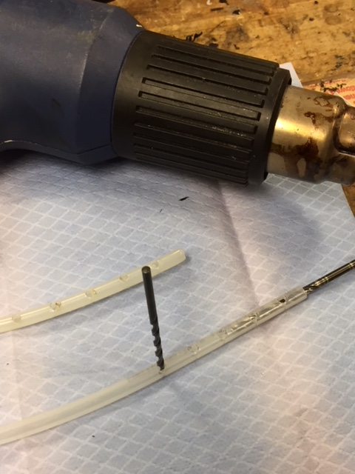

Cut or sand off drill shavings on outside of tube, these must be removed to keep oil clear
Likewise, run the 0.138” drill inside to remove shavings, blow clear
Use the heat gun to shrivel any remnants,
Rerun both drills, repeat heat gun
Inspect,
if clear, OK to install

