LRAUV CS (fin) ACTUATORS- 3/13/18
A-200711-10 Jim Scholfield
900739\LRAUV\PROJ DOCS\OPERATIONS\OPER MANUALS\SUB ASS’Y
These are complex assemblies taking some time and experience to properly assemble.
Have on hand—
Blue Loctite (releasable) for small fasteners
Full sets of metric and US allen keys including .050” and 1.3 mm
Short 1.5mm allen, 1-2” leg
Small vice, snap ring pliers, small needle nose pliers
Small tools such as screwdrivers, jewelers files,
7/16 nut driver (to set bearings and snap rings)
The 5start Acme nut needs to have the 3 screw holes countersunk to accommodate the 6-32 flat head screws
The 4-6mm Helical coupling needs the 6mm bore drilled to 0.55” deep, use a .238” drill
Potentiometer Cal Tool – P-201685-14
DVM
ASSEMBLY--
1. Wire the Impulse Bulkhead connector and assemble to the Strongback
2. Start at motor end - Attach motor mount plate, then the 3-4mm coupling
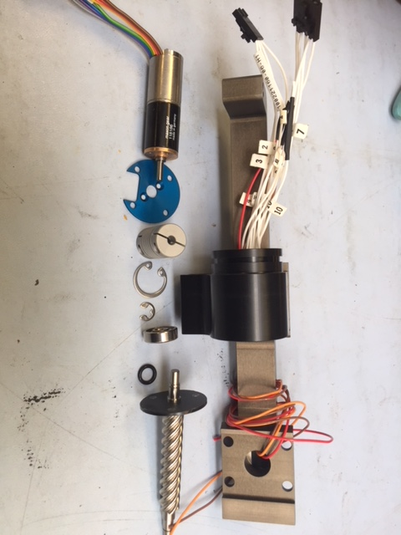

3. Now test fit bearings to the leadscrew. Since this is a very tight tolerance fit, the bearing may or may not slide on with finger pressure. Check both ends. It should slide on with slight resistance, if it does not-the following procedure is required—I found this worked well--
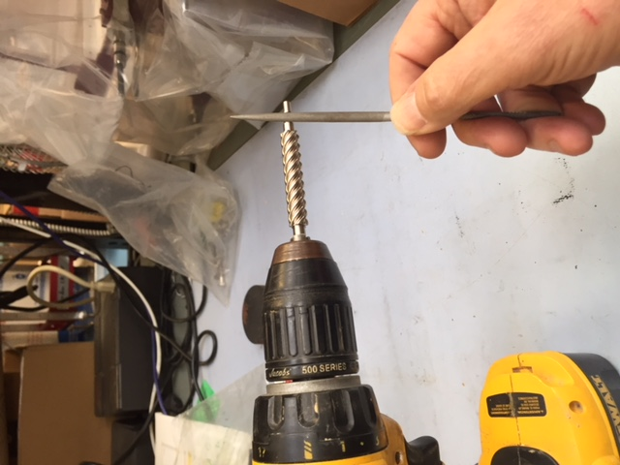
With the drill spinning moderately, take a few passes across the entire bearing area with a fine flat jewelers file, check to see if bearing slides on, repeat as necessary, only taking a few passes each time.

4. Insert the 2-010 oring into the Motor Body, place the oring cap on the lead screw, dab of oring grease on the oring. Hold the lead screw in a soft jawed vice.
5. insert the lead screw into the motor body, slide the bearing down all the way into space at bottom of motor body, 7/16 nut driver. Using a small then a medium screwdriver, patiently place the 6 mm shaft snap ring into position. This groove is not visible at this point so placing snap ring on the bearing and coaxing into position is required.
6. Now the 16 mm snap ring can be placed into its groove. NOTE: Deep inside the Motor Body is a reduced diameter area where the bearing resides. This has left a step which might be difficult to slide the 16mm ring by to properly get to the groove it is supposed to clip into. Avery long reach circlip plier of a very long reach thin nosed plier can be used to place the the circlip deep down past the step and it can be easily inserted then.
7. The motor/coupling ass’y can now be slid into the motor body. The access to the 1.5mm allen screw is thru the bottom of the motor body. The coupling will have to be turned manually, trial and error, to align with the access hole. Use a short allen with a 1-2” reach to tighten this coupling. Longer allens twist and may not provide sufficient torque. Image shows a long reach.
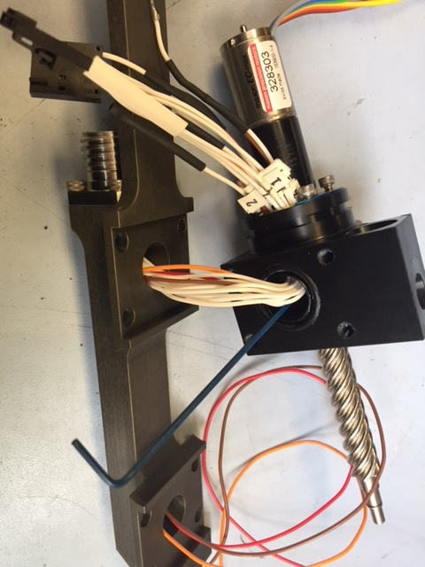

8. Place 2-013 ( bumper) on the leadscrew. Assemble the 2 parts of the nut- install pins,
Place on leadscrew, Place 2nd 2-013 oring.
9. Assemble 2-010 and cap on Enclosure Body. Dab of oring grease. Place 2-016 oring on bottom of Enclosure body, thread wires thru.
10. Slide enclosure body onto Lead Screw, Slide Bearing into position, (nut driver). Coax 6mm snap ring into position as before.
11. fix Encoder Torque plate into position with the potentiometer wires thru one of the smaller slots, using the mount washer and nut.
12. Attach coupler to Potentiometer. Pre -align with 250 ohms showing across pins 3-2 or 2-1 and tightening screws on the coupler prepositioned to be accessed thru the top hole in the Encoder body. This becomes a good starting point for final calibration.

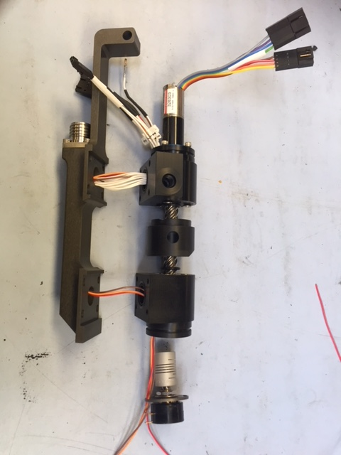
Ready for final assembly and calibrating potentiometer
13. At motor end, Bend wires carefully so connectors lay flat against motor body. Snug down with small tiewrap.
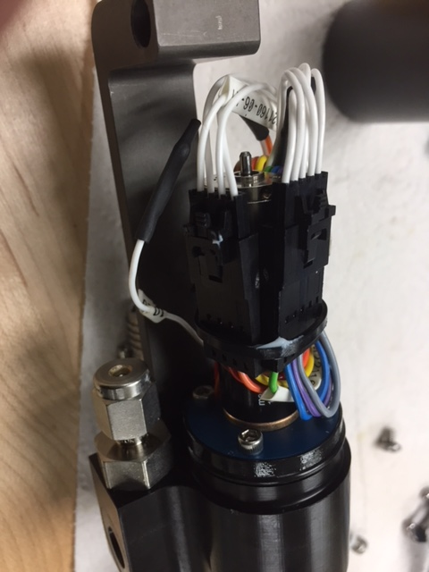

13. Assemble with 8- 8-32 screws with plastic washers to the backbone, mind the wires do not get kinked or nicked and orings are properly positioned.
14. NOTE: Motor cover should have been in place at this point.
Using the Pot. Cal Tool, manually run the nut up till properly positioned(centered), Check that position of the 4-6 coupler can be accessed by a short leg 1.5mm allen key thru the hole. Slide the potentiometer/coupler into the encoder body. Using the Dvm, adjust the position of the pot. so 250 ohms is displayed. Tighten both the coupler and the pot torque plate at this position. (The coupler to pot. connection may have to be repositioned to finally accomplish this step.) This procedure is important for proper fin alignment.
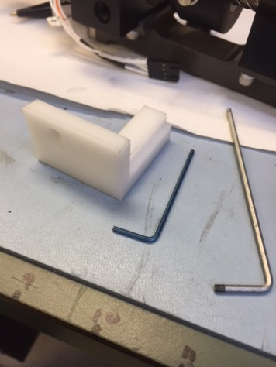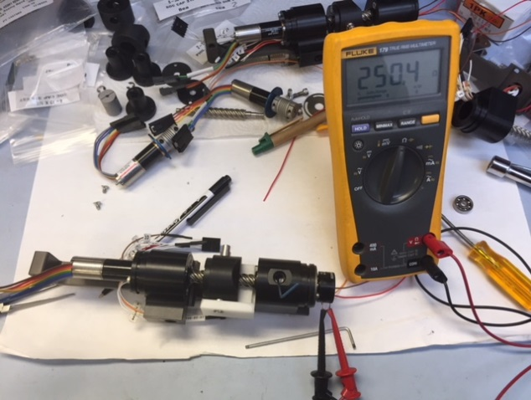
15. Make sure a 260 ohm resistor is on leg 3 of the potentiometer, and wires properly soldered
16. Use a sharp wire clipper to take a small chip out of the sides of the potentiometer to allow air to escape during oil fill.
17. Add pot. cover, complete final assy.
18. Have unit electronically/ functionally checked out BEFORE Oil fill.
19. Oil fill slowly with unit tipped to help air escape.
20. Final step is to degas as below, trimmed micropipettes stuck into vent screw ports. Helps get a little more air out. Try for -15” Hg.

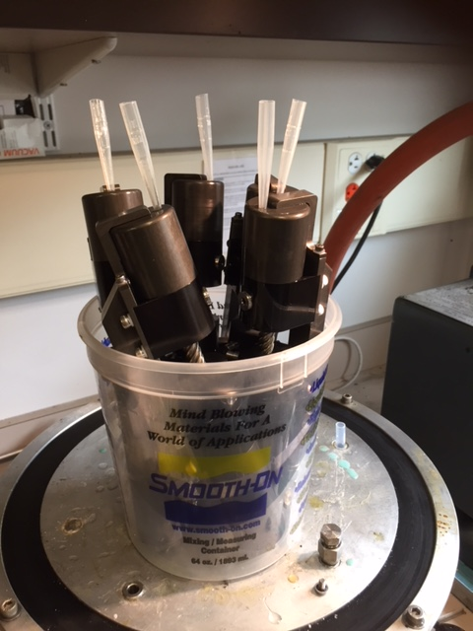

21. Bench check system by plugging into PCIX comps for a few days, leak check.
22. Ready to install.

