LRAUV VB SYSTEM ASS’Y –NOTES 3/7/18
Ref: A-201330-12-VB Sys MIVEGAS .pdf and Res-Pump Tube- Build 5.PDF
See Notes on last page of A-201330.
In addition – Part 7 is changed to SS-400-3TST. This makes this connection short enough to fit the VB system into the internal framework.
Tube 9 will need to be ~1.34” long.
Tube 11 as suggested.
The new part – Positionable T with an SAE 4, fits closely to the end bell and needs to be modified as shown to get one additional turn into the endbell. Remove a small portion of the branch lip on the side closest to the SAE4 connection. Sealing of the SAE4 connection may not occur unless this mod is done.

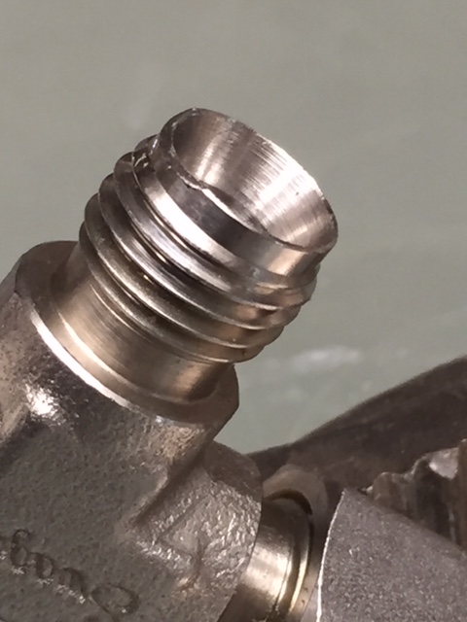

Tube 13 –See Res-Pump Tube- Build 5.PDF, because of an interference fit of the VB barrel plus tube into the rear End Bell Thruster Mount Cylinder, Tube 13 has to be carefully bent and fitted, then flattened slightly as shown. Flattening tube to ~.22 works very well.
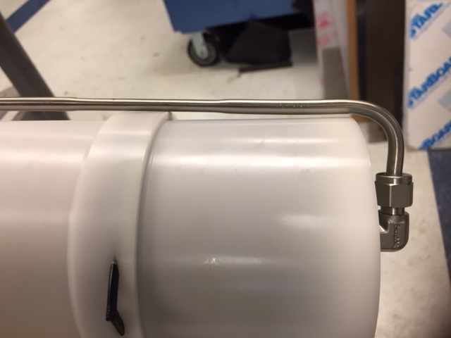

Be sure the torpedo locks are not interfering as well. As shown.
