LRAUV bleed procedure

Things needed:

- oil container with pump and tube with fitting
- 3 port valve that can switch between 1-2 and 2-3
- vacuum pump
- air-tight glass vessel with two ports
- tubes with fittings (we use swagelock 1/4 for everything)

Setup:

- connect oil container hose to port 1 of 3-way valve
- connect one port of glass vessel to vacuum pump
- connect other port of glass vessel to port 3 of 3-way valve
- connect port 2 of 3-way valve to vehicle bladder top tube
(see picture)

The idea is that oil can be dispensed into VB system when valve is set up one way and air can be pulled into vacuum vessel when valve is the other way without introducing air.

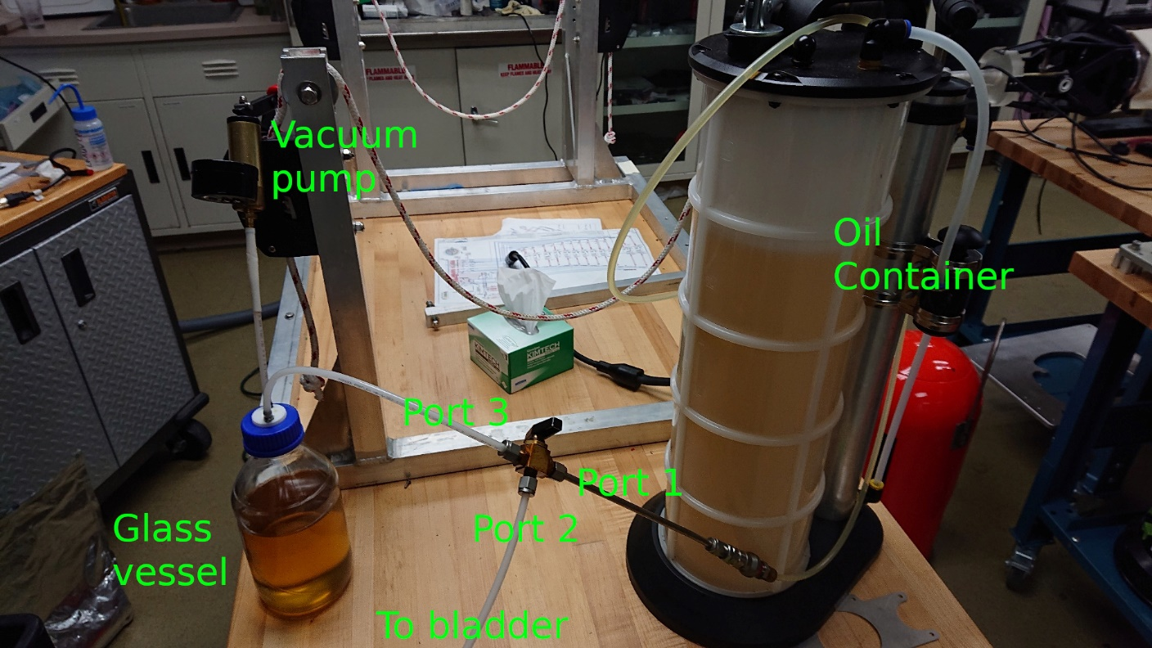

Procedure:

1 bleed internal comp
(note that comp can never be completely bled so do the best you can, assumption here is vehicle buoyancy position is at default [around 950cc])

- fill some oil into the bladder, enough so you can pump about 200 cc into the comp without pulling in air, close 3-way valve (position 2)
- if bladder is empty, put in 1000cc, if there is already some oil in there just make sure there is enough to not suck air into the bladder port connected to pressure hull
- pump in about 200 cc of oil into the comp ("maintain control verticalcontrol.buoynacyaction 750 cc")
- if air gets pulled in, pump back out, add oil, repeat
- pump all the oil back into the bladder by pumping past the default buoyancy position to the physical limit, usually the physical limit is at around 1020cc ("maintain control verticalcontrol.buoynacyaction 1020 cc")
- to determine physical limit, slowly pump (10-20cc at a time) out until you don't see the position moving anymore and the pump will start freewheeling
- now cycle buoyancy position between about 800 cc and the determined limit multiple times, every time you hit the limit, bubbles will show in the tube between pressure hull and bladder
- use wrench or other hard object to tap the line connecting the pressure hull to the bladder to get the air in the tube to go into the bladder
- repeat until you are tired, as mentioned before you can't get all the air out anyway but do at least 4 to 5 cycles
- now the comp is bled, if you see air getting sucked into the tube between pressure hull and bladder during the next steps, you will have to repeat this!!!

2 remove bulk of air

- apply vacuum to pump and set 3-way valve to 2-3 and pump until mostly oil comes out of bladder, a few bubbles at this point don't matter
- close valve (position 2)

3 fill with appropriate amount of oil
(there are two ways to do this, fill the bladder with way more oil than needed and then at the end pull the additional oil out and throw it away or slowly fill the system with the necessary amount and have very little waste oil, I'm describing the latter)
- make sure there is enough oil in the bladder that port that is connected to pressure hull is below the oil level line (bladder should feel bulky around the port)
- slowly!!! pump oil into comp, do 100cc at a time or less if you feel that there is not that much oil in it
- if it feels like you don't have enough oil in there, set 3-way valve to 1-2 and add more from the oil container, then close 3-way valve again (position 2)
- if you pull in air, the comp bleed in step 1 needs to be redone but you can continue with the fill process for now
- note that if you pull in more than 100cc a time, the VB system will fast pump, so if air gets in, a lot of air will get in, it's best to keep the steps at 90 cc to make sure it will always slow pump but the procedure will take longer
- repeat this until you are at the lower buoyancy limit (depending on vehicle but usually around 70-50cc)
- now you have enough oil in the system, if you sucked in air during the process, repeat the comp bleed

4 bleeding the bladder

- set 3-way valve to 2-3
- apply vacuum on glass vessel
- pull out all air that comes out of top bladder tube
- bladder should become shriveled from being completely empty
- it helps to massage the bladder to release air or to move the tube inside the bladder around with your fingers
- it can take a while for some bubbles to dislodge, the idea here is help bubbles make their way to the top of the bladder
- if no bubbles come out anymore, try adding some oil, massage bladder, then pull vacuum again
- make sure that bubbles that come out through the top tube make it all the way past the 3-way valve before adding oil, otherwise they just get pushed back in
- now whole system is bled

5 finishing

- we don't want the bladder to be fully empty when the comp is full, so add 100cc of oil back into the bladder by using the 3-way valve
- if you can't measure 100cc, just make sure the bladder doesn't seem shriveled and you can feel some volume of oil in the bladder when pressing it around the bottom
- set buoyancy position back to default ("maintain clear")
- remove bladder top tube from 3-way valve, holding the end below the bladder, this will slowly drip oil out of the tube without air getting in
- holding the tube down, fill the back of the tube plug with oil that drips out before you screw it onto the fitting, this way no air gets in the tube
- Done!

6 maintenance

- over time, bubbles still trapped in the system might make their way into the bladder's top tube
- to bleed, hold tube upright until bubble is at fitting
- open fitting, and turn tube down below the bladder to bleed some oil and air out before fitting can be closed again as described in step 5

7 determining lower buoyancy limit
(getting this right is important to make sure the internal comp is not getting overfilled which would fill the inner hull with oil)

- vehicle needs to be open
- report buoyancy position on vehicle (report m platform_buoyancy_position)
- pump in to about 150 cc ("maintain control verticalcontrol.buoynacyaction 150 cc")
- pumping in 20 cc at a time, look at hollow metal rod that indicates the position of the comp, it should move smoothly
- once you get down to 80 cc, use 10 cc at a time
- at some point the rod is not moving anymore or you can see it veer to the side (not coming straight out anymore)
- this is the limit of the comp, add 20 cc to that limit to put into the vehicle configuration (Control.cfg: VerticalControl.buoyancyLimitLoCC)

