LRAUV- VB SYSTEM FILL AND CHECK –OUT 6/22/16
- Assemble equipment as shown- assumption is made that internal VB reservoir is filled to capacity ~1000cc. (Operational note: Spring in internal reservoir pushes oil out to bag and VB system may react to vehicle internal pressure.)
Tubing and valves could be much simpler than shown for following procedure. Only 1 isolation valve is necessary between the bag and the vehicle.
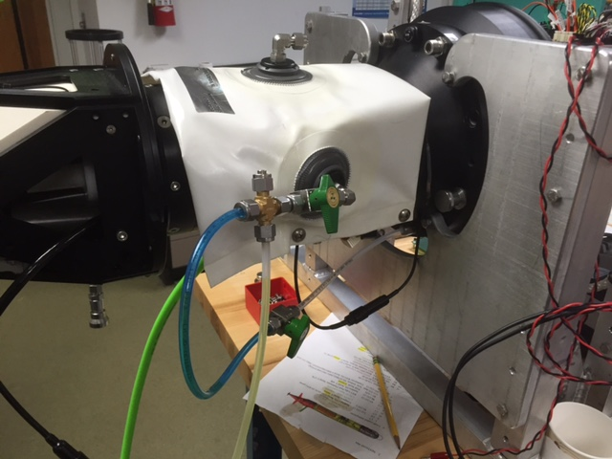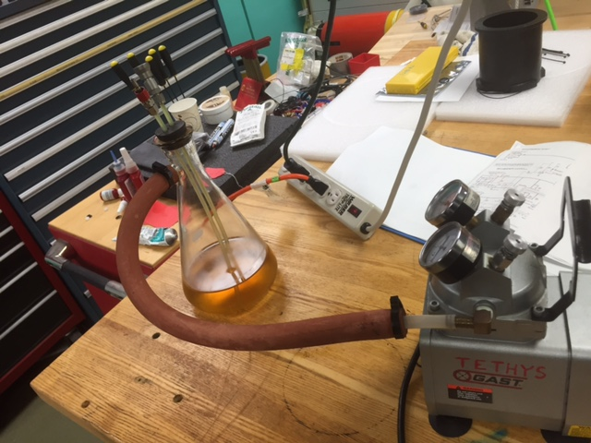
- If external bag is empty – prefill with 200cc oil. LRAUV system must be up with comms.
- Close valve to bag, attach vac line to top of bag- pull with 5-10 in Hg to remove air, when line starts to fill with oil- stop deairation. Close off top of bag.
- Connect tubing as per figures, Align valves to pump oil from internal reservoir into bag with vehicle pump. Pump until internal reservoir is empty.
- Open bag top port, manually purge air with hand pressure, reseal.
- Pull oil back into reservoir to fill limit with vehicle pump. Check pump does not cavitate.
- Cycle oil back out to bag to maximum allowed by vehicle pump.
- Burp any air out of bag via top port as in step 5.
- Cycle system a couple of times, reservoir full to empty to verify adequate oil in system to preclude cavitation.
- Close valves on test/fill tubing, remove from bag spilling minimum oil.
- Vehicle VB system ready.

