MIVEGAS ANTENNA ASSEMBLY PROCEDURE 3/23/17

PARTS & TOOLS NEEDED-
1. Forward Base and Aft sections of Antenna Rev.I, P-200770-15
2. SEE Ass’y Doc, A-201798-16 for additional parts required
3. See LRAUV Antenna Assembly Procedure (electrical tests)
4. Ace Grey Primer, Ace Enamel Orange, #17016 (same as fins)
5. Devcon Flexane 94 or Scotch Cast 2131, 3M Fast Cure 5200
6. 0.316” drill, 10-24 bottoming tap, 0.063” drill, other drills as required
7. Dremel grinder
8. 3M DP100 epoxy or equiv. (small amount)
9. See LRAUV Antenna SMA Connector Sealing for a history of testing these components.
PROCEDURE: NOTE: These procedures are recommended to be done Prior to installing and testing the antenna connections and wiring to avoid any damage to the wiring.
1. Check fitment of parts(castings), some adjustments sometimes are required. Mount pins in rear half (firm fit) and check fit to forward base. Drill out or redrill forward base since those receiving holes are shallow and an easy sliding fit is OK.
2. Likewise check alignment of the Base Clamp to Forward Base, drill clearance holes in Base Clamp to allow for easy alignment of the 4 mounting screws. (Screws also go thru rear shell)
3. Tap 4 mounting screw holes in fwd base, 10-24 bottoming tap, BE VERY careful, .51”DP Max
4. If 0.316 hole in rear section is not perpendicular(earlier mold), redrill 0.316” , Hole center, 6.15” back from front of part. Perpendicular at that point. This should reasonably match hole in rear skin.
5. Install the ¼-20 insert, install with proper tool
6. Use the 0.063” drill to continue the ARGOS antenna hole, rear of ARGOS recess, thru the bottom of rear half. This extra hole will be used to allow a small tool to guide the ARGOS antenna upward thru the top of rear half when the ARGOS is installed.
7. Use the Dremel with a ball end tool to carefully dig a furrow around the antenna well
8. Clean this area carefully, then use one of the sealants or urethanes above to affect an additional seal between the base casting and the antenna well. Follow vendor directions carefully. Water has seeped past here in testing.
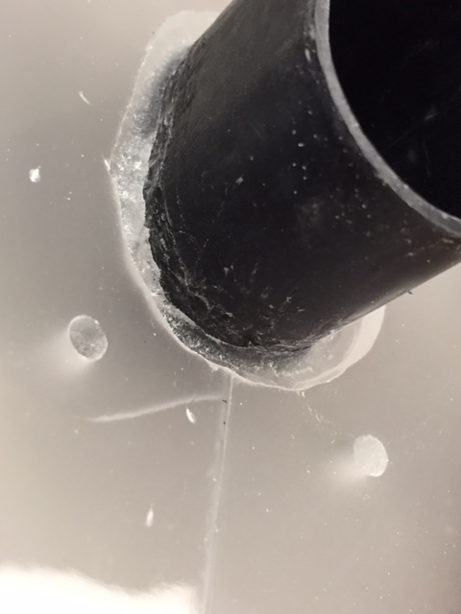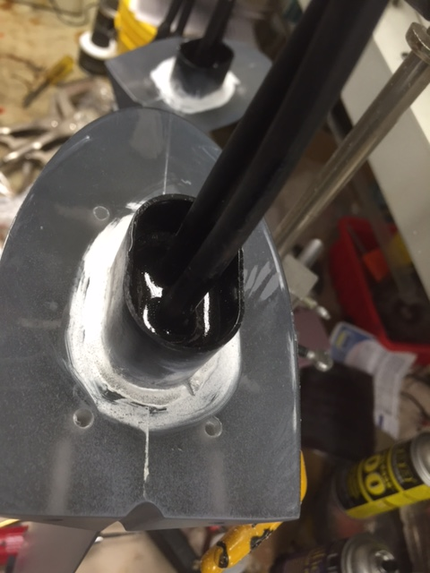

9. Check the rearmost antenna hole, 0.063”, in the rear section.
10. Check fit of small 0.125” dia. x 0.16” steel dowel in groove forward of magnet hole. Dremel can again be used, 1/8” ball end tool, to enlarge this groove slightly so dowel can be completely covered(protected) by epoxy without extending into the magnet hole. Steel keeps the magnet in place when not deployed, to turn emergency radio off.
11. Mask off the LED areas as a parallel stripe to top of fin as well as the entire exposed antenna with a good quality painters masking tape.
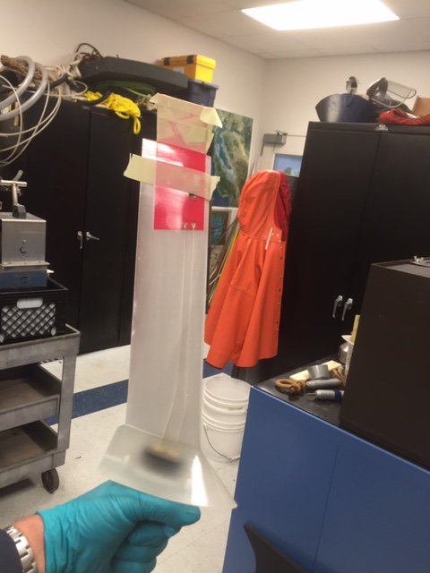
12. Sand all exposed surfaces of both pieces with 150 sandpaper, use 220 to give a smoother surface.
13. remove dust then wipe with alcohol
14. 1 coat primer, 3 coats enamel. See last page
15. Make sure have 2 electronically pretested RG-58 SMA connectors on DGO plug cables
16. Following the procedure in the LRAUV Antenna Assembly Procedure, sand and clean the well and cables, wash and dry the wells and cables/connectors, 100 F overnite
17. Gloved hands, apply the Devcon FL-10 and FL-20 Primers, let dry as directed, attach the cables to the SMA connections in the well with the proper torque, special tool available.
18. Have antenna ass’y checked electronically, capacitance etc., keeping potting area clean
19. Hold wires in layback position, pot with Devcon Flexane 94, 50cc/antenna, again following procedure, cure overnight

20 . Double bag whole Antenna forward ass’y in seawater, cycle 3 x to 500 psi with several hour soak on last cycle.
21. Retest electronically,
22. OK - install on vehicle
NOTE: the cleaning and testing procedures are scrupulous due to the extreme reliability required of the communication systems on these vehicles.

