MIVEGAS FIN MOLDING PROCEDURE 7/10/17

EQUIPMENT LIST-
NEW MOLD – 2016, ME LAB
ULTEM BASE INSERT-provides void for fin axle
ROD INSERT-Provides allen wrench access hole in fin
TC-854-A/B BJB Enterprises-RIGID SHORE 84 D POLYURETHANE
ORANGE COLORING FOR URETHANE-IGNITE Flourescent from Smooth-On, works fine
MOLD RELEASE- PASTE WAX AND MANN Ease Release 200( Smooth-On)
ACCURATE GRAM BALANCE, 220-280 grit sandpaper
DRILLS-M, S, #28, & 1/8”
10-24 x 1.5” pry screw
VACUUM CHAMBER TO DEGAS URETHANE
PRESSURE POT (50 PSI) GIVES BETTER RESULT IF AVAILABLE
FIN AXLE ASS’Y P-201715-15 & P-201716-15, + 8-32 X 2.5” SHCS
PROCEDURE-
1. Mold release applied to all internal parts of mold, wax on ultem insert and rod, Ease Release 200 on rest of the mold
2. ASSEMBLE AND PREHEAT MOLD TO 50C-lowers viscosity and reduces moisture
Hold ultem insert in position with a 6-32 and align with the 10-24 pry screw inserted so is flush with top surface of the insert. Insert well waxed (allen) rod insert. Insure mold pieces in correct alignment.
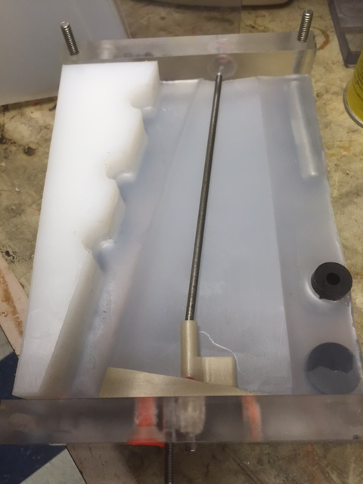

3. WEIGH OUT 80 gms TC-854 A, mix in 1 gm Ignite Orange.
4. WEIGH out 48 gms Part B, MIX as instructed on product sheet,
5. You have about 7 minutes work time, move mixed batch to vacuum chamber,
Pull down to ~25-28”Hg for just a couple minutes, release vacuum smoothly,
5. Pour into mold smoothly so slides down one edge of mold,
This helps remove bubbles
6. Pour until urethane is up in the “wells” on the mold.
7. Move mold into the pressure pot, pressurize, let sit for 60 minutes
8. Wait several hours before demolding, usually overnite
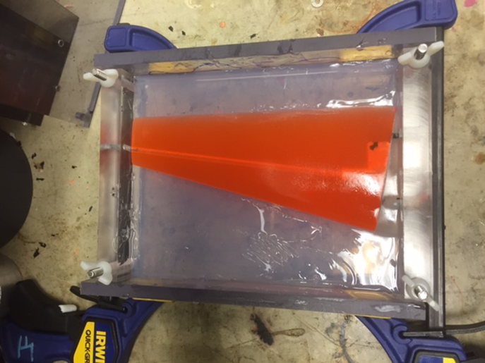
9. Removing the ultem insert takes patience, carefully drill out the wells, use the M & #28 bits to remove excess material, leave insert in place with the 6-32
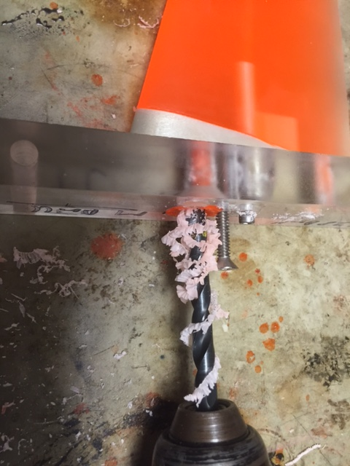
then gently apply pressure with the removal pry screw. A knife blade helps to break the fin tail section loose.
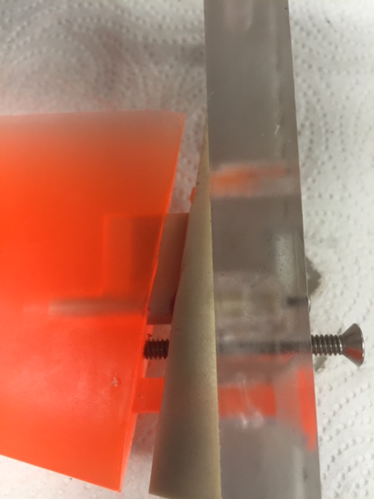
10. Use the S bit to clear the axle recess in the fin to the full depth of the recess, making sure the allen key access is clear as well. Clear the slot by sweeping the 1/8” bit back and forth.
11. Clean up entire casting with gentle sanding with 220-280 grit sandpaper

12. Insert an 8-32 x 2.5 SHCS in the fin axle insert and test fit. Trim recess to fit. Tap gently into place. Bottom of insert should be nearly flush with the fin.
13. Match drill an 1/8” hole in fin, insert a 1/8” dia. Trimmed length of delrin rod. A dab of instant adhesive may be necessary to lock in place.
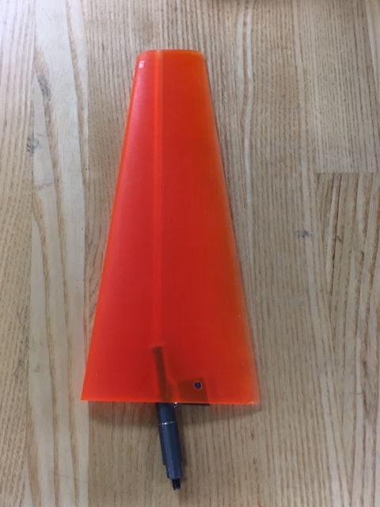

NOTES-Many trials led to using the BJB- TC-854-A/B, This yielded sufficient stiffness without being brittle, or so soft the fin drooped in sun light. Also, compatible with added coloration. When sufficient impact occurs, the Ti fin-axle ass’y typically breaks out of the fin urethane base before bending of the internal fin actuator components are damaged. They should always be checked if this happens, however.

