TECHNADYNE PC1X COMPENSATOR ASSEMBLY 11/14/17
- Collect PC1X comp parts, modified top manifold, 4 x 6-32 x 1.5” FHCS, LocTite Gasket Sealer #2, sand paper, acetone, #11, 6-32 tap, 0.11”transfer punch, 1/8” hole punch, 2 x 7” 1/8” tubing, 1 x 7.5” ¼” parflex , 2-211-70 oring.
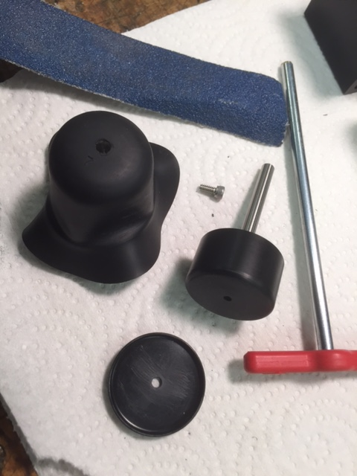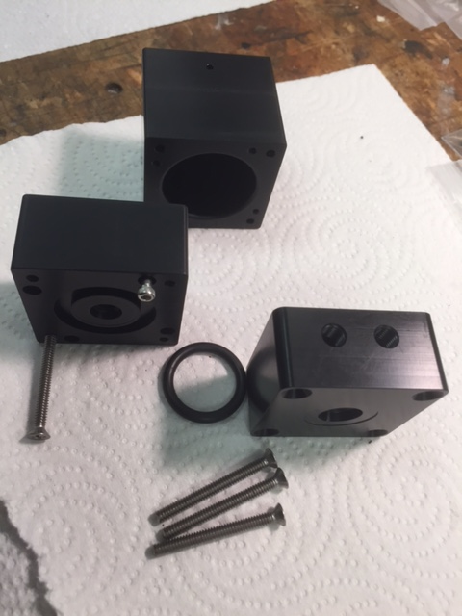
- Use the #11 drill to ream guide pin hole in lower half section.
- Roughen all surfaces to be bonded with Gasket Sealer. Course paper on plastic, med on rubber. Both flat surfaces of housing, both sides of diaphragm, piston top, cap underside.
- Clean surfaces with acetone.
- Punch a 1/8” hole in diaphragm top center.
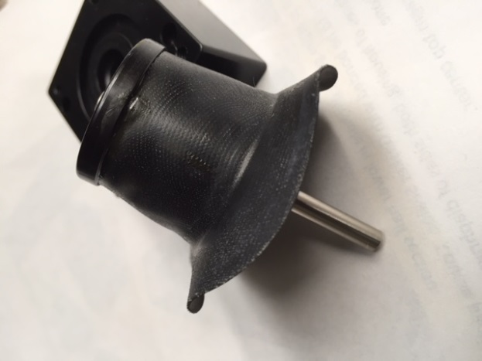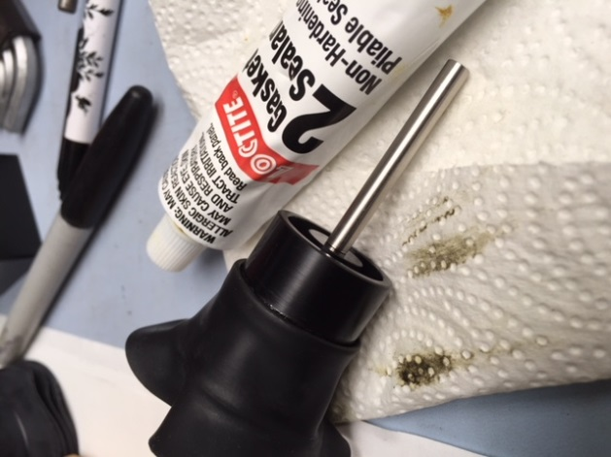

Apply a very thin layer of Gasket Sealer on piston top, diaphragm, cap underside surfaces to be bonded. Q tips help, Avoid radiused edges.

- Assemble piston, diaphram and cap with supplied 4-40 x ¼” SHCscrew.
- Clean any overflow from piston edges.
- Screw piston guide into piston bottom, tighten gently.
- Let dry for a few hours if possible. This ass’y will allow a better fitment and positioning of the punched holes in the diaphragm into the housing.

- Dry fit the piston ass’y and both lower halves, carefully mark the location of the 4 remaining holes required. The corner holes in the lower half of comp are not used. Care is needed using the transfer punch to avoid damaging the existing tapped 4-40 holes. Piston ass’y is pushed ½ way down to position diaphragm at midtravel.
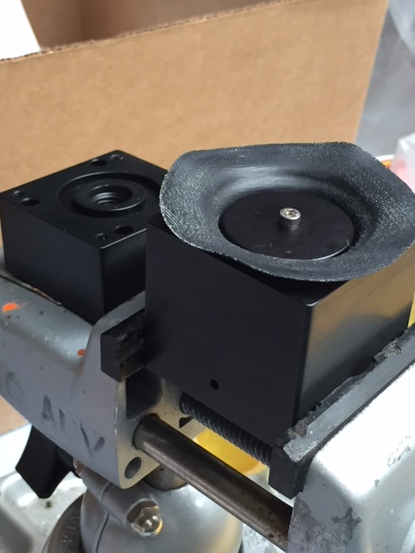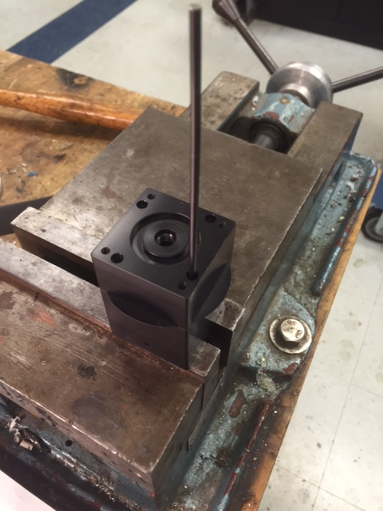
- Punch the remaining 4 screw 1/8” holes in diaphragm.

- Apply a very thin layer of Gasket Sealer as before on diaphragm, housing surfaces to be bonded. Q tips help, Avoid radiused edges.

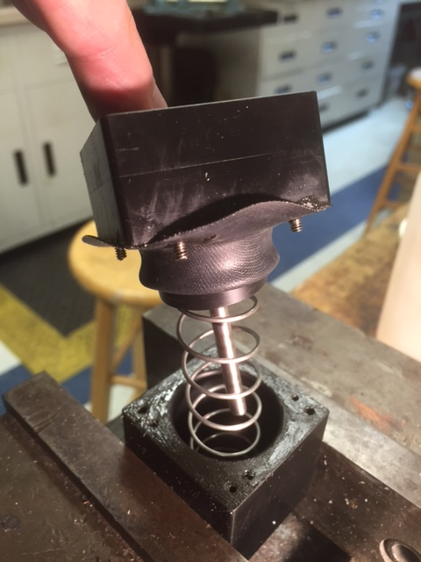

- Insert spring, assemble housing, piston ass’y, using supplied 4-40 SHCS as a guide. This isn’t easy, spring is strong. A small clamp on the piston guide rod to hold it in the retracted position is very helpful.

- Dry for 24 hours.
- Trim excess rubber from outside of housing with a razor blade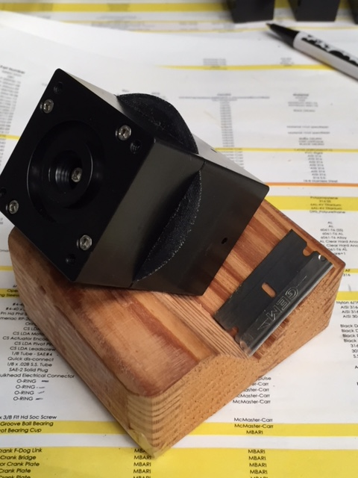
- Mid block, tap corner holes 5/8” deep with 6-32. If not done earlier.
- Clean parts, grease oring, groove, install oring, assemble with 4 x 6-32 x 1.5” FHead
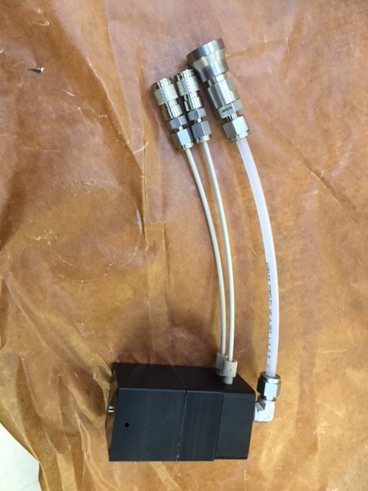
- Finish ass’y .
- Do a functional check by pumping in oil, should move smoothly from 4-7 psi for full travel. 1st fill may not be very smooth.
- Leave filled for 24 hrs to leak check.

