Mark Chaffey & Brett Hobson
LRAUV Build Project 901727.99
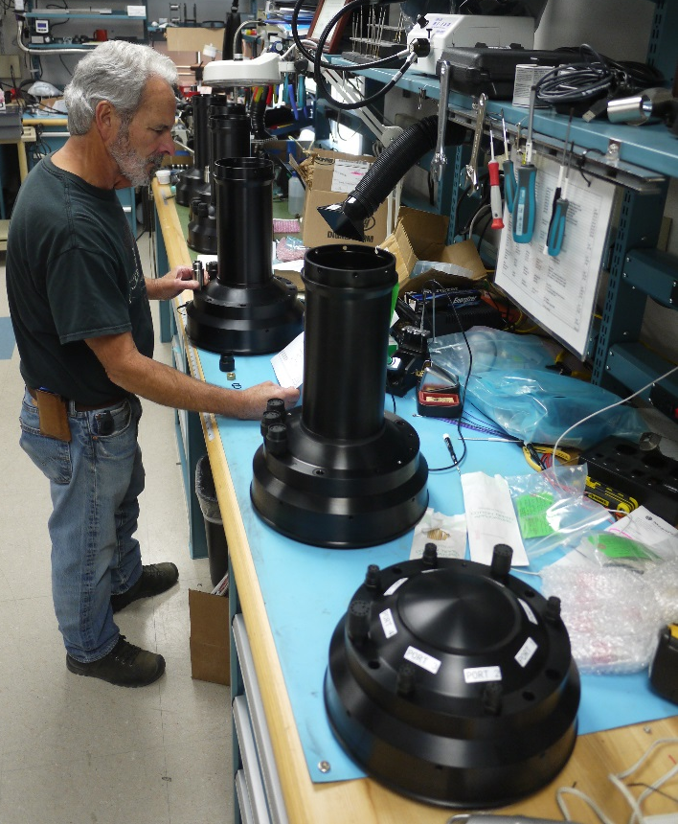
Responding to requests by MBARI researchers for more missions utilizing the MBARI Long Range Autonomous Vehicle (LRAUV), an internal project has been initiated to fabricate three additional science research vehicles and, for efficiency, this has been combined with a fourth vehicle build for Mathieu Kemp’s Fault Prognostication engineering project. In addition to these four in-house vehicles we are actively collaborating with a Woods Hole Oceanographic Institute (WHOI) project funded by the Department of Homeland Security (DHS) Arctic Domain Awareness Center, which is fabricating a fifth vehicle to MBARI’s specification and guidance.
MBARI technician Tom Marion installs electrical fittings in the new LRAUV bulkheads.
The build effort began with the organization of the design drawings and bills of material to ensure that the documentation was up to date for the more than 1200 parts and assemblies that make up each LRAUV. Major parts were then competitively bid and awarded to numerous machine shops and wiring fabricators. When it has been cost effective, and does not delay other projects, some specialty parts are being manufactured using MBARI’s well equipped in-house facilities, including high quality 3D printing of parts.
Progress to date is that the updating of the drawings and documentation is complete and over 75% of the parts for all four MBARI vehicles have been received or are currently being fabricated. The project is on track to deliver a vehicle to Mathieu Kemp’s Fault Prognostication engineering project in July 2018 and the three remaining science vehicles in December 2018.

Recent Professional Activities
Expeditions
- June 2017 – Brett Hobson. Expedition to 3D map the submerged surface of an iceberg with the MBARI “Iceberg” AUV on the Danish-flagged Research Vessel Adolf Jensen in eastern Greenland.

