Mark Chaffey and Brett Hobson
LRAUV Build Project 901727.99
This project is directed at building four additional current generation Long Range Autonomous Vehicles (LRAUV’s) for MBARI and a fifth vehicle for the Long-range AUV (LRAUV) Artic Domain Awareness externally funded project. One of the MBARI vehicles is specifically allocated for Matt Kemp’s fault detection lab.
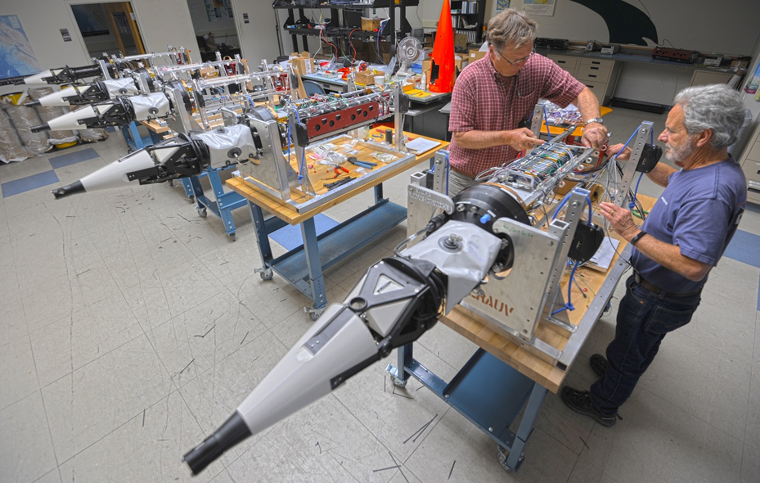
LRAUV's under construction. The Artic Domain Awareness vehicle in the foreground and the vehicle behind it for the Kemp lab have been completed. The final three vehicles are nearing completion.

