Building G Battery Safety Guide
Rev. 17JAN18 – Mark Chaffey

In the event of smoke or fire from a battery pack pull the fire alarm and call 911. For all other issues contact member of LRAUV team first, then MBARI safety team.

Contact Information
MBARI LRAUV Build Team Contacts

Mark Chaffey
Project Manager
(831) 775-1708
(831) 236-5191 (cell)
chma@mbari.org
Denis Klimov
Battery Engineer
(831) 775-1914
klimov@mbari.org
Ken Heller
Battery Technician
(831) 775-2074
kheller@mbari.org
Brett Hobson
Project Engineer
(831) 775-1941
(831) 601-5499 (cell)
hobson@mbari.org

MBARI Safety Office Contacts

Norm Steinberg
Safety Officer
(831) 775-1711
(831) 345-2515 (cell)
stno@mbari.org

Tara Vadas
Safety Assistant
(831) 775-1774
(831) 251-1611 (cell)
tara@mbari.org

Edward Peltzer
Assistant Safety Officer
(831) 775-1851
(831) 566-5063 (cell)
etp3@mbari.org

Greg Voogd
Assistant Safety Officer
(831) 775-1755
(831) 970-9218 (cell)
gregv@mbari.org

Introduction
This guide is an extension of the MBARI Hazard Communication and the Battery Policy, both available on the MBARI Canyon Head at https://mww.mbari.org/safety
The purpose of the guide is to inform those working building G on the proper handling procedures for the Lithium Ion battery packs used by the Long Range AUV (LRAUV). Note that the LRAUV battery packs are “lithium ion” secondary batteries, not “lithium metal” primary batteries and are treated differently.

LRAUV Lithium Ion Battery Assemblies
The MBARI LRAUV battery assemblies are built up from arrays of Inspired Energy NH2034 packs each containing 8 Li-Ion 18650 cells. Each of these individual packs contains internal protection for over-charge, over-discharge and short circuit. For redundancy, passive safety devices have also been integrated into the pack to protect against over-current and over-temperature, and secondary over-voltage protection has been implemented with a logic-fuse and controller.
These internal safety features substantially reduce the possibility of external factors damaging the battery packs and causing a battery failure.

LRAUV Battery Assembly Handling Procedure
To avoid physical damage to the individual battery packs the battery packs and assemblies should be handled with care. Store and move the battery assemblies in a manner that prevents them from being dropped or falling. Take care to prevent mechanical damage during assembly in the LRAUV. Any physical damage should be carefully evaluated and the affected individual packs removed from Building G to the hazmat storage area as soon as possible (see Ed Peltzer).

LRAUV Battery Assembly Storage Procedure
Received batteries should be stored in their original shipping packages separate from other flammable materials. Batteries should be protected from heat sources and mechanical damage. In building G received batteries will be stored in the Metal Battery Storage Cabinet shown in figure 1.
Complete battery assemblies should be stored on clean bench surfaces separated from each other by a minimum of six inches and separate from any flammable materials and any clutter or tools that could cause electrical shorting or mechanical damage. Moving the battery assemblies should be done by LRAUV team members only.
Batteries assemblies that have been installed in the LRAUV chassis systems should be kept free of any flammable materials in the immediate vicinity such as cardboard or plastics.

LRAUV Battery Assembly Electrical Charging
Charging and manipulation of the electrical connections to the LRAUV Battery Assemblies should be by knowledgeable LRAUV team members only. In no case should a voltage higher than 20 Volts be applied to the battery assembly. During LRAUV construction if it is necessary to high current charge a battery pack this should be done during normal working hours under technical supervision. Maintenance charging should be accomplished with power supplies with over voltage over protection (OVP) set to the maximum allowed voltage (above).

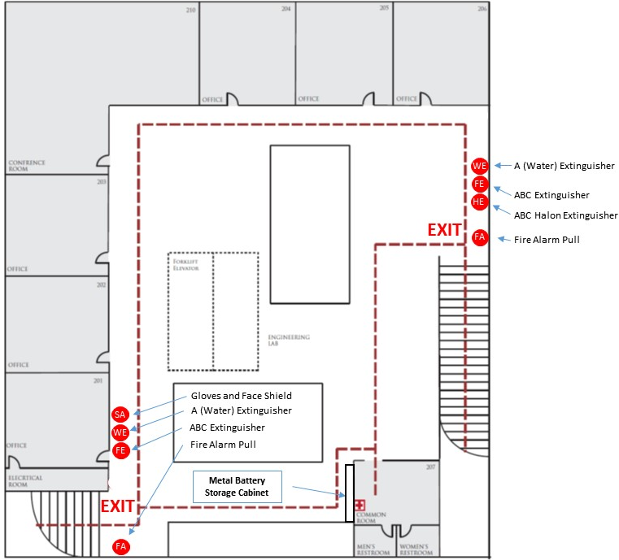
Figure 1, Building G Egress and Fire Extinguisher Map

Safety Equipment
The building G second floor is equipped with three types of fire extinguishers and a face shield and gloves in locations shown on the egress diagram in figure 1. Fire extinguisher types, listed in order of effectiveness:
A Type Water: These extinguishers are effective at putting out Lithium Ion battery fires and simultaneously cools down the battery pack, preventing thermal runaway and re-ignition. Do NOT use this extinguisher on high voltage electrical fires! The LRAUV battery packs are safe low voltages (< 20 volts).
ABC Type Halon: These extinguishers are effective at putting out Lithium Ion battery fires and leave no residue, preventing damage to adjacent equipment. They do not cool down the battery pack to prevent thermal runaway and re-ignition. This extinguisher should be immediately followed with the type A water extinguisher to cool down the battery pack.
ABC Type Dry Chemical: These extinguishers are effective at putting out Lithium Ion battery fires however they leave a caustic residue and do not effectively cool down the battery pack to prevent thermal runaway and re-ignition. For these reasons it is not recommended. If this extinguisher is used it should be immediately followed with the type A water extinguisher to cool down the battery pack.

Battery Overheating, Venting and Fire Response
The uncontrolled failure of properly designed Lithium Ion battery packs is extremely rare, however if a failure does occur and the battery overheats, it may vent, catch fire or explode, causing a release of smoke, carbon monoxide, carbon dioxide, and hydrogen fluoride gas which is an inhalation hazard. If a battery failure is detected the recommended response is listed below:
Swollen Battery or Evidence of Battery Elevated Temperature
Contact a member of LRAUV team and a member of MBARI safety team. Prepare to evacuate building G if necessary.
LRAUV or Safety team response: If deemed safe to do so, using face shield and gloves, disconnect any electrical wires and move battery pack to a metal tub and cool the battery pack with a water fire extinguisher. If the battery cannot be safely moved then cool in place with the water fire extinguisher. The objective is to prevent uncontrolled thermal cell-to-cell runaway. Continue water cooling until there is no evidence of elevated temperature.
Strong Chemical Smell with Smoke or Evidence of Battery Venting
Pull FIRE ALARM and Evacuate building G. Contact a member of LRAUV team and a member of MBARI safety team.
LRAUV or Safety team response: If it is deemed safe to do so, using face shield and gloves, and you are not exposed to smoke or battery fumes cool the battery in place with the water fire extinguisher. Do not approach closely or attempt to move the battery pack. The objective is to prevent uncontrolled thermal cell-to-cell runaway. Continue water cooling until there is no evidence of elevated temperature.
Fire and Smoke from Battery Pack
Pull FIRE ALARM and Evacuate building G. Contact a member of LRAUV team and a member of MBARI safety team.
LRAUV or Safety team response: If deemed safe to do so, and you are not exposed to smoke or battery fumes, using face shield and gloves, extinguish visible fire with the Halon or Water Fire extinguisher. Continue to cool battery in place with the water fire extinguisher. The objective is to put out active fire and then prevent continued uncontrolled thermal cell-to-cell runaway. Continue water cooling until there is no evidence of elevated temperature. If the fire is not immediately extinguished evacuate the building.

