Building G Battery Safety Guide

&
Material Safety Data Sheets

In the event of smoke or fire from a battery pack pull the fire alarm and call 911. For all other issues contact member of LRAUV team first, then MBARI safety team.

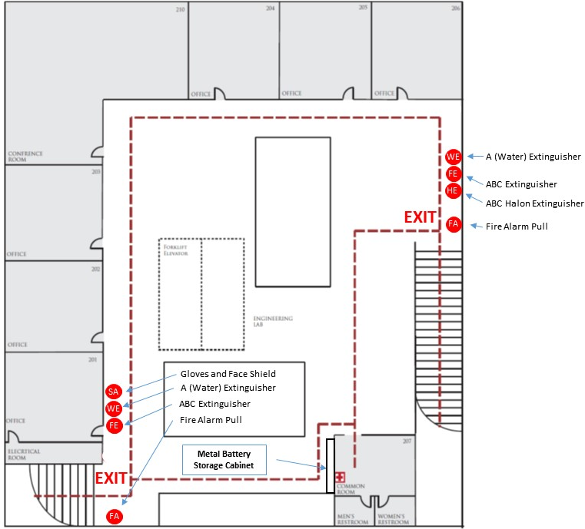
Figure 1, Building G Egress and Fire Extinguisher Map.

