Date: 3/13/2018

Simple MATLAB test.

%LICOR optical chamber volume: 14.5 mL
%Tubing internal diameter: 1/16 in
%DIC range: 1800-2300 (open ocean); 1600 - 2300 (coastal/estuarine) umol/kg

%sample concentration range
DIC = 1600:10:2300;%umol/kg
%sample volume range
Vs = 1:.5:10;%mL
%average seawater density
rho = .001027;%kg/cm3
%internal volume of system that moles will be diluted into
Vol = 14.5 + 60 + ((20.*(pi.*(1/32)^2)).*16.3871);%mL = Licor + chamber + dryer + tubing (16.3871 cubic cm/ cubic in)
%Ideal gas constant
R = 0.082057*1000;%L atm mol-1K-1 = mL atm mol-1K-1
%Assumed Sample Temp
T = 15 + 273.15;% K

for i =1:length(DIC)
for j = 1:length(Vs)
C_mol(i,j) = DIC(i).*(Vs(j).*rho).*10^-6;%mol
pCO2(i,j) = ((C_mol(i,j).*R.*T)./Vol).*10^6;%uatm
end
end

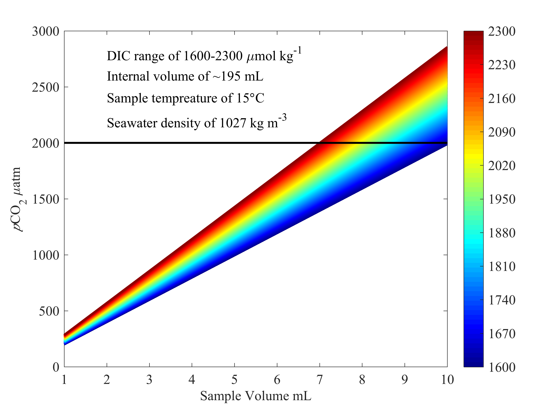
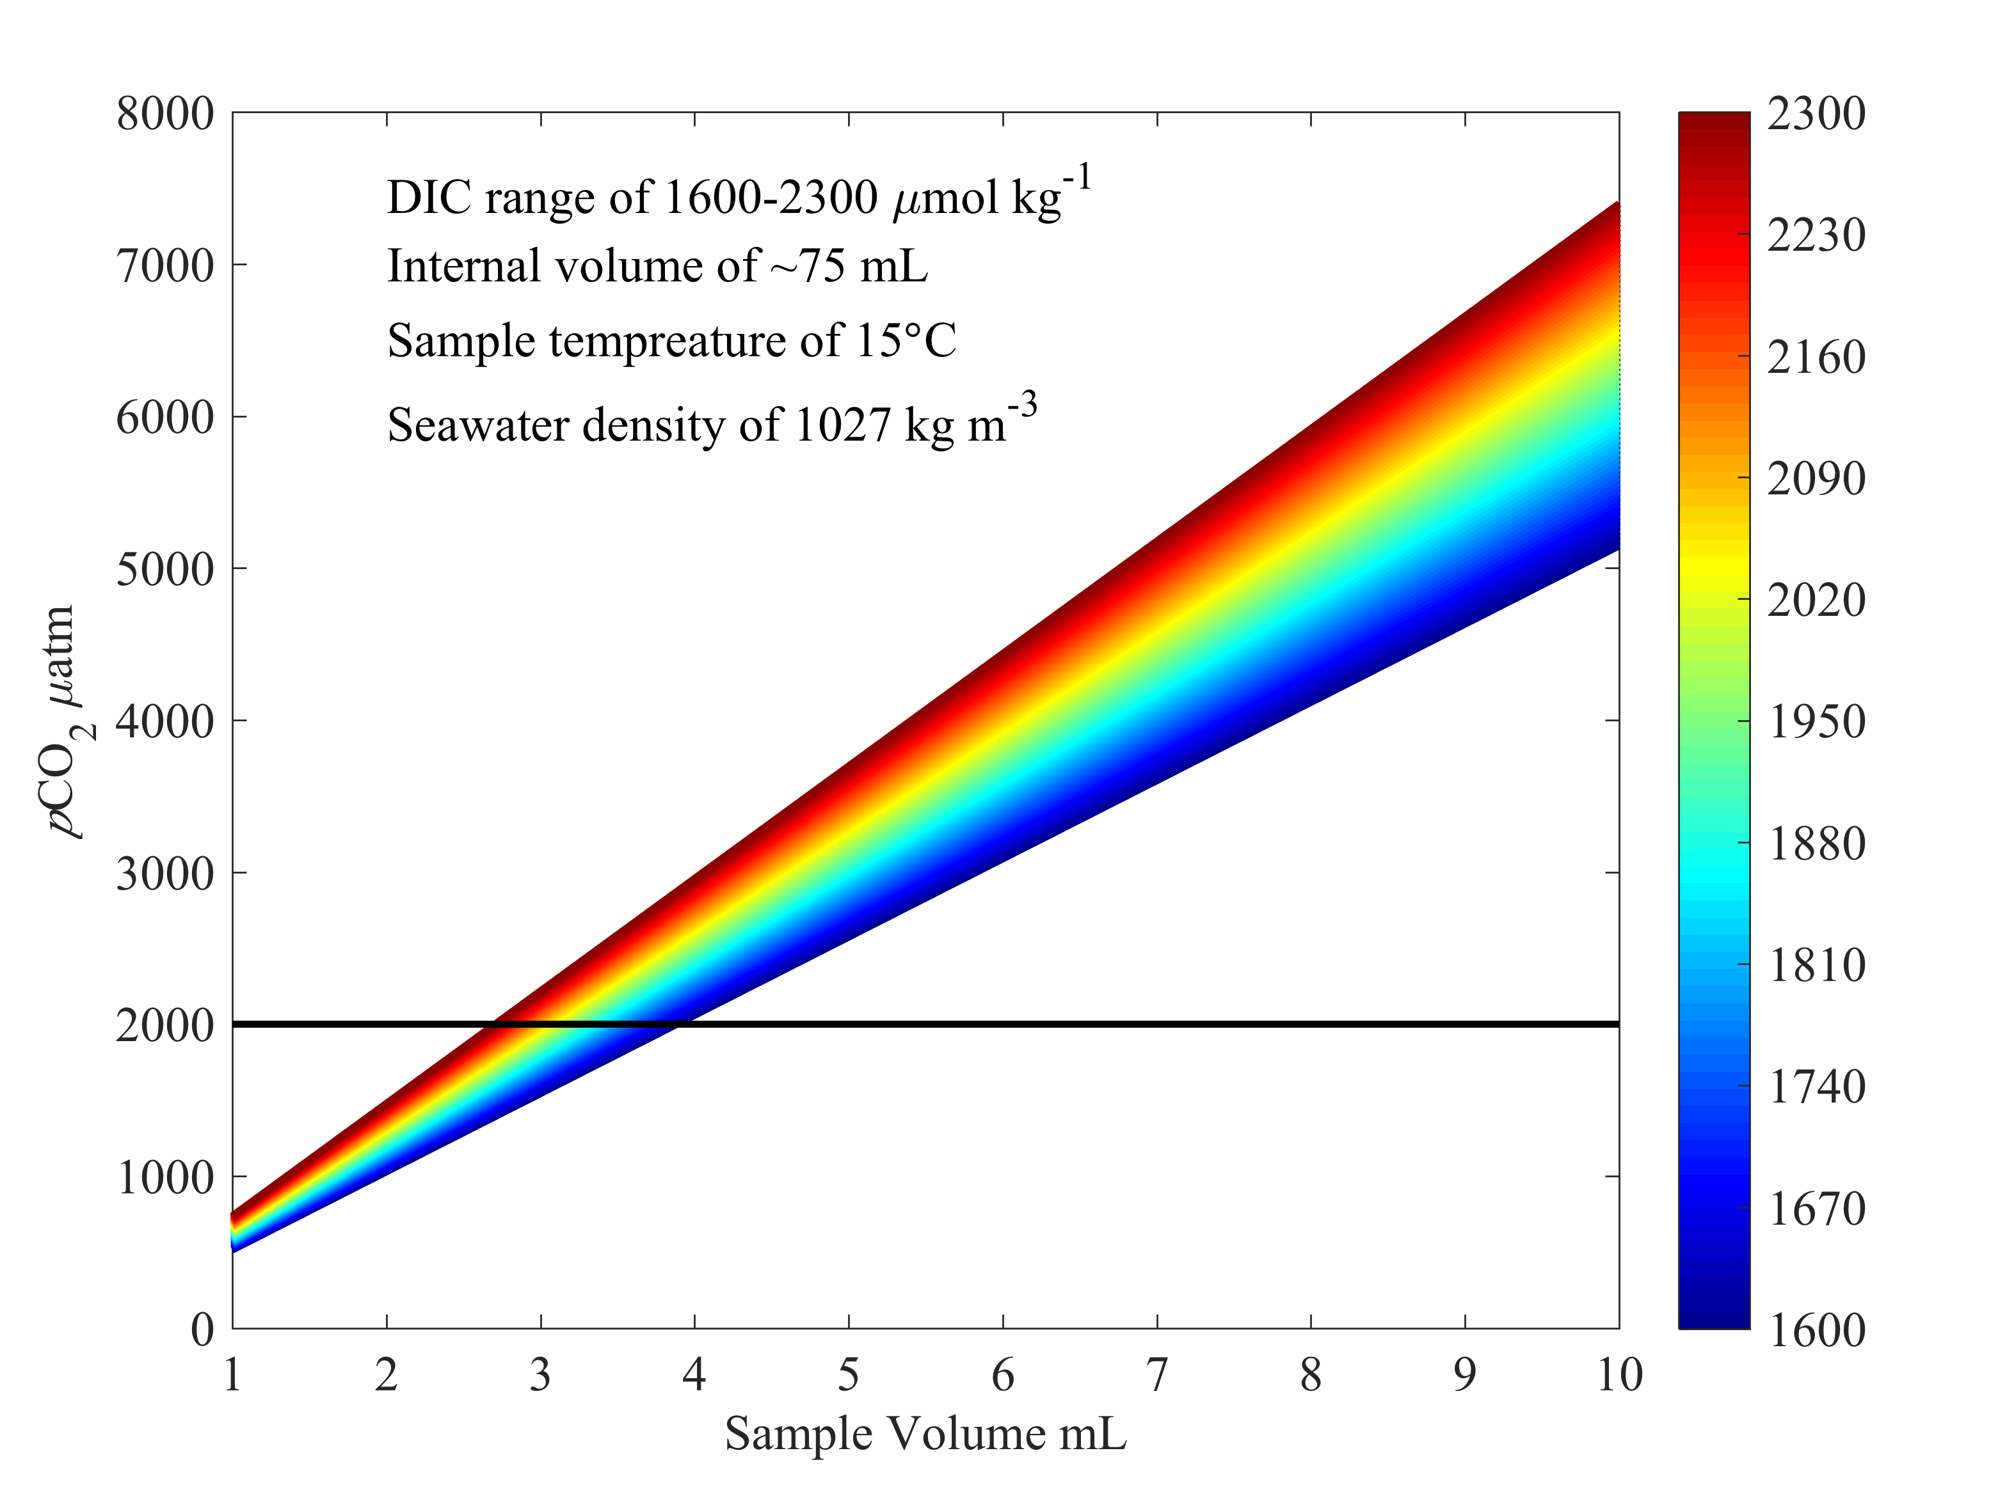

The PMEL DIC system internal volume was ~60mL, which seems a bit large, though I suppose the drying path was small via use of nafion. Importantly, this approach assumes a well-mixed gas within the internal volume, which will not be the case. So, I would say that we either need to build in dead volume, or work with smaller volumes of fluid. As fluid handling is always a concern, how large of a volume do we need to work with 5mL? 140mL – and still the peak pCO2 evolution may exceed 2000 ppm.

This could be achieved with a 1 in diameter stripping chamber that is 11 in long. This is very large and we have to consider orientation; however, between the drying chamber and stripping chamber, we can likely accommodate this, or build in dead volume elsewhere. Extra dead volume would likely help distribute/dilute the gas, assisting in minimizing the peak pCO2.

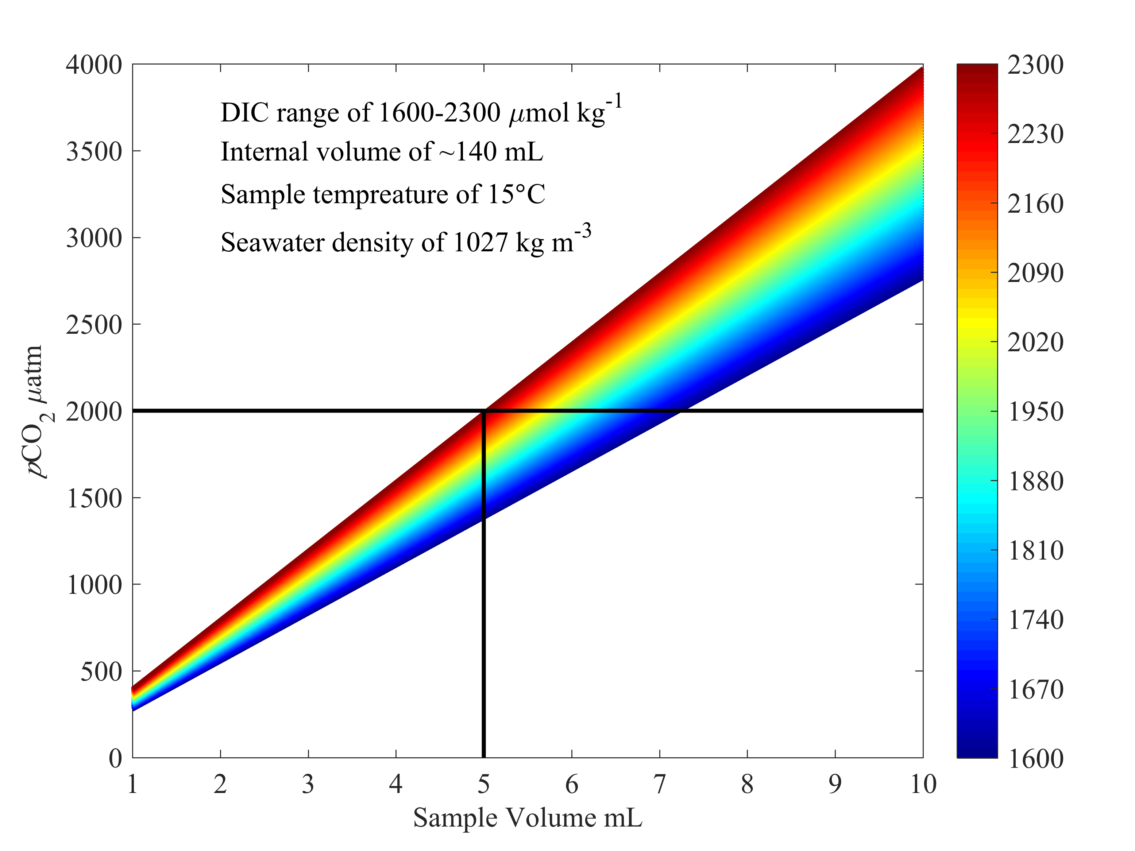

Our lab DIC system uses ~10mL of sample and reads in the low-ish pCO2 ranges. Jules says it doesn’t matter because they just calibrate the system against CRMs. I think there also must be a large internal volume.

Notes:
- Look into what CRM levels we have – I’ll probably need to buy more for testing.

