Project Number: | 901803

Project Start: Jan. 1, | 2018 | Project Duration (in years): | Year 2 of 3 ¹

Please indicate if proposal includes requests for any of the following (mark all that apply).

 | X |  |  |  |  |  |  |  |  | X
Ship Time |  |  | ROV |  |  | AUV |  |  | Wave Glider |  |  | Mini ROV

Please indicate what type of project is being proposed (mark only one).

 |  |  |  | X
Feasibility/Scoping  [Less than 100 days effort] |  |  | Development |  |  | Research |  |  | Infrastructure² |  |  | Education |  |  | Time Series |  |  | Institute Initiative

Project Manager: Paul McGill
Principal Investigator: Andrea Fassbender
Lead Scientist: Andrea Fassbender
Lead Engineer: Craig Okuda, Kent Headley

Project Title: Carbon Wave Glider Development

Please indicate which category best describes the project theme (mark only one).

 | X
Ocean  biogeochemistry |  |  | Ecosystem dynamics |  |  | Ocean visualization |  |  | Exploration & discovery

Please indicate percentage of effort on this project anticipated for 2019 toward these three highest institutional goals (percentage total should equal 100%).

Goal | Developing/adapting innovative technologies | Utilizing developments to explore and understand ocean systems | Technology/knowledge transfer
Percentage | 90 | 0 | 10

- ABSTRACT (new projects only)

[Paste abstract here]

- PROPOSAL

  - All Projects

Statement of the challenge, why it is important

The ocean has absorbed ~40% of the total anthropogenic carbon emitted to the atmosphere during the industrial era and exhibits a modern anthropogenic carbon uptake rate of ~2.5 PgC yr⁻¹ [Sabine et al., 2004; DeVries, 2014] - representing ~25% of annual global emissions. Constraint of the marine carbon sink is essential for closing the global carbon budget [Le Quéré et al., 2018] and modern estimates hinge on our ability to quantify the annual global air-sea CO₂ flux. This is a relatively straight-forward method that has yielded extensive international collaboration to observe surface ocean pCO₂ values on a global scale over the annual cycle and to collate the results into a common data repository – the Surface Ocean CO₂ Atlas (SOCAT; Bakker et al., 2016). However, pCO₂ data alone do not provide enough information about the carbonate system to fully characterize the processes governing pCO₂ variability and thus the air-sea exchange. Without understanding the drivers and sensitivities of ocean carbon uptake, it is not possible to confidently project how the ocean carbon sink may be changing. This represents a critical knowledge gap in our understanding of how ocean carbon cycle feedbacks will impact climate change.

Full characterization of marine carbonate chemistry requires information about salinity, temperature, pressure, and at least two of the four commonly measured parameters, which include pCO₂, pH, dissolved inorganic carbon (DIC), and total alkalinity (TA). Commercial pH and pCO₂ sensors are presently available for oceanographic use [Martz et al., 2015]; however, the strong negative correlation between these parameters renders this the least ideal pair for constraining the system [Gray et al., 2011; Fassbender et al., 2015]. Instead, the pH-DIC or pCO₂-DIC pair provides the most robust information [Dickson and Riley, 1978]. Thus, the goal of this project is to develop an instrument system that can measure pCO₂, pH, and DIC aboard the autonomous Wave Glider platform to meet current and future technology needs of the marine biogeochemistry research community.

Relevance

How does it relate/contribute to MBARI’s mission and strategic plan?

This project contributes to MBARI’s mission through creative development and engineering of a novel tool that can be used to address important scientific questions concerning the efficiency of ocean carbon uptake, biochemical processes, and ecosystem function. The National Oceanic and Atmospheric Administration (NOAA) has expressed significant interest in testing the developed instrument system to see if it could be implemented on their open ocean climate mooring array (~40 moorings). The instrument system may also be of interest to the broader ocean carbon community due to its unique capacity for use in both coastal and open ocean domains. Future applications of the Carbon Wave Glider in tandem with biogeochemical profiling floats and autonomous underwater vehicles (AUV’s and gliders) will provide opportunities to conduct cutting-edge research through unique sensor combinations (e.g., high-resolution biogeochemical and acoustical observations). Further, implementing the instrument system on other autonomous surface vehicles (e.g., Saildrone) and underway ships could introduce alternative use cases that may improve ocean carbon observing across a wide domain of ocean science. Thus, this project will enhance MBARI’s collaborations, yield an innovative and much needed new tool that may be commercially transferable, and has potential for significant climate observing impact through implementation on NOAA’s global mooring array (Figure 1).

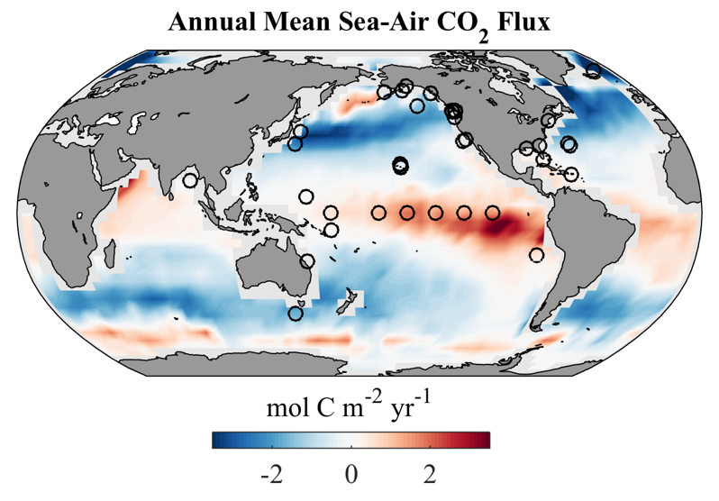
Figure 1. Annual mean sea-air CO₂ flux in units of mol C m⁻² yr⁻¹, after [Takahashi et al., 2002]. Black circles show locations of the ~40 surface moorings in NOAA’s global climate array that presently measure air and sea pCO₂, and pH in some cases, in addition to a suite of meteorological and physical oceanographic parameters. The moorings are maintained in collaboration with numerous partners throughout the world.

Development of the Carbon Wave Glider will ultimately address all three of the overarching goals laid out in MBARI’s Strategic Plan, which include:
- Develop or adapt innovative technologies that allow researchers to identify and resolve important questions and advance our understanding of the ocean.
- Utilize those developments to explore and understand how natural ocean systems operate and how they respond to natural and anthropogenic change.
- Transfer the knowledge gained, solutions devised, and the technology developed to communities outside of MBARI— researchers, educators, policy makers, resource managers, industry, and the general public
The project also aligns with two of the Strategic Plan Research Themes targeted for 2011-2020, including:
- Ecosystem dynamics research aims to comprehensively study productivity and transfer of matter and life between the ocean surface and the deep sea.
- Ocean biogeochemistry exploits the use of MBARI sensor technologies, both by MBARI and by colleagues worldwide, for developing a predictive understanding of global-scale processes, including climate change.

Does it relate to the Technology Roadmap? If so, please describe how. (See http://mww.mbari.org/oed/TechnologyRoadmap.pdf.)

This project is strongly related to the Technology Roadmap through the implementation of wet chemistry at sea and development of the first autonomous dissolved inorganic carbon sensor designed for extended deployments (>4 months) on a mobile surface platform. These project characteristics address the Technology Roadmap goals of taking the laboratory into the ocean and advancing a persistent presence.

How does it relate/contribute to the Packard Foundation’s Ocean Grantmaking Program? (See https://www.packard.org/what-we-fund/ocean/ and documents therein.)

The Packard Foundation’s Strategic Framework for Oceans Grantmaking highlights Enhanced Scientific Understanding of the Function of Marine Ecosystems and Improved Coastal Management as two of the three key objectives. The Carbon Wave Glider will contribute to both of these goals by providing novel observing capabilities and improved scientific understanding that can help to inform coastal management decisions. For example, once developed the Carbon Wave Glider may be used to identify and characterize regional ocean acidification (OA) refuges [Chan et al., 2017] along the coastline of the California Current System. Strategic missions of this nature will be guided by ongoing regional modeling and observing efforts (e.g., CeNCOOS; http://www.cencoos.org/data) to locate and study coastal OA asylum regions over a range of spatiotemporal scales, providing information that may be useful to regional policy makers, resource managers, and industry stakeholders. With the novelty of measuring three carbonate system parameters (pCO₂, pH, and DIC), the developed sensor system presents exciting opportunities for enhanced coastal ocean acidification observing programs.

On a larger scale, I hope to apply this technology on the Saildrone platform for future western boundary current research in the western North Pacific Ocean and Southern Ocean. The North Pacific effort aligns with the Packard Foundation Grantmaking vision because the study location lies within one of the Packard Foundation’s High-Ranked Focal Regions for research, management, and restoration in the North Pacific Ocean. Further, the mode waters formed in this region upwell along the United States west coast ~50 years after subduction [Feely et al., 2008], directly linking the biogeochemical and physical processes that occur in the western Pacific to ecosystem processes along our coast. In summary, there are numerous coastal and open ocean applications for the Carbon Wave Glider and associated technology that will advance scientific understanding, which could be used to guide coastal management.

Overall approach to the challenge: Over the complete term of the project, what is needed to address the challenge (e.g., sensors, platforms, marine operations, de novo R & D, etc.)

Research

The goal of this project is to merge methodologies for autonomously measuring the pCO₂ and dissolved inorganic carbon (DIC) content of seawater into a single instrument that can be deployed on MBARI’s Liquid Robotics SV3 Wave Glider autonomous surface vehicle. By targeting the relatively small Wave Glider platform, the system will be transferable to larger autonomous surface vehicles, such as the Saildrone, as well as moorings or underway ships. pCO₂ and pH measurements from the Wave Glider are already routine at MBARI; however, the DIC component is novel.

This development effort will benefit significantly from the prior work of project team members. In collaboration with scientists and engineers at the NOAA Pacific Marine Environmental Laboratory (PMEL), Dr. Fassbender previously modified the Battelle Memorial Institute MAPCO₂ system [Sutton et al., 2014] to make DIC measurements on surface moorings [Fassbender et al., 2015]. Importantly, the original version of the MAPCO₂ system was developed at MBARI [Friederich et al., 1995] and has already been enhanced and miniaturized by MBARI staff for application on the Wave Glider platform (Figure 2) where it is now used regularly in tandem with a Honeywell Durafet II pH electrode [Martz et al., 2010; Bresnahan et al., 2014; Chavez et al., 2017]. Additionally, Lead Engineer Craig Okuda and collaborating Wave Glider technician Christopher Wahl have recently reduced the pCO₂ system size by >50% to fit into a smaller chamber on the Wave Glider in order to make room for additional science payloads. Since the DIC and pCO₂ instruments rely on the same infrared detector (LICOR 840) and share ~90% of their components, this project will largely be an integration exercise to incorporate the DIC liquid-handling and valving components into the existing pCO₂ sensor design. It is therefore fortuitous that Okuda and Wahl are now extremely familiar with the space constraints of the platform in addition to other functional aspects (power, communications, sampling challenges, etc.) associated with the pCO₂ instrument. The proposed project team brings an immense amount of experience with the chemical approach, sensing components, platform, and functionality requirements needed to efficiently complete this work.

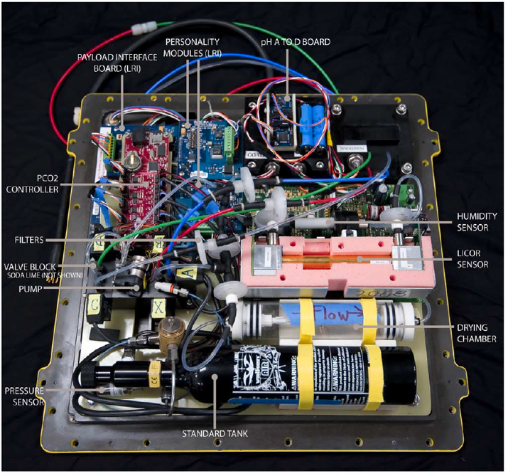

Figure 2. “Layout of CO₂ system components as installed inside a SV2-style dry box for the Wave Glider. The Payload Interface and Personality Module (2) Boards are from Liquid Robotics and are used to log data from the CTD with oxygen and transmit them to shore together with the pCO₂ and pH data. The pCO₂ controller board, with a PIC micro-processor, operates the pCO₂ and pH systems and logs their data.” From Chavez et al., 2017. This configuration is approximately three times larger than the newly miniaturized version.

In order to integrate the two measurement capabilities (DIC and pCO₂), there are important functionality and design challenges that must be overcome. These include:

- Laboratory Testing:
  - Evaluate equilibration and gas extraction methods for DIC measurement in the laboratory. The equilibration technique was used in the moored DIC system application; however, it may be possible to streamline the measurement and improve accuracy and precision by moving to an extraction method. Both methods are well known and widely applied scientifically. Thus, the challenge lies in determining which approach is more appropriate for the moving platform application. This will be assessed in the laboratory.
  - Determine the specific liquid and dead volumes required to maximize accuracy and precision while operating in the ideal detector sensitivity range.
- Fluid Handling:
  - Design and integrate the seawater intake and evacuation channels for DIC sample measurements.
  - Design a chamber where the seawater sample and acid can mix and dissolved CO₂ can be equilibrated with or extracted into the carrier gas.
  - Incorporate syringe pumps for sample and acid injection volume control. Notably, many of the liquid handling challenges associated with syringe pumps have been addressed by the MBARI Environmental Sample Processer (ESP) team, so we can draw from their experience.
- Software Development:
  - Decide whether to build off of existing pCO₂ software architecture or start from scratch.
  - Decide whether to use the Liquid Robotics communication system or move to the OASIS-5 controller. The Liquid Robotics system requires data to pass through their communications network. Many Wave Glider users are interested in alternatives.
  - Determine data communications needs (cell phone vs. satellite links) for both nearshore and open ocean deployments and how much data must be returned to shore.

Engineering/Technology Development

A collaborative grant between NOAA PMEL, the University of Hawaii, and MBARI was recently awarded by NOPP. The project primarily funds PMEL to develop a dual pCO₂-DIC instrument for ASV application, similar to the one being developed at MBARI but using a different detector. The MBARI project will apply infrared sensing technology while the parallel PMEL project will use a new sensing technology, yielding two complementary systems that may have different use cases and costs. The goal is that these projects will result in two unique tools capable of scientific application on a suite of coastal and open-ocean observing platforms. The grant will support ~5.5 months of MBARI technician time over 2 years as well as travel to Seattle for collaborative meetings. A small amount of time will be required of the Carbon Wave Glider project engineers (~8 h per person per quarter) for preparation and participation in quarterly Skype meetings with PMEL and UH, which is included in the labor estimate for this project.

Marine Operations/Field Programs

2019 – Anticipated Field Programs
- Preliminary wet testing will begin during the 3rd quarter of 2019, likely in the test tank, and we envision the initial field trials occurring on the M1 mooring near the end of 2019. M1 is an attractive test platform because it maintains a fixed location that is easy to access, already caries pCO₂ instrumentation, and discrete DIC sampling occurs every ~3 weeks during repeat BOG cruises to the mooring - providing an opportunity for validation samples. These deployments are intended to identify and correct mechanical or design issues as well as bugs in the software.
  - We anticipate using 4-6 days of R/V Paragon time to deploy and service instrumentation on the M1 mooring and would like to participate in scheduled Chavez BOG cruises on the R/V Rachel Carson. We will coordinate with the Chavez Lab when ready to plan field trials.
  - There may be opportunities to simultaneously deploy the PMEL instrument package in the test tank or on the M1 mooring. Alternatively, our instrument could be tested in the PMEL test tank in late 2019. Ultimately, the goal is to conduct side-by-side comparisons of the two instruments being developed by MBARI and PMEL when ready, which may be in 2020.
- Depending on project progress, Wave Glider integration of the instrument package may begin in 2019 with the possibility of initial field test on the platform toward the end of 2019.
  - 4-6 days of R/V Paragon time would likely meet these needs.

2020 – Anticipated Field Programs
- In 2020, we intend to conduct rigorous field testing of the instrument package on the Wave Glider platform to validate the sensor performance. This will include operating the Carbon Wave Glider in the vicinity of another Wave Glider equipped with the standard pCO₂ and pH measurement capability so that direct comparisons can be made between the current pCO₂ configuration and the modified dual pCO₂-DIC instrument system proposed here. This test will be coordinated to overlap with a repeat hydrography cruise out to the M1 mooring such that discrete DIC and pH samples can be collected along the Carbon Wave Glider flight path. Further, pCO₂ observations from the ship’s underway line and the M1 mooring will also be used for comparison with the Carbon Wave Glider pCO₂ observations. Details about this validation test will evolve when we coordinate with the Chavez Lab and determine ship time opportunities during 2019. Although we intend to leverage ongoing ship activities, we will likely require supplementary ship time (4-6 days) to collect additional validation samples next to the Carbon Wave Glider during the test.
- We intend to submit a separate proposal in 2020 to conduct a science experiment with the Carbon Wave Glider (or Saildrone) during 2021 in collaboration with NOAA and UH. If we have multiple working prototypes, we may also deploy a fixed platform system in Hawaii on or near the HOT mooring. If we are ahead of schedule in 2020, it may be possible to either (a) incorporate the Carbon Wave Glider into the 2020 Coastal Profiling Float experiment or (b) send the instrument system to PMEL for testing on a coastal surface mooring.

Data
What data products will be generated?

Lab testing and field trial data from the MBARI test tank and/or M1 mooring.

How will the data products be managed?
NOAA PMEL and Andrea Fassbender will be responsible for managing the Wave Glider project datasets. All MBARI project data will be stored locally on the Atlas Carbon Wave Glider Project Share.

Describe data availability outside of the project team.

Development data will be shared with NOAA PMEL and the University of Hawaii, who will also be sharing their development data. No data will be shared outside of the collaborative agreement until agreed upon presentation or publication of initial field test results.

Describe data storage requirements.

Atlas Carbon Wave Glider Project Share (a few GB should be sufficient).

Anticipated Impact

Who are the consumers of the instruments, methods, systems, and data that will be generated?

This project may be of interest to a wide range of scientists who use autonomous and fixed platform systems to observe the carbonate system. In particular, NOAA has expressed interest in using this technology on their ~50 climate moorings distributed throughout the global ocean if accuracy requirements can be met. Dr. Fassbender has plans to apply the technology on the Saildrone platform.

  - Continuing Projects

If the proposed project includes multiple individual projects, please list each of these projects as a subheading in the proposal. For each subheading, please address the following:

Current status of project and results to date

We are on track to meet our projected milestones. So far in 2018, our team developed the scientific and technical specifications for a laboratory benchtop DIC system as well as a field worthy DIC-pCO₂ system. We used a simple theoretical model to define the range of seawater sample volumes that would accommodate DIC measurement within the 0-2000 ppm CO₂ LICOR operating range, which helped to constrain system requirements and design. With this information, we’ve moved forward with ordering parts and designing the system operational layout, building from the MBARI pCO₂ instrument design. Detailed achievements related to system software and hardware are listed below.

2018 Software Activities and Status:
- In 2018, the software effort focused on supporting the benchtop DIC system that will be used to evaluate key components and methods leading to a deployable system in 2019.
- The three main software components include hardware control logic, a graphical touch panel interface, and data logging. For the benchtop DIC system, it was important to minimize development engineering to bring up a working system quickly. Required features included the ability to manually control pumps and values, and the ability to define and run operational sequences.
- We selected COTS programmable logic controllers (PLC) because of their low cost, flexibility, and ease of use. Similarly, we used a COTS touch panel that supported our PLC (Figure 2a). Both the PLC and touch panel vendors provide low cost/free software tools. The simple development environment made it easy to build basic manual hardware control in a couple of weeks, and the hardware had enough resources to support the addition of more sophisticated features (e.g. operation sequence editing and playback), which also went together pretty quickly.

2018 Hardware Activities and Status:
- In our last proposal, multiple valves and pumps had to be added to the pCO₂ system to accommodate the new DIC measurement capability. Since then, Craig Okuda has designed a mechanical fluid handling system that significantly reduces the number of fluid valves required, instead utilizing pneumatic valves and pumps, which are more reliable. Craig also designed a new valve manifold for the DIC-pCO₂ system that greatly reduces system connection points and dead volumes (Figure 2a). For initial benchtop testing, we will not use the pCO₂ valve flow paths but they are ready for use when we begin combined DIC-pCO₂ measurement testing.

a
b
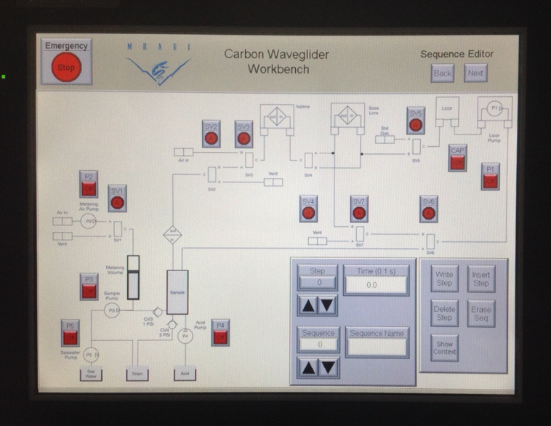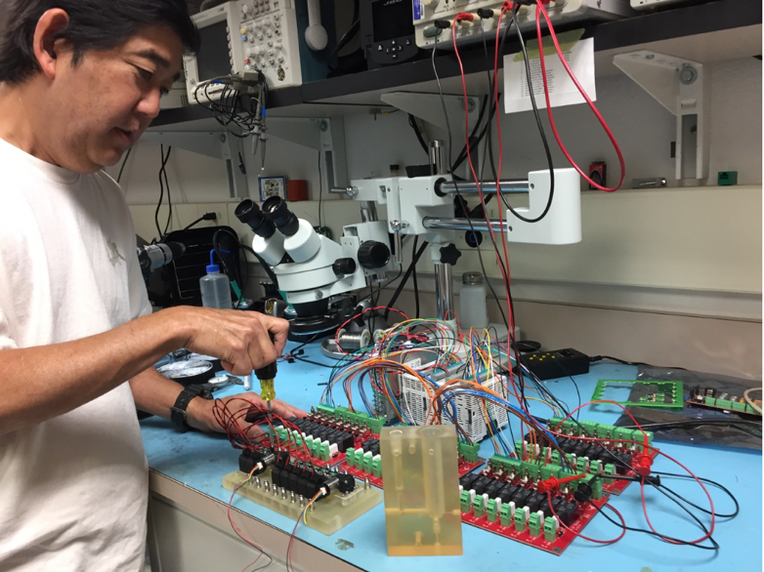

Figure 2. (a) COTS touch panel that will be used to control benchtop DIC system functionality. (b) Benchtop system manifolds and control electronics.

What percentage of labor and budget have been used through the 1st half of year?

Labor: 21%
Budget: 30%

Will you complete the current year’s scheduled work?

Yes. We are on track with our projected timeline and great progress has been made in the past few months with the benchtop system design, software, and parts manufacturing. We are now in the process of building the benchtop DIC system with initial testing expected to begin in September.

If you are at less than 50% resource usage, what is the plan to complete, or what work won’t be done this year?

Benchtop system buildup, initial testing, and troubleshooting will occur in the next few months, which will get us caught up in terms of labor and budget use.

Significant changes from previous project proposal

A successful NOPP proposal is now linking this project with NOAA PMEL and the University of Hawaii. This collaboration greatly improves the potential for future Saildrone applications.

Over the past two years, what peer-reviewed publications, education and/or outreach activities have resulted directly from this project? Please be brief.

None so far.

  - All Projects: Specific Plans for 2019

Research Activities

2018 Work:
- Build benchtop system.
- Test benchtop system:
  - Finalize sampling sequences to be used and determine appropriate timing of sequences.
  - Determine whether CO₂ extraction or equilibration will be used for the DIC measurement.
  - Determine the ideal sample and acid volumes for coastal vs. open-ocean DIC applications.
  - Run tests across a range of seawater sample concentration and temperatures. We can collect water during BOG cruises to get a range of DIC concentrations for lab testing.
  - Identify which data streams will need to be transmitted from the field system.
- Iterate on component design and manufacturing to further develop the fluid handling system.

2019 Work:
- Continue lab testing and determine the benchtop DIC system accuracy and precision.
  - We will make bulk DIC standards in the lab using our laboratory, high-quality DIC instrumentation to characterize poisoned seawater collected from the shore intake line or BOG cruises. For publication quality testing, we will use Certified Reference Materials.
- Integrate the DIC and pCO₂ systems.
- Test integrated system in the lab.
  - Finalize sampling sequences and timing.
  - Ensure DIC accuracy and precision isn’t compromised by integration.
  - Ensure pCO₂ accuracy and precision isn’t compromised by integration.
- Quarterly Skype meetings with PMEL and the University of Hawaii.
- Trip to Seattle to visit collaborators and share information (Long + Fassbender).
- Package the pCO₂-DIC system for wet testing.
- System trials in test tank and possibly on M1.

Engineering/technology development

See above.

Field programs (detail ship requirements/deployments/diver requirements)

We anticipate needing 4-6 days of R/V Paragon time to deploy and service instrumentation on the M1 mooring and would like to participate in scheduled Chavez BOG cruises on the R/V Rachel Carson. We will coordinate with the Chavez Lab when ready to plan field trials.

Depending on project progress, Wave Glider integration of the instrument package may begin in 2019 with the possibility of initial field test on the platform toward the end of 2019.
  - 4-6 days of R/V Paragon time would likely meet these needs.

We have requested 10 days of R/V Paragon time for this work

Additionally, we may have the opportunity to conduct field trials in conjunction not only with the PMEL pCO₂-DIC instrument but also with the ammonium (NH₄⁺) and DIC Digiscan analyzer being developed by Yui Takeshita and Ken Johnson. Our labs will work together to coordinate this activity if the opportunity arises.

Isotope Usage
Project teams must provide details regarding any planned isotope use on shore, on ships, in the Sanctuary, etc. Please review the guidance on isotope usage at http://www.mbari.org/at-sea/cruise-planning/hazardous-materials/ and policy at http://mww.mbari.org/safety/SafetyManual/Isotope_Use_Policy.pdf, and then provide details on plans below.

None.

Specific deliverables

- Preliminary accuracy and precision metrics for benchtop DIC instrument – completed 1st quarter
- Integration of DIC and pCO₂ functionality – completed 2nd quarter
- Successful lab trials of integrated pCO₂-DIC system – completed 3rd quarter
- Packaging of pCO₂-DIC system for test tank/M1 wet testing – completed 3nd quarter
- System trials in test tank - start 4th quarter

Milestones and required personnel (see personnel classification list for staff classifications)

2019 Project Start Date:  01/01/2019 | Milestone 1 | Milestone 2 | Milestone 3 | Milestone 4 | Milestone 5 | Total Resources (in hours) for each resource category for all milestones listed here
Milestone Date | Prelim. DIC accuracy & precision | pCO₂-DIC integration | pCO₂-DIC lab trials | Packaging of pCO₂-DIC system | System trials in test tank
Milestone Description
Electrical Engineer | CO: 80  PM: 60 | CO: 80  PM: 60 | CO: 80  PM: 60 | CO: 80  PM: 80 | CO: 40  PM: 40 | CO: 360  PM: 300
Software Eng-Embedded | KH: 540 | KH: 100 | KH: 60 | KH: 40 | KH: 45 | KH: 785
Software Eng-Info Eng
Mechanical Engineer | CO: 56 | CO: 56 | CO: 56 | CO: 56 | CO: 56 | CO: 280
Mechanical Eng-Division
Mechanical Eng-Mfg
Associate Engineer
Electrical Tech |  | 80 | 40 | 80 | 40 | 240
Software Tech
Mechanical Tech |  | 50 | 50 | 50 | 50 | 200
Machinist |  | 80 | 40 | 40 | 40 | 200
Divers

Budget justification

Lab Supplies and consumables | $10,000.00
Rapid prototyping, outside | $5,000.00
Tools and test equipment | $10,000.00
Electronics/PCB Fab | $5,000.00
Plumbing/pneumatics | $15,000.00
Total | $45,000.00

We’ve reduced our 2019 budget by $30k (relative to 2018) based on costs experienced and anticipated this year and our projections for 2019.

Project team

Andrea Fassbender (PI), Paul McGill (PM), Craig Okuda (EE, ME), Kent Headley (SE), Christopher Wahl (MO-Tech), Jacki Long (Sci.-Tech.)

14 days (112 h) of Chris Wahl’s time is requested for R/V Paragon outings (10 days) and Wave Glider integration discussions (4 days).

Project lab and office space requirements
In addition to any changes to current space usage, please also include anticipated office and lab needs for students, postdocs, collaborators, etc.

We plan to use bench space in the Fassbender-Takeshita Lab for 2019 bench testing, but space may be an issue in late 2019 or early 2020 when instrument integration into the Wave Glider platform begins.

R/V Paragon Requests
If the project team will be requesting time for the R/V Paragon, please specify the operators in the group and provide estimates of their availability to operate the vessel.

1010 days on R/V Paragon time with Chris Wahl as Captain.

Risk matrix (development and infrastructure projects only)

 | Technical Risk | Organizational Risk | Tech Transfer Risk | Labor Estimate Risk
High |  |  |  | X
Medium | X |  | X
Low |  | X

  - Compliance Considerations

Export Regulation
Does the project team anticipate any foreign collaborations or international travel? If so, please identify collaborators by name, institution, and country.

None.

Does the project team plan or anticipate export-controlled purchases, shipments, or transfers of items (e.g., research instruments, proprietary data, hand-carried tools or samples) outside the U.S. temporarily or permanently? If yes, please identify country or countries and indicate whether these items will remain under MBARI control while abroad or controlled by others. Will the items be exported to more than one country? Please include foreign collaborator information as described above.

None.

Monterey Bay National Marine Sanctuary (MBNMS)

General Permit
Projects teams need to indicate if any work will be performed that is either: (1) currently authorized under our general permit; or (2) will require that we obtain authorization. The current permit can be viewed at http://mww.mbari.org/pco/permits/mbnms-2015-002_feb2015.pdf. Please see Mandy Allen for questions.

Is a permit with MBNMS required for your work?

No.

SESAs (General map)
Projects will need to indicate whether or not work will be conducted within one of the Monterey Bay National Marine Sanctuary's Ecologically Significant Areas (SESAs). An interactive map can be found on the Sanctuary's SIMoN webpages at https://sanctuarysimon.org/regional_sections/maps/mpaviewer/. If your work will be conducted in one of these areas, please indicate which area by number or name (zoom in to see names of MPAs).

None.

California Department of Fish & Wildlife
A Scientific Collecting Permit will be required for biological and geological sample collections offshore California (even in Federal waters and beyond), and for many activities in State Marine Protected Areas. Please see Mandy Allen for questions.

Will you be collecting samples that require a permit?

No.

Will you be working in a State Marine Protected Area?

No.

Authorizations/Permits from other Agencies or Organizations
Is the project team aware of any other permits or authorizations that will be necessary to perform the proposed work? If so, please list below along with status of authorizations (obtained, pending, need to apply, etc.). Please see Mandy Allen if you have questions.

None.

Active Acoustics
We are keeping an inventory of acoustic instrumentation. The current list is posted here: https://mww.mbari.org/resources/2019_Proposal_Process/documents/mbari_acoustic_instruments_2018-05-29_ver_11.pdf. If you have or plan to use equipment that is not already on this list, please be sure to include that information here.

None.

References
Bakker, D. C. E. et al. (2016), A multi-decade record of high-quality fCO₂ data in version 3 of the Surface Ocean CO₂ Atlas (SOCAT), Earth Syst. Sci. Data, 8(2), 383–413, doi:10.5194/essd-8-383-2016.
Bresnahan, P. J., T. R. Martz, Y. Takeshita, K. S. Johnson, and M. LaShomb (2014), Best practices for autonomous measurement of seawater pH with the Honeywell Durafet, Methods Oceanogr., 9(October), 44–60, doi:10.1016/j.mio.2014.08.003.
Chan, F. et al. (2017), Persistent spatial structuring of coastal ocean acidification in the California Current System, Sci. Rep., 7(1), 2526, doi:10.1038/s41598-017-02777-y.
Chavez, F. P., J. Sevadjian, C. Wahl, J. Friederich, and G. E. Friederich (2017), Measurements of pCO₂ and pH from an autonomous surface vehicle in a coastal upwelling system, Deep Sea Res. Part II Top. Stud. Oceanogr., (xxxx), doi:10.1016/j.dsr2.2017.01.001.
DeVries, T. (2014), The oceanic anthropogenic CO₂ sink: Storage, air-sea fluxes, and transports over the industrial era, Global Biogeochem. Cycles, 28(7), 631–647, doi:10.1002/2013GB004739.
Dickson, A. G., and J. Riley (1978), The effect of analytical error on the evaluation of the components of the aquatic carbon-dioxide system, Mar. Chem., 6, 77–85, doi:10.1016/0304-4203(78)90008-7.
Fassbender, A. J., C. L. Sabine, N. Lawrence-Slavas, E. H. H. De Carlo, C. Meinig, S. Maenner-Jones, and S. Maenner Jones (2015), Robust Sensor for Extended Autonomous Measurements of Surface Ocean Dissolved Inorganic Carbon, Environ. Sci. Technol., 49(6), 3628–3635, doi:10.1021/es5047183.
Feely, R. A., C. L. Sabine, J. M. Hernandez-Ayon, D. Ianson, and B. Hales (2008), Evidence for Upwelling of Corrosive “Acidified” Water onto the Continental Shelf, Science (80-. )., 320(5882), 1490–1492, doi:10.1126/science.1155676.
Friederich, G. E., P. G. Brewer, R. Herlien, and F. P. Chavez (1995), Measurement of sea surface partial pressure of C02 from a moored buoy, Deep Sea Res. Part I Oceanogr. Res. Pap., 42(7), 1175–1186, doi:10.1016/0967-0637(95)00044-7.
Gray, S. E. C., M. D. DeGrandpre, T. S. Moore, T. R. Martz, G. E. Friederich, and K. S. Johnson (2011), Applications of in situ pH measurements for inorganic carbon calculations, Mar. Chem., 125, 82–90, doi:10.1016/j.marchem.2011.02.005.
Martz, T., K. Daly, R. H. Byrne, J. Stillman, and D. Turk (2015), Technology for Ocean Acidification Research: Needs and Availability, Oceanography, 25(2), 40–47, doi:10.5670/oceanog.2015.30.
Martz, T. R., J. G. Connery, and K. S. Johnson (2010), Testing the Honeywell Durafet for seawater pH applications, Limnol. Oceanogr. Methods, 8, 172–184, doi:10.4319/lom.2010.8.172.
Le Quéré, C. et al. (2018), Global Carbon Budget 2017, Earth Syst. Sci. Data, 10(1), 405–448, doi:10.5194/essd-10-405-2018.
Sabine, C. L. et al. (2004), The Oceanic Sink for Anthropogenic CO₂, Science (80-. )., 305(5682), 367–371, doi:10.1126/science.1097403.
Sutton, A. J. et al. (2014), A high-frequency atmospheric and seawater pCO2 data set from 14 open-ocean sites using a moored autonomous system, Earth Syst. Sci. Data, 6(2), 353–366, doi:10.5194/essd-6-353-2014.
Takahashi, T., S. C. Sutherland, C. Sweeney, A. Poisson, N. Metzl, B. Tilbrook, N. R. Bates, R. Wanninkhof, R. A. Feely, and C. L. Sabine (2002), Global sea–air CO₂ flux based on climatological surface ocean pCO₂, and seasonal biological and temperature effects, Deep Sea Res. Part II Top. Stud. Oceanogr., 49(9–10), 1601–1622, doi:10.1016/S0967-0645(02)00003-6.

This date and number should remain the same for the duration of the project. If your project start date for 2019 is not January 1, please indicate the start date in the first cell of the milestone chart. Format for duration example: “Year 2 of 5”.
Development and infrastructure projects must complete the risk matrix (see end of the proposal form).
Not all projects will require all four titles to be filled in. Please indicate individuals only for those titles that are appropriate for your project.
This category includes transfer of hardware, know-how, publications, presentations, etc.
This number should be the same number you entered on the resource requests for this particular resource.

