Project Number: | 901803

Project Start: Jan. 1, | 2021 | Project Duration (in years): | Year 1 of 3

Please indicate if proposal includes requests for any of the following (mark all that apply).

 | X |  |  |  |  |  |  |  |  | X
Ship Time |  |  | ROV |  |  | AUV |  |  | Wave Glider |  |  | Mini ROV

Please indicate what type of project is being proposed (mark only one).

 |  |  |  | X
Feasibility/Scoping  [Less than 100 days effort] |  |  | Development |  |  | Research |  |  | Infrastructure² |  |  | Education |  |  | Time Series |  |  | Institute Initiative

Project Manager: Paul McGill
Principal Investigator: Andrea Fassbender
Lead Scientist: Andrea Fassbender
Lead Engineer: Craig Okuda
Project Title: Carbon Wave Glider Development

Please indicate which category best describes the project theme (mark only one).

 | X
Ocean  biogeochemistry |  |  | Ecosystem dynamics |  |  | Ocean visualization |  |  | Exploration & discovery

Please indicate percentage of effort on this project anticipated for 2021 toward these three highest institutional goals (percentage total should equal 100%).

Goal | Developing/adapting innovative technologies | Utilizing developments to explore and understand ocean systems | Technology/knowledge transfer
Percentage | 70 | 10 | 20

- ABSTRACT (if submitted during abstract phase)

This project represents the next phase in developing a dual pCO₂-DIC instrument for surface vehicle and surface platform applications. During the first three years of this project our team developed instrument specifications, made engineering designs to package the pCO₂ and DIC measurement capabilities in a 1U Wave Glider payload housing, formalized our collaboration with NOAA PMEL, created a functional DIC instrument prototype using preliminary software for laboratory testing, advanced the software and designed control boards for the field instrument and began testing in the lab, and we anticipate making significant progress on the evaluation of DIC instrument accuracy and precision in the laboratory before 2021 (COVID restrictions dependent). The next three years of this project would involve: (1) adding pCO₂ measurement capability, (2) laboratory and tank testing of the combined pCO₂-DIC instrument, (3) integration onto the Wave Glider platform; and (4) field trials on a Wave Glider and a mooring.

- PROPOSAL

  - All Projects

Statement of the challenge, why it is important

Presently, there are no commercially available, dual-carbonate system sensors or instruments for autonomous application. Our goal is to develop a pCO₂-DIC instrument for use on surface platforms and vehicles and we are targeting the Wave Glider due to its small size, so that the instrument can be deployed on any larger platform. We are collaborating with NOAA PMEL on this development project via a NOPP grant, as well as a Cooperative Research and Development Agreement (CRADA), to strategically (1) leverage NOAA’s recent advancement of the ASVCO₂ pCO₂ system and (2) line up an immediate end user for the technology. If specifications are met, this instrumentation could be implemented on a NOAA CO₂ mooring array (~50 moorings) and would become a tool used on autonomous surface vehicles to more comprehensively study and monitor the marine carbon cycle. Simultaneously monitoring sea-surface pCO₂ and DIC over time will provide information about the efficiency at which the ocean is absorbing pCO₂ and make it possible to differentiate physical and biological signals that are often hard to disentangle from pCO₂ (or pH) observations alone. By incorporating a DuraFET pH sensor on the Carbon Wave Glider, this instrument will directly measure sea-surface and atmospheric-boundary-layer pCO₂, as well as wind speed and atmospheric pressure, and could contribute significantly to further validating BGC float-based approaches for estimating sea-surface pCO₂ and air-sea CO₂ flux in new regions of the global and coastal ocean. Additionally, by measuring three carbonate system variables simultaneously, this instrument may be able to contribute new information to ongoing debates regarding the internal consistency of the carbonate system for which there is an active OCB Working Group collaborating to address the issue https://www.us-ocb.org/ocean-carbonate-system-intercomparison-forum/).

Relevance

How does it relate/contribute to MBARI’s mission and strategic plan?

Development of a Carbon Wave Glider (CWG) addresses all three of the goals in MBARI’s Strategic Plan, which include:
- Develop or adapt innovative technologies that allow researchers to identify and resolve important questions and advance our understanding of the ocean.
- Utilize those developments to explore and understand how natural ocean systems operate and how they respond to natural and anthropogenic change.
- Transfer the knowledge gained, solutions devised, and the technology developed to communities outside of MBARI - researchers, educators, policy makers, resource managers, industry, and the general public

The project also aligns with two of the Strategic Plan Research Themes targeted for 2011–2020, including:
- Ecosystem dynamics research aims to comprehensively study productivity and transfer of matter and life between the ocean surface and the deep sea.
- Ocean biogeochemistry exploits the use of MBARI sensor technologies, both by MBARI and by colleagues worldwide, for developing a predictive understanding of global-scale processes, including climate change.

Does it relate to the Technology Roadmap? If so, please describe how. (See http://mww.mbari.org/oed/TechnologyRoadmap.pdf.)

This project is related to the Technology Roadmap through the implementation of wet chemistry at sea and development of the first autonomous dissolved inorganic carbon sensor designed for extended deployments (>4 months) on a mobile surface platform. These project characteristics address the Technology Roadmap goals of taking the laboratory into the ocean and advancing a persistent presence.

How does it relate/contribute to the Packard Foundation’s Ocean Grantmaking Program? (See https://www.packard.org/what-we-fund/ocean/ and documents therein.)

The Packard Foundation’s Strategic Framework for Oceans Grantmaking highlights Enhanced Scientific Understanding of the Function of Marine Ecosystems and Improved Coastal Management as two of the three key objectives. The CWG will contribute to both of these goals by providing novel observing capabilities and improved scientific understanding that can help to inform coastal management decisions. For example, the CWG may be used to identify and characterize regional ocean acidification (OA) refuges [Chan et al., 2017] along the coastline of the California Current System. Strategic missions of this nature will be guided by ongoing regional modeling and observing efforts to locate and study coastal OA asylum regions over a range of spatiotemporal scales, providing information that may be useful to regional policy makers, resource managers, and industry stakeholders. Over a longer time horizon, this technology could be adapted for application on the Saildrone to study western boundary currents or remote and severe regions of the Southern Ocean, which are notoriously challenging to observe yet are home to some of the largest air-sea fluxes of heat, moisture, momentum, and CO₂ in the global ocean. Being able to observe the exchanges of heat and carbon in these regions will provide context for observations of ecosystem functionality and change from platforms such as BGC profiling floats and remote sensing.

Overall approach to the challenge: Over the complete term of the project, what is needed to address the challenge (e.g., sensors, platforms, marine operations, de novo R & D, etc.)

Research

The primary goals of this three-year project are to complete the development, lab testing, and field trials of the CWG and subsequently conduct a science mission. This process will involve collaboration with PMEL and ultimately a transfer of the CWG software and design to PMEL to facilitate scaleup.

The first year of the project will involve (1) extensive testing of the DIC benchtop system to asses accuracy and precision and optimize the liquid handling system (including design iteration as needed), (2) final benchtop testing to assess performance of the merged pCO₂-DIC system, (3) tank testing, and (4) a possible field deployment on the M1 mooring.

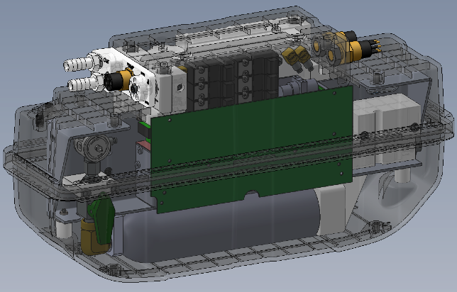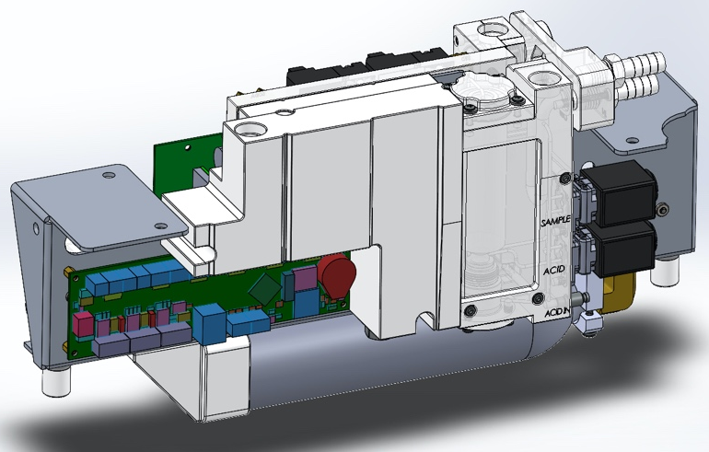
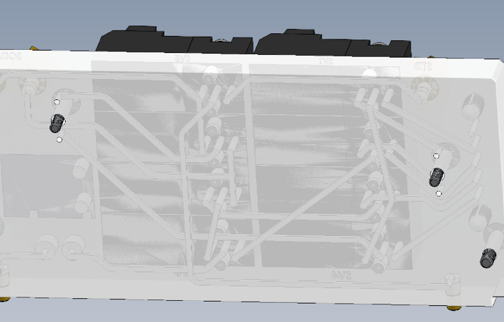
Figure 1. Schematic of prototype pCO₂-DIC unit in a 1U Wave Glider payload housing (upper left), outside of the housing and rotated 180° (upper right), and a close up of the fluid flow paths (minimizing external tubing) controlled by eight valves (lower left). System control diagram (lower right; a larger version is included at the end of the proposal).

Year two of the project will involve integrating the instrument into a 1U Wave Glider payload housing and finalizing software functionality. Craig Okuda has already drafted designs to fit the instrument in a 1U housing (Fig. 1) and Kent Headley has made significant progress in developing software capable of field application (Fig. 2). The firmware implementation is functionally complete and capable of supporting benchtop testing. 2020 Q3/4 software effort will focus on lab test support and advancing host-side software, telemetry, and components supporting post-processing workflows.

Figure 2. Instrument firmware features.

After some initial CWG tank testing, preliminary Wave Glider field trails would ideally involve operating the CWG in the vicinity of another Wave Glider equipped with the standard pCO₂ and pH measurement capability in Monterey Bay. This test will be coordinated to overlap with a BOG cruise out to the M1 mooring such that discrete DIC and pH samples as well as high-frequency pCO₂ observations from the ship (underway) and M1 mooring can be used for validation. The year-three science mission is TBD but may involve (1) collaboration with local CPF experiments, (2) deployment in a Hawaiian coral reef environment via collaboration with Christopher Sabine at the University of Hawaii, or (3) incorporating the CWG into the anticipated Jupiter Research Foundation California Current System project, which the Chavez and Fassbender Labs are involved in.

Engineering/Technology Development
We anticipate the following engineering & technology needs:
- Year 1:
  - Laboratory:
    - Conclude preliminary DIC instrument performance bench testing
    - Merge the pCO₂ and DIC instrument capabilities and bench test
  - Test tank: Deployments to verify extended, autonomous operation
  - Ship: M1 mooring deployment(s)
- Year 1-2:
  - Platform: Integration of the instrument package onto the Wave Glider
- Year 2-3:
  - Platform: Wave Glider field trials
  - Platform: Mooring deployment near Washington or Hawaii in collaboration with PMEL and UH
- Year 3:
  - Platform: Wave Glider science application

Marine Operations/Field Programs

M1 deployments will be coordinated with Jared Figurski and will leverage scheduled BOG cruises from which we can compare instrument measurements with underway ship pCO₂ values as well as discrete DIC and pH samples. Mooring pCO₂ values will also provide a local, continuous reference.

- 5 days of Chris Wahl’s time are requested for instrument integration.
- 36 days of Wave Glider Hansen time are requested for instrument integration and field testing.
  - 5 days for sensor integration
  - 2 x 5 days for preliminary field trials
  - 21 days for field experiment. This is tentative as we may opt for an M1 mooring deployment, which would delay the preliminary Wave Glider field trials.
- 5 days of R/V Paragon and a TBD (possibly Jacki Long) captain’s time are requested to collect discrete carbon validation samples next to the M1 mooring and/or Carbon Wave Glider during instrument field testing.

Data
What data products will be generated?

We need to support a variety of over-the-horizon (OTH) telemetry options, which may include expensive satellite and cellular links with limited bandwidth. While it is good practice to preserve raw sensor data, the native data format of the LI-COR sensor isn’t ideal for telemetry because the native records are large with high overhead; many records are needed for each measurement. Our strategy is to log raw records on the instrument as well as more compact measurement summaries that may be returned in real-time and enable first-order data analysis, QC, and system monitoring.

One telemetry option we have discussed is integrating the pCO₂-DIC instrument with the OASIS5 instrument controller/logger. This could be deployed on either a mooring or Wave Glider as a stand-alone package, including its own telemetry resources (e.g. 900 MHz radio). Using OASIS5 would also enable collection of synchronized, co-located CT measurements critical to analysis. Using an OASIS controller and separate radio for initial field testing has additional benefits:

- Software integration is faster and simpler for OASIS. Data-landing infrastructure exists for OASIS, which is not proprietary and has less of a learning curve.

- OASIS is better suited to a long-term test in the MBARI test tank, since the hardware is readily available and can be used for long periods.

- OASIS uses less power than the Wave Glider SMAC, and so may extend deployment duration.

We plan to integrate fully with platforms like Wave Glider and Saildrone in following years, and will work on this as time permits. We also think it makes sense to use the fastest path to field testing the instrument at this stage. The pCO₂ controller hardware is compatible with many host environments; OASIS5 is not a requirement, so this should not generally affect exportability.

Our planned data processing pipeline consists of
- telemetry endpoint (i.e. radios and PC hardware) at MBARI
- software and computing resources to produce real-time QC and visualizations
- public presentation on the MBARI web site
- data archive (accessible to collaborators at PMEL by some means)

Figure 3. Telemetry and processing pipeline concept

We plan to build as much of the processing pipeline (Fig. 3) as possible to use for lab work, integration, and testing. Much of the detailed design for telemetry, post-processing workflows and products are planned for Q3-4 2020, as it makes sense to work through lab testing procedures to fully understand the requirements. This work is underway.

Known data products include the raw LI-COR data and summaries produced on the CWG hardware, along with CTD and pH sensor data and any other ancillary sensors and host data.

Derived data products would include analysis data sets, measurements, plots, and publications.

How will the data products be managed?

All MBARI project data will be stored locally on the Atlas Carbon Wave Glider project share.

Describe data availability outside of the project team.

Any development data will be shared with NOPP collaborators at NOAA PMEL and the University of Hawaii. No data will be shared outside of the collaborative agreement until an agreed-upon presentation or publication of initial field test results.

Describe data storage requirements.

Atlas Carbon Wave Glider Project Share.
Storage estimates for data products are shown below (Fig 4).

Figure 4. Data storage estimate basis

Post-production data products have yet to be defined. Initial discussions with PMEL collaborators suggest that we will need to produce duplicate and derivative data products in a standard form such as NetCDF.

However, if we decide to implement telemetry, we’ll need a machine on the MBARI network that can host telemetry data and a Web server with scripting and applications to generate and serve real-time status and data. This could be a VM; we’d like it to be backed up and would require administrative access to allow us to install and maintain software.

The Fassbender lab post-processing workflows will likely use a combination of custom utilities, scripting, and MATLAB for data analysis. It is not clear at this time what the final data products will be. We anticipate that these might include duplications of subsets of the original data, and small amounts of storage for derivative data products, plot images, etc.

Using a conservative estimate and ample margin of error, total storage would be ~100 GB/year.

To summarize data and computing infrastructure needed for 2021:
- 100 GB storage, with backup support
- A Linux VM or desktop with admin access and backup support
- MATLAB licenses (via Fassbender UCSC license)

Anticipated Impact

Who are the consumers of the instruments, methods, systems, and data that will be generated?

MBARI PIs and collaborators at PMEL would be the initial users of the instrumentation. Upon achieving successful field trials, the goal would be to scale up production (PMEL or industry partner effort) and deploy the instrument on NOAA’s carbon mooring array (n~50). Other potential applications include use on underway ships and additional ASVs. This CWG may also be of interest for the ongoing Jupiter Research Foundation REACT Project that MBARI is engaged in.

Anticipated Outreach

What outreach assets might you need to better reach the audience/consumers you are targeting? Specify how you might like to reach your audience (published paper, seminar, conference, social media, etc.) and what type of assets (graphic, animation, video, etc.) you might need ITD to help generate.

Working with ITD to develop an animation or video would help to promote potential applications of the technology as well as the larger vision for its use.

Intellectual Property (IP) Considerations

Do you anticipate a need for a cooperative research and development agreement or licensing arrangement with an external entity?

This is a collaborative project with NOAA PMEL and a formal CRADA is already in place. PMEL will lead the effort to identify an industry partner that would manufacture the instrument once desired performance is achieved.

Will novel IP be created, and how might it be disseminated (e.g., open-source, royalty-free license, commercial license agreement)?

The pCO₂-DIC instrument firmware is maintained on a Bitbucket repository, potentially accessible to collaborators at PMEL. We could elect to use a related repository to share hardware designs and other IP covered by our licensing agreement.

Will the work potentially result in a patentable product or service?

It is not yet clear if this work will result in a patentable product, but we’ll make that determination as the design matures.

For additional guidance please review MBARI’s intellectual property internal web page: https://mww.mbari.org/itd/ip/.

[Click here to provide any additional details]

  - Continuing Projects

If the proposed project includes multiple individual projects, please list each of these projects as a subheading in the proposal. For each subheading, please address the following:

Current status of project and results to date

[Click here to enter text]

What percentage of labor and budget have been used through the 1st half of year?

[Click here to enter text]

Will you complete the current year’s scheduled work?

[Click here to enter text]

If you are at less than 50% resource usage, what is the plan to complete, or what work won’t be done this year?

[Click here to enter text]

Significant changes from previous project proposal

[Click here to enter text]

Over the past two years, what peer-reviewed publications, education and/or outreach activities have resulted directly from this project? Please be brief.

[Click here to enter text]

To date has any novel intellectual property been developed and/or disseminated?

[Click here to enter text]

  - All Projects: Specific Plans for 2021

Research Activities

- Laboratory:
  - Conclude preliminary DIC instrument performance bench testing
  - Merge the pCO₂ and DIC instrument capabilities and bench test
- Test tank: Deployments to verify extended, autonomous operation
- Ship: M1 mooring deployment(s)

Engineering/technology development

See above.

Will novel intellectual property be developed and/or disseminated?
Dissemination includes patenting, licensing, and collaboration agreements.

We will continue our CRADA with NOAA PMEL, and it’s likely that a licensing agreement will have to be set up with a manufacturing partner to produce the instruments not only for MBARI/PMEL needs, but to make instruments available to the greater research community as well.

Field programs (detail ship requirements/deployments/diver requirements)

In addition to describing anticipated field programs, please be sure to include requirements for specific platforms and equipment (Dorado AUVs, LRAUVs, Wave Glider, mini ROV, etc.) for each proposed field program so that expectations are clear. Requests must also be entered in the budget entry system.

Five days of R/V Paragon and a TBD (Chris Wahl or Jacki Long) captain’s time are requested to collect discrete carbon validation samples next to the M1 mooring during instrument field testing.

Isotope Usage
Project teams must provide details regarding any planned isotope use on shore, on ships, in the Sanctuary, etc. Please review the guidance on isotope usage at http://www.mbari.org/at-sea/cruise-planning/hazardous-materials/ and policy at http://mww.mbari.org/safety/SafetyManual/Isotope_Use_Policy.pdf, and then provide details on plans below.

N.A.

Safety Disposal Needs

So the Safety office can plan and budget accordingly, please respond to the questions below regarding any anticipated safety disposal needs for the coming year. Budget for cost of such removal will be captured by the safety office based on responses received.

Will this project generate more than 1 gallon (4 liters) of battery waste per year?

No.

If yes, please indicate the type of batteries (alkaline, NiCad, NiMH, lithium ion or lithium metal) and the approximate amount of each to be generated.

N.A.

Will this project generate more than 15 gallons (60 liters) of hazardous liquid waste per year?

Unlikely but possible.

If yes, please indicate the composition of the waste(s) and the quantity of each to be generated.

Seawater poisoned with mercuric chloride (0.00204% HgCl₂, or 20.4 ppm).

Specific deliverables

2021 deliverables:
- DIC prototype accuracy and precision testing – 1st & 2nd quarter
- Final testing of integrated pCO₂-DIC system in lab – 3rd quarter
- Tank testing – 3nd quarter
- Possible field trials on M1 mooring – 4th quarter

Milestones and required personnel (see personnel classification list for staff classifications)

2021 Project Start Date:  01/01/2021 | Milestone 1 | Milestone 2 | Milestone 3 | Milestone 4 | Milestone 5 | Total Resources (in hours) for each resource category for all milestones listed here
Milestone Date | Year 1: 04/1/2021 | Year 1: 07/1/2021 | Year 1: 01/01/2022 | Year 2 | Year 3
Milestone Description | DIC accuracy/  precision testing | Integrated pCO₂-DIC system testing | Tank and M1 trials | WG integration, WG/M1 testing | Science application – woohoo!
Electrical Engineer | 100 (CO)  60 (PM) | 80 (CO)  60 (PM) | 80 (CO)  80 (PM) | TBD | TBD | 260 (CO)  200 (PM)
Software Eng-Embedded | 50 (KH) | 530 (KH) [1] | 100 (KH) | TBD | TBD | 680 (KH)
Software Eng-Info Eng
Mechanical Engineer
Mechanical Eng-Division
Mechanical Eng-Mfg
Associate Engineer |  |  |  |  |  | 240
Electrical Tech
Software Tech |  |  |  |  |  | 200
Mechanical Tech |  |  |  |  |  | 200
Machinist
Divers
[1] includes development for host, telemetry, processing

Budget justification

Lab supplies and consumables $2,500
OASIS5, UHF telemetry radio and payload box $8,000
LICOR 850 (2 units) $7,000

Rapid prototyping, outside $4,000

Tools and test equipment $5,000

Electronics/PCB fab $5,000

Plumbing/pneumatics $10,000

Total $41,500

Project team

Andrea Fassbender (PI: 460h), Paul McGill (PM: 200 h), Craig Okuda (EE/ME: 260 h), Kent Headley (SE: 680 h), Jacki Long (Sci.-Tech.: 567 h)

We are also requesting the following labor hours:
- Associate Engineer: 240 h
- Software Tech.: 200 h
- Mechanical Tech.: 200 h

~8 h per person per quarter will be required of the Carbon Wave Glider project engineers (Kent Headley, Paul McGill, and Craig Okuda) for preparation and participation in quarterly Skype meetings with PMEL and UH.

Project lab and office space requirements
In addition to any changes to current space usage, please also include anticipated office and lab needs for students, postdocs, collaborators, etc.

We will use bench space in Lab B126 for testing.

R/V Paragon Requests
If the project team will be requesting time for the R/V Paragon, please specify the operators in the group and provide estimates of their availability to operate the vessel. DMO staff have extremely limited availability to be operators and only with advanced budgeting and planning.

Five days of R/V Paragon and a TBD (Chris Wahl or Jacki Long) captain’s time are requested to collect discrete carbon validation samples next to the M1 mooring during instrument field testing.

Risk matrix (development and infrastructure projects only)

 | Technical Risk | Organizational Risk | Tech Transfer Risk | Labor Estimate Risk
High |  |  |  | X
Medium | X |  | X
Low |  | X

  - Compliance Considerations

Export Regulation
Does the project team anticipate any foreign collaborations or international travel? If so, please identify collaborators by name, institution, and country.

None.

Does the project team plan or anticipate export-controlled purchases, shipments, or transfers of items (e.g., research instruments, proprietary data, hand-carried tools or samples) outside the U.S. temporarily or permanently? If yes, please identify country or countries and indicate whether these items will remain under MBARI control while abroad or controlled by others. Will the items be exported to more than one country? Please include foreign collaborator information as described above.

None.

Monterey Bay National Marine Sanctuary (MBNMS)

General Permit
Projects teams need to indicate if any work will be performed that is either: (1) currently authorized under our general permit; or (2) will require that we obtain authorization. The current permit can be viewed at https://mww.mbari.org/pco/permits/mbnms-2020-006_exp28feb2025.pdf. Please see Mandy Allen for questions.

Is a permit with MBNMS required for your work?

Yes. Wave Glider and M1 mooring activity within the MBNMS is already covered by MBARI’s permit; however, our instrument will discharge a small quantity (~1 mL) of acidified seawater (pH ~4) after each DIC measurement. Based on notes from last year’s proposal, Mandy Allen will add this new payload characteristic to MBARI’s permit during the renewal process near the end of 2020.

SESAs (General map)
Projects will need to indicate whether or not work will be conducted within one of the Monterey Bay National Marine Sanctuary's Ecologically Significant Areas (SESAs). If your work will be conducted in one of these areas, please indicate which area by number or name.

None.

Anchors
For activities conducted under MBARI's permit for the Monterey Bay National Marine Sanctuary, Paragraph 16, we are required to recover anchors weighing less than 500 pounds. Project proposals, which involve anchors weighing less than 500 pounds, shall specifically indicate cruise time allocated to anchor recovery. Lack of cruise time is not an acceptable reason for deeming an anchor less than 500 pounds “unrecoverable” under Paragraph 17 of MBNMS permit. Also under Paragraph 17, ALL anchors not recovered during the year must be reported detailing location, description of anchor, and reason not recovered. (Mandy Allen will collect this information from project teams to submit as part of the annual report to the Sanctuary.) Each ship will be tracking anchors deployed, duration of attempted anchor recovery, and anchors abandoned on the seafloor with the intent that they be recovered in the future as per MBNMS permit requirements.

Will you be deploying equipment that will require anchoring? If so, please indicate approximate weight of anchors to be used and recovery plans.

N.A.

California Department of Fish & Wildlife
A Scientific Collecting Permit will be required for biological and geological sample collections offshore California (even in Federal waters and beyond), and for many activities in State Marine Protected Areas (MPAs). Please see Mandy Allen for questions.

Will you be collecting samples that require a permit?

No.

Will you be working in a State Marine Protected Area?(See link above for Statewide MPAs or this link for Central California MPAs.)

No.

United States Coast Guard

If your project will deploy or maintain moorings, the project team must ensure proper compliance and notification of these activities to the US Coast Guard. DMO does not automatically do these notifications on behalf of projects. Two common types of permits and notifications that may apply to your project are Private Aid to Navigation (PATON) authorizations (required for buoys deployed for six (6) months or longer) and Notice to Mariners, which must be submitted for temporary PATONs (less than 6-month deployments). Other science operations may submit a request for a Local Notice to Mariners and are useful for missions or deployments with risk of 3rd Party Liability such as the Wave Glider.

Will your project require a PATON?

No.

If yes, have you obtained a PATON? (Please provide a copy to Mandy Allen.)

No.

Will your project require submission of a Local Notice to Mariners?

No.

If yes, please indicate who will be submitting request and provide a copy of the submission to Mandy Allen.

N.A.

Authorizations/Permits from other Agencies or Organizations
Is the project team aware of any other permits or authorizations that will be necessary to perform the proposed work? If so, please list below along with status of authorizations (obtained, pending, need to apply, etc.). Please see Mandy Allen if you have questions.

No.

Active Acoustics
We are keeping an inventory of acoustic instrumentation. The current list is posted here: https://mww.mbari.org/resources/2021_Proposal_Process/mbari_acoustic_instruments_updated_may_13_2020_ver_13.xlsx. If you have or plan to use equipment that is not already on this list, please be sure to include that information here.

N.A.

Larger version of lower right panel in Figure 1.

Development and infrastructure projects must complete the risk matrix (see end of the proposal form).
Not all projects will require all four titles to be filled in. Please indicate individuals only for those titles that are appropriate for your project.
This category includes transfer of hardware, know-how, publications, presentations, etc.
This number should be the same number you entered on the resource requests for this particular resource.

