Deep-Sea-DuraFET (DSD) k2 cap for 250ml Jacketed Beaker design requirements
10/16/2020
Objective:
Design a cap to conduct temperature calibrations for the DSD pH sensor using the 250 ml jacketed beaker. For this, the sensing elements for the DSD and thermometer must be submerged in the beaker solution (e.g. 0.1M HCl) to measure sensor voltage and temperature. Then temperature will be ramped to make measurements across a range of 2-35C. There will be two versions of this base design: one with ports only for sensor and thermistor, and a second with two extra ¼-28 ports in addition to the thermistor and sensor.
Design requirements:
- A starting point for this would be the cap Hans designed for the 1L Jacketed Beaker that is attached to a frame to mount electronics, optics (fiber), all attached to a rod. This was designed this way because we wanted to keep the optics in place while we change solutions. This does not have this consideration. Solids located in: \\atlas\carbonlab\pH DSD spec comparison\ThermalBeakerFrame\318jahaThermalBeakerSetup. Relevant pictures below:
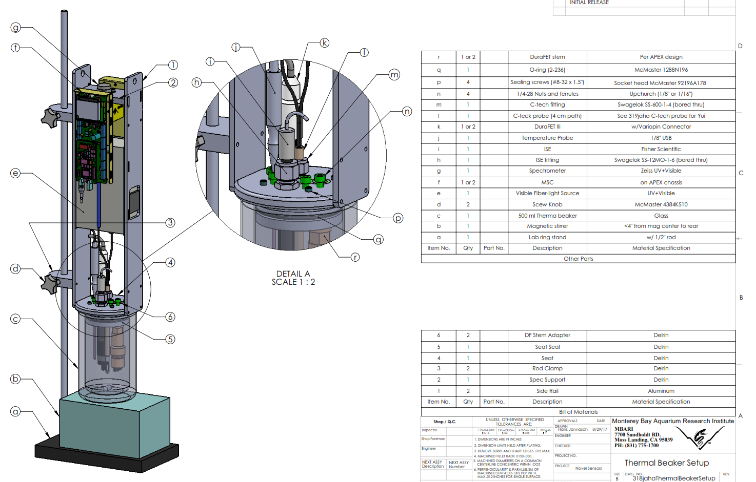

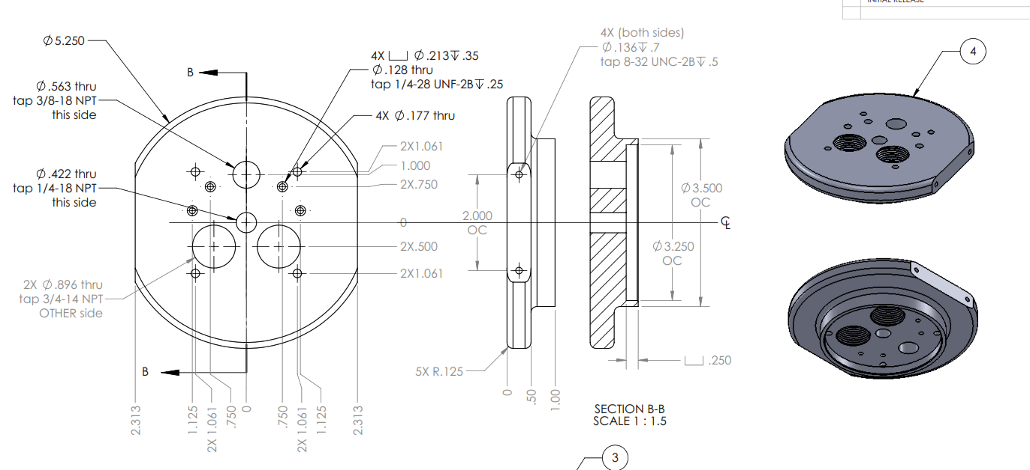
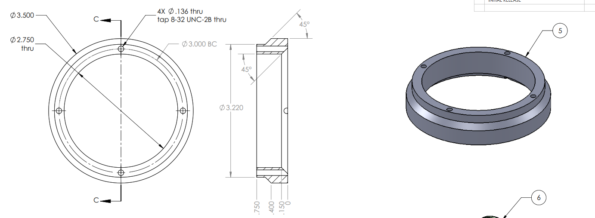
- The overall cap should have a mechanism to seal along the inner beaker surface with o-ring by e.g. compressing two parts together with screws (see drawings above). I think 2 screws are sufficient; 4 is overkill and annoying to deal with.
- Cap 1 should accommodate:
  - DSD pH sensor (sealed using o-ring near sensing surface)
  - ¼-28 port for thermometer
- Cap 2 should accommodate:
  - DSD pH sensor (sealed using o-ring near sensing surface)
  - ¼-28 port for thermometer
  - 2x additional ¼-28 ports for doping/sampling the solution (and for minimizing headspace via top-off filling)
Additional Design considerations:
- Does pH sensor need a locking mechanism? There will be a bit of internal pressure pushing up because of the thermal expansion of the solution. Below is the density of seawater (salinity = 35) as a function of temperature.
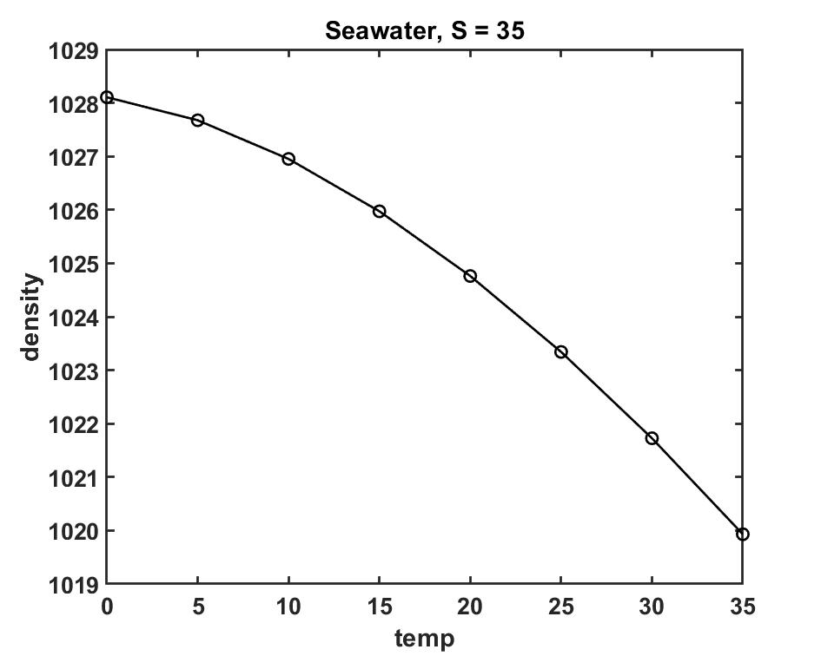
- Over 35 C, density changes by 8 kg/m³, or by about 0.8%. Assuming starting volume of 250 ml, we expect a volume change of 2ml. I don’t think this is enough to pop out the pH sensor out, but should be checked. We can also make the squeeze for the o-ring higher so it adds extra force to push back.
- Minimize headspace in beaker. At low temperatures, water will condense on the top of the inside of the beaker cap. This will change the concentration of the solution slightly, so minimizing headspace is best, as we need to know the concentration of the solution.

