Data-Driven Animation Journal
Here, you will document your data-driven animation journey. Follow along in this table of contents and complete your self-assessment/rubric as you go.

Animator

Data Contributor

Project Title

Project Summary

Table of Contents

A: Syllabus 5
COVID Guidelines 5
Course Information 5
Course Resources 5
Teaching Team 6
Daily Agenda 6
Course Description 7
Course Goals 7
Learning Outcomes 7
Course Prerequisites 8
Software 8
Assignments & Grading 8
Expectations 9
Accessibility 9
Community Guidelines 9
Title IX/Care Advisory 10
Difficult Conversations 10
B: Preparing your data 11
A) Rotation & Position 12
B) Swimming / flying / walking 13
C) Heart Rate 14
C: Preparing your workstation 15
1: Introductions and Collaboration 16
Agenda 16
Abstract switch 16
What did they do? 17
What did they find? 17
Why does it matter? 17
Reflection 17
Lecture: Intro to Data Visualization (20min) 18
Data Description 18
Style Guide 19
Who is your audience? 20
Script - First Draft 21
HOOK 21
METHODS 21
RESULTS 21
CONCLUSION 21
Script - Revised 22
Budget 23
Conceptualization 23
Creation of original artwork 23
Animation 23
Video editing and narration 23
Music production 23
Revisions 23
Administrative 23
Contract 24
File Organization 28
File naming convention: 28
Folder structure 28
Homework: Data Description, Style Guide, Contract, & Budget 29
2: Conceptualization 31
Agenda 31
Opening Activity: Critique & Reflection- Scripts & Style Guides 31
Lecture: Storyboards - Illustration for animation 32
Storyboard Template 32
Demo/Lecture and Closing Activity:
Creating an animatic in Premiere Pro 35
Homework: Storyboard, Animatic, & List of Key Assets 36
3: Digital Art & Design 37
Agenda 37
Opening Activity: Critique & Reflection- Animatics & key assets 37
Lecture: Introduction to Digital Art 38
Demo: Vector Graphic - Outlines in Illustrator 38
Demo: Raster Graphic - Painting in Photoshop 38
Homework: Animatic & List of Key Assets 38
4: Data Visualization 39
Agenda 39
Opening Activity: Decoding Code & Figures 39
Lecture: Data Visualization 40
Demo/Work time 40
Homework: Code & key figure 41
5: Animation & Motion Graphics 42
Agenda 42
Opening Activity: Animation Storyboard Sketch 42
Animation Reflection 42
Lecture: Introduction to Animation 43
Demo: Animating in After Effects 43
Work time: Make your animated motion graphic 43
Homework: Motion Graphics Scene 43
6: Animating 2D Data 44
Agenda 44
Opening Activity: 2D Data Animation Storyboard Sketch 44
2D Data Animation Reflection 44
Lecture: Introduction to 2D Data Animation 45
Demo: Animating 2D Data (using CSVs) in After Effects 45
Demo: Other techniques for 2D Data Animation 45
Work time: Make your animated 2D data scene 45
Homework: 2D Data Scene 45
7: Intro to 3D Animation 46
Agenda 46
Opening Activity: Exploring assets in Maya 46
Lecture: Introduction to 3D Animation 46
Work time: Explore 3D model in Maya 46
Demo: Animating a locomotion cycle 46
Work time: Animate your 3D model 46
Homework: Locomotion cycle 46
8: Animating 3D Data 47
Agenda 47
Opening Activity: Critique & Reflection- Locomotion Cycles 47
Lecture: Introduction to 3D Data Animation 48
Demo: Animating 3D Data (using CSVs) in After Effects 48
Demo: Other techniques for 3D Data Animation 48
Work time: Make your animated 3D data scene 48
Homework: 3D Data Scene 48
9: Editing & Compositing 48
Agenda 48
Opening Activity: Feedback & Discussion 49
Lecture: Compositing 49
Work time: Assembling animation 49
Homework: Submit Final Project 49
10: Final Critique & Communication Strategy 50
Agenda 50
Opening Activity: Final Project Critique & Reflection 50
Self-Assessment 50
Work time: Revisit animation tasks- solicit feedback 50
Lecture: Science Communication Strategy 50
Work time: Create Science Communication Strategy 50
Homework: Science Communication Strategy 50
Rubric 52
Guest Speakers 58

A: Syllabus

COVID Guidelines
WHAT WE CAN EXPECT FROM EACH OTHER — Each individual should act in the best interests of everyone else in our community. Please take care to comply with all CSUMB university guidelines about masking in indoor settings, performing daily symptom checks, testing as required by the campus vaccine policy, self-isolating in the event of exposure, and respecting others’ comfort with distancing. If you forget your mask, you can ask me for one; there is a limited supply of disposable masks in each classroom. If you are ill or suspect you may have been exposed to someone who is ill, or if you have symptoms that are in any way similar to those of COVID-19, please err on the side of caution and stay home until you are well or have tested negative after an exposure. Let me know that you’re not feeling well and I’ll respond about how best you can keep learning.

WHAT YOU CAN EXPECT FROM ME — I have designed our course following campus guidance and with current public health guidelines in mind. However, these guidelines may change in accordance with shifting infection rates or the emergence of new variants. If updated public health recommendations and university requirements make our current course format unfeasible, or if I experience a need to self-isolate, I will alter the format. This may include moving in-person sessions onto Zoom, modifying course assignments to work in a remote format. I will communicate clearly with you via email or Canvas announcement about any changes that occur. I will provide as much advance warning as possible and give you all the information you need to transition smoothly to the new format. If you have questions about the changes, please reach out to me so I can answer them.

WHAT I EXPECT OF YOU — If you experience an illness or exposure that requires you to miss class sessions or to attend remotely, please communicate with me as soon as possible and I will provide you with options to allow you to continue making progress in the class. While we have designed the course to operate primarily in person, we do not want to encourage folks to show up if they are sick. If you are sick, I will do my best to create a virtual learning option (following along in this journal and providing recordings or Zoom meetings when possible).

For updated campus news and policies related to COVID-19, please refer to the CSUMB COVID informational website: https://csumb.edu/health/coronavirus-information/

Course Information
Course name | Days/Times | Instructor
Data-Driven Animation for Science Communication | July 18-29  Monday-Friday  2:00 PM to 6:30 PM | Dr. Jessica Kendall-Bar (she/her)  jkb@ucsc.edu

Course Resources
- CANVAS: https://csumb.instructure.com/courses/16101
  - Lectures, assignment submissions
- Shared Google Drive: https://drive.google.com/open?id=1nPMy8T-9RJd8YEpBeTomZM2bXNYda__o&authuser=jmkendal%40ucsc.edu&usp=drive_fs
  - Multimedia file-sharing
- Data-Driven Animation Journal Google Document
  - Step-by-step guides, instructions, and self-assessment rubric
- DISCORD: https://discord.gg/qQpYDNybaE
  - Informal discussions, troubleshooting, feedback, and help

Teaching Team
Should you need to contact the teaching team to inquire about a question, please send an email (“Dear Teaching Team,”) and CC the three of us so that we can assist you in a timely manner.
Before emailing the teaching team, make sure to:
- Search this google document for the information you are looking for
- Look in our Discord server for the answer to your question (first in #general and then in the topic-specific channels) : https://discord.gg/qQpYDNybaE
- If your question could be relevant to others, post your question in the Discord server.
Name | Role | Email
Dr. Jessica Kendall-Bar (she/her) | Instructor | jkb@ucsc.edu
Salma Abdel-Raheem (she/her) | Instructional Assistant | stabdelr@ucsc.edu
Aaron Zachmeier  (he/him) | Instructional Designer | zachmeier@ucsc.edu

Daily Agenda
Example daily course agenda structure

2:00 - 2:20: Agenda & questions (20 min)
2:20 - 2:50: Opening Activity -
Interactive activity where you present your work and receive feedback (30 min)
2:50 - 3:00: Break / Reflection (10 min)
3:00 - 3:30: Lecture - Lecture with background information on the topic of the day (30 min)
- 20 minute lecture
- 10 minutes for questions / discussion
3:30 - 4:00: Work time - Topic-based brainstorming and reflection (30 min)
4:00 - 4:10: Break (10 min)
4:10 - 4:40: Closing Activity (Instructions) - Demo / specific guidance (30 min)
4:40 - 5:20: Work time - Individual work time (40 min)
5:20 - 5:30: Break (10 min)
5:30 - 6:30: Guest speaker interview with time for questions (30 min interview)
- 40 minutes of Q&A with pre-prepared questions
- 20 minutes of office-hour-type consultation where students may ask questions

Course Description

Each student will create a scientific animation that tells a story with data to better communicate scientific results – along the way they will learn programming, science writing, and technical animation skills.

At a glance (subject to change):
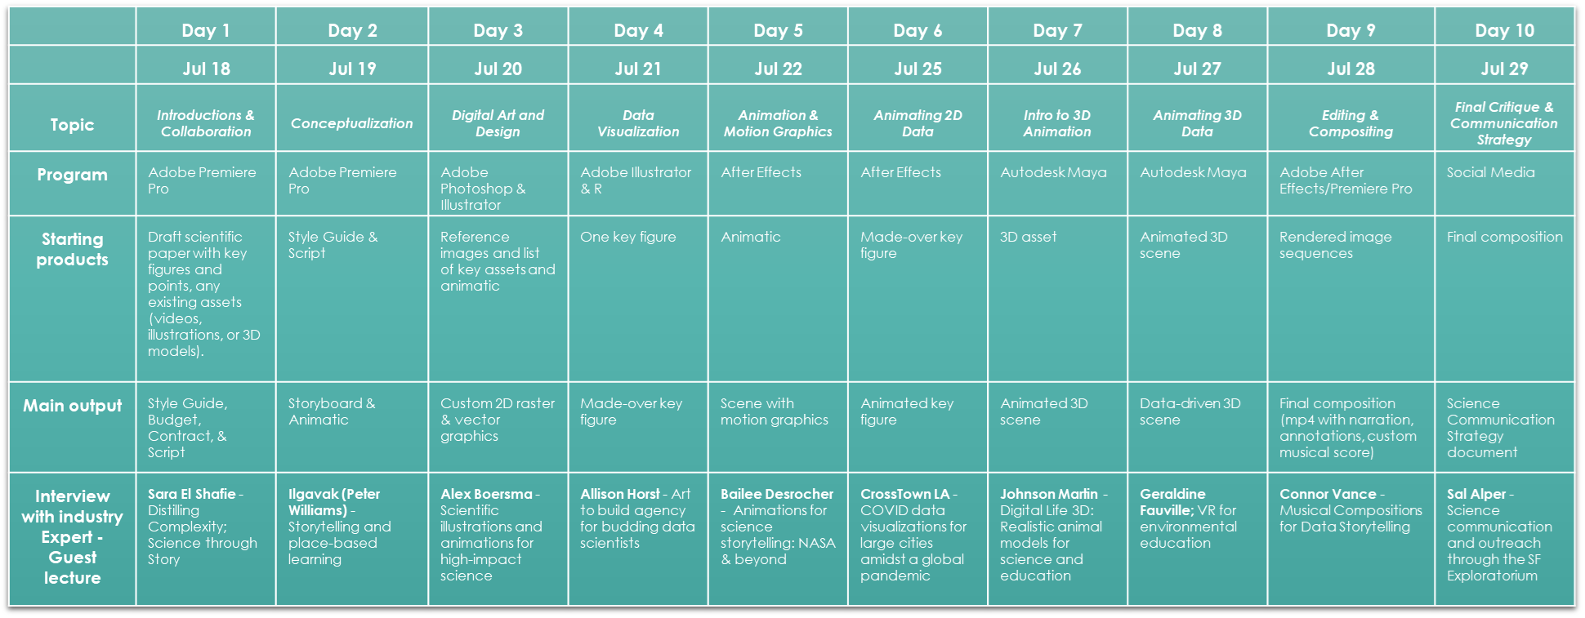

Course Goals
- Build students’ intersectional identities as science communicators, programmers, scientists, & artists
- Build students’ agency to teach these skills to coworkers, mentees, and students
- Build students’ agency as science communicators- to take on new projects

Learning Outcomes
By the end of the class, students should be able to:
- Science Communication:
  - Clearly and succinctly explain the methods, results, purpose, and implications of a scientific study.
  - Distill this scientific information into an accessible, succinct science animation.
  - Pitch this animation to potential venues (film festivals, museums, institutions, etc.).
- Digital Art & Animation:
  - Prioritize effort and decide which custom assets are critical to a visualization.
  - Create 2D raster and vector graphics for use in animations.
- Data Visualization and Programming:
  - Categorize data and identify suitable visualization techniques for different data types.
  - Create 2D and 3D animations.
  - Create animations (in 2D and 3D) based on tabular data.
- Professional Development:
  - Create style guides, contracts, budgets, scripts, animatics, and storyboards to:
    - Communicate their vision for a data-driven animation to a client.
    - Advocate for their skills, expertise, and compensation.
  - Explain how diverse domain experts leverage storytelling, animation, art, and/or science to improve the methods, communication, and education of scientific research
- Interdisciplinary data-driven science communication:
Create a short, 2-min animation that weaves together data visualizations, science storytelling, and animation to communicate a scientific study.

Course Prerequisites
While this course is designed for beginners with no prior experience in art, science, or programming, you will be learning many programs and techniques within a short period of time. If you would like to practice using some of the software or techniques beforehand, we suggest that you explore our online learning portal at https://jessiekb.com/artforscicomm and other online tutorials for the programs we explore in this course (listed below).

Software
For the summer CSUMB course, we will have access to computers in the computer lab for those who have computational limitations. However, for those who would like to continue using these programs after the course, we suggest that you download and get access to the following programs:

Required:
- Adobe Creative Cloud: Illustrator, Photoshop, After Effects, Premiere Pro (institutional licenses available through CSUMB or UCSC during instruction)
- Autodesk: Autodesk Maya 2020 or newer (Go here for educational license)
- R/RStudio: free (download R here and RStudio here).
- Microsoft Office 365: Excel, Powerpoint
Optional - Other programs that might be useful
- ESRI: ArcGIS Pro for geospatial data
- JMP Statistical Software for quick data visualizations and statistics

Assignments & Grading
We will be following a single rubric throughout the course. Please find a list of all assignments on the CANVAS website and a self-assessment version of this rubric at the very end of this comprehensive Data-Driven Animation Journal. If you lose any points along the way during the daily checkpoints, it is possible to recuperate these points. In order to request a re-grading of earlier assignments, please attach a step-by-step explanation (<1 page) to your final animation submission, explaining how you have addressed missing, incomplete, or incorrect elements from earlier assignments.

Expectations
This condensed, intensive course will require active participation for 4.5 hours a day across 10 days. We will usually require no more than 30 min to 1 hour of homework to complete assignments before the next day. You will also have time during the class to complete assignments.

I will be unable to provide detailed technical troubleshooting to all students. I encourage you all to act as resources to each other by helping troubleshoot each other’s problems and share solutions to issues you faced (Discord is a great place for this). Therefore, we have backup datasets for you to use to demonstrate your understanding of the concepts (even if your own custom animation may not be ready in time). However, we encourage you all to follow the established timeline as it will allow you to get feedback and help from your instructor and classmates.

Accessibility
We are committed to creating an academic environment that supports our diverse student body. If you are a student with a disability who requires accommodations to achieve equal access in this course, please affiliate with the Student Disability Resources (SRD- CSUMB). For students already affiliated, make sure that you have requested Academic Access Letters, where you intend to use accommodations. You can also request to meet privately with me during my office hours or by appointment, as soon as possible. I would like us to discuss how we can implement your accommodations in this course to ensure your access and full engagement in this course.

Community Guidelines
I am committed to providing an atmosphere for learning that respects diversity and supports inclusivity. We need to work together to build this community of learning. I ask all members of this class to:
- be open to and interested in the views of others
- consider the possibility that your views may change over the course of the term
- be aware that this course asks you to reconsider some “common sense” notions you may hold
- honor the unique life experiences of your colleagues
- appreciate the opportunity that we have to learn from each other
- listen to each other’s opinions and communicate in a respectful manner
- keep confidential discussions that the community has of a personal (or professional) nature
- ground your comments in the texts we are studying. Refer frequently to the texts and make them the focus of your questions, comments, and arguments. This is the single most effective way to ensure respectful discussion and to create a space where we are all learning together.

Title IX/Care Advisory
CSUMB is committed to providing a safe learning environment that is free of all forms of gender discrimination and sexual harassment, which are explicitly prohibited under Title IX.

Please be aware that if you tell me about a situation involving Title IX misconduct, I am required to share this information with the Title IX Coordinator. This reporting responsibility also applies to course TAs and tutors (as well to all CSUMB employees who are not designated as “confidential” employees, which is a special designation granted to counselors). Although I have to make that notification, you will control how your case will be handled, including whether or not you wish to pursue a formal complaint. The goal is to make sure that you are aware of the range of options available to you and that you have access to the resources you need.

Difficult Conversations
In our in-class and online discussions and dialogues, we will have the opportunity to explore challenging, high-stakes issues and increase our understanding of different perspectives. Our conversations may not always be easy. We sometimes will make mistakes in our speaking and our listening. Sometimes we will need patience or courage or imagination or any number of qualities in combination to engage our texts, our classmates, and our own ideas and experiences. We will always need respect for others. Thus, an important aim of our classroom interactions will be for us to increase our facility with difficult conversations that arise inside issues of social justice, politics, economics, morality, religion, and other issues where reasonable people often hold diverse perspectives. This effort will ultimately deepen our understanding and allow us to make the most of being in a community with people of many backgrounds, experiences, and positions.

B: Preparing your data
A guide for data contributors providing data and scientists seeking to animate their own data.

IMPORTANT: We will not have time to do these data processing and transformation steps during the course. If you would like a student to use your data or to use your own data, you must complete your data processing before the course.

Processing steps like peak-detection are fairly universal with functions across many programming languages. However, processing steps like transforming raw gyroscope, accelerometer, and compass data into pitch, roll, heading and a dead-reckoned track require calibrated sensors and are dependent on the way you attach the tag to the animal, including both the orientation of the tag itself (upside down, right-side up compared to its intended orientation) and the attachment method (i e. glued-on tags vs. suction cups which may slide on the animal). Specialized tools have been developed to help scientists process inertial motion sensing data such as this, see the CATS toolbox for a well-documented set of functions for transforming motion sensor data. This type of processing can be especially time consuming if you do not know exactly how the tag was attached (in what orientation and in what position relative to the center of mass of the animal). As a result, we require the scientist who collected the data to perform these calibrations and transformations. The CATS toolbox Wiki contains step-by-step instructions for performing these calibrations.

TIMESTAMPS - For all data types, it is important to give enough information to sync independent datastreams. It is up to you how you would like to do this, but I suggest using a column for total seconds elapsed (since the start of the recording) as well as a seconds elapsed in the excerpt and (optionally) a date/time column, especially for longer recordings. Make sure that you note what format your date/time value is in (i.e. MM/DD/YYYY HH:MM:SS).

SAMPLING RATE - We will be working with data at different sampling intervals, please put the sampling rate or sampling interval in the filename (i.e. 1Hz, 5Hz, 20Hz, 10s, 30s).

COMBINING DATA - When deciding which datastreams to combine into a single file, consider maintaining the maximum resolution while saving computational power where possible. Also consider the minimum sampling rate needed to accurately convey the data and group data into files with the same sampling rate. To accurately represent fast-moving animals with jerky motion, you may need to use a higher frequency than slow-moving animals with smoother motion. For example, I usually have a 1Hz version of my data for text counters and line graphs, but maintain a higher resolution (10Hz) dataset for animating swimming, rotation, and position. While higher resolution (25Hz) may be needed for finescale analyses, I typically do not need this resolution for my animations.

BEST PRACTICES - Please include a text file with the name of each column in the datasets provided that describes each column in the dataset including the units, sampling rate, and any transformations required to obtain the provided data.

A) Rotation & Position

- POSITION ONLY - If no accelerometer or rotation (only depth or GPS position, for example), will not be able to acquire information on rotation or position, but can transform the animal or object according to any known position coordinates (such as depth). In this case, provide any known x, y, z coordinates at the highest time resolution possible.
  - GEOSPATIAL DATA - Provide coordinates in Latitude and Longitude in Decimal Degrees (DD; i.e. 37.112864, -122.340961).
    - Please process your geospatial data (i.e. smooth tracks, apply land/water filters, etc.) before the class.
    - If you have high resolution diving/position/rotation data, please also include Lat and Long in the same data table as it may unlock some fun animation possibilities!
  - DEPTH (vertical position) - use METERS (m) only
    - Depth sensors require calibration and may record values other than zero at the surface. To avoid applying an arbitrary post-hoc adjustment to your data when you animate it, apply a zero-offset correction and any necessary calibrations before the class.

- ROTATION & 2D POSITION - If have only accelerometer (3D):
  - Raw data: Accelerometer (3D) & Depth
  - Transformation: Calibrations & matrix rotation - use CATS toolbox or similar
  - Processed data requested:
    - ROTATION DATA - Pitch & roll (>= 1 Hz) in degrees
      - It will not be possible to determine heading without data from gyroscope & magnetometer/compass.
    - TRANSFORM DATA - Depth (>= 1 Hz) in meters for vertical position (usually z-axis)
      - If no speed information is provided, we will assume a constant speed of 1 m/s for the animation. Optionally, include measured speed as a horizontal translation by adding a column.
- 3D ROTATION & POSITION - If have all 3D inertial motion sensors:
- Raw data: Accelerometer, gyroscope, compass (3D)
- Transformation: Calibrations & matrix rotation - use CATS toolbox or similar
- Processed data requested:
  - ROTATION DATA - Pitch, roll, heading (>= 1 Hz) in degrees
  - TRANSFORM DATA - x, y, and z position in meters (>= 1 Hz)
    - Create a dead-reckoned track using pitch, roll, and heading and a speed estimate. Again, the CATS toolbox has good tools for this (use CATS toolbox)

Example position & rotation data below:
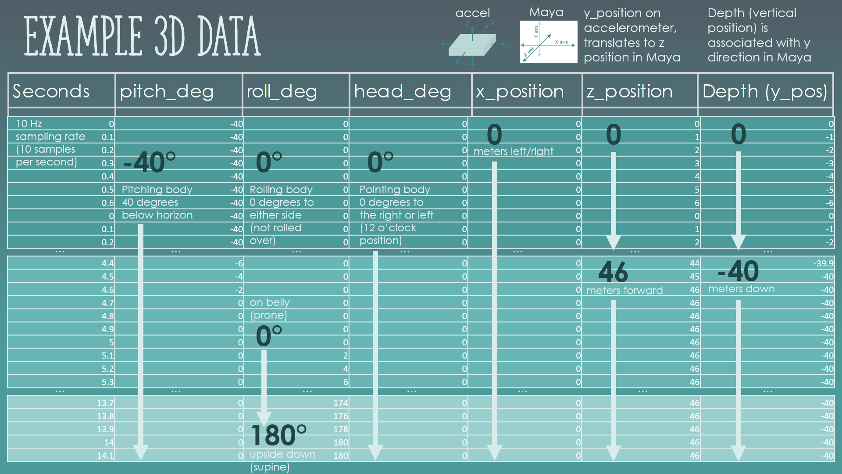

B) Swimming / flying / walking
See this instructional manual for detailed instructions and data examples.

- Raw data: Accelerometer or Gyroscope
  - horizontal axis for seals [usually y axis], vertical for whales [usually z])
- Transformation: Peak-detection
- Processed data requested:
  - Required: Stroke rate with column for Stroke Detected (>5Hz) for setting stroking & gliding
    - Must be more than 5 Hz (10, 15, 16, or 20 Hz for example) to allow accurate placement of strokes. As a general rule, you want the sampling frequency to be twice what you would need to accurately place a stroke.
    - Columns:
      - STROKE RATE: Continuous- strokes detected per minute
      - STROKE DETECTED: Binary- 1 stroke detected; 0 for not
      - GLIDE: Continuous- 1 for gliding; 0 for not
        - Use stroke rate to set a minimum realistic stroke rate at which the animal would be gliding (i.e. for a seal, strokes are typically faster than 10 beats per minute, so set values below that to gliding)
        - If stroke rate falls below gliding criteria, set to 1 (gliding), if not set to zero (stroking).
        - Apply a smoothing filter to ensure a smooth transition from stroking to gliding.
  - (Optional) Stroke rate (1Hz) for text counter
  - (Optional) Strokes table with column for Inter-stroke interval (each row represents one stroke) for creating audio file for “tail-wooshing”
Example data (AccX, AccY, AccZ, Depth, Processed AccY, Stroke Rate, Glide Controller):
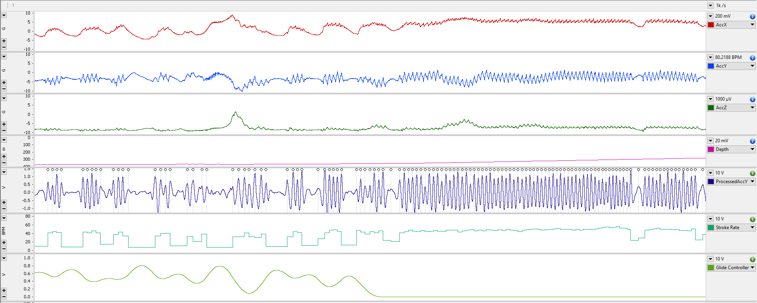

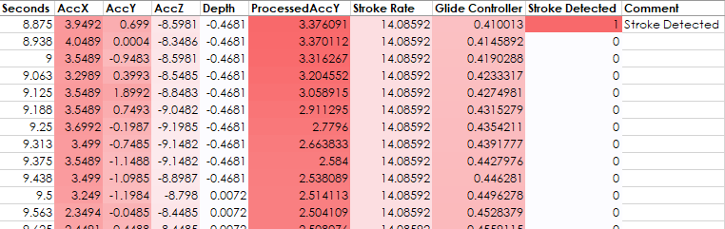

C) Heart Rate
The script I have written turns heart rate into a sound file using precise interbeat intervals. Include decimal places and calculate interbeat intervals as precisely as possible to ensure the accuracy of the sound recording.
- Raw data: Electrocardiogram (ECG)
- Transformation: Peak-detection
- Processed data requested:
  - (Optional) Heart rate (1Hz) for text counter
  - (Optional) Heartbeat table with column for Inter-stroke interval (each row represents one heartbeat) for creating audio file for heartbeats
Example heart rate data (for a very slow heartbeat in a narwhal escaping entanglement):
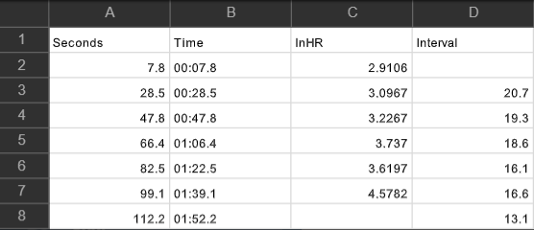

C: Preparing your workstation
A guide to installing your software.

While we will be providing computers for you to work on during the course, downloading the software on your own machine will allow you to familiarize yourself with the software and continue to use these tools after the class.
- Required software:
  - Autodesk Maya 2023 (free educational license) - make sure to check the box next to the "PyMEL" plugin upon installation
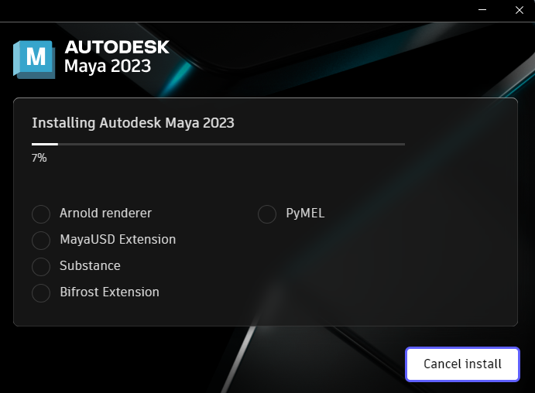
  - Adobe Creative Cloud (sign into Adobe with your CSUMB email or institutional email for free access)
  - Install Adobe applications: After Effects, Premiere Pro, Illustrator, and Photoshop
- R & RStudio (free)
  - Install R
  - Install RStudio (an integrative development environment for editing your code)
- Optional software but recommended:
  - ArcGIS Pro (free CSUMB license or get through your institution) - Can be used for geospatial animations and visualizations.
  - Epic Games Launcher / Unreal Engine (free) - Unreal Engine relies on the Epic Games Launcher. We will show how game engines can be used for data-driven animation and visualization. This application uses a lot of space (50GB) so make sure you have enough space available on your machine.
  - JMP Pro v15/16 (get trial or get through your institution) - I will use this for some demos but CSUMB does not seem to provide it, so we will not rely on it during the course.
  - Python & a Text-Editor/Integrated Development Environment such as Spyder. Python is required if you would like to use the heartbeat to sound file script.

1: Introductions and Collaboration

Agenda
Agenda for the day:
2:00 - 2:20: Agenda & questions - Course Outline & Welcome! (20 min)
2:20 - 2:50: Opening Activity - Abstract switch, introductions, and reflection (30 min)
2:50 - 3:00: Break / Reflection (10 min)
3:00 - 3:30: Lecture: Intro to Data Visualization & Design (30 min)
3:30 - 4:00: Work time - Data Description, Style Guides, Audience Brainstorming (30 min)
4:00 - 4:10: Break (10 min)
4:10 - 4:40: Closing Activity (Instructions) - Scripts / Contracts / Budgets (30 min)
4:40 - 5:20: Work time - Scripts / Contracts / Budgets / Approvals (40 min)
5:20 - 5:30: Break (10 min)
5:30 - 6:30: Guest speaker - Science through Story with Sara ElShafie

Abstract switch
Scientists, give your abstract and key figure to your artist (scientist to animator or scientist-animators exchange). Artists, you have 10 minutes to read the abstract and learn about their work. The focus here is to understand the science (how it was done, what the results were, and why this is useful). You will introduce your partner and their work to the class.

What did they do?
Thiehreindf sldkj

What did they find?

Why does it matter?

Reflection
For scientists, when did you find yourself wanting to interrupt and correct your introduction? How can you work to make these points clearer in your abstract and especially in your animation? What visuals might help? Discuss with your partner and clarify any questions.

Lecture: Intro to Data Visualization (20min)

Data Description
Describe the dataset you will be working with. This is your chance to review the data, identify issues in the data, and ask the scientist clarifying questions. Modify the example below to add as many rows or columns as necessary. If it is easier, feel free to comment on the Excel file directly and paste your data description as an image here.

 | 1 | 2 | 3 | 4 | 5 | 6
Variable name | Time | Depth | Pitch | Roll | Heading | Stroke Detected
Units or Format | mm/dd/yyyy hh:mm:ss.00 | meters | degrees |  |  | 0 or 1
Type of data | Numeric - discrete (sample freq. 10 Hz) | Numeric - discrete (resolution 0.5m) | Numeric - continuous |  |  | Categorical - binary
Scale to visualize | Position (horizontal) or time | Position (vertical) or | Rotation (up or down) | Rotation (side to side) | Rotation (direction of animal) | Swimming behavior
2D or 3D | 2D & 3D | 2D & 3D | 3D only | 3D only | 3D only | 3D only
Maximum value | End date | 400 m | ±90° | ±180° | ±180° | 1
Meaning of min/max value | Begin/End of recording | Surface / Deepest z-position | Pitched down  / up | Rolled upside down | Headed south | Begin stroke detected or not

Style Guide
Verbal description
Describe the intended emotion or feeling of your animation. List words that you would like your audience to feel, observe, or experience.

Inspiring, 'wow'-ing, optimistic, informative

Font
Pick a font that is legible and consistent with your verbal description above. Change the font in the color palette table below to match your selected font. https://fonts.adobe.com/

Color palette
Use the Adobe color tool (https://color.adobe.com/) to help you pick 3 main hues (3 values for each hue) ; 3 main hues must be distinguishable and colorblind friendly; text and background colors must have enough contrast (https://color.adobe.com/create/color-contrast-analyzer).

Dark on light | Dark on light | Dark on light
Dark on light | Dark on light | Dark on light
Light on dark | Light on dark | Light on dark

To check your color palette, go to https://color.adobe.com/. Press ‘Extract Theme’ and drag & drop a screenshot of the table above. Go to ‘Accessibility Tools’ and ‘Color Blind Safe’ and/or the ‘Contrast Checker’ to analyze your image.

Credit Slide and Watermarks, Permit #s, Logos, etc.
Consult with your collaborating scientist(s) to ensure that you have properly listed all funding agencies and contributors. (e.g. USGS has very specific requirements for videos hosted on their site). On the right, a sample frame from the animation should show any and all required watermarks and logos (e.g. NMFS Permit # displayed for marine mammal research/data visualizations).

Example Credits Slide | Example Frame Grab from Animation

Who is your audience?
Let’s focus on your most challenging audience members:

THE SKEPTIC
Audience members who are opposed
to your work.
What does this person think about?

What does this person care about?


THE OVERWHELMED
Audience members who do not understand
the details of your work.
What does this person think about?

What does this person care about?

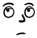
THE INDIFFERENT
Audience members who do not care
about your work (yet).
What does this person think about:

What does this person care about?

Your hook should grab even your most difficult audience members’ attention. Your methods and results should make sense to even your most general audience. Simplify your message enough to keep the attention of your overwhelmed or indifferent audience members, while convincing the skeptics. At the end, appeal to something universal across your most difficult audience members’ priorities (examples include: protecting nature, people, or livelihoods).

Keep this in mind as you craft your script below.

Script - First Draft
Overall guidelines: Must be less than 2 minutes. Script avoids using acronyms and domain-specific jargon unless absolutely essential to the story. If terms are deemed essential, a definition must be provided. Script should be intelligible to a lay audience (no assumed prior knowledge related to the study).

HOOK
Why should we keep watching? Use one of the strategies below to grab the audience's attention and interest.
Strategies:
- Pair extraordinary with ordinary
  - Example: Pixar’s Incredibles - an ordinary family with extraordinary powers
- Ask a what-if question
- Personal anecdote/Gripping story

METHODS
What the scientists did: Explain how and why the science was done.

RESULTS
What the scientists found: Distill the main point of the paper into at most 3 separate ideas (~ at most 3 key points).

CONCLUSION
Why does it matter: Focuses on the impact of the study with respect to the audience, appeals to the audience using their predicted cares and interests.

Script - Revised
Assess your first draft with a partner using the self-assessment rubric at the end of the journal. Add transitions and revise your script in the box below. Share your script with your scientific collaborator(s) for approval. Find the rubric in the appendix.

Budget
Example budget for a 5-part video production. Follow this template to construct a budget for your project. Approximate values are provided as a starting point, but budgets may vary greatly depending on the size of the animation studio and/or the animator’s experience.

Artist’s Letterhead
Company Name
Artist(s) name(s)
Address; Phone; E-mail
Budget
DATE
CLIENT NAME, Address, Email

Animator Task | Per hour/unit | Total
Conceptualization  Meeting to establish direction, creation of data description, style guides, storyboarding, and script (allots 1 hr meeting to plan animation, 16 hrs to create style guides, script, and storyboard, and 1 hr meeting to review style guide, script, and storyboard). | $100/hr
Creation of original artwork  Vector graphics and/or raster graphics representing unique features of the ecosystem in question including:  LIST ASSETS HERE.  Custom assets priced at $_ per custom vector graphic or 3D asset (depending on complexity). | $100-500
Animation  Support for _ hrs of animation at $50/hr. | $50/hr
Video editing and narration  Support for _ hrs of video editing and audio production at $50/hr. | $50/hr
Music production  Contract musical composer to compose original, royalty-free music OR purchase royalty-free music. | $500 / $20
Revisions  First, second, and final draft ($500 per revision - one 1 hr meeting and 4 hr of editing per revision) | $500 | $1,500
Administrative  Support for _ h of compiling bid materials and other administrative tasks. | $50/hr
Total

Contract
Refer to source for more information: https://graphicartistsguild.org/the-letter-of-agreement/
*Disclaimer: The information provided in this document does not, and is not intended to, constitute legal advice; instead, all information, content, and materials available on this site are for general informational purposes only. Information on this website may not constitute the most up-to-date legal or other information.

Artist’s Letterhead
Company Name
Artist(s) name(s)
Address; Phone; E-mail
Art Commission Contract
(alternately: Agreement; Confirmation of Engagement; Confirmation of Assignment)
DATE
CLIENT NAME
CLIENT Address
CLIENT email
CLIENT phone
Name of person commissioning art

AGREEMENT entered into by and between CLIENT NAME (hereinafter referred to as the "Client"), located at CLIENT Address; CLIENT email, and ARTIST NAME (hereinafter referred to as the "Artist"), located at [Please add ARTIST Address; ARTIST email], with respect to the creation of certain illustrations and animations (hereinafter referred to as the "Work").

- WHEREAS, Artist is a professional Artist of good standing;
- WHEREAS, Client wishes the Artist to create certain Work described more fully herein; and
- WHEREAS, Artist wishes to create such Work.
- NOW, THEREFORE, in consideration of the foregoing premises and the mutual covenants hereinafter set forth and other valuable considerations, the parties hereto agree as follows:

- Project Title:
[Title of your animation]

- Description.
  - Reference materials:
The Client agrees to provide the following products upon initiation of the Work by the Artist:

[List of assets the Client agrees to provide the Artist.]

Example List of assets required (for a humpback whale bubble-net feeding animation):
- Processed Dataset (.CSV format) containing:
  - Position (x, y, z in meters)
  - Rotation (pitch, roll, heading in degrees)
  - Bubble-blowing status (discrete variable; 0 or 1 - 1: Blowing bubbles)
  - Whale ID (01, 02, 03, 04, 05 - Maximum 5 whales)
  - Stroke-detection data (discrete variable; 0 or 1 - 1: Stroke cycle start detected)
  - Gliding parameter (continuous variable; 0-1 - 1: Gliding)
- Abstract of scientific paper summarizing methods, key results, and implications
- One key figure (2D data visualization) to be incorporated in the animation

  - Preliminary materials
The Artist agrees to create the Work in accordance with the following specifications for preliminary review and approval by the Client:
[Insert a description of the content of the animation you agree to create.]
E.g. A draft script and storyboard, edited together as an animatic.

  - Finished art

The Artist agrees to create the Work in accordance with the following specifications:

Subject matter:
[Insert a description of the content of the animation you agree to create.]
E.g. Animation describing the bubble-net feeding strategy of a humpback whale that shows at most 5 animals and integrates data on animal position, rotation, and bubble-blowing status.

Number of products:
[Insert a description of the products you agree to create.]

E.g. 1 animation of 60 seconds, 1 rigged humpback whale 3D model with bubble emitter.

Other specifications:

Client purchase order number: 001
Artist job number: 001-2022

- Timeline. As of the signing of this Agreement, the Client has provided Preliminary Materials (2A) to the Artist. The Artist agrees to provide a draft script, sketches, storyboard, and further reference material to the Client (2B). Upon approval and review by the Client (only one revision allowed), the Artist shall begin the Word and provide Finished art (2C) shall be delivered to the Client by August 15, 2022, 12:00pm PST/ 3:00pm EST.
- Grant of Rights. Upon receipt of full payment, the Artist grants to the Client the following rights in the finished art:
For use in:

[Specify the Client’s use cases for the Work.]

E.g. All workshops, presentations, and materials created and distributed by Client, including recordings licensed through Client and content made available to the public by Client,

In the following territory: N/A
For the following time period: Specify if necessary

After this time period, this Agreement may be renegotiated and renewed if desired by the Client and amenable to the Artist.

Limitations on media in which used: N/A
Limitations on number of insertions: N/A

Other limitations: Use of the finished art specified in this Agreement by any entity other than the Client must be renegotiated under a separate licensing Agreement.

With respect to the usage shown above, the Client shall have non-exclusive rights.

- Reservation of Rights. All rights not expressly granted hereunder are reserved to the Artist, including but not limited to all rights in sketches, comps, or other preliminary materials.
- Fee. Client agrees to pay Artist the fee of $40/hour, which will include time spent on planning and preparation (e.g., sketches) for the Work. In addition, Client agrees to pay Artist a licensing fee of 35 percent of the final invoice for the usage rights specified in this Agreement. Client agrees to pay sales tax, if required.
- Additional Usage. If Client wishes to make any additional uses of the Work, Client agrees to seek permission from the Artist and make such payments as are agreed to between the parties at that time.
- Advances. At the time of signing this Agreement, Client shall pay Artist $____ as a nonrefundable advance against expenses. If the advance exceeds expenses incurred, the credit balance shall be used to reduce the fee payable or, if the fee has been fully paid, shall be reimbursed to Client.
- Payment. Client agrees to pay the Artist within thirty (30) days of the date of Artist's billing, which shall be dated as of the date of delivery of the finished art. In the event that work is postponed at the request of the Client, the Artist shall have the right to bill pro rata for work completed through the date of that request, while reserving all other rights under this Agreement. Overdue payments shall be subject to interest charges of 2 percent monthly.
- Revisions. Limit one revision after submission of preliminary materials and only minor revisions allowed upon submission of the Finalized art (changes that do not constitute re-rendering animations or re-recording script, only minor text edits or content cutting). The Artist shall be given the first opportunity to make any revisions requested by the Client. If the revisions are not due to any fault on the part of the Artist, an additional fee shall be charged. If the Artist objects to any revisions to be made by the Client, the Artist shall have the right to have his or her name removed from the published Work.
- Copyright Notice. Copyright notice in the Artist's name and the current year shall be published with the Work.
- Authorship Credit. Authorship credit in the name of the Artist shall accompany the Work when it is reproduced. If the finished art is used as a contribution to a magazine or for a book, authorship credit shall be given unless specified to the contrary in the preceding sentence.
- Cancellation. In the event of cancellation by the Client, the following cancellation payment shall be paid by the Client: (A) cancellation prior to the finished art being turned in: $40 per hour accrued at that point or 50 percent of the final fee; (B) cancellation due to finished art being unsatisfactory: 100 percent of fee or final invoice; and (C) cancellation for any other reason after the finished art is turned in: 100 percent of fee or final invoice. In the event of cancellation, the Client shall also pay any expenses incurred by the Artist and the Artist shall own all rights in the Work and Client forfeits any and all usage. The billing upon cancellation shall be payable within thirty (30) days of the Client’s notification to stop work or the delivery of the finished art, whichever occurs sooner.
- Ownership and Return of Artwork. The ownership of original artwork, including sketches and any other materials created in the process of making the finished art, shall remain with the Artist. If the Work is digital, shipping expenses do not apply.
- Permissions and Releases. The Client agrees to indemnify and hold harmless the Artist against any and all claims, costs, and expenses, including attorney's fees, due to materials included in the Work at the request of the Client for which no copyright permission or privacy release was requested or uses that exceed those allowed pursuant to a permission or release.
- Arbitration. All disputes arising under this Agreement shall be submitted to binding arbitration before California and settled in accordance with the rules of the American Arbitration Association. Judgment upon the arbitration award may be entered in any court having jurisdiction thereof. Disputes in which the amount at issue is less than $10,000 shall not be subject to this arbitration provision.
- Miscellany. This Agreement shall be binding upon the parties hereto, their heirs, successors, assigns, and personal representatives. This Agreement constitutes the entire understanding between the parties. Its terms can be modified only by an instrument in writing signed by both parties, except that the Client may authorize expenses or revisions orally. A waiver of a breach of any of the provisions of this Agreement shall not be construed as a continuing waiver of other breaches of the same or other provisions hereof. This Agreement shall be governed by the laws of the State of California.

IN WITNESS WHEREOF, the parties hereto have signed this Agreement as of the date set forth below.

DATE:
Artist Name:
Artist Signature:
Client Name:
Client Company Name:
Client Signature:

File Organization
Before you start your project, you will want to organize your project. Here is a project organization strategy from my own experience.

File naming convention:
My strategy:
Job#_Nickname-ClientInitials_ProcessingStep_Description.ext

Job#: Unique ID for all my animation/freelance work
Nickname: Short name for project (this and your Job# combined will be the unique identifier)
Processing Step: A two digit identifier to match the step of your processing pipeline with other scripts and data for the project

E.g. ‘05_Narwhal-TW_00_August normal dive pre seis.csv’
This is my 5th animation job, about a narwhal for Terrie Williams and is a raw data file (Processing step 00) that the client provided. I’ve kept the original file name so that I can find the file in my email if I ever need to look back at what the client sent originally.

What is your unique job identifier (Job#_Nickname-ClientInitials)?
01_FloatsGliders-YT

Folder structure
My strategy:
🗀 Visualization
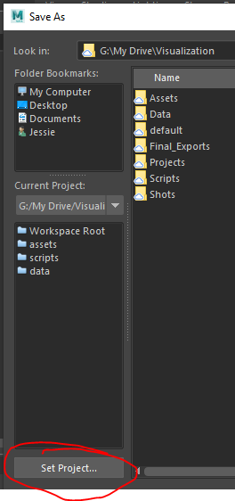
This is a root project directory where I tell my codes to start looking for fun things. For example, when using Maya, you will set your project in this directory (see screenshot below).
Let’s look inside:
> 🗀 Data
Here is where I store my data, named in the format above.
> 🗀 Scripts
Here is where I store my scripts and tools. I name these with the same processing step as the data files that are created as a result of the script.
> 🗀 Assets
Here is where I store my animation assets. This could be anything from a .wav recording of a heartbeat, to a 2D vector graphic, to a 3D model or an animated seal cycle. You should think of these as the building blocks to create your scenes (next folder). I normally organize these in folders with unique names like:
🗀 2D_Vector-Graphics
🗀 2D_Background-Textures
🗀 Emperor-Penguin_Rigged_External-Anatomy
Be specific with your names! It’s incredible how many “Elephant Seal 3D Model”s one can end up with… :)
Generally, it is good practice to have a version number at the end. For example: 00_Asset-Description_V0001.ext
> 🗀 Shots
Here is where I store my shots that reference different Assets.
Setting project directory in Maya:

Homework: Data Description, Style Guide, Contract, & Budget
Once your scientist approves your script, style guide, contract, and budget, create a PDF version to upload. Then, record a high-quality audio recording (.mp3) of your script. It is possible to obtain high-quality audio even with relatively low-cost equipment. The key is: the recording environment is critical (see following page for detailed audio recording tips).

- Submit your Data Description, Style Guide, Script, Contract, and Budget as a single PDF named 01_DataDescription-StyleGuide-Script-Budget-Contract_FirstName_LastName.pdf:
  - To the shared Google Drive (in the 🗀 01_DataDescription-StyleGuide-Budget-Contract folder):
https://drive.google.com/open?id=1nVBeRIbfALQWN6P1dbnQl4FVQ0Dg6518&authuser=jmkendal%40ucsc.edu&usp=drive_fs
  - Submit it in CANVAS (under “01_DataDescription-StyleGuide-Budget-Contract”): https://canvas.ucsc.edu/courses/54357/assignments/343531
- Submit a PDF and mp3 of your script named 01_Script_FirstName_LastName.mp3:
- To the shared Google Drive (in the 🗀 01_Script-Recording_mp3 folder):
https://drive.google.com/open?id=1nSvHbTIFnBcgc1sCndZ4Y-FHoux5cZu0&authuser=jmkendal%40ucsc.edu&usp=drive_fs
- Submit it in CANVAS (under “Script Recording”): https://canvas.ucsc.edu/courses/54357/assignments/343526

DAY 1 RUBRIC - See full rubric here.
Data Description | Correctness (0.25) | Data is described/interpreted correctly.
Data Description | Completeness (0.25) | Data is categorized correctly.
Style Guide | Verbal description (0.3) | Verbal description is provided and evokes the intended emotion/feeling.
Style Guide | Color palette (0.3) | Color palette has 3 main hues (3 values for each hue); 3 main hues are distinguishable and colorblind friendly; text and background colors have enough contrast
Style Guide | Fonts (0.3) | Fonts are provided, legible, and consistent with verbal description
Style Guide | Credit slide and Watermark (0.3) | Example credit slide has all required funders acknowledged according to their style stipulations (e.g. USGS has very specific requirements for videos hosted on their site). A sample frame from the animation shows required watermarks and logos (e.g. NMFS Permit # displayed for marine mammal research/data visualizations)
Style Guide | Spelling/Abbreviations/Capitalization (0.3) | List critical assets that may be labeled in your animation to ensure that you are using proper and consistent spelling/abbreviations/capitalization.
Script | Hook (0.375) | Script uses one of the discussed strategies to grab the audience's attention and interest.
Script | What the scientists did (0.375) | Script explains how and why the science was done.
Script | What they found (0.375) | Distills the main point of the paper into at most 3 separate ideas (~ at most 3 key points)
Script | Why does it matter (0.375) | Focuses on the impact of the study with respect to the audience, appeals to the audience using their predicted cares and interests.
Script | Clarity & intelligibility (0.375) | Script avoids using acronyms and domain-specific jargon unless absolutely essential to the story. If terms are deemed essential, a definition must be provided. Script should be intelligible to a lay audience (no assumed prior knowledge related to the study).
Script | Recording quality (0.375) | Audio quality is good (no background noise, no interruptions, no static, no popping)
Script | Time Limit (0.375) | The recorded script is less than 2 minutes long.
Contract & Budget | Completeness (0.375) | Contract/Budget is filled out.

Here are some tips to ensure your environment is conducive to recording high-quality audio (tips from USC Annenberg’s Home Studio Recording Tips) :

Choosing a room
If you are setting up an interview or a more permanent recording space, here are a few things to keep in mind when choosing a location.
- One of the easiest home studios is throwing an oversized thick blanket over your head. This works well to isolate your voice and give the recording more warmth, but it may force you to hunch and squeeze your diaphragm and vocal chords. Get creative. You can drape a blanket over a high dining room table or two barstools.
- You can use a closet where the hanging clothes and coats help absorb the sound.

Control the surfaces:
- Soft surfaces are your friend, hard surfaces are your enemy.
- Avoid tiled rooms or rooms with a lot of glass like the kitchens and bathrooms. Instead, choose smaller bedrooms or offices with carpets, bedding, window drapes.
- Choose a suitable surface. Avoid unstable surfaces or those that cause vibration.
Control the ambience
- Avoid TVs, traffic sounds, fans, AC, refrigerators.
- Be on alert for unexpected sounds like phones, dogs barking, loud
machinery (like leaf blowers), ice makers, etc.
- Before you start recording, do the following:
o Turn off TVs, fans or air conditioning
o Put your phone & all smart devices on silent
o Turn your computer sound down
o Close all windows and doors
o Let everyone in your location know you are recording

2: Conceptualization

Agenda
Agenda for the day:
- 2:00 - 2:20: Script Critique – Listen critically to all scripts (20 min)
- 2:20 - 2:50: Group Script Reflection – Reflect on what worked, what did not (30 min)
- 2:50 - 3:00: Break / Reflection (10 min)
- 3:00 - 3:30: Lecture: Illustration for Animation (30 min)
- 3:30 - 4:00: Work time - Storyboarding (30 min)
- 4:00 - 4:10: Break (10 min)
- 4:10 - 4:40: Demo – Premiere Pro: Creating an Animatic (30 min)
- 4:40 - 5:20: Work time – Premiere Pro: Creating an Animatic (40 min)
- 5:20 - 5:30: Break (10 min)
- 5:30 - 6:30: Guest speaker – Ilgavak: Place-based science learning

Opening Activity: Critique & Reflection- Scripts & Style Guides
Review the rubric as you listen to each other’s audio recordings and review their style guides. We will compile a list of things that were successful in scripts and audio recordings. Listen to all of the recordings and then give your overall impressions.

What were some things that you enjoyed in the scripts? What grabbed your attention? What was effective in making the research accessible?

What were some things that you think could be improved? How could you grab attention more effectively? How can you make the research more accessible?

Lecture: Storyboards - Illustration for animation
Fill in the Storyboard Template on the following page. The storyboard should provide one image (hand-illustrated or digitally rendered, in the medium of choice) for each major shot in the animation (minimum of ~10, maximum of ~20). The script should be divided into 2-3 sentences per shot where the text matches the visual depiction in the image. You should provide a verbal description of the action and a description of any audio accompaniment.
Example shot:
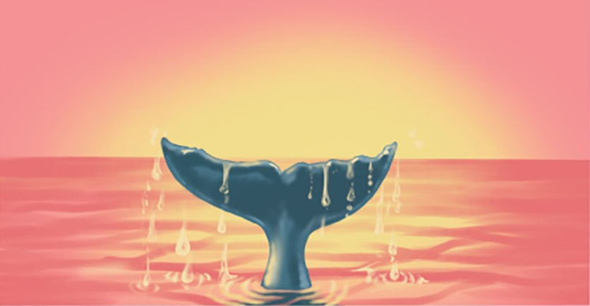 | Script: As humans, we’re only able to catch a glimpse of the elusive creatures that spend their lives beneath the waves.  Verbal description: Calm ripples on the water’s surface. Humpback surfaces (only back is visible), blows, and flukes as it dives down.  Audio description: Inquisitive, curious music- not too loud. Add sound for whale blow.

Storyboard Template
Feel free to use the template below or use your own and copy it here. *Each slide should represent ~10s of video
Script: Insert text.

Verbal description: Insert text.

Audio description: Insert text.
Script: Insert text.

Verbal description: Insert text.

Audio description: Insert text.
Script: Insert text.

Verbal description: Insert text.

Audio description: Insert text.
Script: Insert text.

Verbal description: Insert text.

Audio description: Insert text.
Script: Insert text.

Verbal description: Insert text.

Audio description: Insert text.
Script: Insert text.

Verbal description: Insert text.

Audio description: Insert text.
Script: Insert text.

Verbal description: Insert text.

Audio description: Insert text.
Script: Insert text.

Verbal description: Insert text.

Audio description: Insert text.

Script: Insert text.

Verbal description: Insert text.

Audio description: Insert text.
Script: Insert text.

Verbal description: Insert text.

Audio description: Insert text.
Script: Insert text.

Verbal description: Insert text.

Audio description: Insert text.
Script: Insert text.

Verbal description: Insert text.

Audio description: Insert text.
Script: Insert text.

Verbal description: Insert text.

Audio description: Insert text.

Demo/Lecture and Closing Activity:
Creating an animatic in Premiere Pro
Create a project in Adobe Premiere Pro. Create a sequence titled 01_Animatic. Import your audio narration and individual shot illustrations (from storyboard). Edit your animatic to display each storyboard frame for the duration of its explanation in the recorded script. Add captions to your animatic.
- Create a new Premiere Pro project. You will use this throughout the course as you complete new shots. Name it and place it in your Visualization folder. The project will use relative file paths to find shots and media, so avoid making changes to folder names/organization.
- Create a New Sequence (File > New Sequence) with widescreen settings (1920 x 1080 this will create an aspect ratio matching YouTube/PowerPoint dimensions).
- Import media:
  - Import narrated script mp3.
  - Import individual photos (.png/.jpg) for each shot in the storyboard.
- Drag & drop all media (photos and the script mp3) into the sequence’s timeline.
- Add “Open Captions” throughout the project. Instructions here.
- Export mp4 using Adobe Media Encoder (instructions here and below)
  - To export a sequence as an H.264 file (the most popular option), make sure the Timeline panel is active and choose File > Export > Media or press Control+M (Windows) or Command+M (macOS).
  - In the Export Settings dialog box, choose Format: H.264 and Preset: Match Source – High Bitrate.
    - (Note: In order to save as an mp4 you will need to make sure you select the H.264 format and not MPEG4)
  - To choose a filename and location, click the blue filename to open the Save As dialog box. Use this to choose an export location and a name for your new file, and then click Save.
  - Click Queue to add to Adobe Media Encoder (allows you to use Premiere Pro during export) or Export (exports within Premiere Pro and does not allow you to use the program during export).

Homework: Storyboard, Animatic, & List of Key Assets
Upload your animatic to the shared Google Drive & Canvas and name it:

02_Animatic_FirstName_LastName.mp4

Based on your animatic, think of all the assets you would ideally need (or ideally want) to tell the story. Designate whether the asset is critical to the storyline and prioritize them below:

Priority | Asset description
HIGH - Critical Assets | - 3D models:  - 2D Vector graphics:  - 2D Raster graphics:
LOW - Optional Assets | - 3D models:  - 2D Vector graphics:  - 2D Raster graphics:

STORYBOARD & ANIMATIC RUBRIC - See full rubric here.
Storyboard | Completeness (0.875) | One image (hand-illustrated or digitally rendered, medium of choice) for each major shot in the animation (minimum of ~10, maximum of ~20).
Storyboard | Script (0.875) | Script is divided into 2-3 sentences per shot where the text matches the image.
Storyboard | Verbal Description (0.875) | Verbal description of the action is provided.
Storyboard | Audio Description (0.875) | Audio description of action is provided (sound effects, musical direction - louder or softer, etc.)
Animatic | Video Format (0.5) | Provided .mp4 is in the correct format (Widescreen Youtube Preset HD 1080p H.264 Codec)
Animatic | Visuals (0.5) | Storyboard illustrations are digitized, legible, and inserted at the correct time in the video
Animatic | Captions (0.5) | The script is included as open captions at the bottom of the video. Grammar and spelling in captions is correct.

3: Digital Art & Design

Agenda
Agenda for the day:
- 2:00 - 2:20: Animatic Critique – Watch animatics and discuss key assets (20 min)
- 2:20 - 2:50: Animatic Reflection – Small group discussions & troubleshooting (30 min)
- 2:50 - 3:00: Break / Reflection (10 min)
- 3:00 - 3:30: Lecture & Demo: Introduction to Digital Art / Vector Graphics (30 min)
- 3:30 - 4:00: Work time - Vector Graphics (30 min)
- 4:00 - 4:10: Break (10 min)
- 4:10 - 4:40: Demo – Raster Graphics (30 min)
- 4:40 - 5:20: Work time – Raster Graphics (40 min)
- 5:20 - 5:30: Break (10 min)
- 5:30 - 6:30: Guest speaker – Alex Boersma: Science illustration and animation

Opening Activity: Critique & Reflection- Animatics & key assets
Review the rubric as you watch each other’s animatics. We will compile a list of things that were successful. What were some things that you struggled with while making your animatic? How did you decide to prioritize what key assets you will need?

What were some things that you enjoyed in the animatics?

What were some things that you think could be improved?

Lecture: Introduction to Digital Art

Demo: Vector Graphic - Outlines in Illustrator
Use this step-by-step guide to outline your study organism in Illustrator.

Demo: Raster Graphic - Painting in Photoshop
Follow the in-class demonstration to color in your outlined study organism.

Homework: Animatic & List of Key Assets
Upload your key assets to the shared Google Drive & Canvas and name them:

03_Asset01_FirstName_LastName_AssetName.jpg

KEY ASSET RUBRIC - See full rubric here.
Vector Graphic | Completeness/Format (0.6) | Vector graphic is provided in .ai, .pdf, .eps, or .svg format and paths/curves are editable in Illustrator.
Vector Graphic | Organization (0.6) | Provide a screenshot of your layer organization and explain your strategy and any challenges you faced.
Vector Graphic | Effort/Technique (0.6) | Demonstrates use of at least 3 techniques provided in the digital painting demo.
Vector Graphic | Output quality (0.6) | Outline is a continuous, closed path (can be accurately filled with a color).
Vector Graphic | Path quality (0.6) | Points on outline path are kept to a minimum, lines are smooth (unless a sharp curve is warranted).
Raster Graphic | Completeness/Format (0.67) | Raster graphic is provided in 300 ppi and is large enough to be clearly visible if viewed full screen or at desired zoom level (suggest ~ 20 inches wide to be safe).
Raster Graphic | Organization (0.67) | Provide a screenshot of your layer organization and explain your strategy and any challenges you faced.
Raster Graphic | Effort/Technique (0.67) | Demonstrates use of at least 3 techniques provided in the digital painting demo.

4: Data Visualization

Agenda
Agenda for the day:
- 2:00 - 2:20: Decoding Code – (20 min)
- 2:20 - 2:50: Code Reflection – Discuss the code (30 min)
- 2:50 - 3:00: Break / Reflection (10 min)
- 3:00 - 3:30: Lecture: Coding & Data Visualization (30 min)
- 3:30 - 4:00: Partner Work Time - Discuss figure improvements (30 min)
- 4:00 - 4:10: Break (10 min)
- 4:10 - 4:40: Demo: Coding in R – Editing figures with ggplot in R (30 min)
- 4:40 - 5:20: Work time – Edit key figures (40 min)
- 5:20 - 5:30: Break (10 min)
- 5:30 - 6:30: Guest speaker – Allison Horst: Art to build agency for budding data scientists

Opening Activity: Decoding Code & Figures
Switch figures, data, and code with your partner; discuss ways to improve your key figure. List your ideas here:

- Figure Interpretation - List your interpretation of the figure (where your eye is drawn, what you interpret as the main result or pattern, and any suggestions you have to improve this).
There are some evident patterns between the variable panels, however some graphical focus on these correlations would be helpful.

- Figure Edits List - List potential edits to improve key figures and indicate a preferred method for addressing these edits (R/other coding language or Illustrator).
For the final animation, the variable plot will need to be rotated so that it appears in a 3D grid, trailing the spray glider. Using Matlab, I can take one of these section plots to focus on, and map it in 3D rather than 2D using the plot3 function.

- Code commenting - Comment code so that each processing step is clearly interpretable and can run with the CSV only (imports necessary libraries, etc).

- Code reflection - Reflect on the changes to code that were needed / might be needed to help the code’s organization or improve its clarity.
Further commenting was needed, I generating this script for myself but if sharing it would have been a mess to read.

Lecture: Data Visualization

Demo/Work time
With code & in Illustrator, change and improve your key figure (colors, layout, chart type etc.).
- CORRECTNESS: Figure should maintain the integrity of the data, axes, and results.
- CLARITY: Figure should avoid visual clutter including extraneous information (minimize use of legends, gridlines, rotated labels, etc).
- ORGANIZATION: Data should be organized in such a way to expedite interpretation (e.g. by ordering values from largest to smallest).
- RESPONSIBILITY: Figure should be "responsible". The visual take-away should not be misleading. Potential causes include: axes might not include 0 and focus on small data range to amplify patterns; axes might be inverted from what you might expect, etc.
- COLORS: Colors in figure should be appropriate for the intended purpose (colors highlight a group, distinguish between groups, demonstrate values along a continuous (sequential or diverging scale)).

KEY FIGURE BEFORE  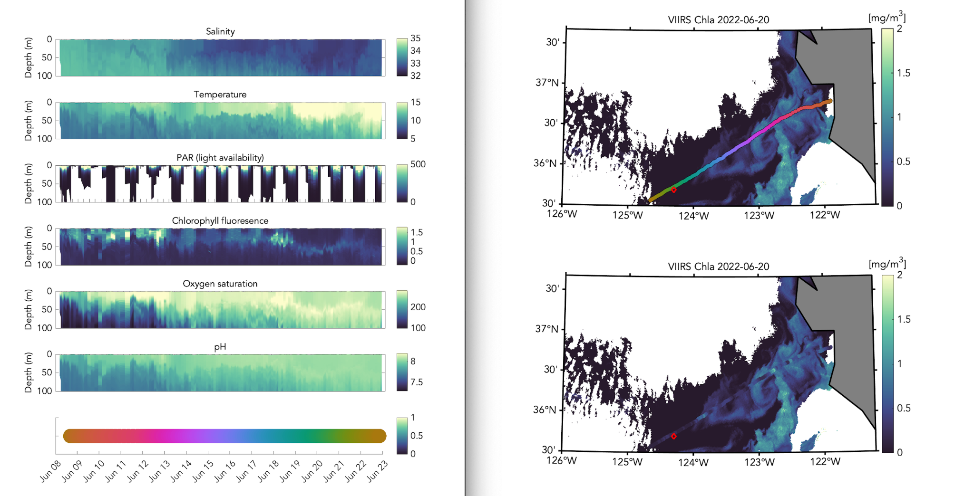 | KEY FIGURE AFTER  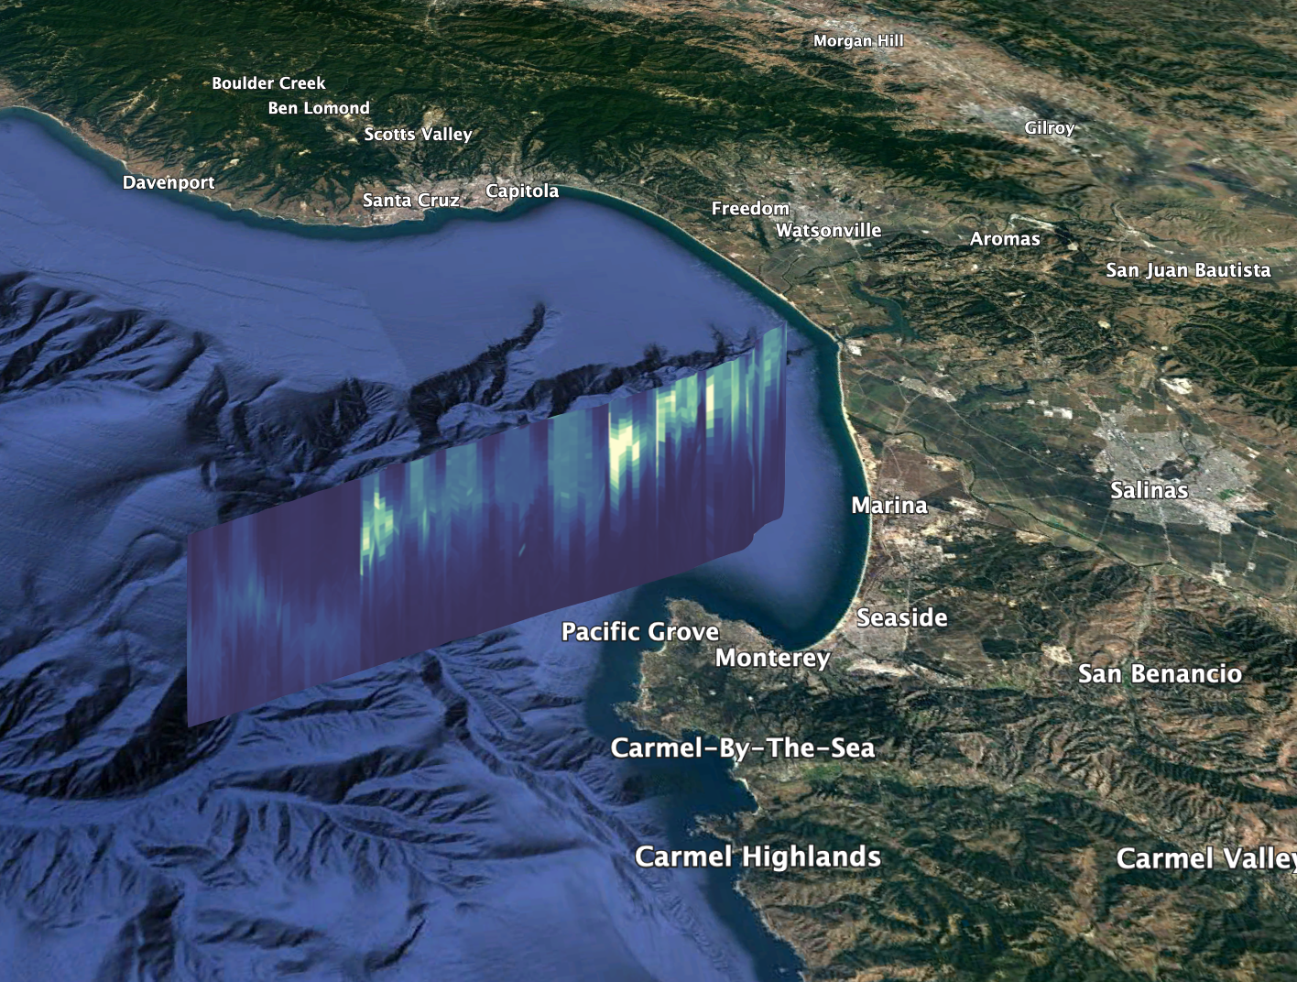

Homework: Code & key figure
Upload your code and key figure to the shared Google Drive & Canvas and name them:

04_Code_FirstName_LastName_CodeFilename.R (or other code file extension)
04_Figure_FirstName_LastName_FigureFilename.jpg
04_Figure_FirstName_LastName_FigureFilename.pdf (or other vector file format)

CODE & KEY FIGURE RUBRIC - See full rubric here.
Code Commenting | Completeness/Format (0.4) | Code is commented and can run with the CSV only (imports necessary libraries, etc)
Code Reflection | Completeness (0.4) | Student reflects on the changes needed to commenting or code organization to improve clarity.
Figure Interpretation | Completeness (0.4) | Partner lists what their interpretation of the figure is (where their eye is drawn, what they interpret as the main result or pattern, and any suggestions they have to improve this).
Figure Edits List | Completeness (0.4) | Potential edits to key figure are listed and a preferred method for addressing these edits (R or Illustrator) is indicated.
Figure Edits | Completeness (0.4) | Edits to the figure are made in R or Illustrator.
Figure | Correctness (0.6) | Figure maintains the integrity of the data, axes, and results.
Figure | Clarity (0.6) | Figure avoids visual clutter including extraneous information (minimize use of legends, gridlines, rotated labels, etc).
Figure | Organization (0.6) | Data is organized in such a way to expedite interpretation (e.g. by ordering values from largest to smallest).
Figure | Responsibility (0.6) | Figure is "responsible". The visual take-away is not misleading. Potential causes include: axes might not include 0 and focus on small data range to amplify patterns; axes might be inverted from what you might expect, etc.
Figure | Colors (0.6) | Colors in figure are appropriate for the intended purpose (colors highlight a group, distinguish between groups, demonstrate values along a continuous (sequential or diverging scale)).

5: Animation & Motion Graphics

Agenda
Agenda for the day:
- 2:00 - 2:20: Animation Brainstorming – Sketch explainer shot frames (20 min)
- 2:20 - 2:50: Group Discussion – Collect animation techniques required (30 min)
- 2:50 - 3:00: Break / Reflection (10 min)
- 3:00 - 3:30: Lecture: Introduction to Animation (30 min)
- 3:30 - 4:00: Discussion - List & brainstorm animation techniques (30 min)
- 4:00 - 4:10: Break (10 min)
- 4:10 - 4:40: Demo – Learning to animate in After Effects (30 min)
- 4:40 - 5:20: Work time – Make your animated motion graphic (40 min)
- 5:20 - 5:30: Break (10 min)
- 5:30 - 6:30: Guest speaker – Bailee Desrocher: Scientific animations for science storytelling at NASA & beyond

Opening Activity: Animation Storyboard Sketch
Create a pencil/paper sketch of 6 frames to show ideal animation for a single "explainer" shot. Use arrows and notes to explain effects and motion.

Animation Reflection
Review animation storyboard sketch, keeping in mind 12 principles of animation and the list of potential techniques to accomplish desired effect; decide which techniques to implement and which might be too time-intensive. Come back to this list during the lecture to fill in potential techniques.

Lecture: Introduction to Animation

Demo: Animating in After Effects

Work time: Make your animated motion graphic

Homework: Motion Graphics Scene
Upload your motion graphic shot to the shared Google Drive & Canvas and name it:

05_MotionGraphics_FirstName_LastName_SceneName.mp4

MOTION GRAPHICS RUBRIC - See full rubric here.
Animation storyboard sketch | Completeness (0.5) | Animation is planned out with a clear sequence of what the action is in each sequential shot.
Animation Reflection | Completeness (0.5) | Reviews animation storyboard sketch, keeping in mind 12 principles of animation and the list of potential techniques to accomplish desired effect; decide which techniques to implement and which might be too time-intensive.
Motion Graphics Scene | Completeness (4) | Provided .mp4 incorporates 2 concepts from the lecture to help clarify animation content.

6: Animating 2D Data

Agenda
Agenda for the day:
- 2:00 - 2:20: 2D Data Brainstorming – Sketch frames with 2D data (20 min)
- 2:20 - 2:50: Discussion – List ideas and recall animation techniques (30 min)
- 2:50 - 3:00: Break / Reflection (10 min)
- 3:00 - 3:30: Lecture: 2D Data-Driven Animation - Examples & software (30 min)
- 3:30 - 4:00: Demo/Tutorial - Animating CSV Data Example (30 min)
- 4:00 - 4:10: Break (10 min)
- 4:10 - 4:40: Demo – Overview of other 2D animation methods (30 min)
- 4:40 - 5:20: Work time – Animating your 2D data (40 min)
- 5:20 - 5:30: Break (10 min)
- 5:30 - 6:30: Guest speaker – Katherine Vlamis: CrossTown LA - COVID data visualizations for large cities amidst a global pandemic

Opening Activity: 2D Data Animation Storyboard Sketch
Create a pencil/paper sketch of 6 frames to show your idea for a 2D data animation. Use arrows and notes to explain effects and motion. Be sure to note which rows and/or columns of the dataset are being mapped onto which attributes (i.e. color, position, scale, etc.).

2D Data Animation Reflection
Review 2D data animation storyboard sketch, keeping in mind yesterday’s animation techniques. Which of those techniques might be appropriate for a visualization of this 2D data? Come back to this list during the lecture to fill in potential techniques.

Lecture: Introduction to 2D Data Animation

Demo: Animating 2D Data (using CSVs) in After Effects
To animate a line graph using a CSV, follow steps outlined on this webpage: https://github.com/jmkendallbar/VisualizingLifeintheDeep/blob/main/03_2D_lineAnimation_from_CSV.md

Demo: Other techniques for 2D Data Animation

Work time: Make your animated 2D data scene

Homework: 2D Data Scene
Upload your 2D data scene to the shared Google Drive & Canvas and name it:

06_2D-Data_FirstName_LastName_SceneName.mp4

2D DATA ANIMATION RUBRIC - See full rubric here.
Data Exploration | Data description (0.67) | Describe the columns in your dataset, what units they are in, and what type of data (categorical, continuous, etc.)
Data Exploration | Data animation priorities (0.67) | Prioritize which columns you want to include in your animation and in what form (line graph, text counter, etc)
Data Exploration | Pattern Finding (0.67) | Provide a screenshot of a conditionally-formatted data sheet in Excel to show the patterns in your data.
Data Animation | Completeness (3) | Applied techniques from tutorial to create an animated line chart and text counter with your data.
*Extra Credit | *Try/make something new (1) | If you'd like to animate 2D data in another software (R, ArcGIS, etc), you can do this. Please provide a detailed step-by-step list of instructions for someone to follow in your footsteps.
*Extra Credit | *Originality (1) | If your code or tool is brand new (you didn't follow a detailed step-by-step online tutorial), you get a bonus point!

7: Intro to 3D Animation

Agenda
Agenda for the day:
- 2:00 - 2:20: 3D Exploration – Explore example 3D assets folder in Maya (20 min)
- 2:20 - 2:50: Troubleshooting & Questions – How did that go? (30 min)
- 2:50 - 3:00: Break / Reflection (10 min)
- 3:00 - 3:30: Lecture: Introduction to 3D Animation (30 min)
- 3:30 - 4:00: Work time - Explore textures, controls, and skeleton of 3D model (30 min)
- 4:00 - 4:10: Break (10 min)
- 4:10 - 4:40: Demo – Animating a locomotion cycle (30 min)
- 4:40 - 5:20: Work time – Animate your 3D model (40 min)
- 5:20 - 5:30: Break (10 min)
- 5:30 - 6:30: Guest speaker – Johnson Martin: Digital Life 3D: Realistic animal models for science and education

Opening Activity: Exploring assets in Maya

Lecture: Introduction to 3D Animation

Work time: Explore 3D model in Maya

Demo: Animating a locomotion cycle

Work time: Animate your 3D model

Homework: Locomotion cycle
Upload your 2D data scene to the shared Google Drive & Canvas and name it:

07_LocomotionCycle_FirstName_LastName_ModelType_LocomotionType.mp4

LOCOMOTION CYCLE RUBRIC - See full rubric here.
3D Walk or Swim-Cycle Animation | Completeness (3) | Provided .mp4 of animated swim/walk/fly cycle and includes reference video(s) of behavior.
3D Walk or Swim-Cycle Animation | Cycle completion (1) | Swim or walk cycle loops correctly with no visible jumps
3D Walk or Swim-Cycle Animation | Cycle accuracy (1) | Swim or walk cycle looks correct (based on source material video)

8: Animating 3D Data

Agenda
Agenda for the day:
- 2:00 - 2:20: Playblast Critique – Review swim / walk cycle outputs (20 min)
- 2:20 - 2:50: Reflection & Troubleshooting – Discussion & skill-sharing (30 min)
- 2:50 - 3:00: Break / Reflection (10 min)
- 3:00 - 3:30: Demo/Lecture: Adding data to 3D animation (30 min)
- 3:30 - 4:00: Work time - Edit/comment/change code to work with data (30 min)
- 4:00 - 4:10: Break (10 min)
- 4:10 - 4:40: Demo/Lecture: Controlling animation from the command line (30 min)
- 4:40 - 5:20: Work time – Animate your 3D data (40 min)
- 5:20 - 5:30: Break (10 min)
- 5:30 - 6:30: Guest speaker – Geraldine Fauville: Virtual reality for environmental education

Opening Activity: Critique & Reflection- Locomotion Cycles
Review the rubric as you watch each other’s locomotion cycles. We will compile a list of things that were successful. What were some things that you struggled with while making your locomotion cycle? How did you resolve these challenges?

Lecture: Introduction to 3D Data Animation

Demo: Animating 3D Data in Maya
Important notes for setting up your Maya workstation:
- Assure you are working with Autodesk Maya 2023 with PyMEL installed.
- Change up-axis convention to match scientific conventions:
  - Window > Preferences > Settings > Choose these settings:
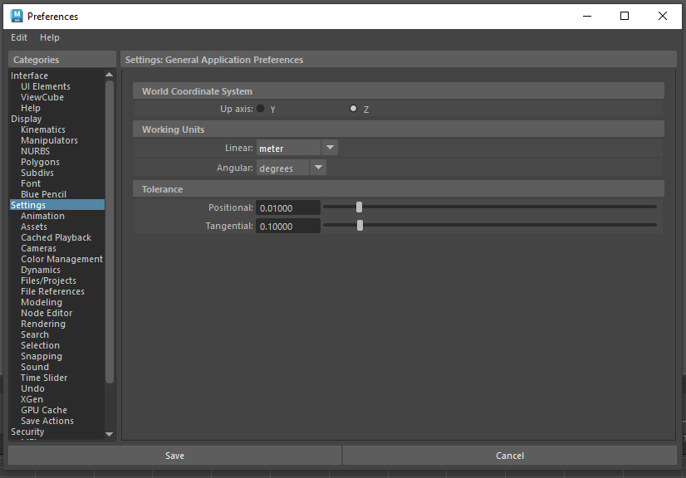
- Import PyMEL & Maya Commands. Explore Maya command documentation: https://help.autodesk.com/cloudhelp/2018/ENU/Maya-Tech-Docs/Commands/index.html
- Instructions for animating 3D position data: github.com/jmkendallbar/VisualizingLifeintheDeep/blob/main/01_3D_setKeysFromData_positionRotation.md
- Instructions for animating 3D behavior:
github.com/jmkendallbar/VisualizingLifeintheDeep/blob/main/00_3D_00_StrokeData_to_Swim.md

Demo: Other techniques for 3D Data Animation

Work time: Make your animated 3D data scene

Homework: 3D Data Scene
Upload your 3D data scene to the shared Google Drive & Canvas and name it:

08_3D-Data_FirstName_LastName_SceneName.mp4

3D DATA ANIMATION RUBRIC - See full rubric here.
3D Data-Driven Animation | Completeness (3) | mp4 generated where 3D data drives the behavior, position, and/or rotation of a 3D model (either demo data or your own)
3D Data-Driven Animation | Code uploaded & commented (1) | Code used to drive data is commented and uploaded to Github
3D Data-Driven Animation | Scenes and assets (1) | Scenes and assets are uploaded to each student's folder.
Extra Credit* | Use a new 3D Model (1) | Reward for animating 3D data for a new 3D model.
Extra Credit* | Originality (1) | If your code or tool is brand new (you didn't follow a detailed step-by-step online tutorial), you get a bonus point!

9: Editing & Compositing

Agenda
Agenda for the day:
- 2:00 - 2:20: Small Group Discussion – Group feedback & troubleshooting (20 min)
- 2:20 - 2:50: Large Group Discussion – Where do we need help/time? (30 min)
- 2:50 - 3:00: Break / Reflection (10 min)
- 3:00 - 3:30: Lecture: Compositing (30 min)
- 3:30 - 4:00: Work time: Assembling animation (30 min)
- 4:00 - 4:10: Break (10 min)
- 4:10 - 4:40: Work time (30 min)
- 4:40 - 5:20: More work time (40 min)
- 5:20 - 5:30: Break (10 min)
- 5:30 - 6:30: Guest speaker – Connor Vance: Musical compositions for data storytelling

Opening Activity: Feedback & Discussion

Lecture: Compositing

Work time: Assembling animation

Homework: Submit Final Project
Upload your finished animation to the shared Google Drive & Canvas and name it:

09_FINAL_FirstName_LastName_AnimationTitle.mp4

3D DATA ANIMATION RUBRIC - See full rubric here.
Sound | Sound - quality (1) | Sound quality of background audio and narration are good - no popping, scratching, hissing, etc.
Sound | Sound - balance (1) | Narration and background music are evenly balanced; words are audible at all times.
Video | Captions (1) | Open captions are legible (adequate contrast) and spelled correctly.
Video | Video - quality (1) | Animation sequences maintain the same aspect ratio and general resolution (with the exception of tag video footage or similar footage).
Video | Transitions (0.5) | Animation transitions between shots smoothly (no long periods of black on the screen, chopped shots or footage).
Video | Credits - double check (0.5) | Double checking that all used footage is cited correctly (permit numbers provided, all funders acknowledged, etc).

EXTRA CREDIT: Revisions
Upon submission of this final project, you also have the opportunity to recuperate lost points from earlier in the course. Revisions should be submitted on Canvas and will be assessed using the following rubric:

Revisions | Addressing feedback and suggestions (5) | Student provides point-by-point review of feedback and suggestions they received throughout the course and how they have addressed those concerns in their final submission.

10: Final Critique & Communication Strategy

Agenda
Agenda for the day:
- 2:00 - 2:20: Final Project Critique - Watch videos (20 min)
- 2:20 - 2:50: Final Project Reflection – What worked, what can be added (30 min)
- 2:50 - 3:00: Break / Reflection (10 min)
- 3:00 - 3:30: Individual reflection: Fill out self-assessment and reassess tasks (30 min)
- 3:30 - 4:00: Work time (30 min)
- 4:00 - 4:10: Break (10 min)
- 4:10 - 4:40: Lecture – Science Communication Strategy (30 min)
- 4:40 - 5:20: Work time – Creating your science communication strategy (40 min)
- 5:20 - 5:30: Break (10 min)
- 5:30 - 6:30: Guest speaker – Sal Alper: Science communication through public outreach at the SF Exploratorium

Opening Activity: Final Project Critique & Reflection
Watch all final projects and keep the following questions in mind for the group discussion. Prepare to review your partner’s animation with respect to the following criteria.
- How do your eyes travel across the screen during the animation?
- How do the colors, style, text, and graphics influence the message?
- Describe the story the animation tells.
- What questions are you still wondering after looking at the animation?

Self-Assessment
Fill out the rubric at the end of this document and reassess remaining tasks. Decide which remaining scenes to improve, delete, or modify.

Work time: Revisit animation tasks- solicit feedback

Lecture: Science Communication Strategy

Work time: Create Science Communication Strategy

Identify outlets
List at least 3 potential outlets where your animation could be featured. Categorize whether you think this outlet would be likely to feature the animation. Identify patterns in the content that is shared by these outlets to begin to think about how to frame your animation as something they would want to feature.
Venue/Outlet (news outlets, museums, institutions, etc.) | Feasibility  (reach / target / safety) | Content Patterns (what does this outlet share/focus on)

Develop your pitch
Talking Points: List of facts, findings, and interesting tidbits about the science to use in an interview with a journalist or in a written pitch to a news outlet.

Science Pitch
Why should this news outlet/aquarium/institution put this science on display?
Why is it important and how does it fit in with their mission?

Animation Pitch
Why should this animation be displayed along with a discussion of the science of the paper?
What does it add?

Networking / Strategy
How are you going to get your animation featured by these institutions? Who will you email/who will you network with/who can help you reach this goal?

Social Media Strategy
List of hashtags, organizations, and their social media handles, and a sample tweet. Include all necessary permit numbers, credits, and paper citations.

Homework: Science Communication Strategy
Upload your Communication Strategy to the shared Google Drive & Canvas and name it:

10_SciCommStrategy_FirstName_LastName.pdf

SCIENCE COMMUNICATION STRATEGY RUBRIC - See full rubric here.
Identifying outlets | List of potential venues/outlets (0.5) | List of social media outlets, news outlets, museums, aquariums, zoos, institutions (including universities), film festivals/competitions, local community centers, schools, etc. List is categorized (reach, target, and safety).
Identifying outlets | Identifying content patterns (0.5) | List of content patterns you identify in the content by your target outlets (above) - how is your content similar or different?
Developing your pitch | Talking Points (critical and supplemental) (1) | List of facts, findings, and interesting tidbits about the science to use in interviews/pitches.
Developing your pitch | Science Pitch (1) | Why should this news outlet/aquarium/institution put this science on display? Why is it important and how does it fit in with their mission?
Developing your pitch | Animation Pitch (1) | Why should this animation be displayed along with a discussion of the science of the paper? What does it add?
Strategy | Networking/Strategy (0.5) | How are you going to get your animation featured by these institutions? Who will you email/who will you network with/who can help you reach this goal?
Strategy | Social media strategy (0.5) | List of hashtags, organizations and their social media handles, and a sample tweet.

Rubric

1: Introductions & Collaboration |  |  |  | Criteria
 | 0.5 | Data Description | Correctness (0.25) | Data is described/interpreted correctly.
 | 0.5 | Data Description | Completeness (0.25) | Data is categorized correctly.
 | 1.5 | Style Guide | Verbal description (0.3) | Verbal description is provided and evokes the intended emotion/feeling.
 | 1.5 | Style Guide | Color palette (0.3) | Color palette has 3 main hues (3 values for each hue); 3 main hues are distinguishable and colorblind friendly; text and background colors have enough contrast
 | 1.5 | Style Guide | Fonts (0.3) | Fonts are provided, legible, and consistent with verbal description
 | 1.5 | Style Guide | Credit slide and Watermark (0.3) | Example credit slide has all required funders acknowledged according to their style stipulations (e.g. USGS has very specific requirements for videos hosted on their site). A sample frame from the animation shows required watermarks and logos (e.g. NMFS Permit # displayed for marine mammal research/data visualizations)
 | 1.5 | Style Guide | Spelling/Abbreviations/Capitalization (0.3) | List critical assets that may be labeled in your animation to ensure that you are using proper and consistent spelling/abbreviations/capitalization.
 | 3 | Script | Hook (0.375) | Script uses one of the discussed strategies to grab the audience's attention and interest.
 | 3 | Script | What the scientists did (0.375) | Script explains how and why the science was done.
 | 3 | Script | What they found (0.375) | Distills the main point of the paper into at most 3 separate ideas (~ at most 3 key points)
 | 3 | Script | Why does it matter (0.375) | Focuses on the impact of the study with respect to the audience, appeals to the audience using their predicted cares and interests.
 | 3 | Script | Clarity & intelligibility (0.375) | Script avoids using acronyms and domain-specific jargon unless absolutely essential to the story. If terms are deemed essential, a definition must be provided. Script should be intelligible to a lay audience (no assumed prior knowledge related to the study).
 | 3 | Script | Recording quality (0.375) | Audio quality is good (no background noise, no interruptions, no static, no popping)
 | 3 | Script | Time Limit (0.375) | The recorded script is less than 2 minutes long.
 |  | Contract & Budget | Completeness (0.375) | Contract/Budget is filled out.
Total: _ / 5 pts |  |  |  | Self Assessment Notes:
2: Conceptualization  (Storyboard and Animatic) |  |  |  | Criteria
 | 3.5 | Storyboard | Completeness (0.875) | One image (hand-illustrated or digitally rendered, medium of choice) for each major shot in the animation (minimum of ~10, maximum of ~20).
 | 3.5 | Storyboard | Script (0.875) | Script is divided into 2-3 sentences per shot where the text matches the image.
 | 3.5 | Storyboard | Verbal Description (0.875) | Verbal description of the action is provided.
 | 3.5 | Storyboard | Audio Description (0.875) | Audio description of action is provided (sound effects, musical direction - louder or softer, etc.)
 | 1.5 | Animatic | Video Format (0.5) | Provided .mp4 is in the correct format (Widescreen Youtube Preset HD 1080p H.264 Codec)
 | 1.5 | Animatic | Visuals (0.5) | Storyboard illustrations are digitized, legible, and inserted at the correct time in the video
 | 1.5 | Animatic | Captions (0.5) | The script is included as open captions at the bottom of the video. Grammar and spelling in captions is correct.
Total: _ / 5 pts |  |  |  | Self Assessment Notes:
3: Digital Art & Design
 | 3 | Vector Graphic | Completeness/Format (0.6) | Vector graphic is provided in .ai, .pdf, .eps, or .svg format and paths/curves are editable in Illustrator.
 | 3 | Vector Graphic | Organization (0.6) | Provide a screenshot of your layer organization and explain your strategy and any challenges you faced.
 | 3 | Vector Graphic | Effort/Technique (0.6) | Demonstrates use of at least 3 techniques provided in the digital painting demo.
 | 3 | Vector Graphic | Output quality (0.6) | Outline is a continuous, closed path (can be accurately filled with a color).
 | 3 | Vector Graphic | Path quality (0.6) | Points on outline path are kept to a minimum, lines are smooth (unless a sharp curve is warranted).
 | 2 | Raster Graphic | Completeness/Format (0.67) | Raster graphic is provided in 300 ppi and is large enough to be clearly visible if viewed full screen or at desired zoom level (suggest ~ 20 inches wide to be safe).
 | 2 | Raster Graphic | Organization (0.67) | Provide a screenshot of your layer organization and explain your strategy and any challenges you faced.
 | 2 | Raster Graphic | Effort/Technique (0.67) | Demonstrates use of at least 3 techniques provided in the digital painting demo.
Total: _ / 5 pts |  |  |  | Self Assessment Notes:
4: Data Visualization
 | 2 | Code Commenting | Completeness/Format (0.4) | Code is commented and can run with the CSV only (imports necessary libraries, etc)
 | 2 | Code Reflection | Completeness (0.4) | Student reflects on the changes needed to commenting or code organization to improve clarity.
 | 2 | Figure Interpretation | Completeness (0.4) | Partner lists what their interpretation of the figure is (where their eye is drawn, what they interpret as the main result or pattern, and any suggestions they have to improve this).
 | 2 | Figure Edits List | Completeness (0.4) | Potential edits to key figure are listed and a preferred method for addressing these edits (R or Illustrator) is indicated.
 | 2 | Figure Edits | Completeness (0.4) | Edits to the figure are made in R or Illustrator.
 | 3 | Figure | Correctness (0.6) | Figure maintains the integrity of the data, axes, and results.
 | 3 | Figure | Clarity (0.6) | Figure avoids visual clutter including extraneous information (minimize use of legends, gridlines, rotated labels, etc).
 | 3 | Figure | Organization (0.6) | Data is organized in such a way to expedite interpretation (e.g. by ordering values from largest to smallest).
 | 3 | Figure | Responsibility (0.6) | Figure is "responsible". The visual take-away is not misleading. Potential causes include: axes might not include 0 and focus on small data range to amplify patterns; axes might be inverted from what you might expect, etc.
 | 3 | Figure | Colors (0.6) | Colors in figure are appropriate for the intended purpose (colors highlight a group, distinguish between groups, demonstrate values along a continuous (sequential or diverging scale)).
Total: _ / 5 pts |  |  |  | Self Assessment Notes:
5: Animation & Motion Graphics
 | 1 | Animation storyboard sketch | Completeness (0.5) | Animation is planned out with a clear sequence of what the action is in each sequential shot.
 | 1 | Animation Reflection | Completeness (0.5) | Reviews animation storyboard sketch, keeping in mind 12 principles of animation and the list of potential techniques to accomplish desired effect; decide which techniques to implement and which might be too time-intensive.
 | 4 | Motion Graphics Scene | Completeness (4) | Provided .mp4 incorporates 2 concepts from the lecture to help clarify animation content.
Total: _ / 5 pts |  |  |  | Self Assessment Notes:
6: Animating 2D Data
 | 2 | Data Exploration | Data description (0.67) | Describe the columns in your dataset, what units they are in, and what type of data (categorical, continuous, etc.)
 | 2 | Data Exploration | Data animation priorities (0.67) | Prioritize which columns you want to include in your animation and in what form (line graph, text counter, etc)
 | 2 | Data Exploration | Pattern Finding (0.67) | Provide a screenshot of a conditionally-formatted data sheet in Excel to show the patterns in your data.
 | 3 | Data Animation | Completeness (3) | Applied techniques from tutorial to create an animated line chart and text counter with your data.
 | 1 | *Extra Credit | *Try/make something new (1) | If you'd like to animate 2D or 3D data in another software (R, ArcGIS, etc), you can do this. Please provide a detailed step-by-step list of instructions for someone to follow in your footsteps.
 | 1 | *Extra Credit | *Originality (1) | If your code or tool is brand new (you didn't follow a detailed step-by-step online tutorial), you get a bonus point!
Total: _ / 5 pts |  |  |  | Self Assessment Notes:
7: Intro to 3D Animation
 | 3 | 3D Walk or Swim-Cycle Animation | Completeness (3) | Provided .mp4 of animated swim/walk/fly cycle and includes reference video(s) of behavior.
 | 1 | 3D Walk or Swim-Cycle Animation | Cycle completion (1) | Swim or walk cycle loops correctly with no visible jumps
 | 1 | 3D Walk or Swim-Cycle Animation | Cycle accuracy (1) | Swim or walk cycle looks correct (based on source material video)
Total: _ / 5 pts |  |  |  | Self Assessment Notes:
8: Animating 3D Data
 | 3 | 3D Data-Driven Animation | Completeness (3) | mp4 generated where 3D data drives the behavior, position, and/or rotation of a 3D model (either demo data or your own)
 | 1 | 3D Data-Driven Animation | Code uploaded & commented (1) | Code used to drive data is commented and uploaded to Github
 | 1 | 3D Data-Driven Animation | Scenes and assets (1) | Scenes and assets are uploaded to each student's folder.
Total: _ / 5 pts |  |  |  | Self Assessment Notes:
9: Editing, Compositing, and Custom Musical Scores
 | 1 | Sound | Sound - quality (1) | Sound quality of background audio and narration are good - no popping, scratching, hissing, etc.
 | 1 | Sound | Sound - balance (1) | Narration and background music are evenly balanced; words are audible at all times.
 | 1 | Video | Captions (1) | Open captions are legible (adequate contrast) and spelled correctly.
 | 1 | Video | Video - quality (1) | Animation sequences maintain the same aspect ratio and general resolution (with the exception of tag video footage or similar footage).
 | 0.5 | Video | Transitions (0.5) | Animation transitions between shots smoothly (no long periods of black on the screen, chopped shots or footage).
 | 0.5 | Video | Credits - double check (0.5) | Double checking that all used footage is cited correctly (permit numbers provided, all funders acknowledged, etc).
Total: _ / 5 pts |  |  |  | Self Assessment Notes:
Revisions (extra credit)
 | 5 | Revisions | Addressing feedback and suggestions (5) | Student provides point-by-point review of feedback and suggestions they received throughout the course and how they have addressed those concerns in their final submission.
Total: _ / 5 pts |  |  |  | Self Assessment Notes:
10: Final Review & Communication Strategy
 | 0.5 | Identifying outlets | List of potential venues/outlets (0.5) | List of social media outlets, news outlets, museums, aquariums, zoos, institutions (including universities), film festivals/competitions, local community centers, schools, etc. List is categorized (reach, target, and safety).
 | 0.5 | Identifying outlets | Identifying content patterns (0.5) | List of content patterns you identify in the content by your target outlets (above) - how is your content similar or different?
 | 1 | Developing your pitch | Talking Points (critical and supplemental) (1) | List of facts, findings, and interesting tidbits about the science to use in interviews/pitches.
 | 1 | Developing your pitch | Science Pitch (1) | Why should this news outlet/aquarium/institution put this science on display? Why is it important and how does it fit in with their mission?
 | 1 | Developing your pitch | Animation Pitch (1) | Why should this animation be displayed along with a discussion of the science of the paper? What does it add?
 | 0.5 | Strategy | Networking/Strategy (0.5) | How are you going to get your animation featured by these institutions? Who will you email/who will you network with/who can help you reach this goal?
 | 0.5 | Strategy | Social media strategy (0.5) | List of hashtags, organizations and their social media handles, and a sample tweet.
 | 50 | TOTAL POSSIBLE | Self-Assessment Score: | Self-Assessment Feedback:
 | 7 | EXTRA CREDIT | Self-Assessment Score: | Self-Assessment Feedback:
 |  |  | Peer-Assessment Feedback:
Instructor Score:
Instructor Feedback:

Guest Speakers

- Sara ElShafie, PhD - Distilling Complexity: Science through Story
Founder & Principal, Science Through Story, LLC
(el-SHAA-fee) (she/her)
sara@sciencethroughstory.org
Links: https://www.sciencethroughstory.org/

Sara ElShafie, PhD, is a global change biologist and science storytelling coach. She collaborates with artists in a wide range of industries to uncover the potential of storytelling to engage broad audiences with complex topics. ElShafie is the Founder and Principal of Science Through Story, LLC, dedicated to helping scientists and science educators connect with audiences through effective storytelling. She offers workshops and coaching for audiences ranging from graduate students to NASA scientists to theme park executives. She also organized a symposium, Science Through Narrative: Engaging Broad Audiences, with speakers from the scientific community as well as arts and entertainment industries, and curated a resulting published volume of open access papers. ElShafie holds a B.A. in Biological Sciences from the University of Chicago, a M.S. in Earth & Atmospheric Sciences from the University of Nebraska, Lincoln and she just completed her Ph.D. in Integrative Biology with the Museum of Paleontology at the University of California, Berkeley.

Project: Can Science Be Simple? Distilling Complexity into Engaging Images - PLOS SciComm
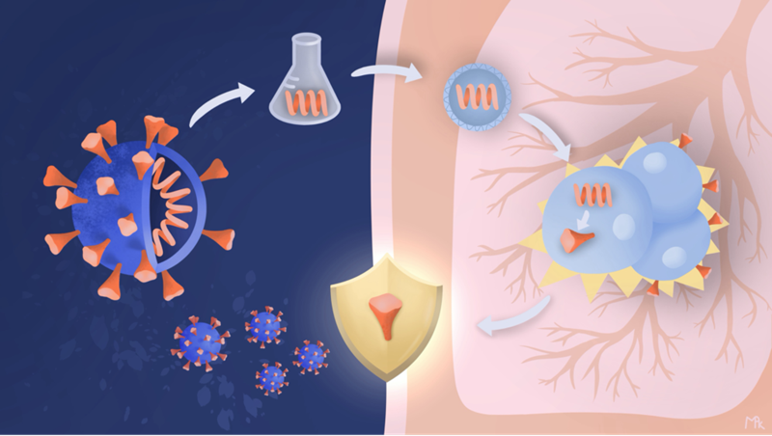
“Revised” version of our mRNA COVID-19 vaccine figure through collaboration between Sara ElShafie and Scientific Illustrator:. © Maya Kostman.

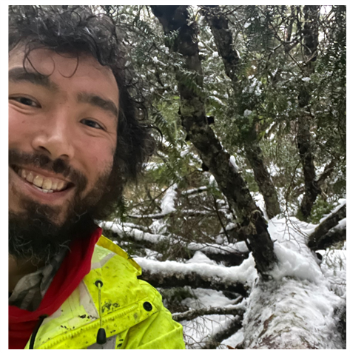
- Ilgavak (Peter Williams) - Storytelling and place-based learning
artist and culture bearer
(e-luc-gah-vuck) (he/him)
seaotterfur@gmail.com
Link: http://www.seaotterfur.com/

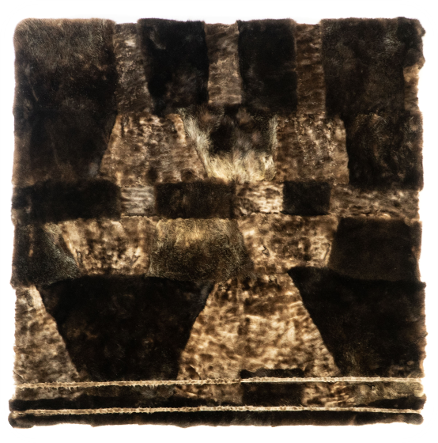
Ilgavak (Peter Williams), is a Yup’ik culture bearer, artist, designer, filmmaker, and educator based in Sheet'ká (Sitka), Alaska. His hand-sewn works repurpose skin from self-harvested traditional foods, bridging worlds of Indigenous art, fashion, and subsistence. Ilgavak completed artist residencies at Santa Fe Art Institute and Institute of American Indian Arts, and has guest lectured and/or taught skin sewing at Yale University, Stanford University, UCLA, Portland Art Museum, and Alaska State Museum, among others. His art has been shown at museums and galleries across North America. His presentations at New York Fashion Week and Fashion Week Brooklyn in 2015 and 2016 led to profiles in The Guardian and The New York Times. He produced the documentary Harvest: Quyurciq, which received a Native Peoples Action project grant. In 2018-2020 Ilgavak became a Cultural Capital Fellow, a Luce Indigenous Knowledge Fellow, and received an Individual Artist Award Project Grant from Rasmuson Foundation. In 2021 he received an NDN Collective Radical Imagination Grant and, in 2022, United States Artists Fellowship. His professional and personal work is increasingly focused on climate change and its disproportionate effects on Indigenous peoples. He doesn’t want to look back and create retrospective work that mourns the loss of Alaska’s life-sustaining environment. He wants to confront the issue now and improve the health of his human and non-human relatives. His ancestors’ wisdom of how to live in reciprocity with the World is embedded in traditional arts. It is an honor to carry this knowledge into the future.
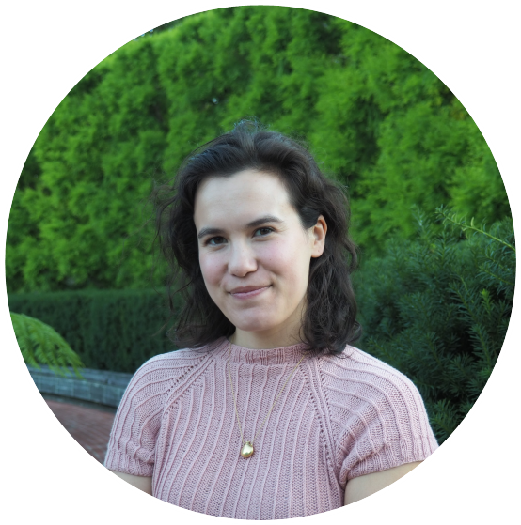
- Alex Boersma - Scientific illustration and animation for high-impact science
Freelance Scientific Illustrator, Alex Boersma Illustration
(b-OR-sma) (she/her)
alexboersmaart@gmail.com
Animations: https://www.alexboersma.com/animation

Alex Boersma is a Canadian scientific illustrator living in Chicago. She received a BA in geology and studio art from Vassar College in 2015, and a master’s in science illustration from California State University, Monterey Bay in 2017. As an illustrator, Alex collaborates with museums, scientists and conservationists, creating visuals to engage the public in scientific ideas. Working both traditionally and digitally, Alex takes particular pleasure in incorporating unconventional mediums and styles into her scientific illustrations. Her clients include the Smithsonian National Museum of Natural History, Stanford University, Woods Hole Oceanographic Institute, and Macmillan Publishers.
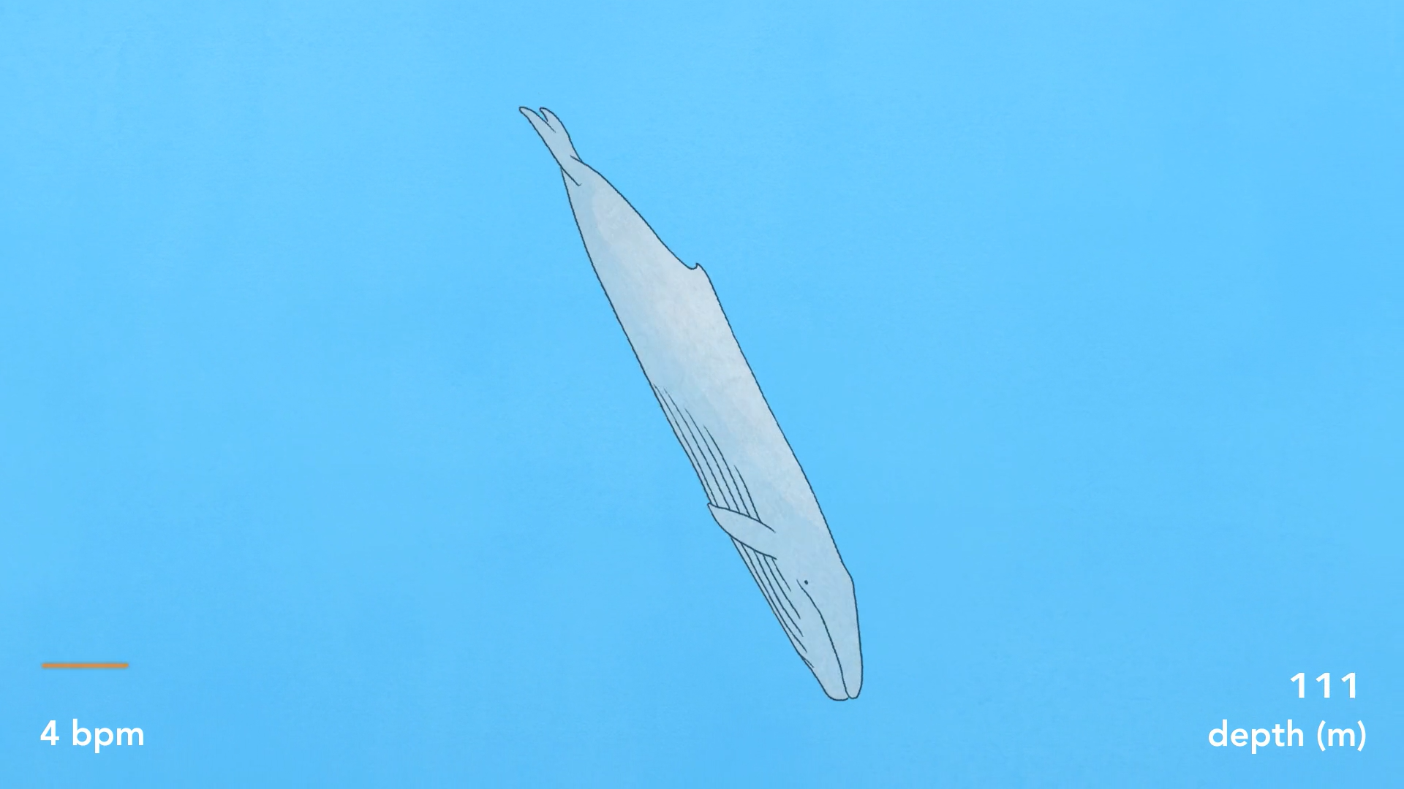
Researchers at Stanford’s Hopkins Marine Station measured a blue whale’s heart beat for the first time, and may have found the secret to how they can feed at depth for long periods of time: during a dive, blue whales can slow down their heartbeat to 4 beats per minute. This animation shows a blue whale’s bpm as it goes through the different phases of lunge feeding at depth (don’t forget to turn on the sound for this one!). Commissioned by the Goldbogen Lab at Hopkins Marine Station.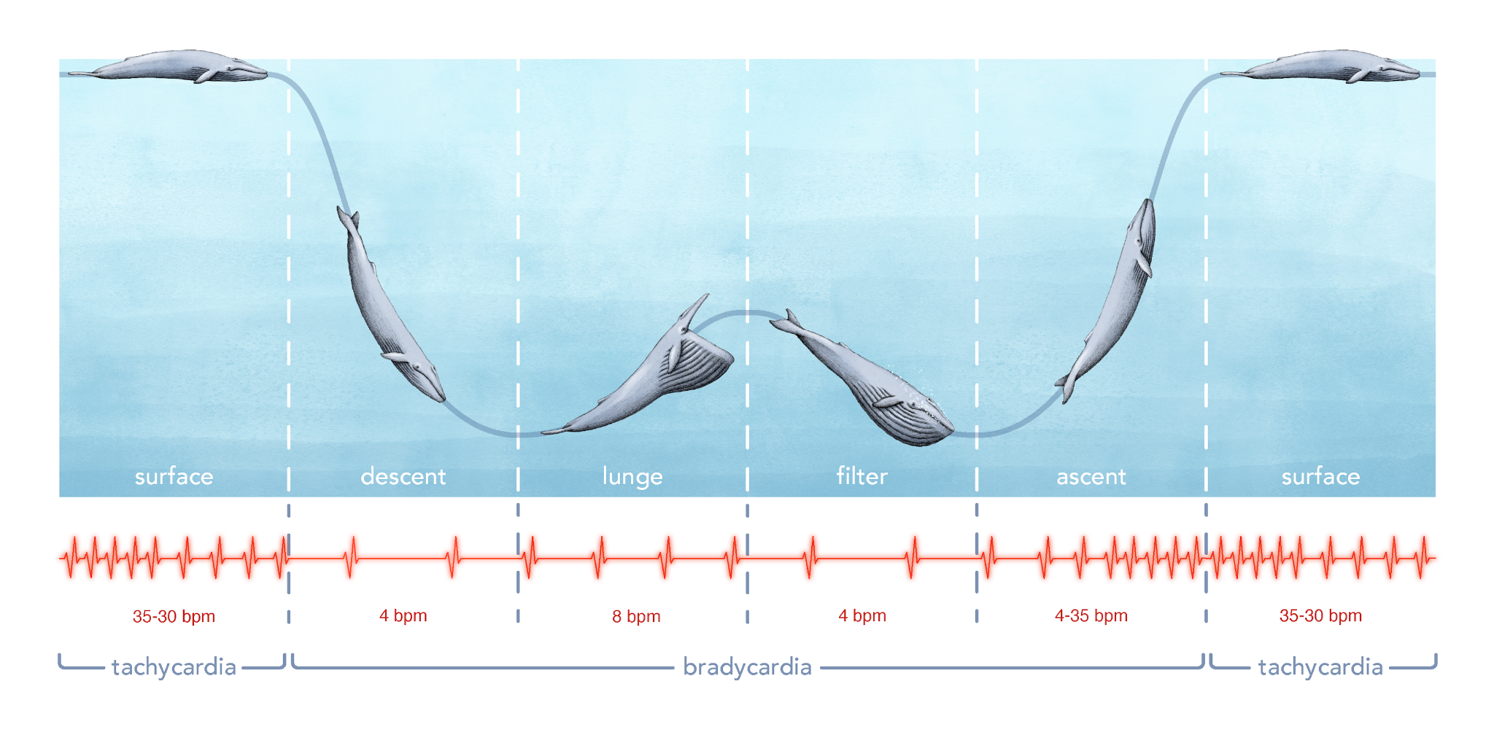

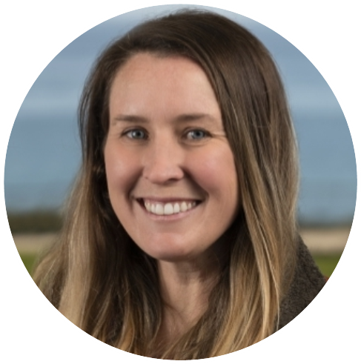
- Allison Horst - Art to build agency for budding data scientists
Assistant Teaching Professor, UC Santa Barbara
(she/her)
ahorst@ucsb.edu
Personal website: www.allisonhorst.com
Art library: github.com/allisonhorst/stats-illustrations

Allison is an Assistant Teaching Professor at the Bren School of Environmental Science and Management at UC Santa Barbara, where she teaches programming, statistics, math, data analysis, data visualization and presentation skills for environmental data science. She studied engineering (BS Chemical Engineering, MS Mechanical Engineering) before earning her PhD from UCSB in 2012 (Environmental Science and Management, emphasis in Nanotoxicology). She actively contributes to open resources and software for data science education, including the palmerpenguins R package and a library of original illustrations that are used in data science courses and workshops around the world. She co-founded Santa Barbara R-Ladies in 2018, and was an Artist-in-Residence with the National Center for Ecological Analysis and Synthesis (2018 - 2019) before joining RStudio as their first Artist-in-Residence from 2019 – 2020. When she isn’t teaching or drawing, she enjoys looking for animal tracks, fly fishing, and walking with her dog Teddy.
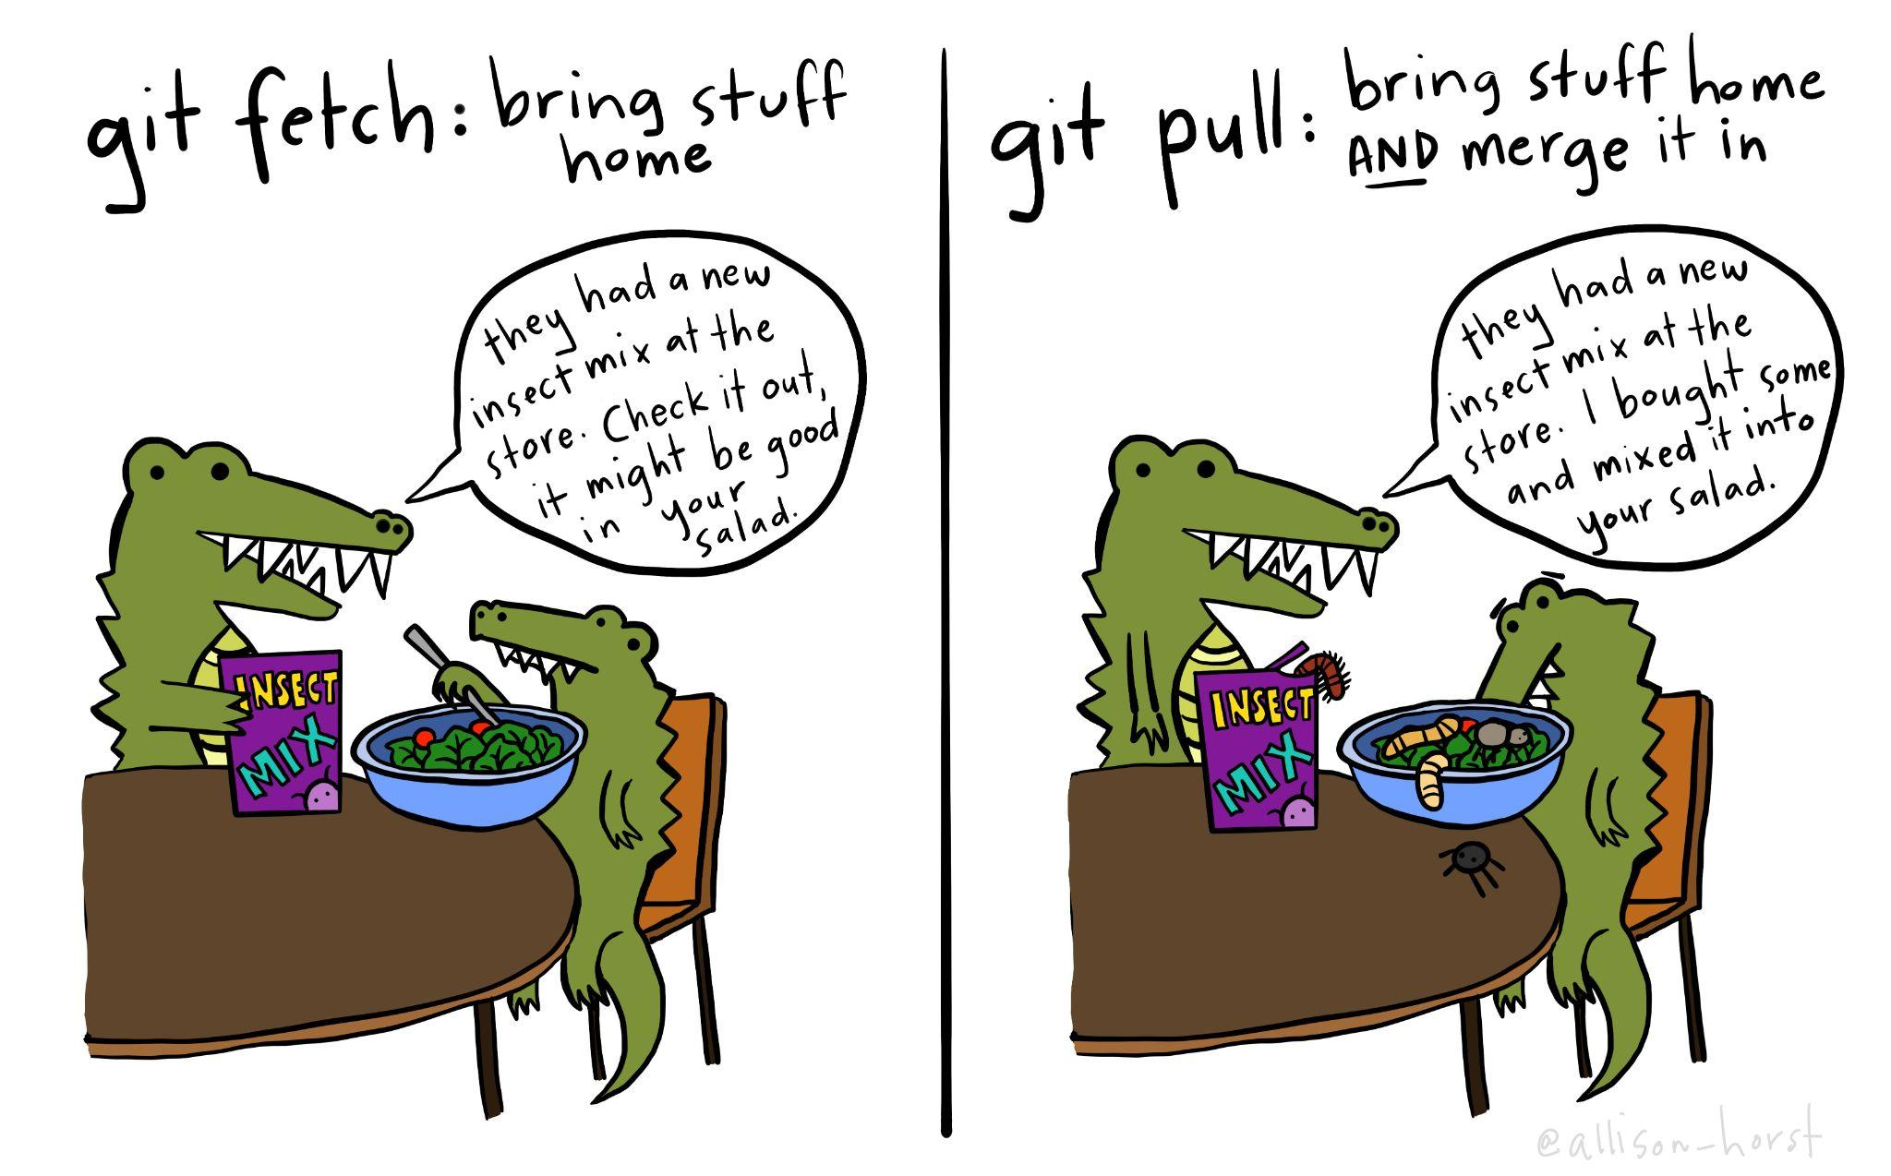

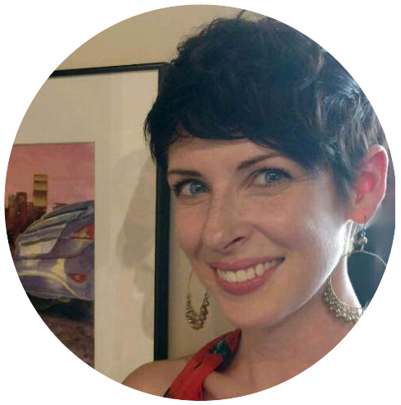
- Bailee DesRocher - Animations for science: storytelling at NASA & beyond
Senior Animator, Ingenuity Studios
(Bay-lee Duh-rosh-er)(she/her)
contact@beautifulcritters.com
Links: https://drawntoexploration.com
https://ingenuitystudios.com
https://cilab.gsfc.nasa.gov
https://svs.gsfc.nasa.gov

Bailee DesRocher's career in motion design and visual effects has consistently taken her to the realms of science and entertainment, where she has come to focus on art direction, concept art, and professional development for junior artists. A graduate of the Science Illustration Certificate Program at Cal State Monterey Bay, she is currently Senior Animator at Ingenuity Studios, a visual effects studio in Los Angeles, working with clients like Imagine Dragons, Dolly Parton, HBO Max, Hulu, NBC, Disney and Marvel. Previous clients include Herzog & Co., the Natural History Museum of Los Angeles County, JPL, Star Talk Radio, the La Brea Tar Pits and Museum, and NASA.
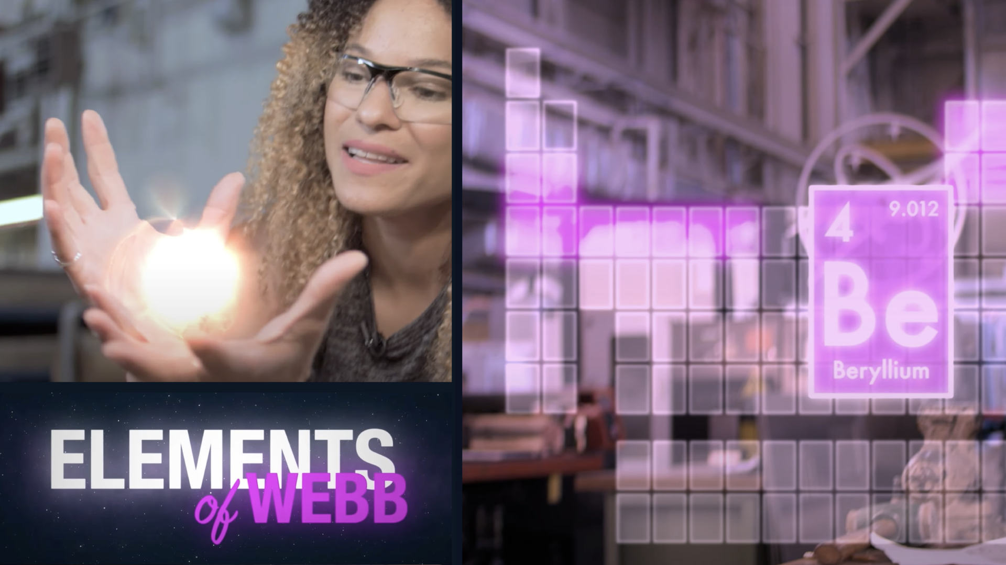
Where does beryllium really come from? To explain beryllium's rare beginnings, we have to talk about the cosmic origins of most elements.

Credits: NASA's Goddard Space Flight Center; https://www.youtube.com/watch?v=BoQ8YJEaf_Y&t=27s


- Katherine Vlamis - COVID Data Visualizations
Marketing and Social Media Editor, Crosstown LA
(ka-thrin vla-mis, a in last name similar to a in ant) (she/her)
vlamis@usc.edu
Link: https://xtown.la/2021/07/22/the-crosstown-vaccine-tracker-2/

Katherine Vlamis is the Marketing and Social Media Editor at Crosstown LA, a non-profit news organization that covers the neighborhoods of Los Angeles through hyperlocal data. As a music industry major and public relations minor at the University of Southern California, Katherine’s main role at Crosstown LA consists of growing their social media presence, online engagement, and newsletter subscriptions. At the beginning of the global pandemic, Katherine began generating social media and website-friendly COVID-19 graphs on cases, hospitalizations, positivity rate, and eventually vaccinations. Gradually, Katherine developed this data into weekly Crosstown COVID Trackers and newsletter segments to provide further analysis and transparency about LA’s progress during the pandemic. In contrast to other news sources and press releases, these short, digestible articles and charts gave Angelenos a more accessible way to learn about LA’s battle against COVID-19. By collecting daily and weekly data from the Los Angeles County Department of Public Health, Katherine has been able to contribute to Crosstown LA’s consistent reporting of COVID-19 in Los Angeles. Beyond her work at Crosstown LA, Katherine has worked at marketing agencies like Bloom XO and larger companies like TikTok to promote entertainment brands on social media. After graduation, she plans to use data analysis to help musicians and film companies create more effective digital strategies to reach target audiences.

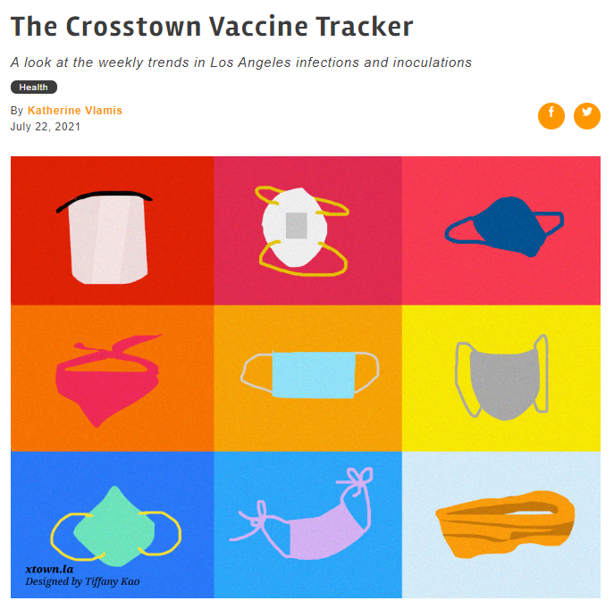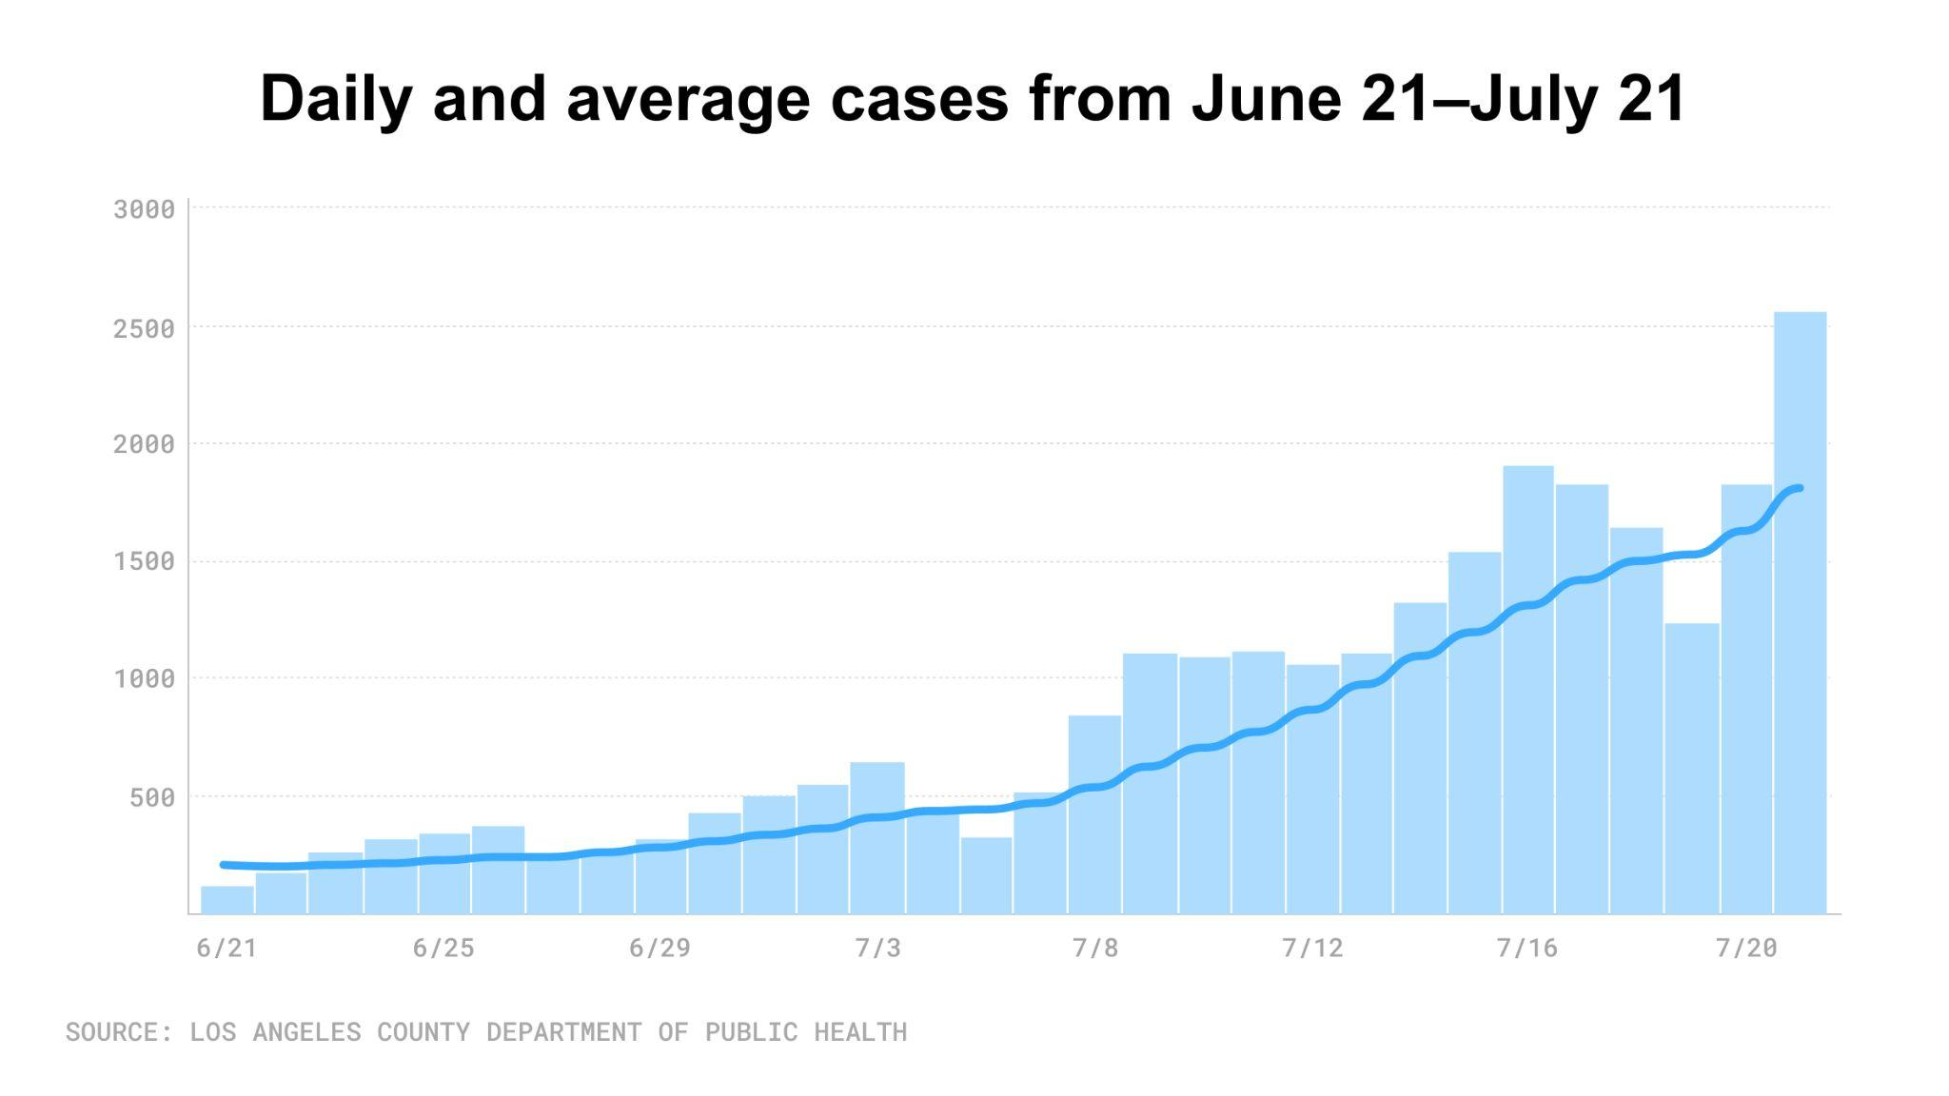
The seven-day case average continues to surge. Over the past month, average cases have gone from 225 on June 21 to 1,787 on July 21. On a brighter note, the seven-day average for deaths remains low, with 5 reported on July 21. However, this is often a lagging indicator, so the figure is expected to increase in the coming weeks following the recent spike in cases.

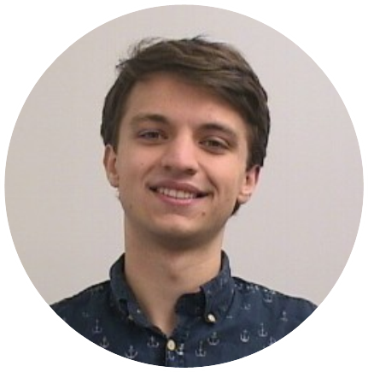
- Johnson Martin - Digital Life 3d: Realistic models for science & education
3d Artist at Digital Life 3d
johnmartin31899@gmail.com
Link: https://www.artstation.com/artwork/v24GwD

Johnson Martin is a 3d artist specializing in visualization and data reconstruction at Digital Life 3d. In his work, he utilizes traditional sculpting, modeling, and texturing methods as well as photogrammetry, python, and raw data to reconstruct virtual representations of living animals. Apart from 3d work, Johnson regularly publishes to many online publications writing about methods and processes in computer graphics and related fields. Johnson graduated from Asbury University with a BA in Philosophy in 2021.

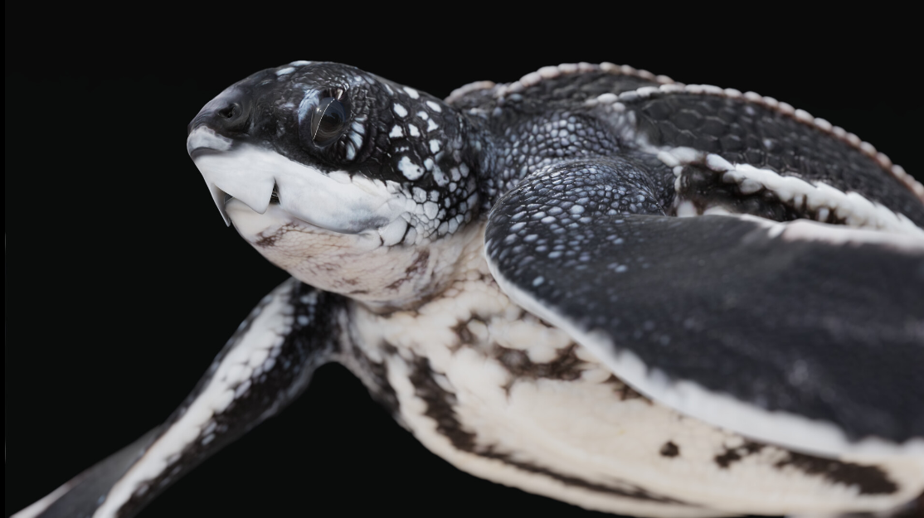
Juvenile Leatherback Sea Turtle (Dermochelys coriacea)
Recently in partnership with Digital Life 3D, I created this model of a juvenile sea turtle based on images of a living specimen. The model was sculpted, textured, baked, and animated in Blender for use in real-time render engines. The images above were rendered in Eevee.
The turtle was collected by Jeanette Wyneken.

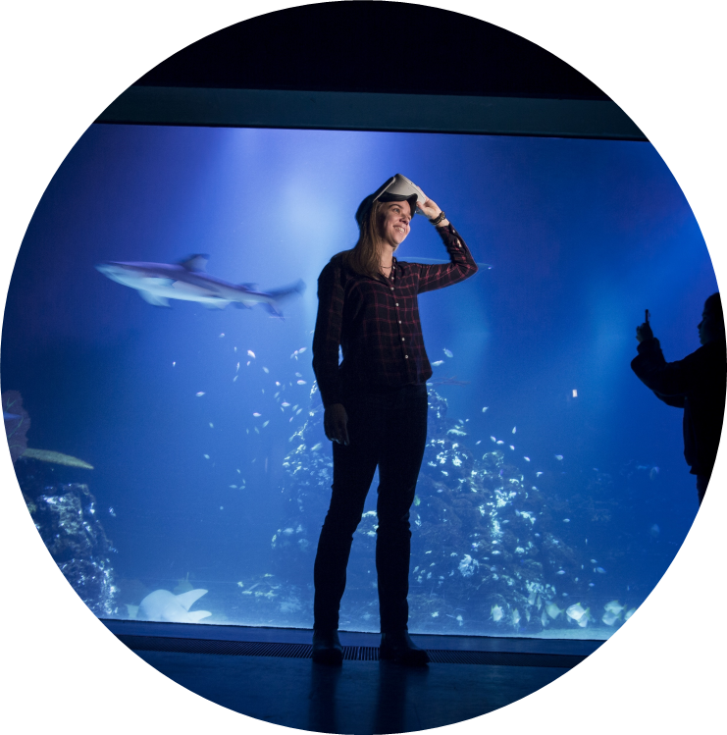
- Géraldine Fauville - Virtual Reality for Environmental Education
Assistant Professor of Education: University of Gothenburg
(she/her)
geraldine.fauville@gu.se

Project link: https://www.youtube.com/watch?v=cnvXJrMBbsI&t=51s

Géraldine is currently an Assistant professor at the University of Gothenburg, Sweden in the department of Education, Communication and Learning where her research focuses on the use of immersive technology for ocean and environmental literacies. Prior to this position, she spent 2 years as a postdoctoral researcher at Stanford University in charge of research on virtual reality and environmental education. Géraldine’s focus of research comes from her background as a marine biologist and her interest in the impact of increased carbon dioxide (CO2) atmospheric concentration on marine environments. Géraldine has also managed marine education projects for the past ten years developing several types of digital learning resources for high school students focusing on marine education. Géraldine is also a co-founder of the European Marine Science Educators Association aiming to empower formal and informal educators to teach about the marine environment and to create a network of marine educator stakeholders willing to establish a more ocean literate future for our society.

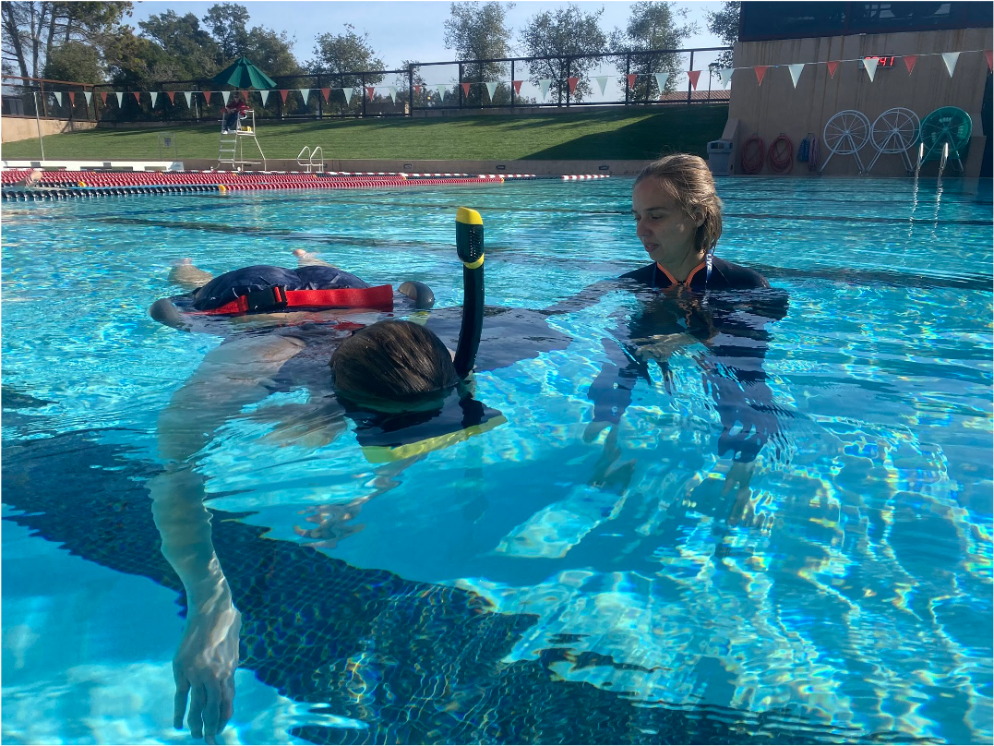

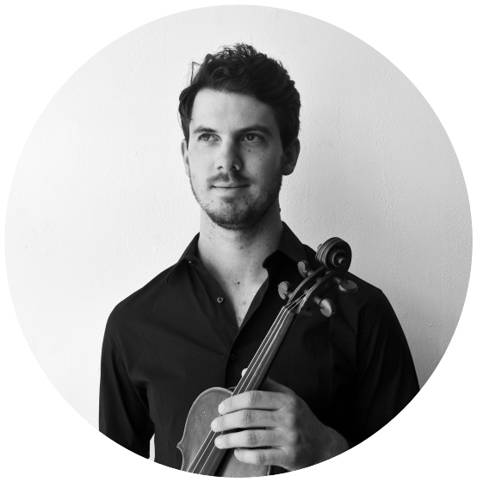
- Connor Vance - Musical Composition for Data Storytelling
Composer
(he/him)
conmanv@gmail.com
Website: https://www.youtube.com/user/TheStatmen/videos https://www.patreon.com/connorvance
Project link: https://vimeo.com/348123778
Demo for underwater film scoring (all done in less than 1.5 hours): https://www.youtube.com/watch?v=kpEgA6C0NCY

Connor Vance is a composer with a career that spans orchestral halls and folk pubs across the world. He specializes in strings, and loves collaborating with scientists in the Marine Biology field.

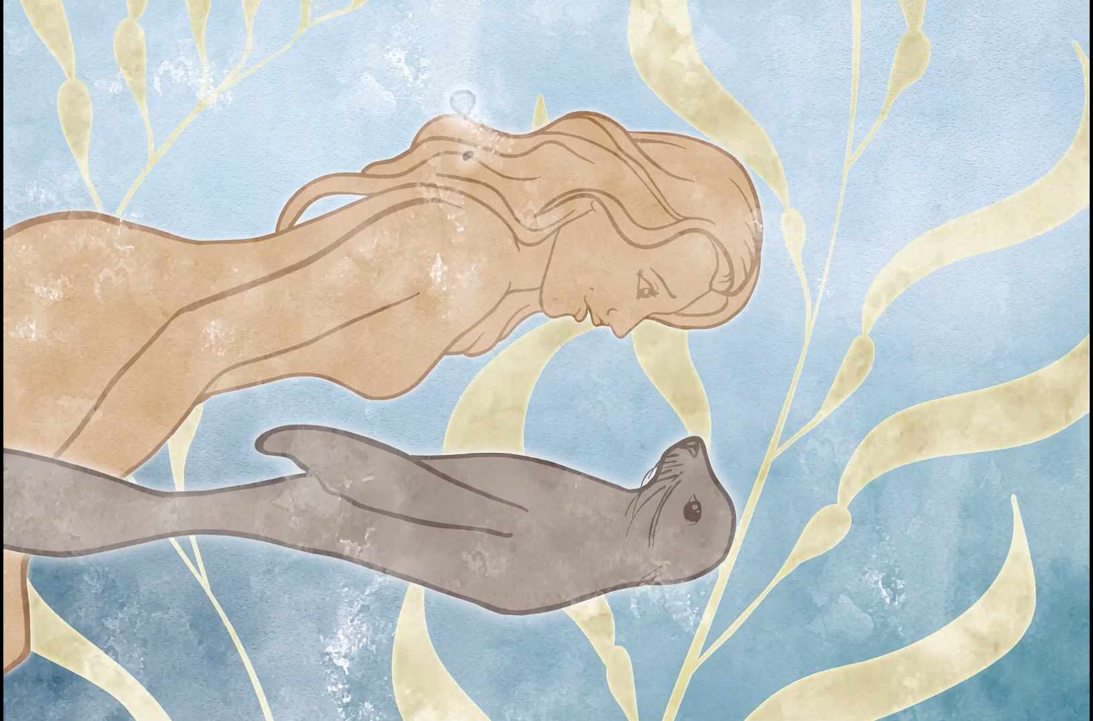
Thumbnail from Selkie Dreams frame-by-frame animation by Jessica Kendall-Bar with a custom musical score composed by Connor Vance.

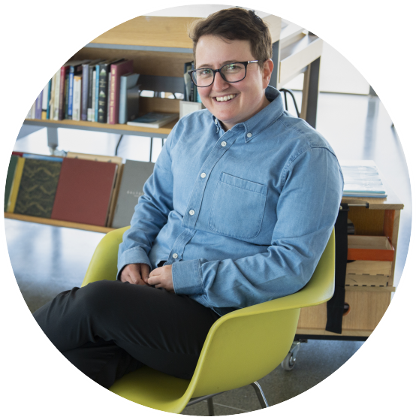
- Sal Alper - Science communication and outreach at the SF Exploratorium
Program Manager: Educational Partnerships at SF Exploratorium
(they/them)
salper@exploratorium.edu

Sal loves learning and believes in the liberatory possibility of museum spaces. Sal works to foster inclusive and engaging learning experiences for young people visiting the Exploratorium for over 10 years. They collaboratively build a team of educators to be responsive to visitors' interests and needs in a dynamic space. Sal also engages in institutional efforts for equitable internal and external practices. Sal recently completed a MA in Education focusing on bridging social justice, education, and museums.

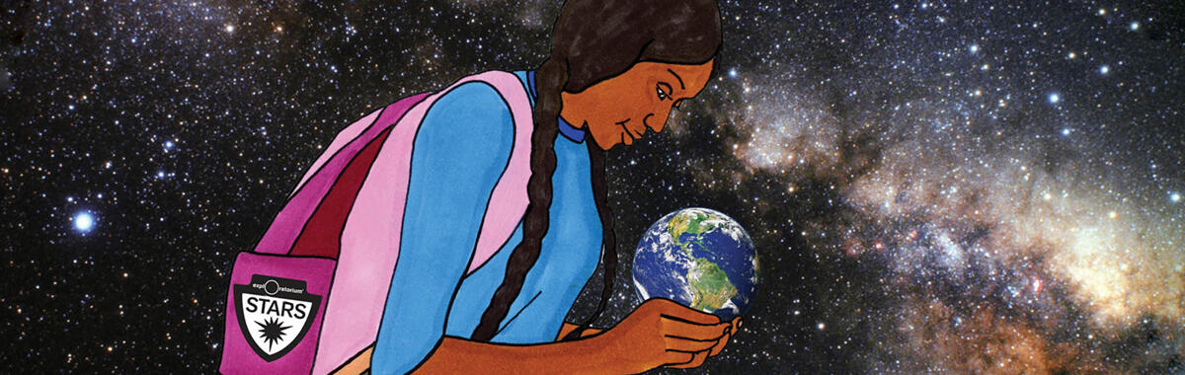
Striving for Trans Inclusion and Anti-Racism in Science Learning at the Exploratorium
The Exploratorium Explainer team has begun a new program called “STARS” (Striving for Trans Inclusion and Anti-Racism in Science Learning). This program builds on the work of the Explainer program: youth and workforce development through transformative learning practices.

