Notes for Today

How to get After Effects Composition into Premiere Pro
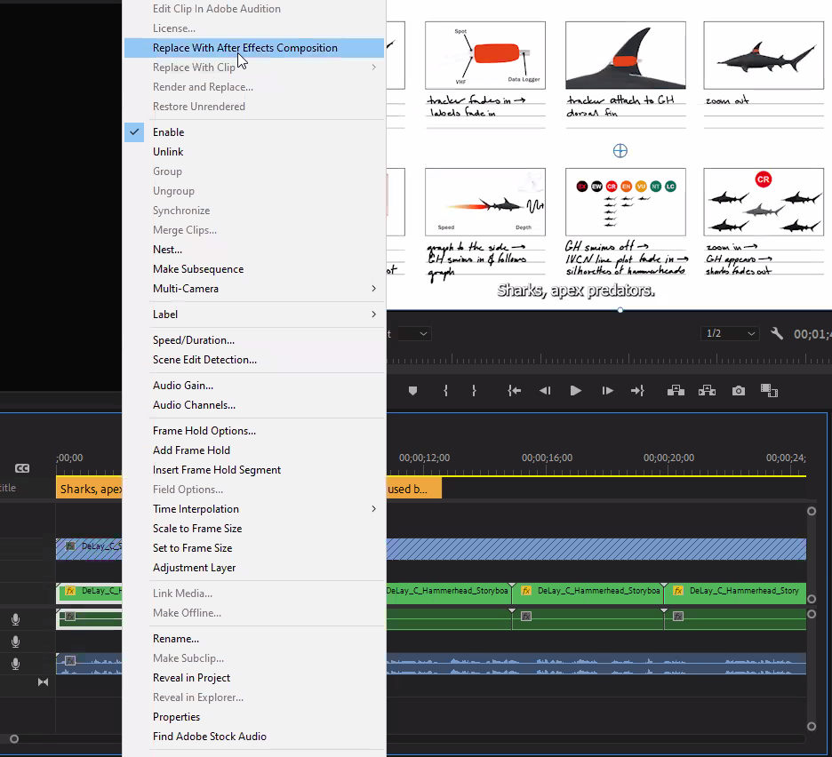
Right-click on track you want to replace and use this selection

Works for smaller projects and transferring workflow between applications, will live update saves once done

