MAYA DAY 1
- Save new scene each time to preserve versions
- In Maya, the axes’ can be different to your data, so check before starting any work
  - To check/change axes’, click Windows -> Preferences -> Settings -> Preferences -> Settings
    - You can also change the units here
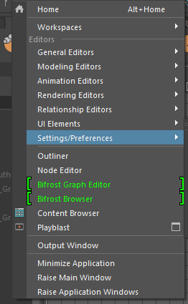
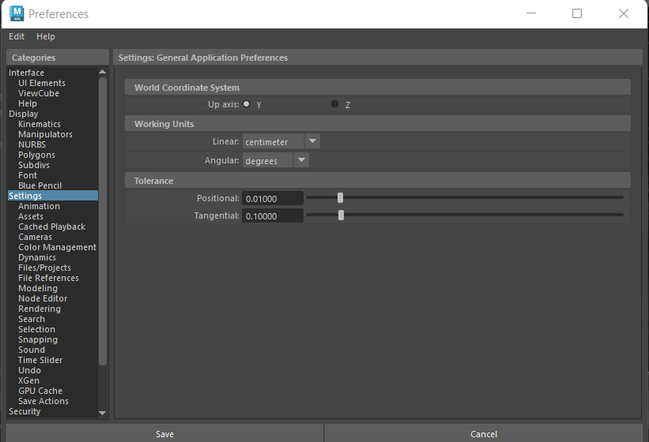

- If you can’t see your model or your ViewCube is not visible, you can select Panels -> Perspective -> persp to change your perspective and to return your ViewCube
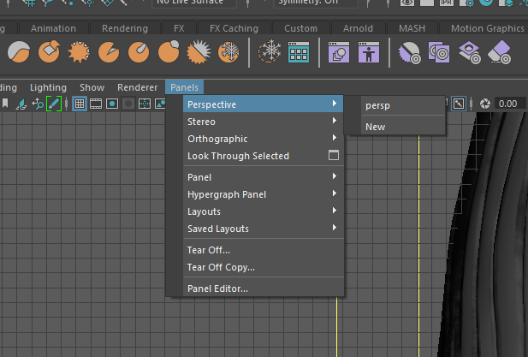

- Use alt-mouse to move around on your screen/with your asset
- To edit the points on your animal, hold down your right click and then drag and release on “Vertex”
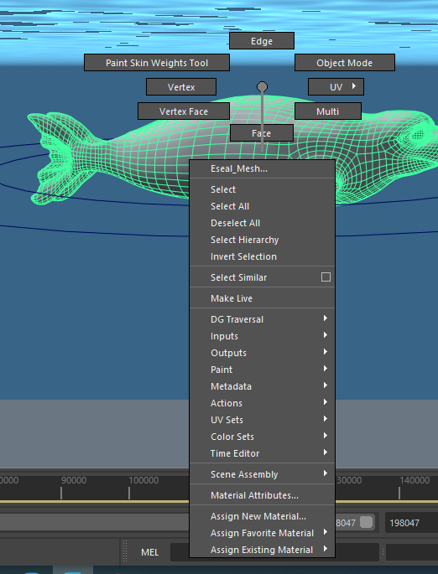
- The panel on the bottom right “Anim” is basically your layers panel
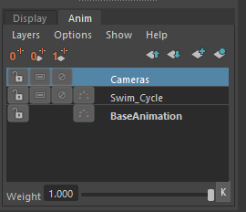
  - Everything that you might need to animate needs it’s own layer
- Select the “bottom” of a group you want to animate and animate “up”
  - For instance, start from the last circle on the whale’s tail
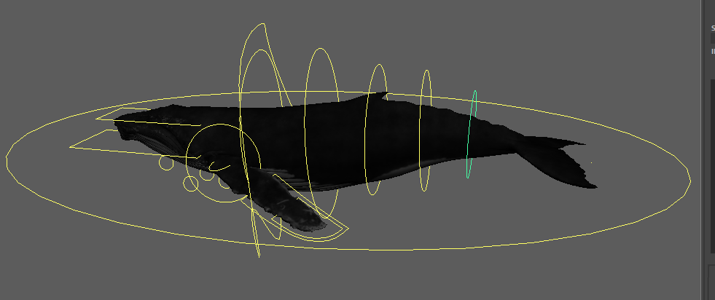
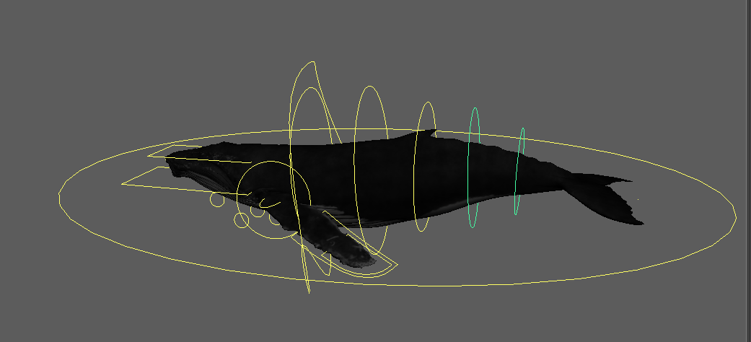
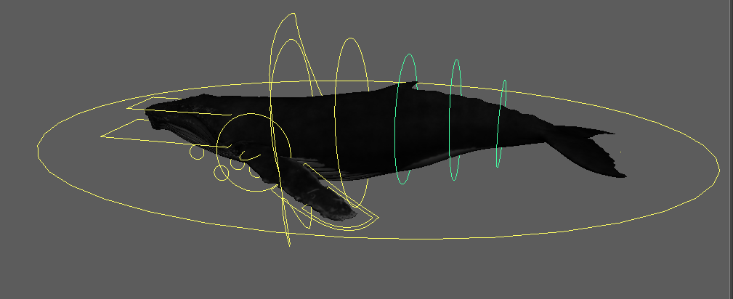
  - If you select the leftmost circle in green first, it will select the entire tail but it won’t actually be selected when you go to animate
- Open the GraphEditor by going to Windows -> Animation Editor -> Graph Editor
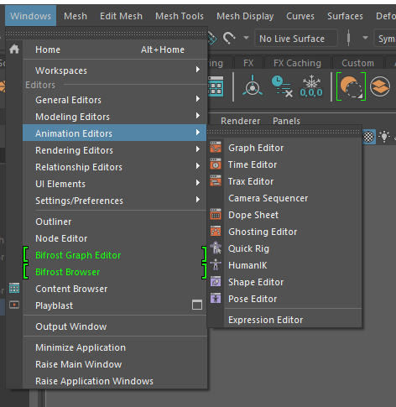
- After selecting the parts of your asset you’d like to animate, select “Create layers from selected” in the Anim Panel -> Layers
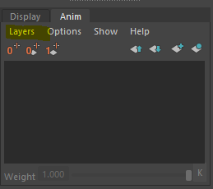
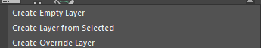
- If the boxes in the Transform channel panel are red, it is being applied to a key frame
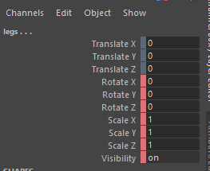
If the boxes are blue, it is being applied to an Anim layer (will turn blue once layer is created from “selected”
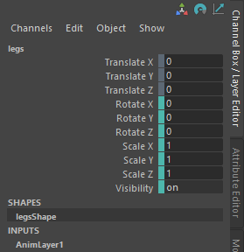
- Drag your GraphEditor down to the bottom and wait until it snaps blue along the length of your timeline
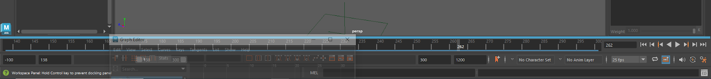

MAYA DAY 2

- Open scene you are working with (.ma - Maya file)
- Import swim controller
- Anim tab -> Select all objects on “AnimLayer1” -> Check beginning and end of key frames (ex. 0 and 30)
- Press play to make sure it’s not jerking/looks good

- Open script editor for coding in Maya
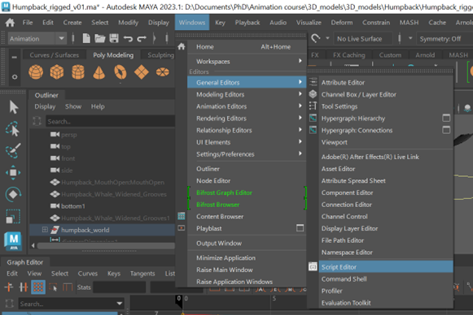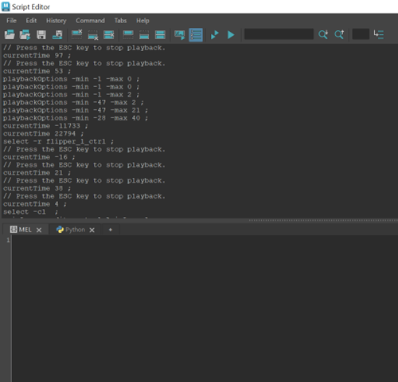
  - To clear command line =
  - “select” command can be used to select specific things (ex. “select -r HUMPBACK_PLAYER”)

- Open Python Script (in this case, provided by Jessie) to link swim control to the asset, can follow along from GitHub tutorial

- Open “02_3D_Linking_Strokes_to_Swim.ma”
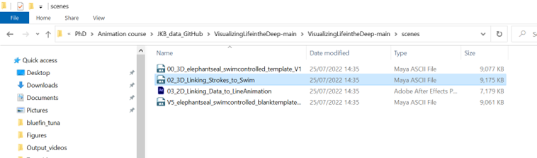
- Open GraphEditor to check key frames, press play
- White lines is stroke rate/swim controller (0 or 1), yellow smooth line is glide controller
  - SCREENSHOT
- Export SWIM_CONTROL from “02_3D_Linking_Strokes_to_Swim.ma”
  - File -> Export Selection -> *as an .fbx file
    - 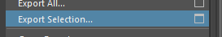
- File -> Import -> SWIM_CONTROL.fbx to your file (in this example, humpback whale rig swim cycle)
- Check that the elephant seal swim cycle imported to your whale file
- To edit script, Windows -> General Editors -> Script Editor
  - SCREENSHOT
  - Open Python script if necessary (VisualizingLifeintheDeep/scripts/02_swim_and_glide.py)
- Highlight first two lines, ctrl-enter to run code
  - First two lines, imports ability to code in Python
    - SCREENSHOT
- Run second set of code: four lines starting with “def GetLayerObjects(layer):”
  - SCREENSHOT
- Change name of “AnimLayer1” to something like “Swim_Cycle”
- Change “xrange” to “range” on line 31 of the script
- Run paragraph of code 10 - 65, then run last two lines
- Check that Swim and Glide options have appeared in the Channels panel
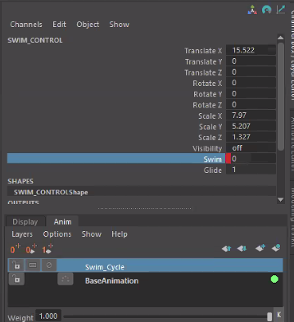
- Set key frame to 0
- At key frame 50, change swim to 1, right-click -> key selected
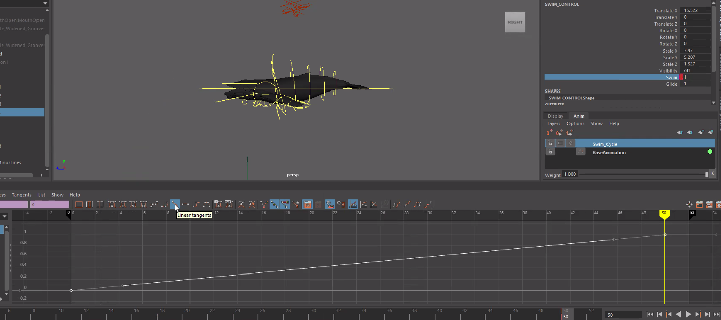
- Move key frame and change swim to 0
- Move key frame further along and change swim to 1
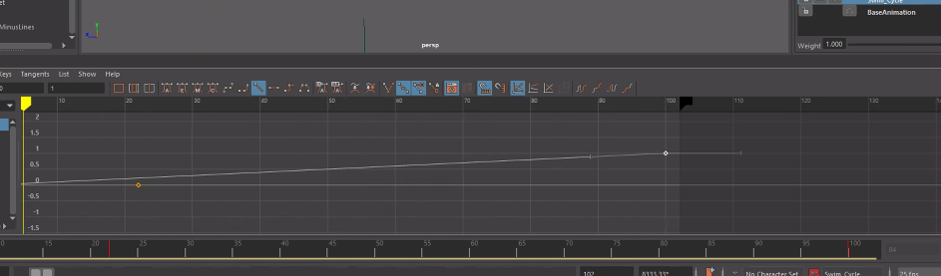

How to import YOUR data so you don’t have to manually create the swim/glide cycle

Demo - Elephant Seal
- Open “V5_elephantseal_swimcontrolled_blanktemplate_001.ma” in Maya
  - Tip: “Sleep-At-Sea” files in the “Elephant Seal Data” file show how to format data you might want to use (might be a giant file - open in Notepad)
- Open ScriptEditor
- Check ESEAL_PLACER -> ESEAL_PIVOT
- Open “00_Scratchpad” from “Elephant Seal Data”
- Run first five lines of code to import libraries
- Replace Jessie’s file path with your own, wherever your data is (“04_Sleep-at-Sea_JKB_00_test33_HypoactiveHeidi_09_Hypnotrack_JKB_1Hz_AnimExcerpt” and “04_Sleep-at-Sea_JKB_00_test33_HypoactiveHeidi_05_ALL_PROCESSED_Trimmed_10Hz_AnimExcerpt”)
  - SCREENSHOT
- Scripts from 32 - 51 (this part of the script sets up color scales)
- Select seal
  - SCREENSHOT - green mesh
- Right-click seal and select “Assign Existing Material” and choose color
  - SCREENSHOT

- Select MyCube1 (created with cube) -> Move outside of elephant seal by dragging it with the mouse
  - 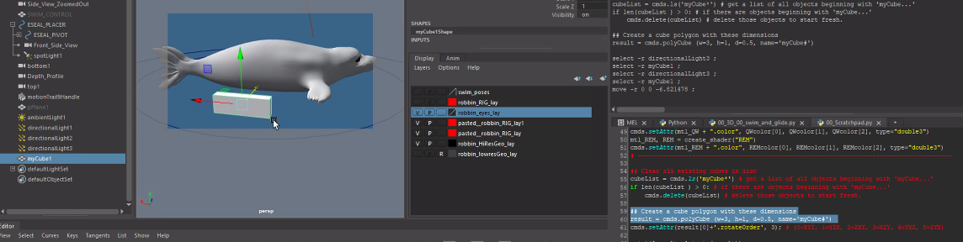
  - Change rotation order dragging with mouse
- Run code to change heading/roll/pitch (line 61)
- Run the rest of the code following annotations within
  - Output should look like a sleep spiral:
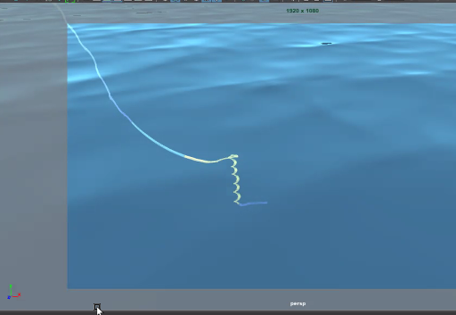
- With your own data, make sure you have X/Y/Z (same columns as example script)
- Define start and end in data at lines 123 and 124
- Change “rotationorder” to “rotateorder” on lines 138 and 139
- Run code
- Changed “rotateorder” to combine PLACER and PIVOT and replace all mentions of PLACER with PIVOT in code (if you don’t have PLACER and PIVOT already)
- After running code (may take a while, your timeline should look like this: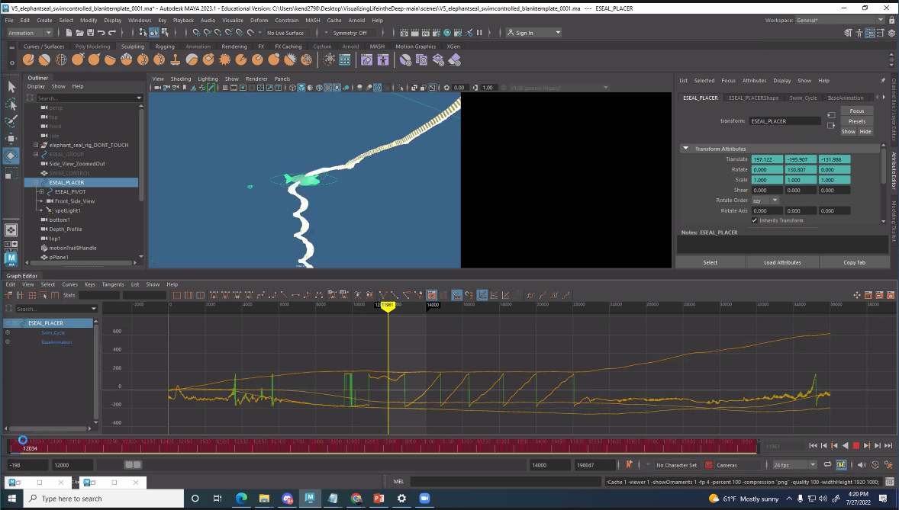
- Save as a playblast and check animation
- Enable lightbulb symbol 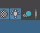and change lights as needed
  - Shift intensity and ambient shade until your asset looks how you want it to
- Open Hypershade and choose “standardSurface3” folder symbol, connect to Seal BaseColor file (in “Elephant Seal Data” folder)
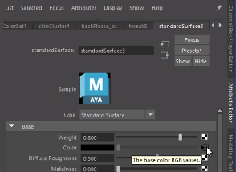

TO RENDER
- Choose Renderer - Render Settings
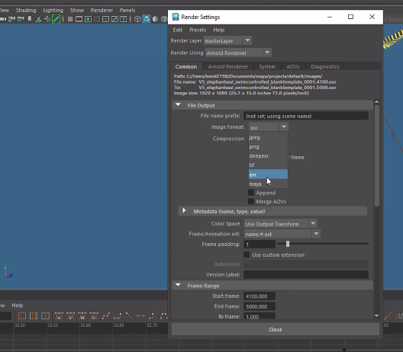
- Export as a .png for smaller, lower quality export, use .exr for high-quality image exports
  - Will number each frame (name.#.ext)
  - RenderLayer = masterLayer
  - Start Frame = where you want the video to start
  - By frame = 1 (frame by frame)
  - End Frame = where you want the video to end
  - Image Size settings
    - Presets = HD_1080
    - Width size = 1920
    - Heigh = 1080
    - Resolution = 72
    - Don’t select anything for “Skip existing frames”
  - RenderUsing = Arnold Renderer (use if you are using Arnold lighting or shading), if using HardwareFog use MayaHardware 2.0
  - Render Sequence -> Render View -> Start playblast then check your output

