To connect to BOG using database toolbox:
This link is super helpful: https://www.mathworks.com/help/database/ug/microsoft-sql-server-jdbc-windows.html
- You need to download a JDBC driver. I got the Microsoft SQL Server JDBC driver from this website: https://docs.microsoft.com/en-us/sql/connect/jdbc/download-microsoft-jdbc-driver-for-sql-server?view=sql-server-2017. I chose driver 7.2
- Downloaded it into BOG folder in dropbox, but I think it can be anywhere.
- JDBC server details were in bogquery.m, obtained from Reiko. Server: perseus.shore.mbari.org, port number = 1433 (see below)
- Use configureJDBCDataSource();to create a ‘BOG’ database. You can also get to that place from ‘database explorer’ from the main menu in matlab (see link above for details). One annoying thing is that you need to reset the figure position/units to its default or else the window shows up off screen.
set(0, 'DefaultFigureUnit', 'pixels', ...
'DefaultFigurePosition', [680 678 560 420]);
- For the database configuration, use the settings below:
C:\Users\yui\Dropbox\BOG\Microsoft JDBC Driver 7.2 for SQL Server\sqljdbc_7.2\enu\mssql-jdbc-7.2.1.jre8.jar
With the following settings:
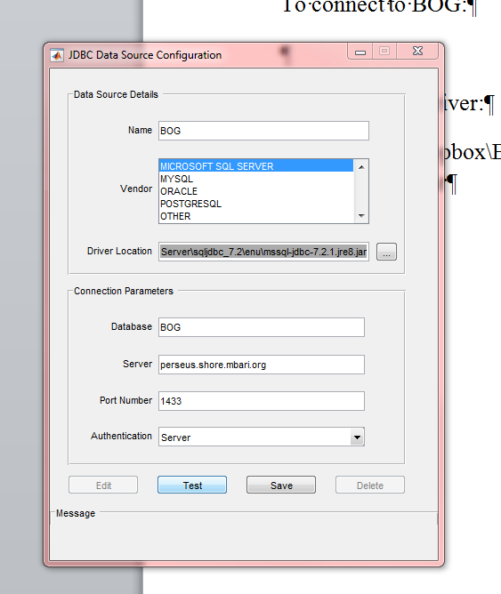
Once this is set up, you can get data from BOG using the following commands:

db = database('BOG', 'everyone', 'guest');
c = exec(db, strsql);
c = fetch(c);

% get the data
trex = c.Data;

close(c);

where strsql is a string for the sql server. For details on how to set that up, look at get_bog_example.YT, extract_bctd, etc. Also for reference:
https://mww.mbari.org/bog/documents/matlab2bog.htm
https://www3.mbari.org/bog/documents/BOG_CTD_Key_Fields.htm

