Spray pH integration:

External:

Machine IE55 port into pressure relief plug. Install “SBE + Fluor cable” in plug and mount in tail hemi. Route cable accordingly. NOTE: This cable sets the optical gain inside the splice. TODO: This cable has a splice that is way too big. I used it because Impulse already had the mold and Gloor told me this would speed up acquisition.

Install a black manifold cap on the SBE5M pump (don’t use the white cap). This prevents light from impacting the pH measurements on the surface.
Remove the old optical cable and install the “pH cable”. Connect pH cable to the pH sensor assembly. Route cable accordingly so the pH assembly lies parallel to the fluorometer. Using BLACK tubing, run tube from the SBE5M manifold outlet to the pH assembly inlet. Run BLACK tubing from the pH outlet to the fluorometer. TODO: We need to design a manifold that eliminates the tubing as this will give us much more real estate to work with and eliminate possible air bubbles. We will also have to see how the tubing works when the Nortek is installed. Its gonna be tight! Hopefully the manifold will eliminate this hurdle
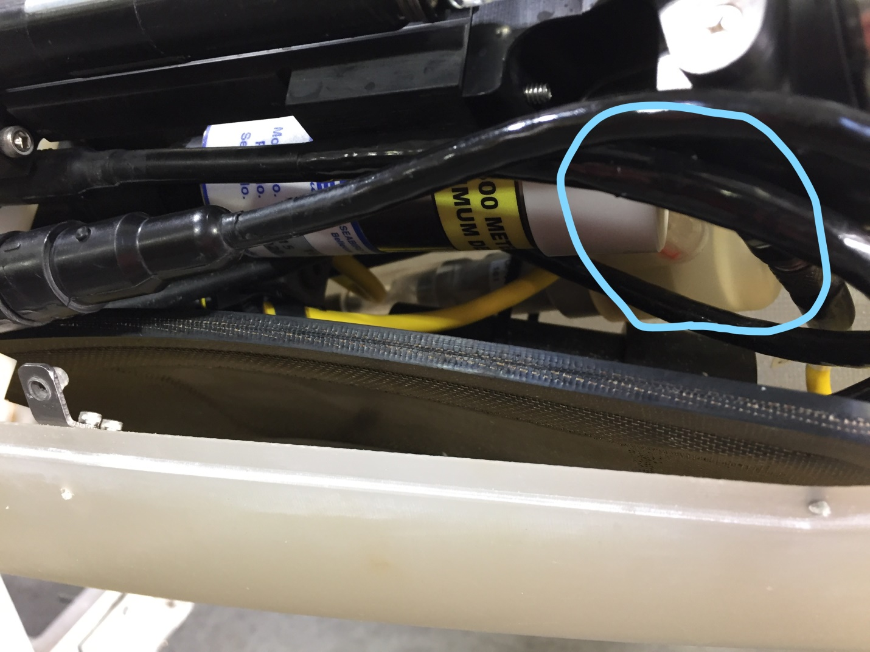
Note the clear pH manifold (blue circle). This was a test 3d part. The actual part is black delrin so as to occlude light.

Internal:

Mount the pH board stack to the G10 back plane (pH daughter card v1.SLDPRT). Mount the battery holder to the back plane. Mount this assembly to the Spray Main Board.
TODO: Perhaps move this assembly down somehow as it makes it hard to screw in the STBD wing cable

Wire pH power and comms to ADP header. TODO: Move this to one of the spare ports. I used the ADP as a quick and dirty integration

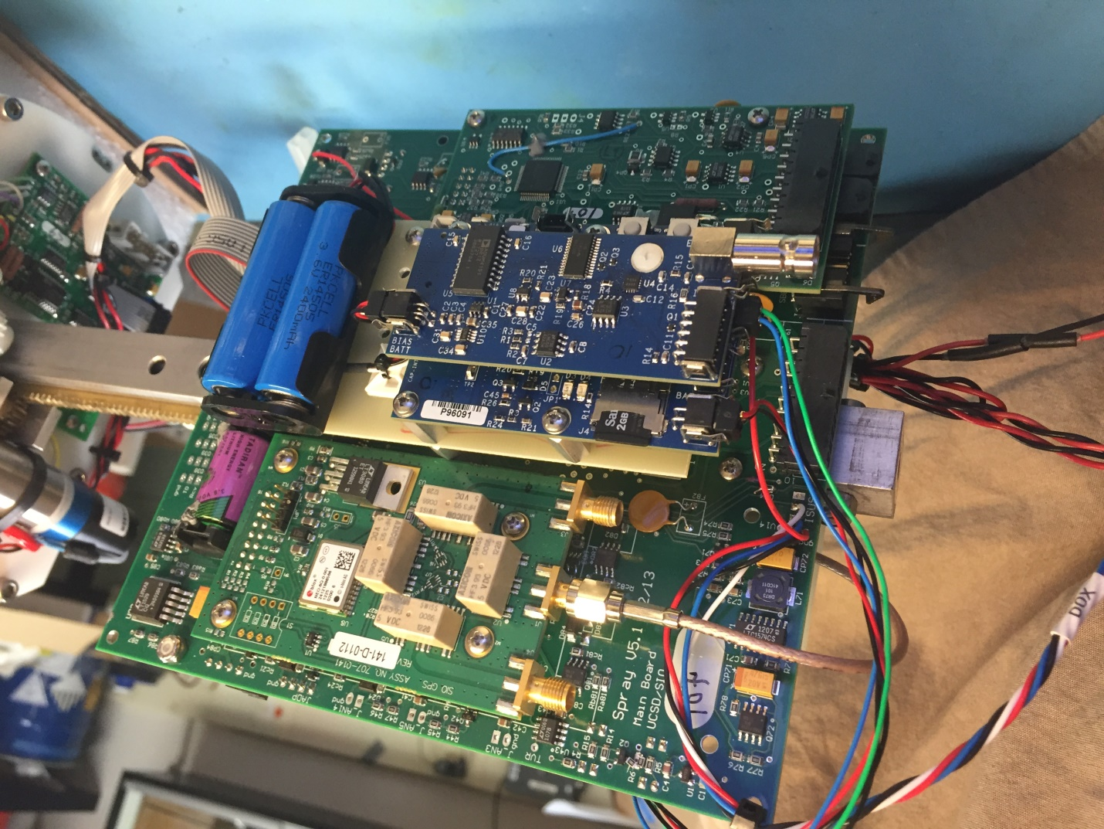

Wire up the penetrator cables according to the electrical drawings provided.

