Deployment details: Mission ID: 23803401
Shore Station: through UCSD and bog-fire. Text based only on bog-fire
Dates: 8/02/23 – 8/18/23
Dives: 165
Deployed and recovered from Paragon

Deployed: 08/02/2023 19:27 36.803, -121.850
Recovered: 08/18/2023 16:13 36.797, -121.850

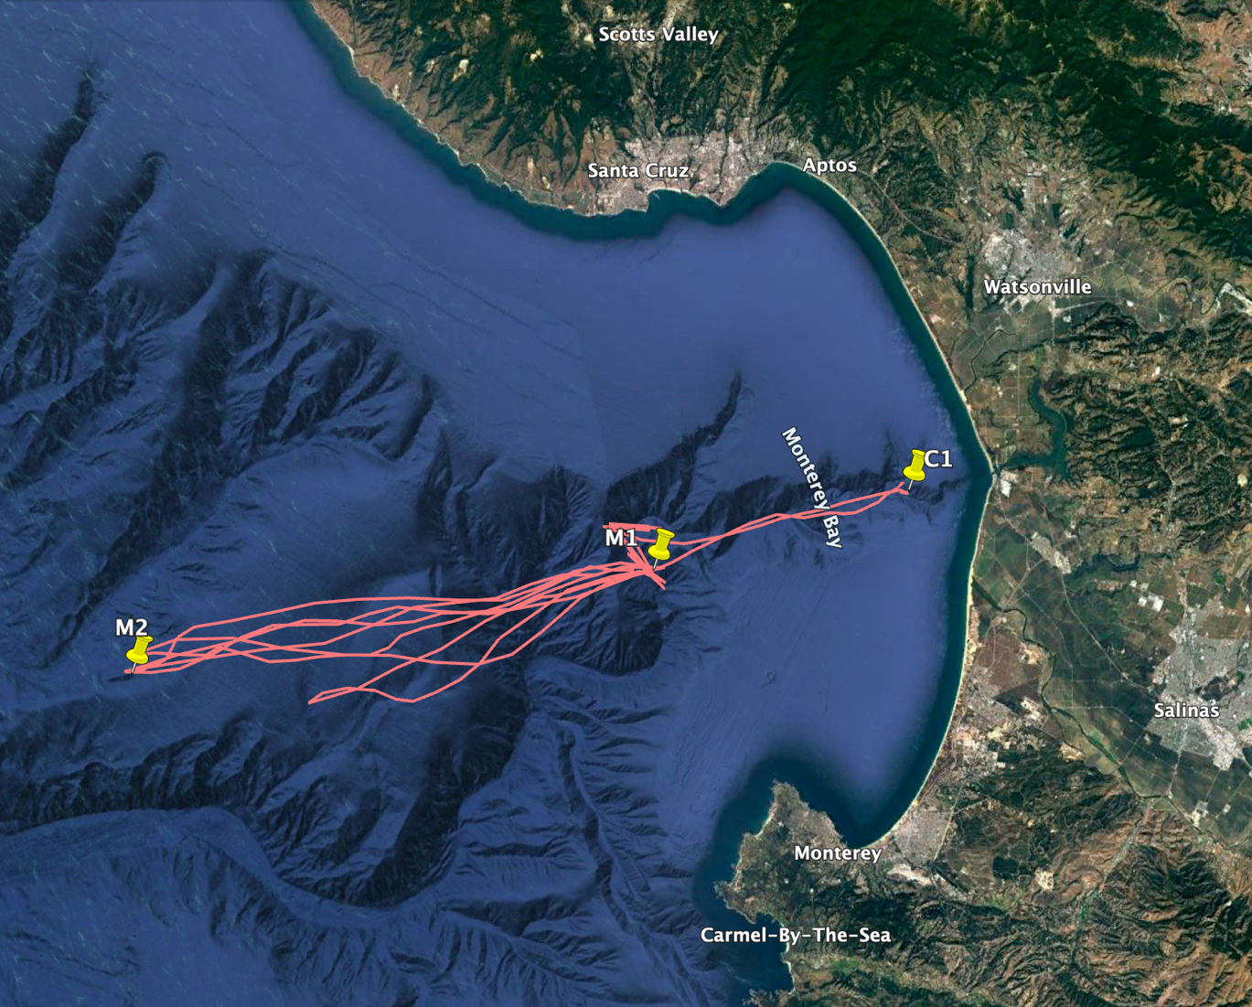

Mission Objectives:
PIE experiment.
WG Tiny tracked Spray34

