Deployment details: Mission ID: 23803401
Shore Station: through UCSD and bog-fire. Text based only on bog-fire
Dates : 8/02/23 – 8/18/23
Dives: 165
Deployed and recovered from Paragon

Deployed: 08/02/2023 19:27 36.803, -121.850
Recoverd: 08/18/2023 16:13 36.797, -121.850

PIE experiment.

E 18 508 13.96 1.05 99.000 260 17 -2713 -499 +36.729 -122.106 3 3 3 0 1 01 200 13 34 1067 5 62 -2 54 530 190 0020

G 18 1 12 Feb 2019 18:07 1 +36 45.36 -122 0.79 40 14 32 40 47 0.9 0 1 36.7560 -122.0132
G 18 2 12 Feb 2019 20:47 1 +36 45.06 -122 2.52 60 14 35 41 48 0.8 0 0 36.7510 -122.0420

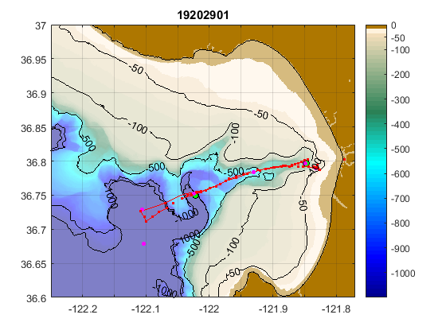

WG Tiny tracked Spray34

Had pH transmission issues starting at prof 66. Started to get worse soon after (Prof 72 as example below). We tried doing shallower dives to 200 m to see if it was an averaging issue (prof 75-81). It was not. This remained a problem for the rest of the mission, and by profile 115 or so, we were essentially not getting any pH data.
Additionally, the shape of Vrs over pressure was very off, with low pH all the way to the surface. Is this also a sensor failure? Or transmission error? The hope was that pH data were being stored internally on the CF card, so we kept the PIE experiment going. Upon recovery, we know that there was a uSD card error.

