Deployment details: Mission ID: 23C02901
Shore Station: through UCSD and bog-fire. Text based only on bog-fire
Dates: 12/12/23 – 12/121/23
Dives: 137
Deployed and recovered from Paragon

Deployed: Tue Dec 12 10:09:59 2023, 36.79419, -121.84115
Recovered: Thu Dec 21 14:46:21 2023, 36.80518, -121.78577

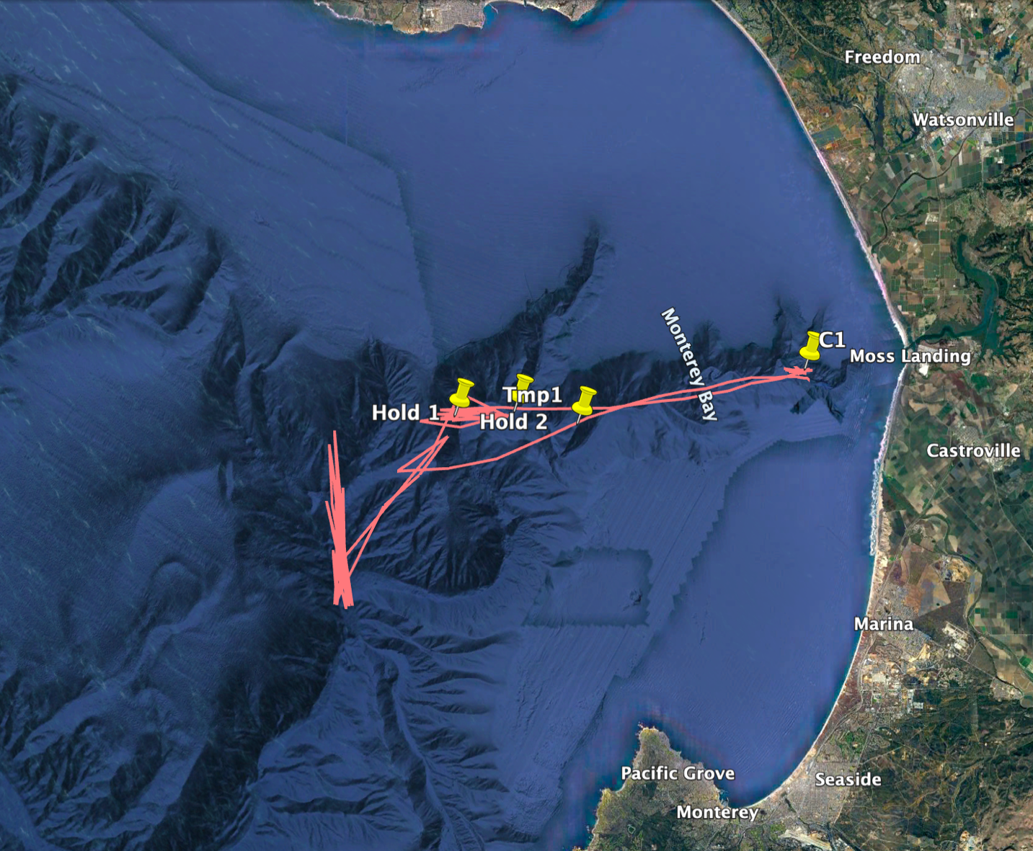

Mission Objectives:
Test new Lionix sensor

