Deployment details: Mission ID: 24802901
Shore Station: through UCSD and bog-fire. Text based only on bog-fire
Dates: 8/12/24 – 8/21/24
Dives: 140
Deployed and recovered from Paragon

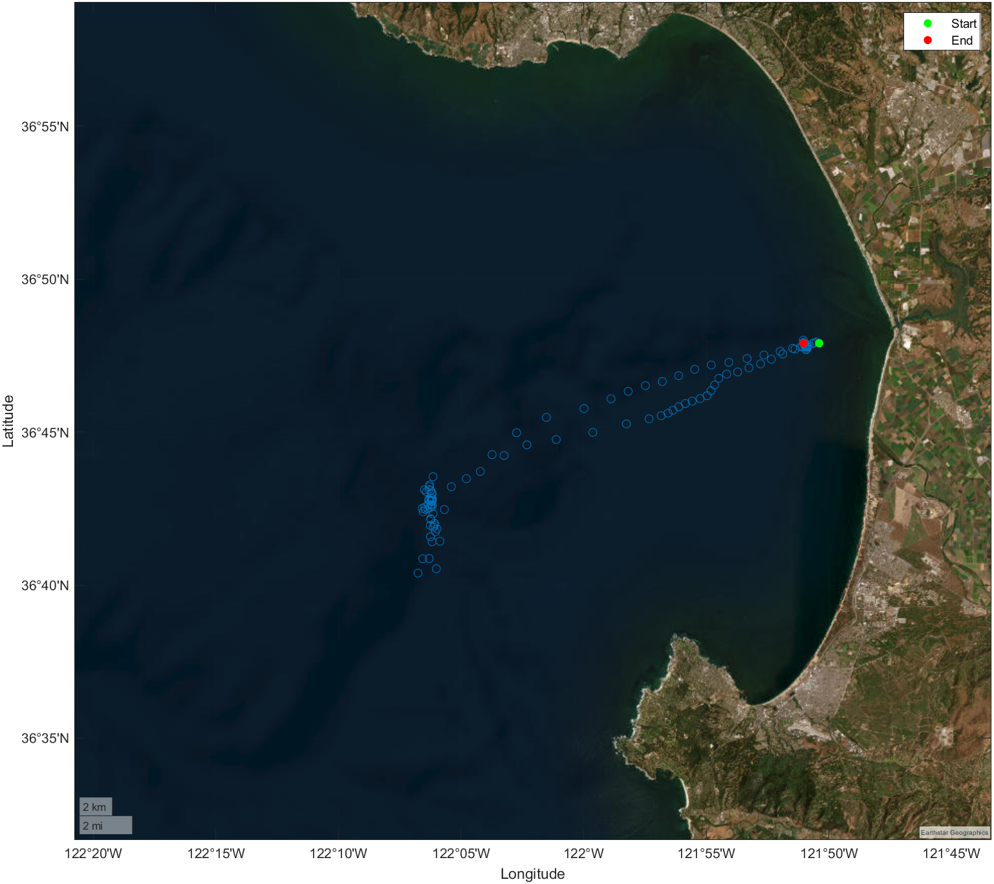
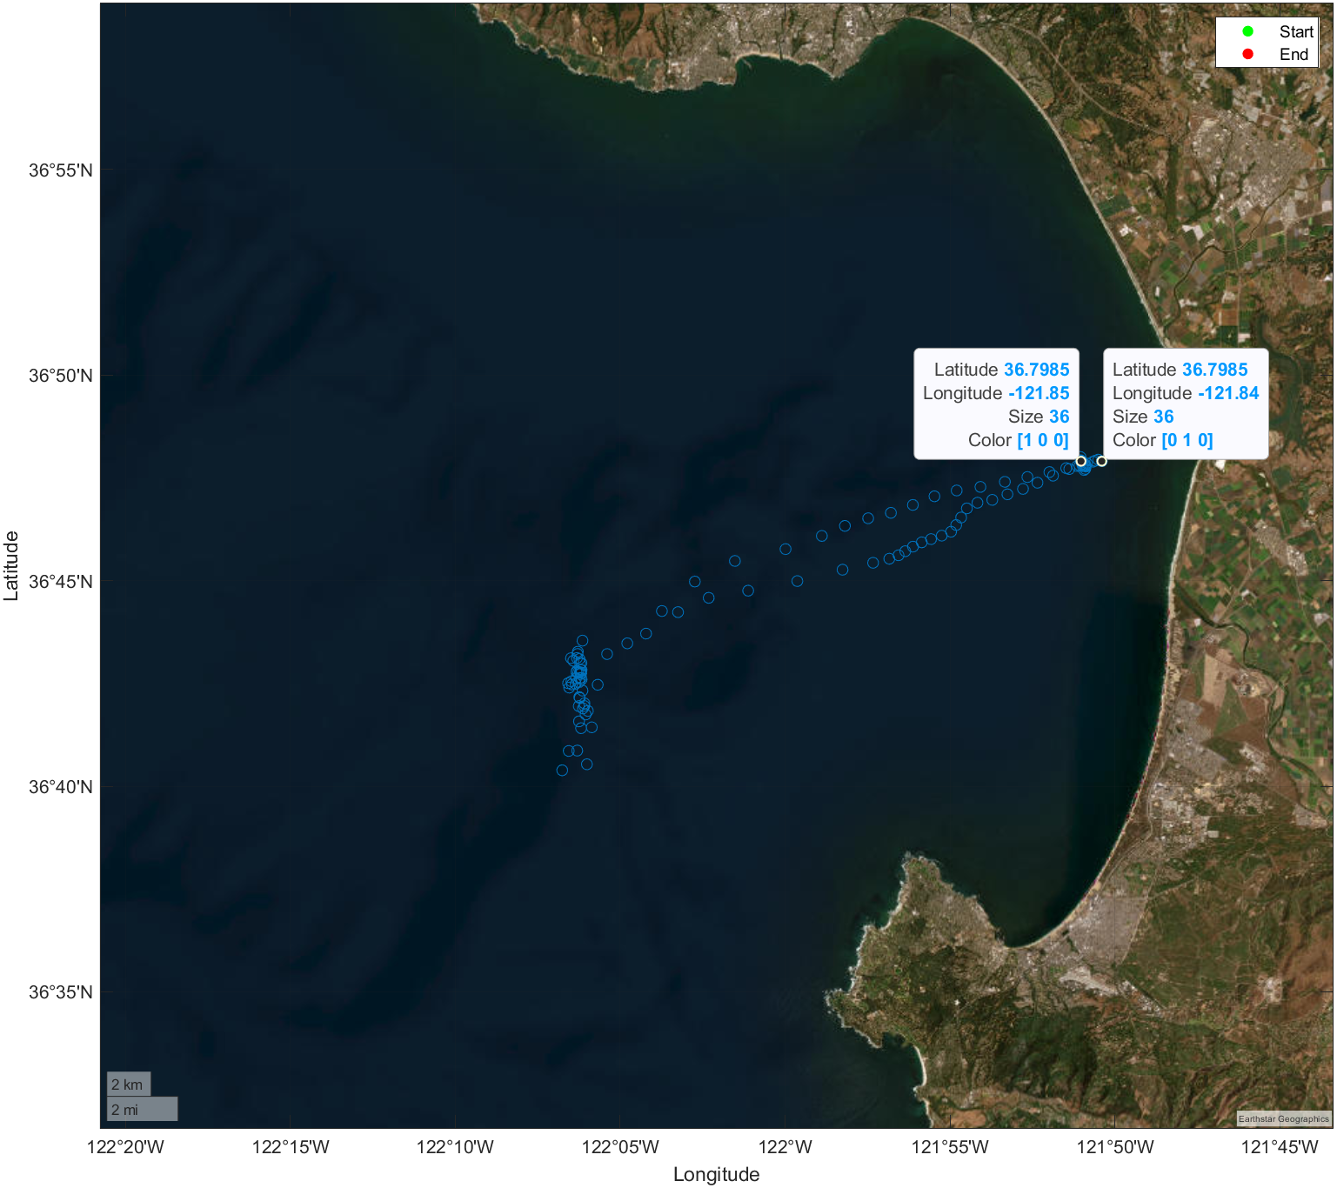

Mission Objectives:
Test new GDP033 oil compensated sensor

