Deployment details: Mission ID: 24A03401
Shore Station: through UCSD and bog-fire. Text based only on bog-fire
Dates: 10/22/24 – 10/31/24
Dives: 67
Deployed and recovered from Paragon

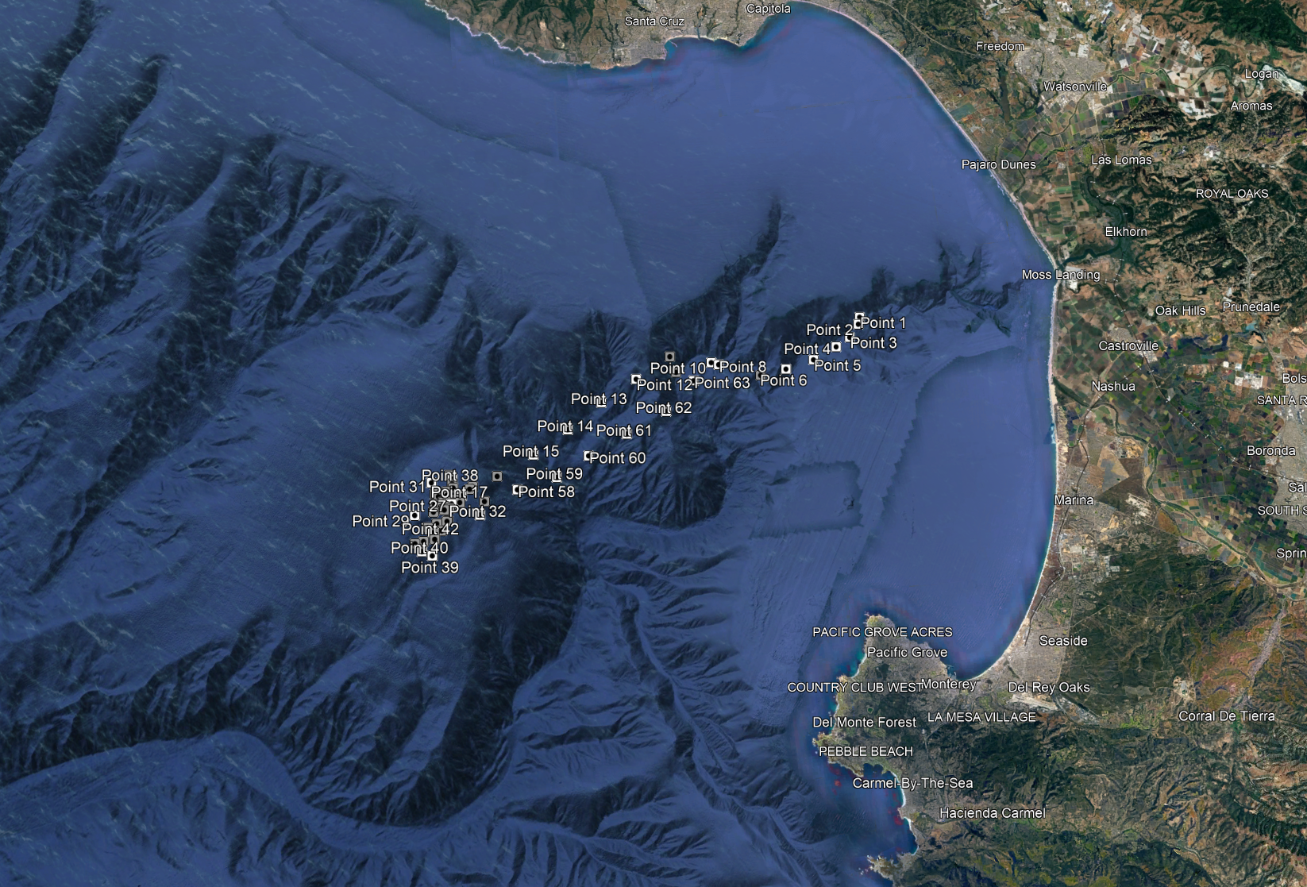

Mission Objectives:
500 m, 60 minute loiter dives near MARS with the Accusonde PAM.
Notes: CTD on glider 034 needs to be recalibrated. All salinity data from this deployment is flagged in QC.

