Deployment details: Mission ID: 24802901
Shore Station: through UCSD and bog-fire. Text based only on bog-fire
Dates: 2/4/2025 – 3/4/2025
Dives: 270
Deployed from Paragon and recovered from MLML White Whaler. Paragon on dry getting upgrades.

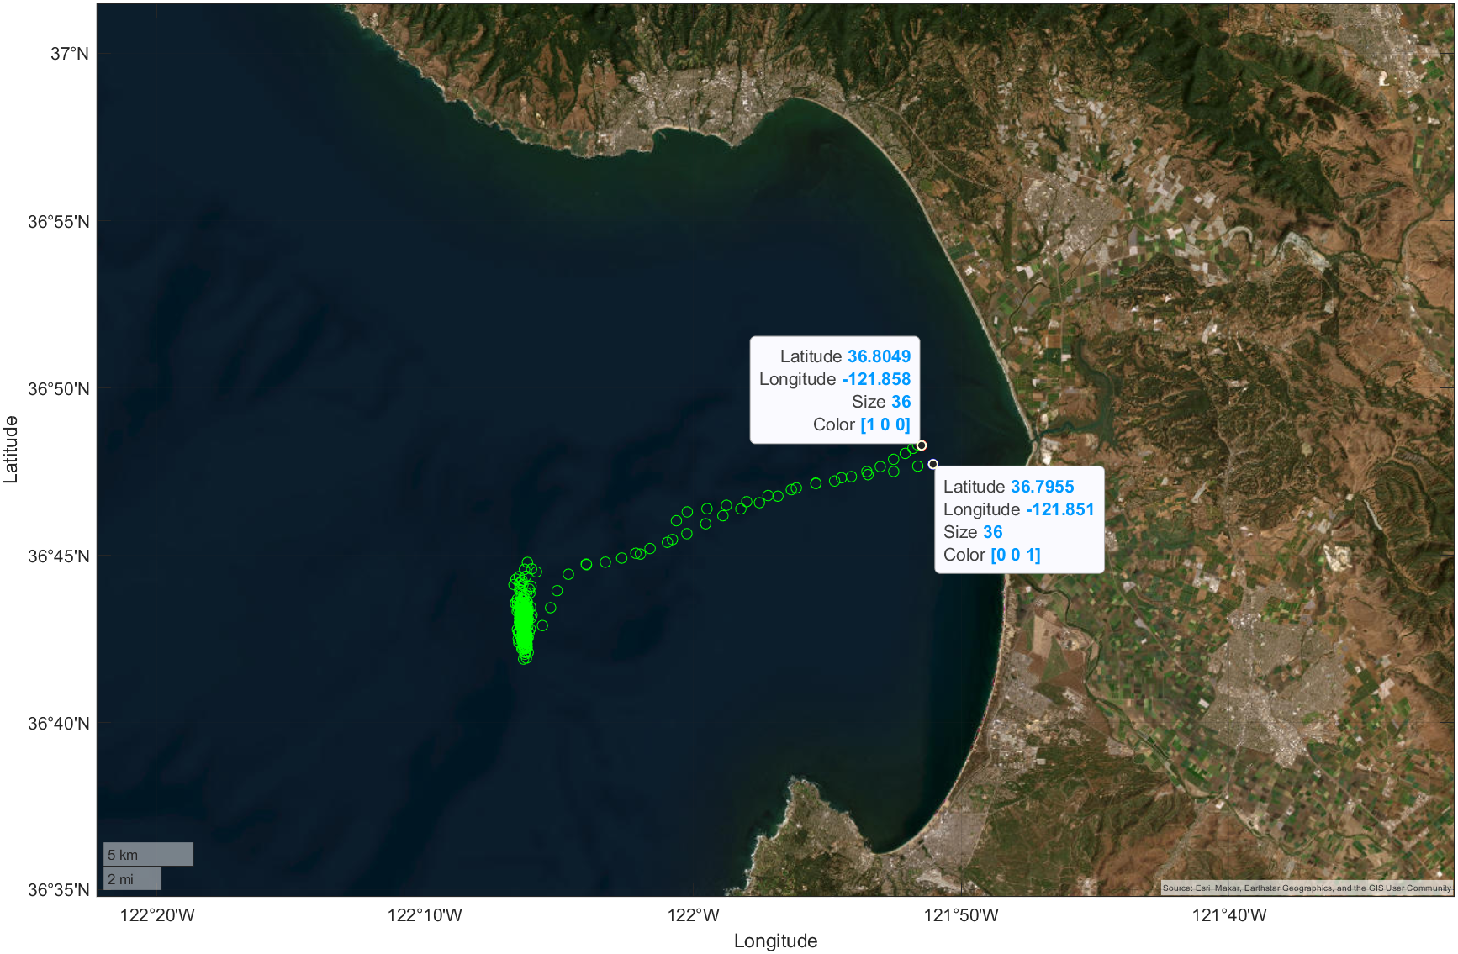
Start location: Northern shown coordinate. End location southern shown coordinate.

Mission Objectives:
Test SurpH 009, oil compensated sensor. This design has an external tube that is filled with oil. Deployment launched from C1 then proceeded to the standard pH test mission holding station between m1 temp1 and temp2. Increased depth from 200 – 1000 m every 3 dives and then returned to 500 m dives once vK began to increase at depth. Repeated the test down to 1000m with same result and remained shallow for remainder of the mission. Picked up one day before scheduled because of a good weather window. Recovered from MLML White Whaler.
Decided to use the same salinity offset from previous 029 deployment. Test tank salinity offset and densometer salinity offset were both +/- .1 off the Spray CTD. Offset from last time matches the salinity at M1 compared to BOG at 500.
Post Deployment:
Increasing vk was thought to have been an issue with salt water leaking into and diffusing in the oil on deeper dives, causing an increase in conductivity between the counter electrode and isfet. Upon recovery all combinations of possible conductive paths were measured to see if an increase had occurred. It seems that the Spray cable was the culprit and was leaking current. Results are ongoing and documented in Google Drive:
https://docs.google.com/spreadsheets/d/17Idh3j_2v3pJpMqpL1reeAGo6xVuuil0cOjLR0u163c/edit?usp=drive_link

Contact: Gene Massion or Yui Takeshita for access info to the doc.

