Yui and JKW ran through the assembly of the mpHOx SCSP on 20220124:

TO DO:
- EE shop order for cabling and potting
  - Bulkhead termination (pinout) needed first
- ADAPT Bulkhead wires to Harwin wire
    - Need lengths
    - Ray Hom can do in future
- Clear fender washers for battery terminals?
    - Acrylic rod vs stock
- Drill divots thru battery end cap and use sealing screws
- Solution for Battery Rattle
- FLOW CELL:
    - Ream ¼-20 drill holes with:
      - Close fit: 0.2010 F
      - Free fit: 0.2570 H(17/64)
- SBE LOOKUP
    - XSG to MCBH conversion/adapter:

- Order:
    - Barrel/butt splice terminal crimper
    - Antifouling spray paint
      - https://www.amazon.com/Interlux-YBA068A-16-Aerosol-Antifouling/dp/B003E1Y31O
    - 8-32 x ⅝”
    - IV bags w/ same tubing as SBE pump (1/2” ID /3/4” OD tube)

BUILD NOTES: (Used 200JD_mphoxhousing.pdf)

- Bulkheads and Endcap:
  - Loctite 242 used to secure 8 and 4 pin male bulkheads
  - Cable management:
    - 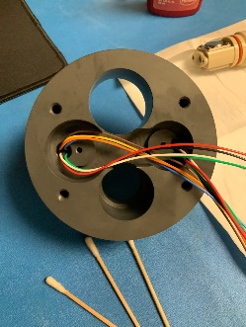
    - 4-40x 1/4” for cable tiedowns
    - 8-32 x ½” PAN head phillips w/ Grey Fender Washers
      - When installing this ensure enough slack and NO PINCH
    - Wire terminal (Ring terminal #8 w/ star grip), with Spring for Negative batt
      - Make sure ring is inserted into spring so that when screw is installed good continuity is maintained between spring/terminal
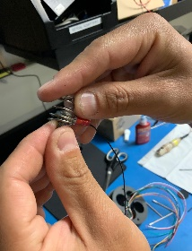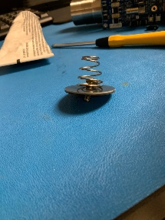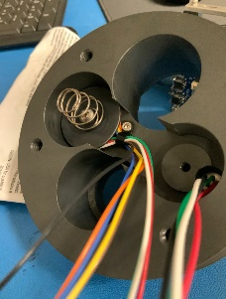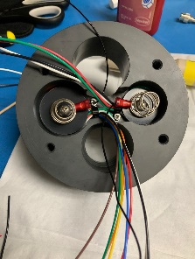
- Durafet:
  - Grease O-ring w/ Vacuum grease
  - Place 2x White delrin washers in receptacle (PN?!?)
  - Push Durafet into proper hole, and push til sensor has clicked into its position.
  - Clock the FET towards the flow path
- OPTODE:
  - Grease O-ring w/ Vacuum grease

- ASSEMBLED:
  - 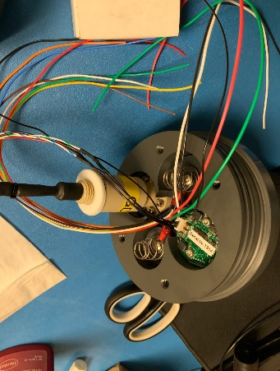

- Sensor/Battery support block
  - No fender washers are needed to attach the positive Bias terminal.
    - 8-32 x ⅝” w/ Nylock (SOCKET MAKES BETTER CONNECTION)
      - Watch amount of solder on terminals, can potentially rattle
      - 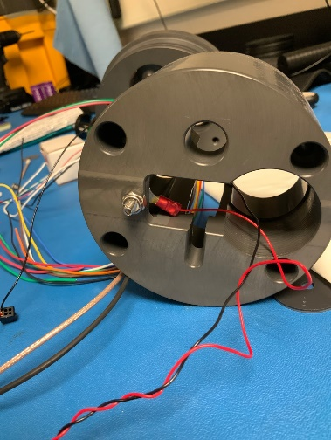
  - Insert D-Cell Bias battery first (FLAT ON SPRING, NIPPLE ON SOCKET) and ensure the cables are in the middle of the channel and not being pinched
    - 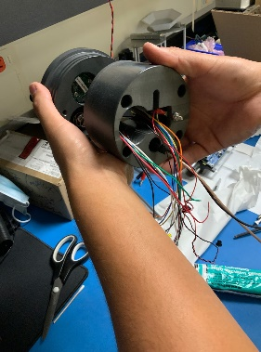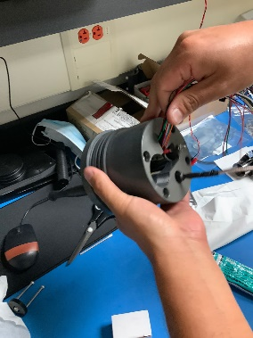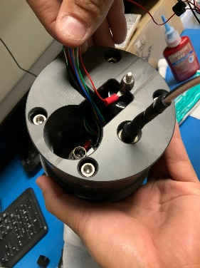
  - ¼-20 2.25” 4x used to secure backing block to endcap and screw til it bottoms out
  - Mount mpHOx board onto clamps that affix to tube:
    - 4-40X 1” for ring clamp assembly
    - 4-40x ¼” stand offs and screws for board mounting
    - 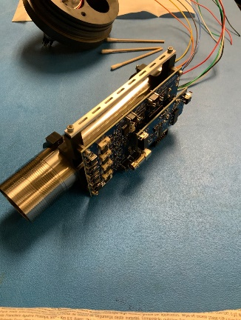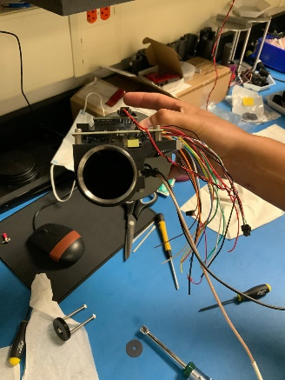
  - Screw in Battery Tube until it bottoms out
  - Insert D-Cell batteries flat end first into tube.
    - Socket for positive side = 8-32x 1”
    - Battery will rattle somewhat even when tightened down all the way
  - Ideal Wire Slack:
    - 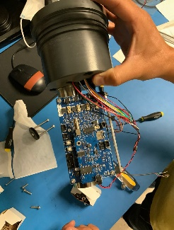

- FLOW CELL
  - Align flow cell as indicated in schematics
    - NOTE: 3D printed cell kind of ‘soft’ not best tolerances

- MOUNTS/BRACKETS
  - Install lower bracket assembly as indicated by JD schematics
  - PUMPS:
    - Remove cap and place cap into flow path with tubing
      - ⅛” Drive for nylon tipped set screws x2
    - MICROCAT:
      - Modifications:
        - Remove Neck bracket near bulkhead
          - 9/64” hex driver
            - NOTE: replace w/ threaded inserts?
        - Remove foot bracket at far end
          - 10mm nut driver
        - Flow Path and TBT Blocks
          - Remove Flat head screws and keep. Replace with 3D printed component
  - Clamp Mounts together
    - 1/4-20 2.5” or 2.25” TBD
    - Ensure tolerances are left for taping/painting the instruments
      - NOTE: Split bottom bracket in half?
      - 