MinipHOX Pinout

Bulkhead (6pin) (MCBH-6-MP SS)
Terminate to a 4-pin Harwin (Data in/out in reference to the microcontroller)
4-pin Harwin header SubConn wet-matable pin/wire #
1: (Data IN) -------------------- 2
2: (Data OUT)------------------ 1
3: ------------------------------- 4

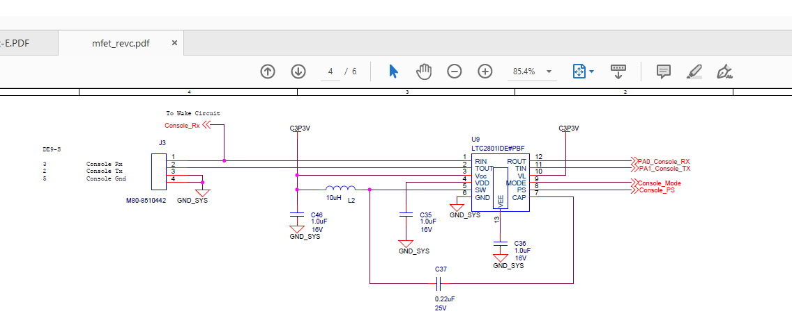
Serial Cable (Same as SeapHOx)

Pig tail cable P/N: MCIL-6-FS (2’ pigtail)
Terminate cable to DB9 (Female)

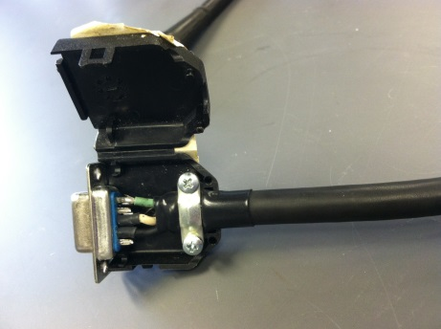
DB9(F) MCIL-6-FS
2 Black (pin 1)
3 White (pin 2)
5 Green (pin 4)

