20210610
Nanofet testing
Scott Jensen, Joseph Warren
Goal: To prove that the latest unipolar bias works (no virtual Ground). We will test solutions with varying pH, temperature, and add/remove electrical noise in the form of a heat gun as well as a stir plate.
Setup:
- Nanofet board:
  - rB mFET: Q27812/ 112. V3.3.1 mfet V2 firmware.
  - Isfet adapter board rA
- Extech PSU: 12V 0.25A
- AA: PKCell 3.6V ER14505
- Durafet II: 1914Y200000087947
  - Durafet UDA
Note on differences in data fields:
- Standard = This board
- Extrefoff = Extref V
  - Read Extrefoff in test menu as if it were Vint usually (not Vint_off).
  - There is not Vint_offset output in this hardware.
- Intrefoff = cntr V (Vk)
- ExtrefV = NA
- IntrefV (Vint) = NA
- Cntr I = Cntr I
  - Difference between Subst Curr and Subst Vol = Cntr I
- Cntr V = NA
- Subs I = SubsV2Gnd
- SubsV = SourceV
- Vtherm=Vtherm

Test 1: 3, 8, S Testmenu with FSW of known pH (Vint ~ 0.08 and 0.1M HCl ~-0.3x).
Notes:
- Vk similar to other mFETS
- Vext_off is dissimilar to other mFETS
- When Durafet was hooked into K2 Box/DB15 MF 146, voltages were correct.
- THERE IS NO NERNST NUMBER
  - = Vint, not Vintoffset
- Allowed us to see that actual Vint is the same across the boards (146 and ISFETADAPT)

TEST 2: Isfet adapter with MF146, Excel tab NFTST02_Response time
Notes:
- Do not have Subst Curr or Subst Vol in the config data fields options, but are available in the test menu.
- File is configured properly, see excel spreadsheet for notes.
pH Solution Tests:
Test 1: File NFTST02.txt
- TRIS in FSW: 8.2, 7.6, 7.4. 60s each solution, manual stirring 3x
- Then: FSW/0.1MHCL mix (pH~3) to 8.2 60s each, 3x.
Summary: We made a rough calibration curve for 8.2, 7.6, 7.4, and tested the FSW/HCl unknown mixture, to see if we could determine its pH, and were able to (1.588). This experiment also shows a nominal response time of 30s til stable readings.
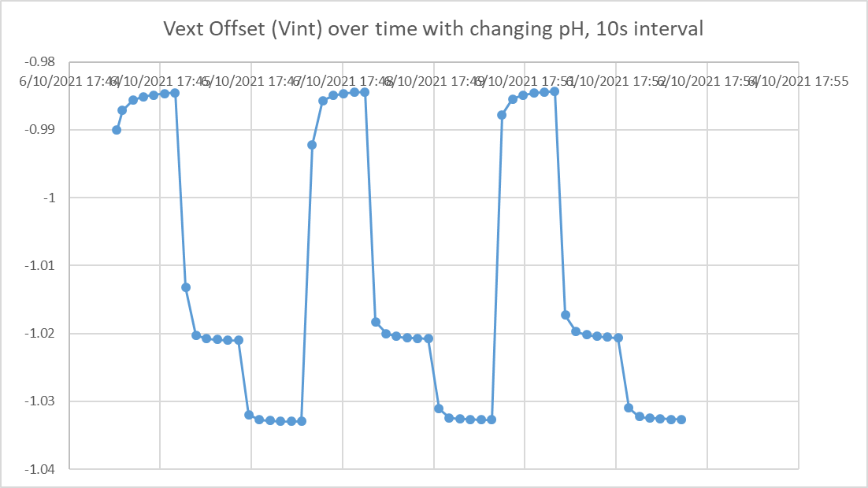
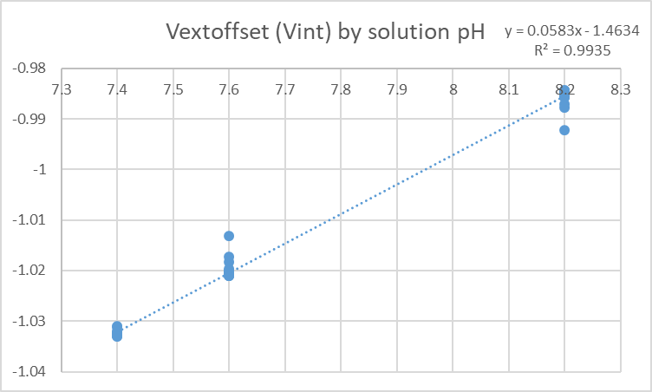

Noise Testing:
Test 1: File NFTST03.txt, excel tab NFTST03_Noise
- Tris in FSW: 8.2, stir bar. 60s resting, 60s stirred, 3x. Stir at 500 rpm.
Summary: No noise was able to be detected throughout the experiment.
